MSC Geography Package V6.8.0
Errata and Planned Changes

A. Resolved Issues
- Attribute Data Changes/Corrections

- In PubMeso and AQStdAlertZone, the province value associated to ‘fea1-1852’ (City of Lloydminster) should be ‘SK,AB’.

- In PubMesoZone, the waterbody value associated to all Manitoba Lakes locations has been corrected to ‘IW’.

- In previous versions, the following zones are found to have incorrect Feature IDs, which are corrected in version 6.8.0:
English Name | French Name | Incorrect Feature ID | Correct Feature ID | Shapefile Set | Depiction(s)
Qimusseriarsuaq | Qimusseriarsuaq | fea1-2830 | fea1-10 | water_IceMaStdZone, water_MarMACanSubZone,  water_MarMACanStdZone | D, C, E, H
Kiatak | Kiatak | fea1-12 | fea1-13 | water_IceMaStdZone, water_MarMACanSubZone, water_MarMACanStdZone | D, C, E, H
Attu | Attu | fea1-6 | fea1-5 | water_IceMaStdZone  water_MarMACanSubZone, water_MarMACanStdZone | D, C, E, H
Hinton | Hinton | fea1-2830 | fea1-2843 | land_CLCBaseSiteP | D, C, E, H
South Wood Buffalo | Wood Buffalo – Sud | fea1-2829 | fea1-2842 | land_CLCBaseSiteP | D, C, E, H
Strathcona County | comté de Strathcona | fea1-2828 | fea1-2841 | land_CLCBaseSiteP | D, C, E, H
The US/Canada Border | frontière canado-américaine | fea1-778 | fea1-2992 | land_CLCBaseSiteP | D, C, E, H
Langara | Langara | fea1-2290 | fea1-2993 | land_CLCBaseSiteP | D, C, E, H
North Vancouver Island | île de Vancouver Nord | fea1-2291 | fea1-2994 | land_CLCBaseSiteP | D, C, E, H
The Wash./BC Border | frontière entre l'état de Washington et la C.-B. | fea1-2292 | fea1-2995 | land_CLCBaseSiteP | D, C, E, H
Robeson | Robeson | fea1-530 | fea1-2845 | water_IceMAStdZone | D, C, E, H
Kane | Kane | fea1-535 | fea1-2846 | water_IceMAStdZone | D, C, E, H
Clarence – northern half | Clarence - moitié nord | fea1-540 | fea1-3002 | water_IceMAStdZone  water_MarMACanSubZone | D, C, E, H

- For the land_TsuBPUSite_detail_unproj shapefile, a new ‘FEATURE_ID’ attribute should be added with the following values:
NAME | FEATURE_ID
Chezzetcook Inlet | fea1-776
Meat Cove | fea1-777
The US/Canada Border | fea1-2992
Charlesville | fea1-779
Strait of Belle Isle | fea1-842
Cape Ray | fea1-843
La Manche | fea1-844
Cape Chidley | fea1-903
Langara | fea1-2993
North Vancouver Island | fea1-2994
The Wash./BC Border | fea1-2995

- For the water_MarDenZone_detail_unproj shapefile, a new ‘FEATURE_ID’ attribute should be added with the following values:
NAME | FEATURE_ID
Qimusseriarsuaq | fea1-10
Kiatak | fea1-13
Attu | fea1-5
Uiffaq | fea1-8

- For the land_TsuWAUSite_detail_unproj shapefile, a new ‘FEATURE_ID’ attribute should be added with the following values:
NAME | FEATURE_ID
Grand Manan Island | fea1-780
Lockeport | fea1-781
Scatarie Island | fea1-782
Cape Makkovik | fea1-846
Battle Harbour | fea1-847
Bonavista | fea1-848
Saint Lawrence | fea1-849

- For the land_UGCStdZone_detail_unproj shapefile, a new ‘FEATURE_ID’ attribute should be added with the following values:
Name English | Feature Obj ID
BCZ110 | fea1-2302
BCZ121 | fea1-2305
BCZ122 | fea1-2307
BCZ130 | fea1-2309
BCZ141 | fea1-2315
BCZ142 | fea1-2316
BCZ150 | fea1-2318
BCZ160 | fea1-2319
BCZ210 | fea1-2320
BCZ220 | fea1-2321
BCZ230 | fea1-2322
BCZ250 | fea1-2326
BCZ260 | fea1-2330
BCZ280 | fea1-2357
BCZ911 | fea1-2408
BCZ912 | fea1-2409
BCZ921 | fea1-2412
BCZ922 | fea1-2413
NBZ550 | fea1-814
NBZ570 | fea1-816
NBZ630 | fea1-819
NBZ641 | fea1-821
NBZ642 | fea1-822
NBZ650 | fea1-823
NBZ660 | fea1-824
NBZ720 | fea1-826
NBZ750 | fea1-831
NBZ760 | fea1-832
NBZ770 | fea1-833
NLZ110 | fea1-853
NLZ120 | fea1-854
NLZ131 | fea1-856
NLZ132 | fea1-857
NLZ140 | fea1-858
NLZ210 | fea1-859
NLZ220 | fea1-860
NLZ230 | fea1-861
NLZ241 | fea1-863
NLZ242 | fea1-864
NLZ310 | fea1-865
NLZ330 | fea1-867
NLZ340 | fea1-868
NLZ510 | fea1-871
NLZ520 | fea1-872
NLZ530 | fea1-873
NLZ540 | fea1-874
NLZ560 | fea1-876
NLZ570 | fea1-877
NLZ610 | fea1-878
NLZ620 | fea1-879
NLZ630 | fea1-880
NLZ710 | fea1-882
NLZ720 | fea1-883
NLZ730 | fea1-884
NLZ740 | fea1-885
NLZ750 | fea1-886
NLZ760 | fea1-887
NLZ770 | fea1-888
NSZ110 | fea1-785
NSZ120 | fea1-786
NSZ130 | fea1-787
NSZ140 | fea1-788
NSZ150 | fea1-789
NSZ160 | fea1-790
NSZ170 | fea1-791
NSZ210 | fea1-792
NSZ220 | fea1-793
NSZ230 | fea1-794
NSZ240 | fea1-795
NSZ250 | fea1-796
NSZ260 | fea1-797
NSZ270 | fea1-798
NSZ280 | fea1-799
NSZ310 | fea1-800
NSZ320 | fea1-801
NSZ330 | fea1-802
NSZ410 | fea1-803
NSZ420 | fea1-804
NSZ430 | fea1-805
NSZ440 | fea1-806
NSZ450 | fea1-807
PEZ810 | fea1-835
PEZ820 | fea1-836
PEZ830 | fea1-837
QCZ280 | fea1-973
QCZ460 | fea1-1003
QCZ470 | fea1-1006
QCZ480 | fea1-1012
QCZ510 | fea1-1020
QCZ520 | fea1-1024
QCZ540 | fea1-1028
QCZ560 | fea1-1035
QCZ570 | fea1-1038
QCZ580 | fea1-1041
QCZ610 | fea1-1044
QCZ620 | fea1-1045
QCZ630 | fea1-1048
QCZ640 | fea1-1049
QCZ650 | fea1-1050
QCZ660 | fea1-1051
QCZ670 | fea1-1052
QCZ680 | fea1-1053
QCZ750 | fea1-1081
QCZ760 | fea1-1084

- The dash character should be changed for a small hyphen “-’’ in the name ‘Wales to Cape Thompson - northern half’. (fea1-14, MarMACanStdZone, MarMACanSubZone)

- For version 6.8.0, there are proposed English and or/French name changes highlighted in red for zones listed below with the following attributes:
Shapefile Set | Old NAME | Old NOM | CLC | Feature ID | New NAME | New NOM
HurStdZone | Kirkland Lake – New Liskeard - Temagami | Kirkland Lake – New Liskeard - Temagami | 049700 | fea1-1330 | Kirkland Lake - Temiskaming Shores - Temagami | Kirkland Lake - Temiskaming Shores - Temagami
PubStdSiteL | Yellowhead Highway - Tête Jaune Cache to the Alberta Border | Route Yellowhead - de Tête Jaune Cache à la frontière de l’Alberta | 080051 | fea1-2787 | Yellowhead Highway - Tête Jaune Cache to the Alberta Border | route Yellowhead - de Tête Jaune Cache à la frontière de l’Alberta
PubStdSiteL | Trans Canada Highway – Eagle Pass to Rogers Pass | route Transcanadienne – du col au col Rogers | 080034 | fea1-2287 | Trans-Canada Highway – Eagle Pass to Rogers Pass | route Transcanadienne – du col au col Rogers
TsuBPCanSite | Langara Islands | île Langara | 080037 | fea1-2290 | Langara | Langara
TsuWACanSite | Grand Manan Island | Battle Harbour | 010024 | fea1-780 | Grand Manan Island | île Grand Manan
PubStdSiteL | Malahat Highway - Goldstream to Mill Bay | Route Malahat - de Goldstream à Mill Bay | 080044 | fea1-2295 | Malahat Highway - Goldstream to Mill Bay | route Malahat - de Goldstream à Mill Bay
land_CLCBaseSiteP (detail depiction) | Bonavista | Langara | 020015 | fea1-848 | Bonavista | Bonavista
land_CLCBaseSiteP (coarse depiction) | Wash./BC Border | frontière entre l'état de Washington et la C.-B. | 080039 | fea1-2995 | The Wash./BC Border | frontière entre l'état de Washington et la C.-B.

- When we have multiple province codes, we should not have a space character between the commas and next values.

- In land_CLCBaseSiteP exag depiction, fea1-2864 for Tofino site has been updated instead of 0 for PERIM_KM with 62.4289 and AREA_KM2 with 306.146.

- In MarStdZone and MarSubZone shapefiles, for coarse depiction only, Douglas Channel was missing the Feature Obj ID and CLC values and has been updated with fea1-49 and 001230.
- In IceSub shapefile, the CLC value for fea1-395 has been corrected to 003631-003632-003637-003638.

- In MarDenZone shapefile, for all locations, the country code has been corrected to DA and the waterbody code has been corrected to AC.

- In version 6.7.0, there are incorrect province codes for the following zones listed below. In version 6.8.0, the province codes have been repopulated with the correct information:

Shapefile Set(s) | English Name | French Name | CLC | Feature ID | Incorrect PROVINCE_C | New PROVINCE_C
MarSub, IceSub | Chaleur – Miscou – western half | Chaleur – Miscou – moitié ouest | 003152 | fea1-152 | NB, PE, QC | NB,QC
MarSub, IceSub | Gulf – Magdalen – northeastern half | Golfe – Madeleine – moitié nord-est | 003161-003162-003163-003168 | fea1-156 | NS, PE, QC | NS,QC
MarSub, IceSub | Gulf – Magdalen – northern half | Golfe – Madeleine – moitié nord | 003161-003162-003167-003168 | fea1-157 | NS, PE, QC | QC
MarSub, IceSub | Gulf – Magdalen – northwestern half | Golfe – Madeleine – moitié nord-ouest | 003161-003166-003167-003168 | fea1-158 | NS, PE, QC | PE,QC
MarSub, IceSub | Northumberland Strait – eastern half | Détroit de Northumberland – moitié est | 003171 | fea1-171 | NB, NS, PE | NS,PE
MarSub, IceSub | Lurcher – western half | Lurcher – moitié ouest | 003232 | fea1-177 | NS | Not Applicable
MarSub, IceSub | Sable – western half | talus Scotian Est – moitié est | 003342 | fea1-219 | NS | Not Applicable
MarSub, IceSub | Strait of Belle Isle – eastern half | détroit de Belle Isle – moitié est | 003411 | fea1-276 | NL, QC | NL
MarSub, IceSub | Northeast gulf – northwestern half | golfe nord-est – moitié nord-ouest | 003421 | fea1-279 | NL, QC | QC
MarSub, IceSub | Northeast gulf – southeastern half | golfe nord-est – moitié sud-est | 003422 | fea1-280 | NL, QC | NL
MarSub, IceSub | Gulf – Port au Port – northwestern half | Golfe – Port au Port – moitié nord-ouest | 003431 | fea1-282 | NL, QC | QC
MarSub, IceSub | Gulf – Port au Port – southeastern half | Golfe – Port au Port – moitié sud-est | 003432 | fea1-283 | NL, QC | NL
MarSub, MarStd | Cornwall to Montréal | Cornwall à Montréal | 004450 | fea1-453 | QC | ON,QC
MarSub, MarStd | Lake of the Woods | Lac des Bois | 004821-004823 | fea1-472 | ON | MB,ON
MarSub, IceSub | Resolution – eastern half | Resolution – moitié est | 005221 | fea1-487 | NU, QC | NU,QC,NL
MarStd, IceStd | Resolution | Resolution | 005220 | fea1-486 | NU, QC | NU,QC,NL
MarSub, IceSub | Ungava – eastern half | Ungava – moitié est | 005231 | fea1-490 | NU, QC | QC
MarSub, IceSub | Belcher – northern half | Belcher – moitié nord | 005321 | fea1-497 | NU, ON, QC | NU,QC
MarSub, IceSub | York – western half | York – moitié ouest | 005432 | fea1-510 | MB, ON | MB
MarSub, IceSub | Central – western half | Central – moitié ouest | 005532 | fea1-519 | BC or NU | Not applicable
MarSub, IceSub | Amundsen - western half | Amundsen - moitié ouest | 006553 | fea1-622 | NT, NU | NT
MarSub, IceSub | North Labrador Coast - north of Saglek | côte du Labrador-Nord - au nord de Saglek | 003611 | fea1-386 | QC | NL
MarSub, IceSub | North Labrador Coast - Saglek and south | côte du Labrador-Nord - Saglek et au sud | 003612 | fea1-387 | QC | NL
MarSub, IceSub | Mid Labrador Coast - north of Hopedale | côte du Labrador-Centre - au nord de Hopedale | 003621 | fea1-389 | QC | NL
MarSub, IceSub | Mid Labrador Coast - Hopedale and south | côte du Labrador-Centre - Hopedale et au sud | 003622 | fea1-390 | QC | NL
MarStd, IceStd | North Labrador Coast | côte du Labrador-Nord | 003610 | fea1-385 | QC | NL
MarStd, IceStd | Mid Labrador Coast | côte du Labrador-Centre | 003620 | fea1-388 | QC | NL
MarSub, MarStd, IceStd | South Labrador Coast | côte du Labrador-Sud | 003510 | fea1-310 | QC | NL
MarStd | Lake Athabasca | lac Athabasca | 008410 | fea1-746 | AB | AB,SK
IceSub | South Labrador Coast - northern half | côte du Labrador-Sud - moitié nord | 003511 | fea1-312 | QC | NL
IceSub | South Labrador Coast - southern half | côte du Labrador-Sud - moitié sud | 003512 | fea1-313 | QC | NL
MarSub | Queen Charlotte Sound – southern half | bassin Reine-Charlotte - moitié sud | 001212-001213 | fea1-44 | BC | N/A
AQStdFcstSiteP | Norman Wells | Norman Wells | 090010 | fea1-2819 | NU | NT
AQStdFcstSiteP (exag) | Wood Buffalo – South | Wood  Buffalo - sud | 070030 | fea1-2842 | SK | AB
AQStdFcstSiteP | Windsor | Windsor | 040011 | fea1-1116 | AB | ON
MarSub | Lake Athabasca – western half | lac Athabasca - moitié ouest | 008412-008413 | fea1-749 | AB | AB,SK

- In version 6.7.0, there are incorrect country codes for the following zones listed below. In version 6.8.0, the country codes have been repopulated with the correct information:
Shapefile Set(s) | Name | Nom | CLC | Feature ID | Incorrect COUNTRY_C | New COUNTRY_C
IceMAStdZone, MarMACanSubZone, MarMACanStdZone | Attu | Attu | Not applicable | fea1-5 | GL | DA
IceMAStdZone, MarMACanSubZone, MarMACanStdZone | Kiatak | Kiatak | Not applicable | fea1-13 | GL | DA
IceMAStdZone, MarMACanSubZone, MarMACanStdZone | Qimusseriarsuaq | Qimusseriarsuaq | Not applicable | fea1-10 | GL | DA
IceMAStdZone, MarMACanSubZone, MarMACanStdZone | Uiffaq | Uiffaq | Not applicable | fea1-7 | GL | DA
water_CLCBaseZone | AC000005 | AC000005 | 000005 | fea1-4 | GL | DA
water_CLCBaseZone | AC000006 | AC000006 | 000006 | fea1-6 | GL | DA
water_CLCBaseZone | AC000007 | AC000007 | 000007 | fea1-7 | GL | DA
water_CLCBaseZone | AC000008 | AC000008 | 000008 | fea1-9 | GL | DA
water_CLCBaseZone | AC000009 | AC000009 | 000009 | fea1-11 | GL | DA
water_CLCBaseZone | AC000010 | AC000010 | 000010 | fea1-12 | GL | DA

- We will fix the waterbody values associated to locations as specified below:
English Name | French Name | CLC | Feature ID | Incorrect WATRBODY_C | New WATRBODY_C
North Channel | chenal du Nord | 002600 | fea1-98 | IW | GL
North Channel | chenal du Nord | 002610 | fea1-99 | IW | GL
Lake Winnipegosis | lac Winnipegosis | 008620 | fea1-754 | N/A | IW
Lake Winnipeg - north basin | lac Winnipeg - bassin nord | 008631 | fea1-757 | N/A | IW
Lake Winnipeg - south basin | lac Winnipeg - bassin sud | 008632 | fea1-758 | N/A | IW
Lake Manitoba | lac Manitoba | 008640 | fea1-759 | N/A | IW

- In MarUSZone, for all locations, the waterbody code has been corrected to AC.

- The POLY ID and PRIME ID attributes in the attribute table should be removed from all derived sets and both projections.

- For the water_MarUSZone_detail_unproj shapefile, a new ‘FEATURE_ID’ attribute should be added with the following values:

Name English | Feature Obj ID
Wales to Cape Thompson – northern half | fea1-14
Cape Thompson to Cape Beaufort | fea1-15
Cape Beaufort to Point Franklin | fea1-16
Point Franklin to Cape Halkett | fea1-17
Cape Halkett to Flaxman Island | fea1-18
Flaxman Island to Demarcation Point | fea1-19
Western U.S. Arctic Offshore | fea1-20
Central U.S. Arctic Offshore | fea1-21
Eastern U.S. Arctic Offshore | fea1-22

- In all shapefiles that have it, remove the Feature ID attribute that starts with “F_”. For example, in the IceSub shapefiles, you would remove the “F_ICESUBZA” attribute.

- In TsuWACanSite_coarse, the FEATURE_ID attribute will be added with the same values as in the other depictions.

- In water_CLCBaseZone_detail shapefile, the locations didn’t have values for the ‘WATRBODY_C’ attribute. Values were assigned using values from other depictions.

- For all shapefiles (except the CAP-CP shapefiles), the attribute tables should have the following attributes:

- FID (ID value automatically generated by ArcGIS)
- Shape (value automatically generated by ArcGIS)
- CLC
- FEATURE_ID
- NAME
- NOM
- PERIM_KM
- AREA_KM2
- LAT_DD
- LON_DD
- KIND
- USAGE
- DEPICTN
- PROVINCE_C
- COUNTRY_C
- WATRBODY_C

After review, this would lead to the following attribute changes:

Shapefile Set(s) | Depiction(s) | Incorrect Attribute(s) | Correct Attribute(s) | Note
AQStdFcstSiteP | D, C, E, H | AQSTDSP | CLC | Remove AQSTDSP as we have identical CLC values
AQStdSiteL | D, C, E, H | AQSTDSL | CLC | Remove AQSTDSL as we have identical CLC values
 |  | LENGTH_KM | Not applicable | Remove LENGTH_KM as it is not listed as the attributes used
 |  | (blank) | WATRBODY_C | Add WATRBODY_C missing from list of attributes
 |  | Canada | CA | Change “Canada” values in COUNTRY to “CA”
AQStdZone | D, E, H | Shape_Leng | Not applicable | Remove Shape_Leng as it is not listed as the attributes used
 |  | Shape_Area |  | Remove Shape_Area as it is not listed as the attributes used
CLCBaseSiteL | C, E, H | (blank) | WATRBODY_C | Add WATRBODY_C missing from list of attributes
 |  | CLC_V5 | CLC | Remove CLC_v5 as we have identical CLC values
 |  | PUBSTDSL |  | Remove AQSTDSL as we have identical CLC values
CLCBaseSiteP | D, C, E | CLCBASEP | CLC | Remove CLCBASESP as we have identical CLC values
 |  | (blank) | WATRBODY_C | Add WATRBODY_C missing from list of attributes
 | C, E | F_Region | Name/Nom | Remove F_Region in detail which are “Name/Nom” attribute values
MarDenZone | D | (blank) | CLC | Added CLC since we are missing this attribute
MarUSZone | D | (blank) | CLC | Added CLC since we are missing this attribute
PubMesoZone | D, E, H | Shape_Leng | Not applicable | Remove Shape_Leng as it is not listed as the attributes used
 |  | Shape_Area |  | Remove Shape_Area as it is not listed as the attributes used
 | E | Shape_Le_1 |  | Remove Shape_Le_1 as it is not listed as the attributes used
PubStdSiteL | D, C. E | PUBSTDSL | CLC | Remove PUBSTDSL as we have identical CLC values
 |  | CLC_V5 |  | Remove CLC_v5 as we have identical CLC values
 |  | WATERBODY | WATRBODY_C | Rename WATERBODY to WATRBODY_C as the attribute name is incorrect
PubStdZone | D, E, H | Shape_Leng | Not applicable | Remove Shape_Leng as it is not listed as the attributes used
 |  | Shape_Area |  | Remove Shape_Area as it is not listed as the attributes used
TsuBCanSite | D, C, E | TSUBPCSP | Not applicable | Remove TSUBPCSP as we have identical CLC values
 |  | WATERBODY | WATRBODY_C | Rename WATERBODY to WATRBODY_C as the attribute name is incorrect
TsuBPUSite | D | TSUBPUSP | Not applicable | Remove TSUBPUSP as we have identical CLC values
 |  | WATERBODY | WATRBODY_C | Rename WATERBODY to WATRBODY_C as the attribute name is incorrect
TsuWACanSite | D, C, E | TSUWACSP | Not applicable | Remove TSUWACSP as we have identical CLC values
 |  | WATERBODY | WATRBODY_C | Rename WATERBODY to WATRBODY_C as the attribute name is incorrect
TsuWAUSite | D | TSUWAUSP | Not applicable | Remove TSUWAUSP as we have identical CLC values
 |  | WATERBODY | WATRBODY_C | Rename WATERBODY to WATRBODY_C as the attribute name is incorrect
UGCStdZone | D | UGCSTDZA | Not applicable | Remove UGCSTDZA as we have identical CLC values

- Boundary Changes / Corrections / Removal / Additions

- The Hurricane program will start to issue the Tropical Cyclone Information Statement alert for water locations. This will require the creation of a new water_HurStdZone shapefiles for all depictions. It will include the following locations with the following attribute values:

CLC | FEATURE_ID | NAME | NOM | KIND | USAGE | PROVINCE_C | WATRBODY_C | COUNTRY_C
003650 | fea1-425 | East Labrador Sea | mer du Labrador-Est | water | HurStdZone |  | AT | CA
004110 | fea1-442 | Lake Melville | lac Melville | water | HurStdZone | NL | IW | CA
003410 | fea1-275 | Strait of Belle Isle | détroit de Belle Isle | water | HurStdZone | NL,QC | AT | CA
003420 | fea1-278 | Northeast Gulf | golfe nord-est | water | HurStdZone | NL,QC | AT | CA
003430 | fea1-281 | Gulf - Port au Port | Golfe - Port au Port | water | HurStdZone | NL,QC | AT | CA
003440 | fea1-284 | Northeast Coast | côte nord-est | water | HurStdZone | NL | AT | CA
003450 | fea1-287 | East Coast | côte est | water | HurStdZone | NL | AT | CA
003460 | fea1-290 | South Coast | côte sud | water | HurStdZone | NL | AT | CA
003470 | fea1-293 | Southwestern Grand Banks | Grands Bancs Sud-Ouest | water | HurStdZone |  | AT | CA
003510 | fea1-310 | South Labrador Coast | côte du Labrador-Sud | water | HurStdZone | NL | AT | CA
003520 | fea1-314 | Belle Isle Bank | banc de Belle Isle | water | HurStdZone |  | AT | CA
003530 | fea1-331 | Funk Island Bank | banc de l'île Funk | water | HurStdZone |  | AT | CA
003540 | fea1-348 | Northern Grand Banks | Grands Bancs Nord | water | HurStdZone |  | AT | CA
003550 | fea1-365 | Southeastern Grand Banks | Grands Bancs Sud-Est | water | HurStdZone |  | AT | CA
003610 | fea1-385 | North Labrador Coast | côte du Labrador-Nord | water | HurStdZone | NL | AT | CA
003620 | fea1-388 | Mid Labrador Coast | côte du Labrador-Centre | water | HurStdZone | NL | AT | CA
003630 | fea1-391 | Northwest Labrador Sea | mer du Labrador-Nord-Ouest | water | HurStdZone |  | AT | CA
003640 | fea1-408 | South Labrador Sea | mer du Labrador-Sud | water | HurStdZone |  | AT | CA
003360 | fea1-237 | Southwest Coast | côte sud-ouest | water | HurStdZone | NL | AT | CA
004450 | fea1-453 | Cornwall to Montréal | Cornwall à Montréal | water | HurStdZone | ON,QC | IW | CA
004440 | fea1-452 | Montréal to Trois-Rivières | Montréal à Trois-Rivières | water | HurStdZone | QC | IW | CA
004430 | fea1-451 | Trois-Rivières to Donnacona | Trois-Rivières à Donnacona | water | HurStdZone | QC | IW | CA
004422 | fea1-450 | Donnacona to Beauport | Donnacona à Beauport | water | HurStdZone | QC | IW | CA
004421 | fea1-449 | Beauport to L'Isle-aux-Coudres | Beauport à L'Isle-aux-Coudres | water | HurStdZone | QC | IW | CA
004410 | fea1-447 | L'Isle-aux-Coudres to Tadoussac | L'Isle-aux-Coudres à Tadoussac | water | HurStdZone | QC | IW | CA
004320 | fea1-445 | Lake Saint-Jean | lac Saint-Jean | water | HurStdZone | QC | IW | CA
004610 | fea1-463 | Richelieu River and Northern Lake Champlain | rivière Richelieu et lac Champlain Nord | water | HurStdZone | QC | IW | CA
004510 | fea1-461 | Lake Memphrémagog - northern half | lac Memphrémagog - moitié nord | water | HurStdZone | QC | IW | CA
003121 | fea1-129 | Pointe-des-Monts to Anticosti - northern half | Pointe-des-Monts à Anticosti - moitié nord | water | HurStdZone | QC | AT | CA
003122 | fea1-130 | Pointe-des-Monts to Anticosti - southern half | Pointe-des-Monts à Anticosti - moitié sud | water | HurStdZone | QC | AT | CA
003112 | fea1-127 | Tadoussac to Pointe à Michel | Tadoussac à Pointe à Michel | water | HurStdZone | QC | AT | CA
003111 | fea1-126 | Pointe à Michel to Pointe-des-Monts | Pointe à Michel à Pointe-des-Monts | water | HurStdZone | QC | AT | CA
004310 | fea1-444 | Saguenay to Tadoussac | Saguenay à Tadoussac | water | HurStdZone | QC | IW | CA
004821-004823 | fea1-472 | Lake of the Woods | lac des Bois | water | HurStdZone | MB,ON | IW | CA
002710 | fea1-103 | Whitefish Bay | baie Whitefish | water | HurStdZone | ON | GL | CA
002610 | fea1-99 | North Channel | chenal du Nord | water | HurStdZone | ON | GL | CA
002512 | fea1-97 | Southern Georgian Bay | baie Georgienne Sud | water | HurStdZone | ON | GL | CA
002511 | fea1-96 | Northern Georgian Bay | baie Georgienne Nord | water | HurStdZone | ON | GL | CA
004810 | fea1-470 | Lake Nipigon | lac Nipigon | water | HurStdZone | ON | IW | CA
002412 | fea1-89 | Southern Lake Huron | lac Huron Sud | water | HurStdZone | ON | GL | CA
004720 | fea1-469 | Lake Nipissing | lac Nipissing | water | HurStdZone | ON | IW | CA
002411 | fea1-87 | Northern Lake Huron | lac Huron Nord | water | HurStdZone | ON | GL | CA
004710 | fea1-468 | Lake Simcoe | lac Simcoe | water | HurStdZone | ON | IW | CA
002310 | fea1-83 | Lake St. Clair | lac Sainte-Claire | water | HurStdZone | ON | GL | CA
002212 | fea1-77 | Western Lake Erie | lac Érié Ouest | water | HurStdZone | ON | GL | CA
004471 | fea1-459 | Kingston to Prescott | Kingston à Prescott | water | HurStdZone | ON | IW | CA
002211 | fea1-75 | Eastern Lake Erie | lac Érié Est | water | HurStdZone | ON | GL | CA
004461 | fea1-455 | Prescott to Cornwall | Prescott à Cornwall | water | HurStdZone | ON | IW | CA
002912 | fea1-118 | Western Lake Ontario | lac Ontario Ouest | water | HurStdZone | ON | GL | CA
002911 | fea1-116 | Eastern Lake Ontario | lac Ontario Est | water | HurStdZone | ON | GL | CA
002812 | fea1-109 | Western Lake Superior | lac Supérieur Ouest | water | HurStdZone | ON | GL | CA
002811 | fea1-107 | Eastern Lake Superior | lac Supérieur Est | water | HurStdZone | ON | GL | CA
004210 | fea1-443 | Bras d'Or Lakes | réseau du lac Bras d'Or | water | HurStdZone | NS | IW | CA
003150 | fea1-150 | Chaleur - Miscou | Chaleurs - Miscou | water | HurStdZone | NB,PE,QC | AT | CA
003160 | fea1-153 | Gulf - Magdalen | Golfe - Madeleine | water | HurStdZone | NS,PE,QC | AT | CA
003170 | fea1-170 | Northumberland Strait | détroit de Northumberland | water | HurStdZone | NB,NS,PE | AT | CA
003210 | fea1-173 | Fundy | Fundy | water | HurStdZone | NB,NS | AT | CA
003220 | fea1-174 | Grand Manan | Grand Manan | water | HurStdZone | NB,NS | AT | CA
003230 | fea1-175 | Lurcher | Lurcher | water | HurStdZone | NS | AT | CA
003240 | fea1-178 | Browns Bank | banc Browns | water | HurStdZone |  | AT | CA
003250 | fea1-181 | Georges Bank | banc Georges | water | HurStdZone |  | AT | CA
003260 | fea1-184 | Southwestern Shore | littoral sud-ouest | water | HurStdZone | NS | AT | CA
003270 | fea1-187 | LaHave Bank | banc LaHave | water | HurStdZone |  | AT | CA
003280 | fea1-190 | West Scotian Slope | talus Scotian Ouest | water | HurStdZone |  | AT | CA
003290 | fea1-207 | Halifax Harbour and Approaches | port d'Halifax et ses abords | water | HurStdZone | NS | AT | CA
003310 | fea1-208 | Cabot Strait | détroit de Cabot | water | HurStdZone | NL,NS | AT | CA
003320 | fea1-211 | Fourchu | Fourchu | water | HurStdZone | NS | AT | CA
003330 | fea1-214 | Eastern Shore | littoral est | water | HurStdZone | NS | AT | CA
003340 | fea1-217 | Sable | abords de l'île de Sable | water | HurStdZone | NS | AT | CA
003350 | fea1-220 | East Scotian Slope | talus Scotian Est | water | HurStdZone |  | AT | CA
003370 | fea1-241 | Banquereau | Banquereau | water | HurStdZone |  | AT | CA
003380 | fea1-258 | Laurentian Fan | cône Laurentien | water | HurStdZone |  | AT | CA
003140 | fea1-131 | Anticosti | Anticosti | water | HurStdZone | QC | AT | CA

- In the AQStdFcstSiteP shapefiles (all depictions), remove the ‘Petawawa’ site as requested by the AQ program for RI30. (fea1-1146)

The following changes (items 3 to 13) are all minor boundary adjustments following the exaggerated vertices investigation:
- For the location represented by the Feature Obj ID ‘fea1-384’ (Tail of the Grand Banks) in water_CLCBaseZone_exag shapefile, replace the polygon by the one in the water_IceStdZone_exag shapefile.

- For the location represented by the Feature Obj ID ‘fea1-372’ (Southeastern Grand Banks - southeastern half) in water_IceSubZone_exag shapefile, replace the polygon by the one in the water_MarSubZone_exag shapefile.

- For the location represented by the Feature Obj ID ‘fea1-378’ (Southeastern Grand Banks - western half) in water_IceSubZone_exag shapefile, replace the polygon by the one in the water_MarSubZone_exag shapefile.

- For the location represented by the Feature Obj ID ‘fea1-798’ (Halifax Metro and Halifax County West) in land_HurStdZone_exag shapefile, replace the polygon by the one in the land_PubStdZone_exag shapefile.

- For the location represented by the Feature Obj ID ‘fea1-796’ (Hants County) in land_HurStdZone_exag shapefile, replace the polygon by the one in the land_PubStdZone_exag shapefile.

- For the location represented by the Feature Obj ID ‘fea1-1267’ (Halton - Peel) in land_PubStdZone_exag shapefile, replace the polygon by the one in the land_HurStdZone_exag shapefile.

- For the location represented by the Feature Obj ID ‘fea1-2265’ (WestShore) in all CLCBaseSiteP shapefiles, replace the site by the one in the AQFcstStdSite shapefiles.

- For the locations represented by the Feature Obj ID ‘fea1-2269’ (Haines Road - Yukon border to Pleasant Camp) and ‘fea1-2272’ (South Klondike Highway - Yukon border to White Pass), in all AQStdSiteL shapefiles, replace these roads by the ones in the CLCBaseSiteL shapefiles.

- For the following locations, for the exaggerated depiction, replace these polygons in land_AQStdFcstSiteP_exag by the ones in the land_CLCBaseSiteP_exag shapefile:
Feature Obj ID | English Name
fea1-2602 | St. Albert
fea1-2603 | Sturgeon County
fea1-2818 | Saint Andrews
fea1-2819 | Norman Wells

- For the location represented by the Feature Obj ID ‘fea1-1946’ (Rocky View Co. near Cochrane) in land_CLCBaseZone_exag shapefile, replace the polygon by the one in the land_PubMesoZone_exag shapefile.

- For the location represented by the Feature Obj ID ‘fea1-1961’ (City of Calgary) in land_PubStdZone_exag shapefile, replace the polygon by the one in the land_PubMesoZone_exag shapefile.

- The water_CLCBaseZone derived set should match the image below for Canada-US claims in the Marine program.
Canada-US claim
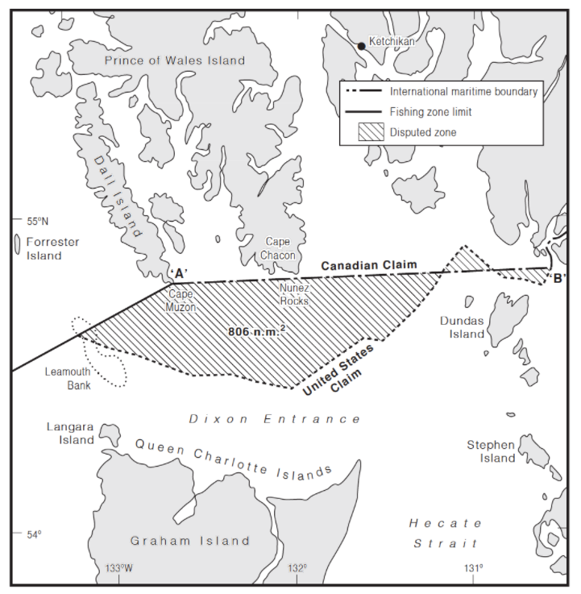

Original Image Corrected Image

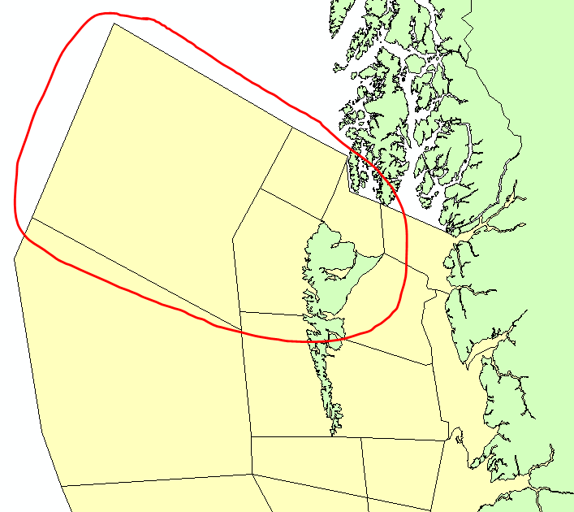
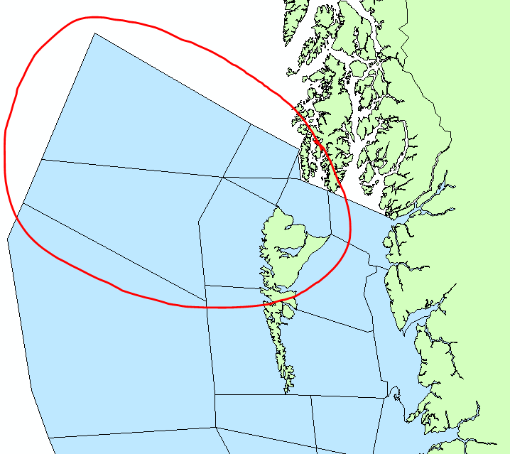

For the 6 new zones that would get generated, we would assign the following Feature Obj ID values:
fea1-2996
fea1-2997
fea1-2998
fea1-2999
fea1-3000
fea1-3001

- For the detail depiction, these shapefiles need a minor boundary adjustment that would match water CLCBaseZone detail shapefile because of an overlap issue with the polygon represented by the Feature Obj ID fea1-2407:
- land_PubMesoZone_detail
- land_AQStdZone_detail
- land_PubStdZone_detail
- land_CLCBaseZone_detail

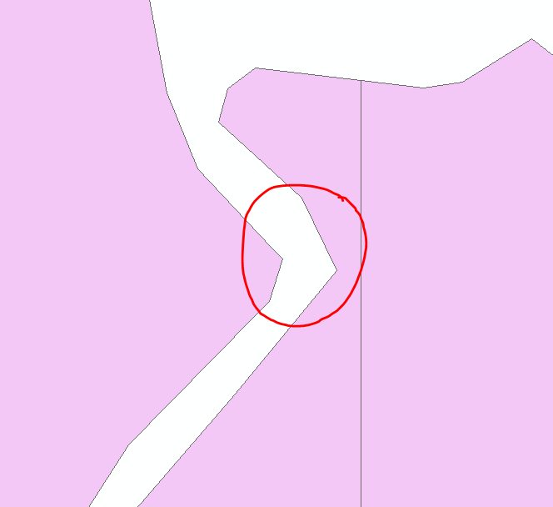
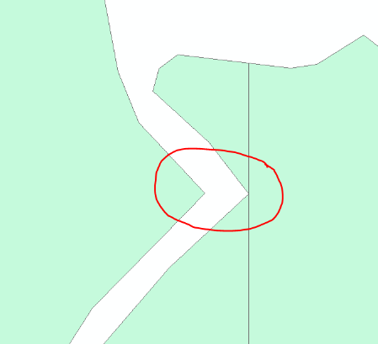
Original Image Corrected Image

- In PubMesoZone, land_CLCBaseZone, AQStdZone, HurStdZone, and PubStdZone coarse depictions, we are missing the some important islands that have been covered in the detailed depiction.

(L’Île Perrot)
Original Image Corrected Image
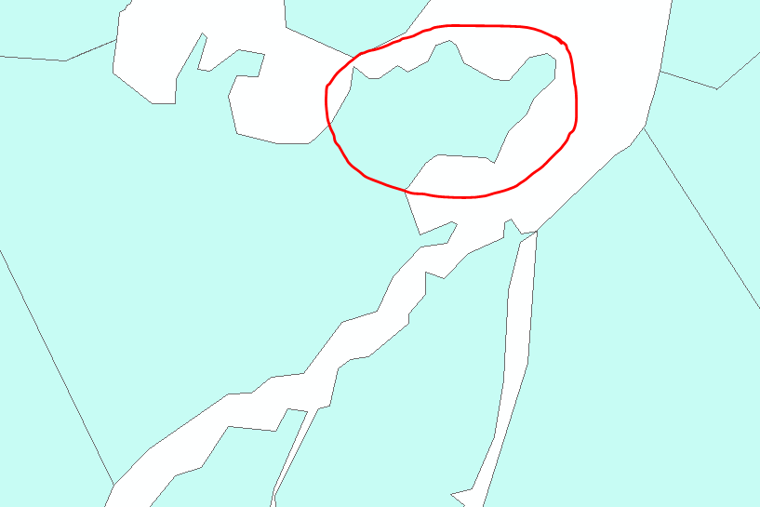
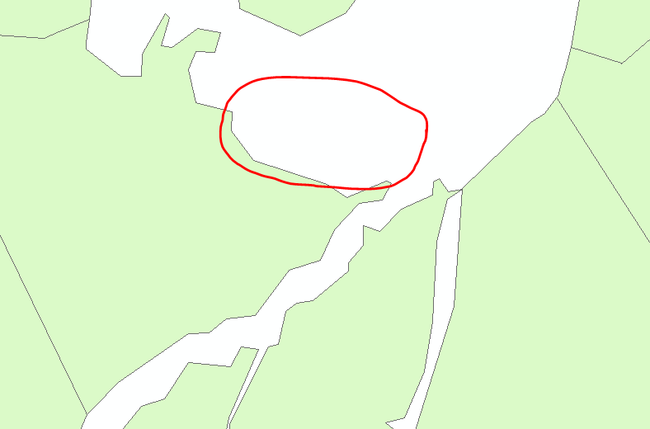

(L’Île Orléans)
Original Image Corrected Image
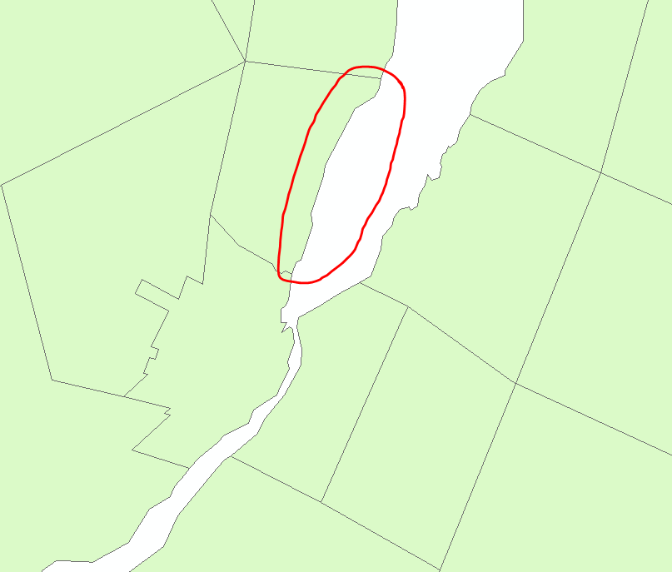
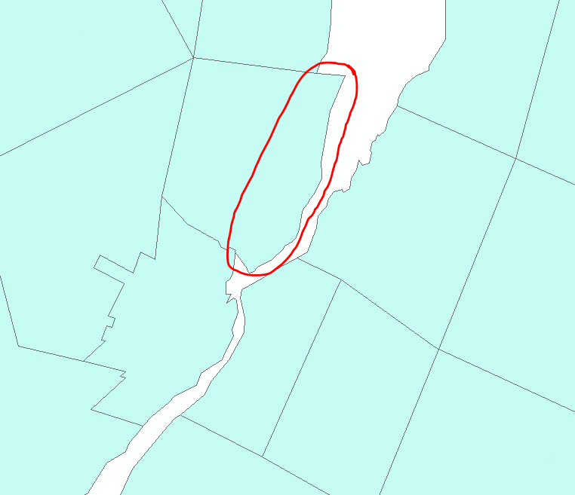

- There is a hole which needs to be removed in PubStdZone coarse depiction for fea1-1055 that was a result of removing a waterbody in the polygon from v6.7.0.

Original Image Corrected Image
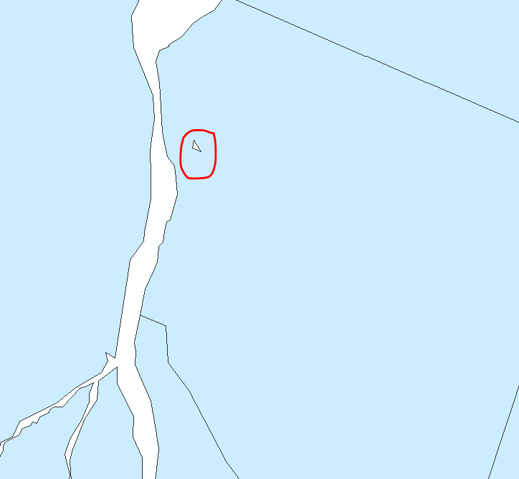
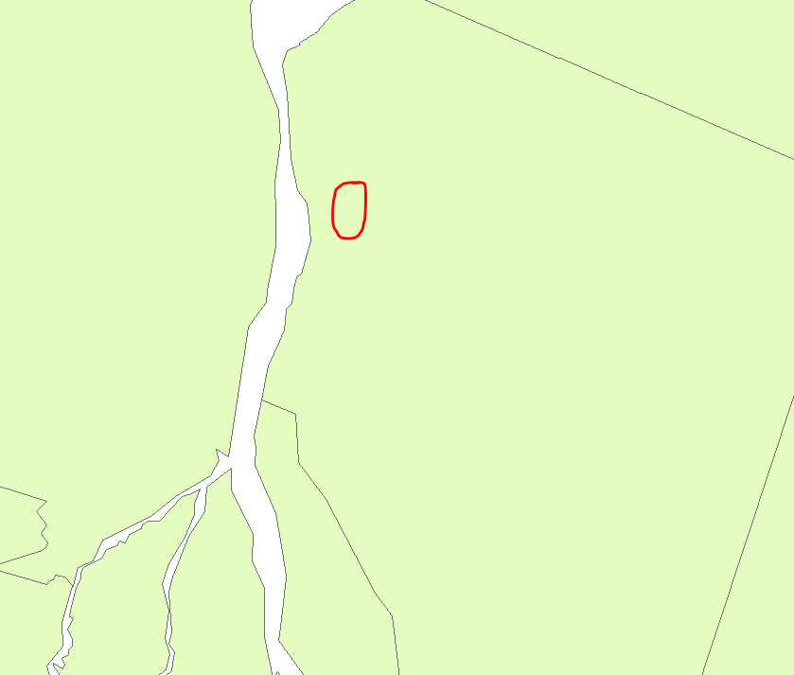

- The CAP-CP_land_detail_unproj shapefile would need to be updated with the latest 2011 Stats Can census subdivision boundaries. We updated the CAP-CP_land_detail_unproj shapefile w/ the Stats Can 2011 Shapefile.

- In MarStd, MarSub, IceStd and IceSub shapefiles, remove ‘Detroit River’ from the ‘Lake Erie’ polygons.

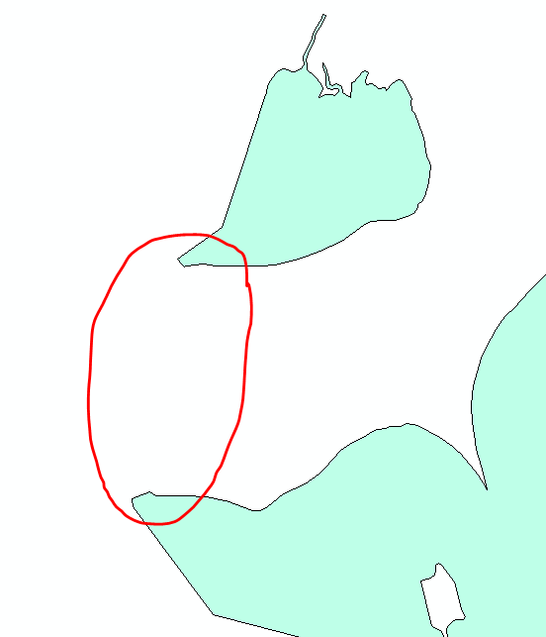
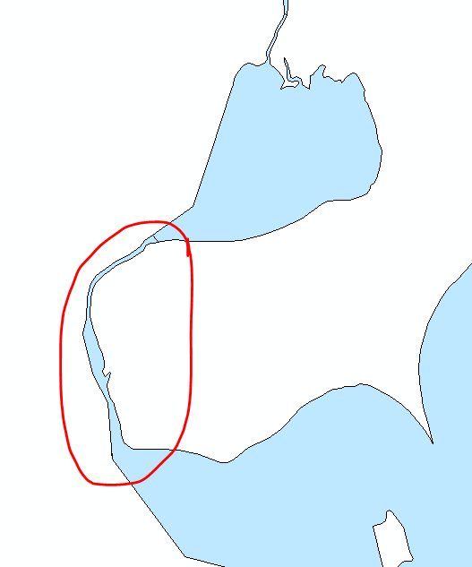
Original Image Corrected Image

- In MarStd, MarSub, IceStd and IceSub shapefiles, remove ‘St. Clair River’ from the ‘Lake Huron’ polygons.

Original Image Corrected Image
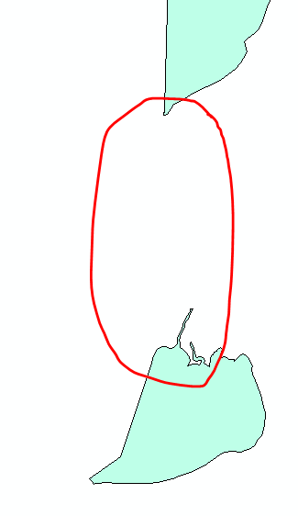
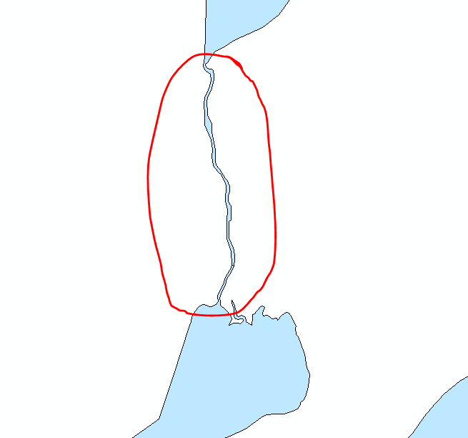

- In MarStd, MarSub, IceStd and IceSub shapefiles, remove ‘St. Marys River’ from the ‘North Channel’ polygon.

Original Image Corrected Image
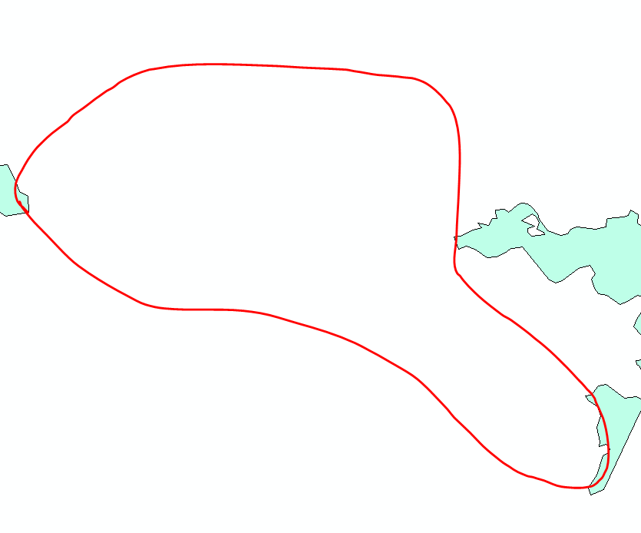
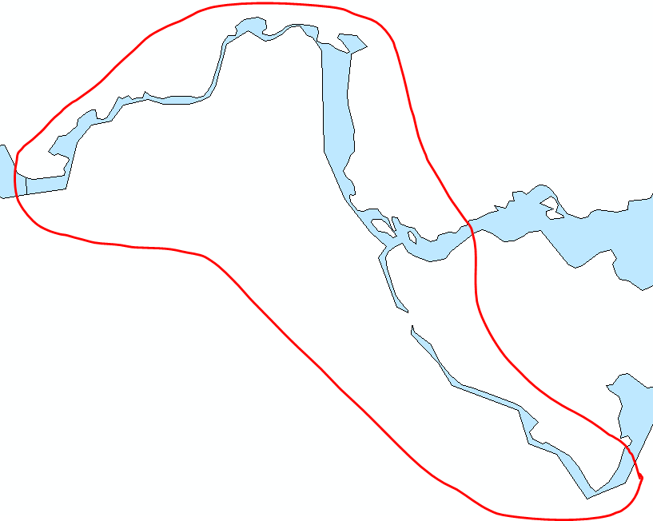

- In water_CLC_BaseZone shapefiles, as specified in items 18-19-20 above, remove the rivers from the existing polygons that intersect with those and create the following new locations:
Feature Obj ID | CLC Geocode | Name | Nom | Province | Country | Waterbody
fea1-3005 | 004761 | Detroit River | rivière Détroit | ON | CA | IW
fea1-3006 | 004762 | Detroit River | rivière Détroit |  | US | IW
fea1-3007 | 004771 | St. Clair River | rivière Sainte-Claire | ON | CA | IW
fea1-3008 | 004772 | St. Clair River | rivière Sainte-Claire |  | US | IW
fea1-3009 | 004781 | St. Marys River | rivière Sainte-Marie | ON | CA | IW
fea1-3010 | 004782 | St. Marys River | rivière Sainte-Marie |  | US | IW

Detroit River (Canadian and US parts highlighted)

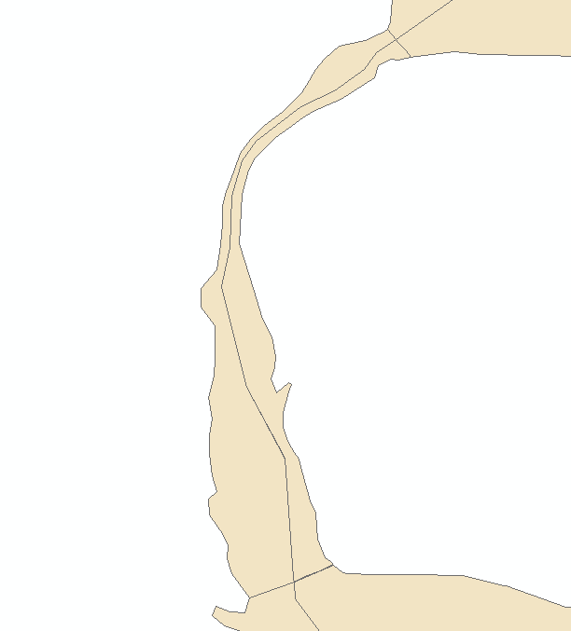
Canadian part
US part

St. Clair River (Canadian and US parts highlighted)

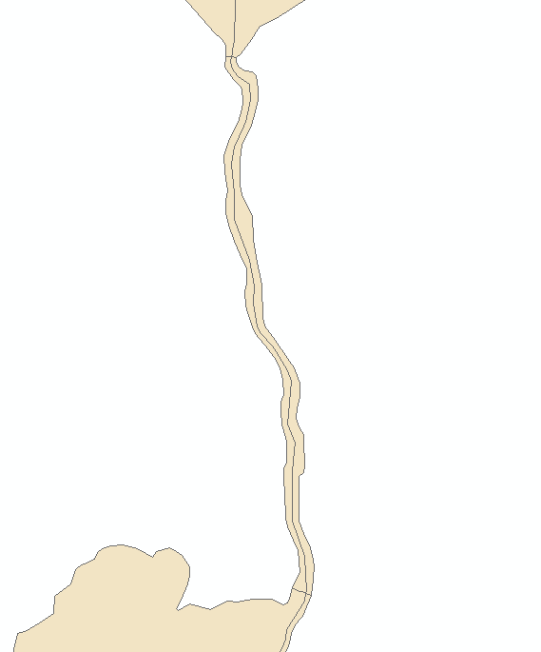
Canadian part
US part

St. Marys River (Canadian and US parts highlighted)

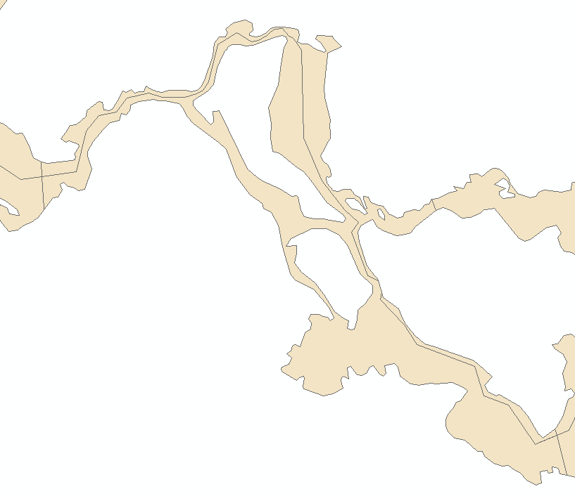
US part
Canadian part

- In the CAP-CP_water_detail_unproj shapefile, add the Canadian portions of the rivers that will be added to the water CLC base set as described in item 21 above.
The attribute values for these new locations will be the following:
CAPCPGCODE | Name | Nom | Province | Waterbody
00476 | Detroit River | rivière Détroit | ON | IW
00477 | St. Clair River | rivière Sainte-Claire | ON | IW
00478 | St. Marys River | rivière Sainte-Marie | ON | IW

Detroit River

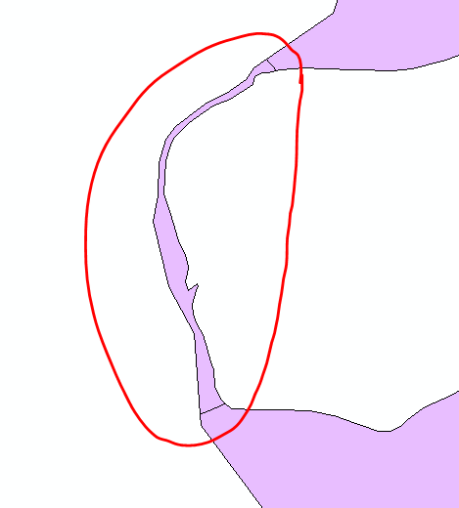

St. Clair River

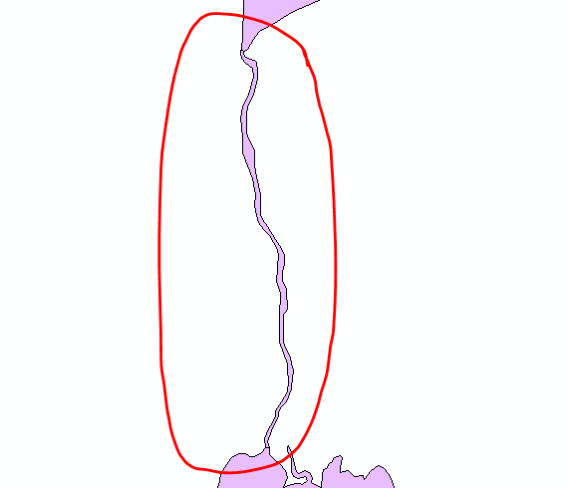

St. Marys River
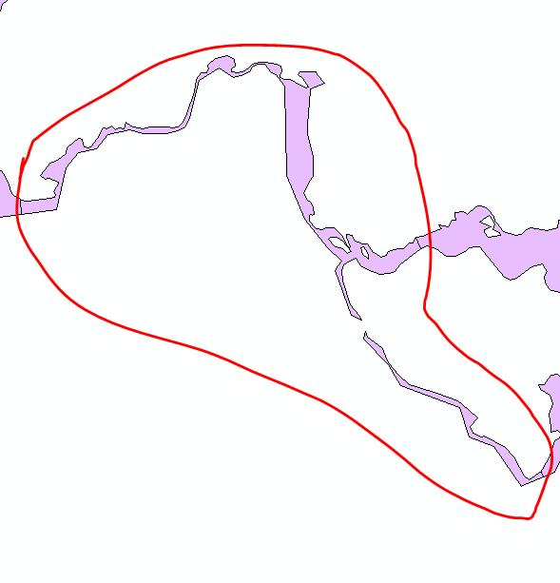

- In v6.8.0, the MarSubZone and MarStdZone in all depictions should follow that of v5.5.0 along the BC coast from Haida Gwaii and Vancouver Island. Also, we changed more boundaries as displayed in the images below.

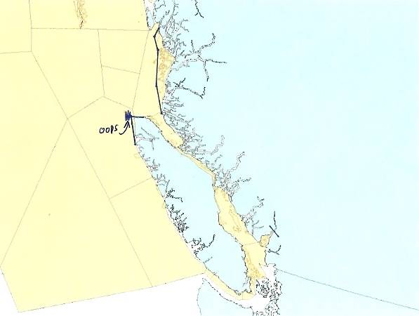
Haida Gwaii Vancouver Island
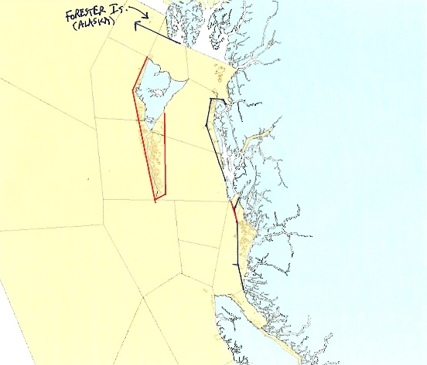

Original Image Corrected Image

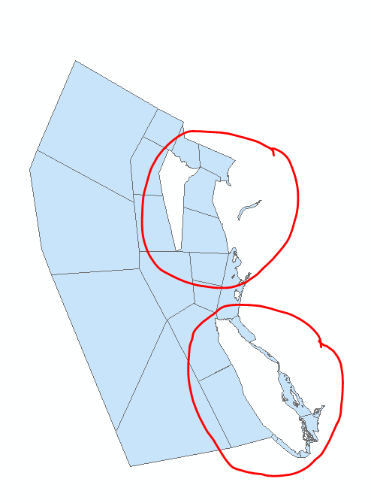
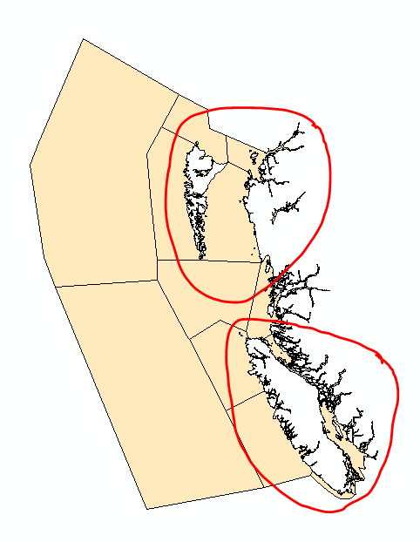

- In the St. Lawrence River near Cornwall, Île Saint-Régis should be moved to be in Quebec waters as displayed below. This would only affect the detail depiction for the following derived sets: land_PubMesoZone, land_PubStdZone, land_HurStdZone, land_AQStdZone, land_CLCBaseZone, water_MarStdZone, water_MarSubZone, water_CLCBaseZone.
In the detail depiction, this island should be part of the Quebec zone only and should be moved to follow the boundaries from the Stats Can shapefile:
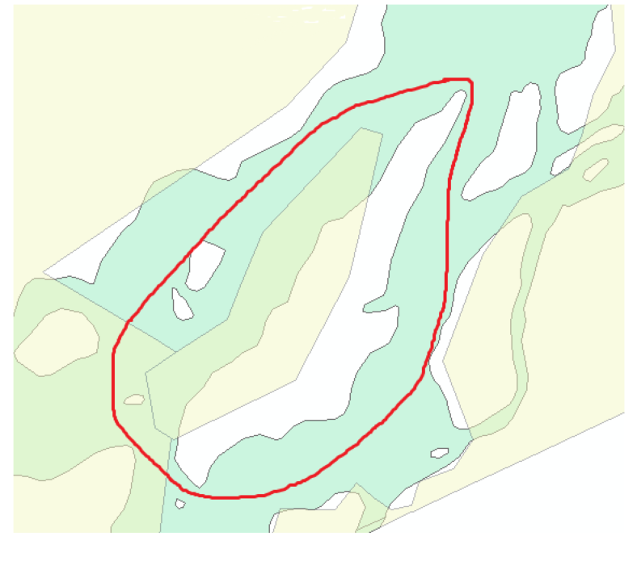

- WeatherCAN – Public Boundary Improvement:
The boundary of some forecast zones are requested for change in response to the WeatherCAN client feedback received on incorrect location mapping. Since October 2019, a review has been conducted by the Public Program regional offices to detect areas of major misalignment in the public forecast zones in comparison to the 2018 Census Subdivision (CSD) boundaries. In images below, the layer with the red line identifies the forecast zone boundary (hybrid) overlaying above the world topographic map from the ArcGIS Basemap Gallery. Although changes to the requested forecast zones focus on the hybrid set, detailed, coarse and exaggerated might also be adjusted accordingly to the change.

Due to the large volume of changes required, a priority list is prepared based on the population size of the areas. The zones listed below are corrected for this version:

- Richmond (BC)
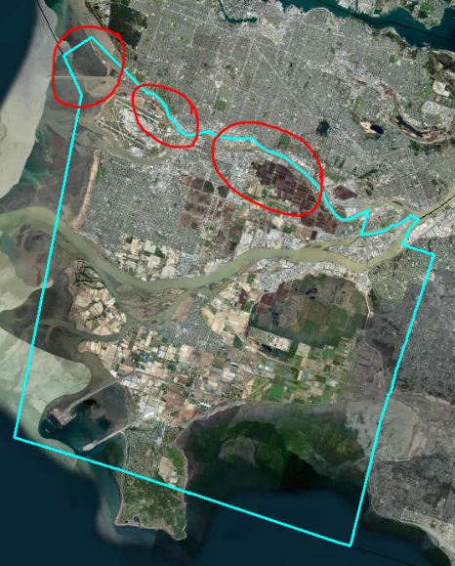
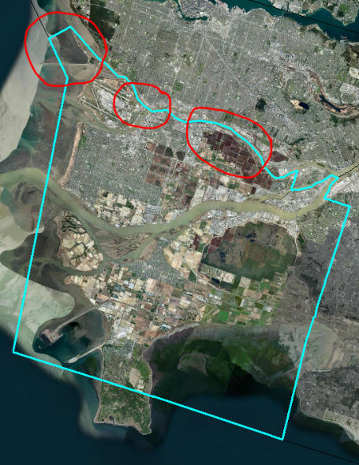
Original Image Corrected Image

- Burlington (ON)
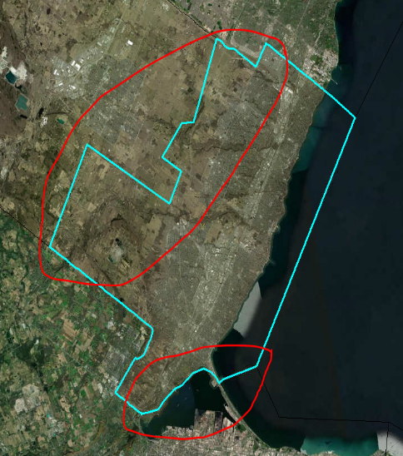
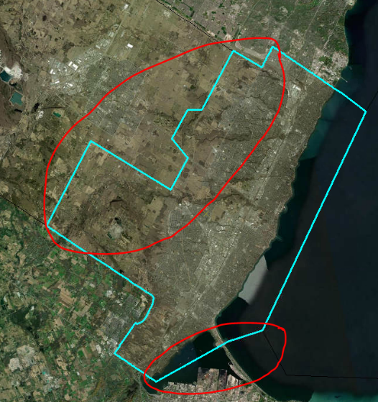
Original Image Corrected Image

- West Vancouver, Vancouver (BC)

Original Image Corrected Image
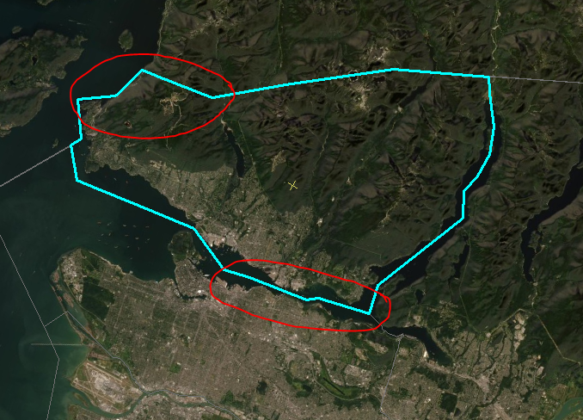
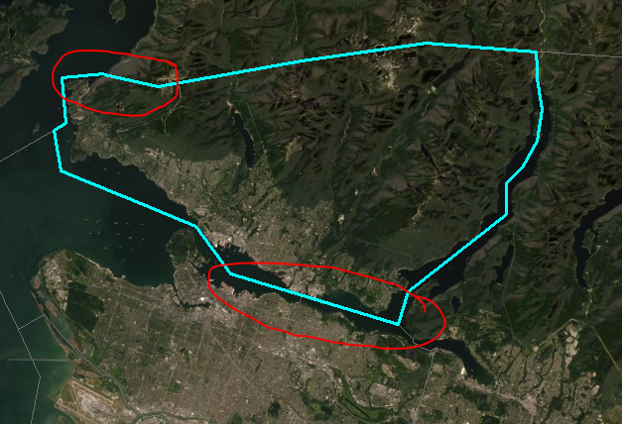

- Sherbrooke (QC)

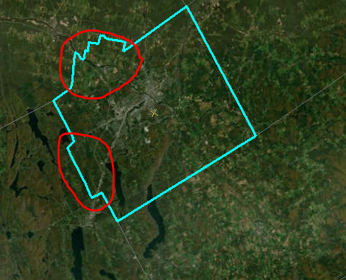
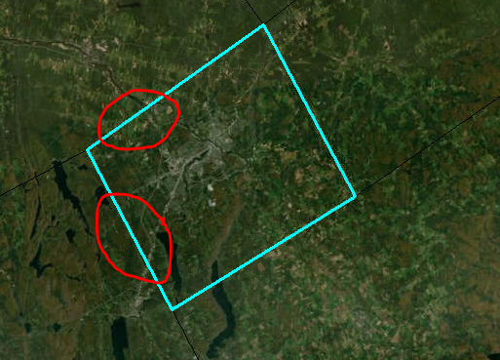
Original Image Corrected Image

- Barrie, Angus (ON)
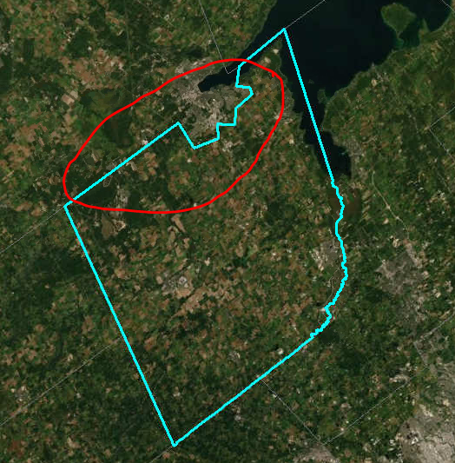
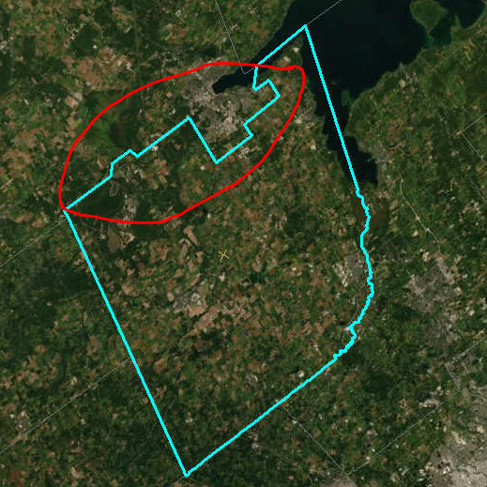
Original Image Corrected Image

- Saguenay, St-Charles-de-Bourget, Saint-Ambroise (QC)

Original Image Corrected Image
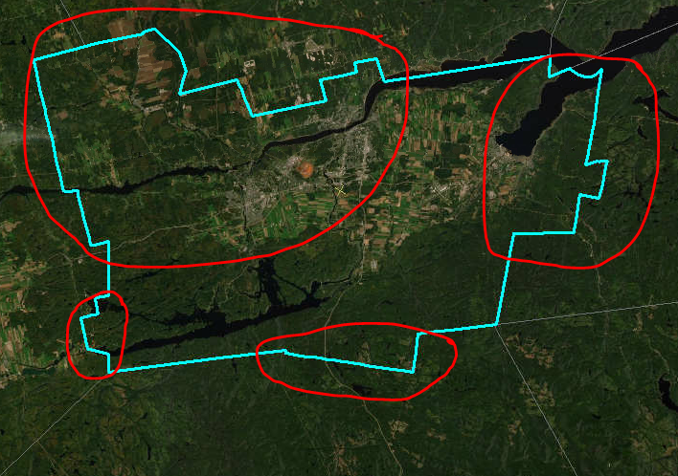
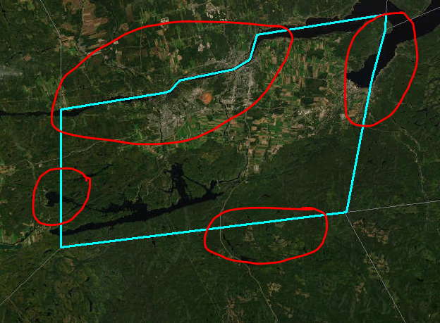

- Abbotsford (BC)

Original Image Corrected Image

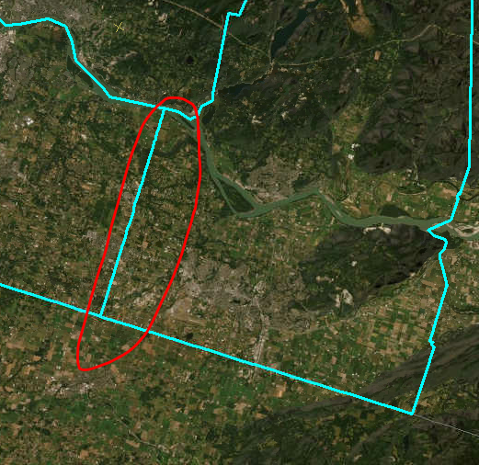
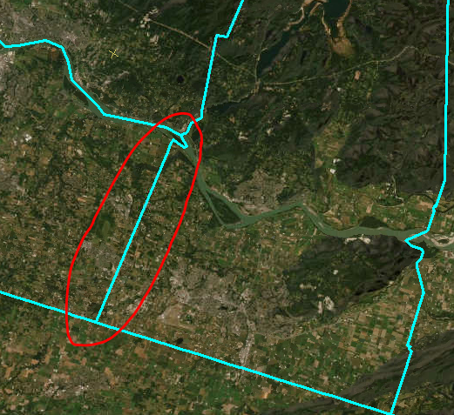

- Châteauguay, St-Constant, Candiac, La Prairie - Montréal's South Shore (QC)

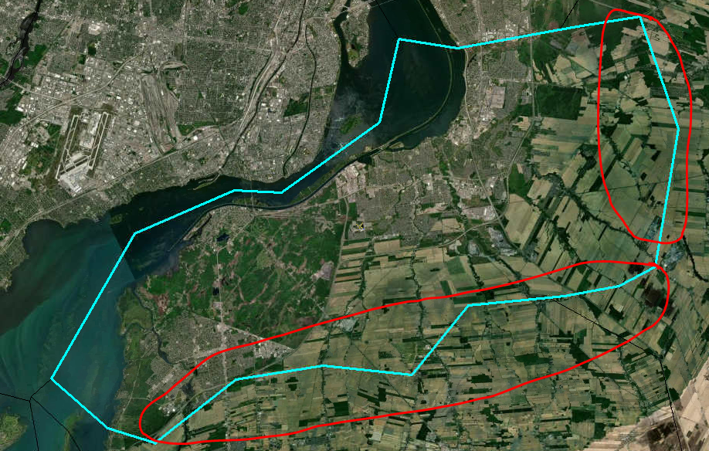
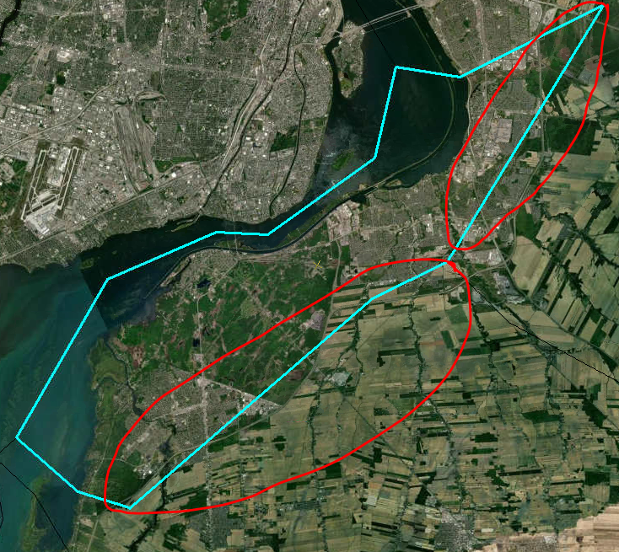
Original Image Corrected Image

- Red Deer (AB)

Original Image Corrected Image
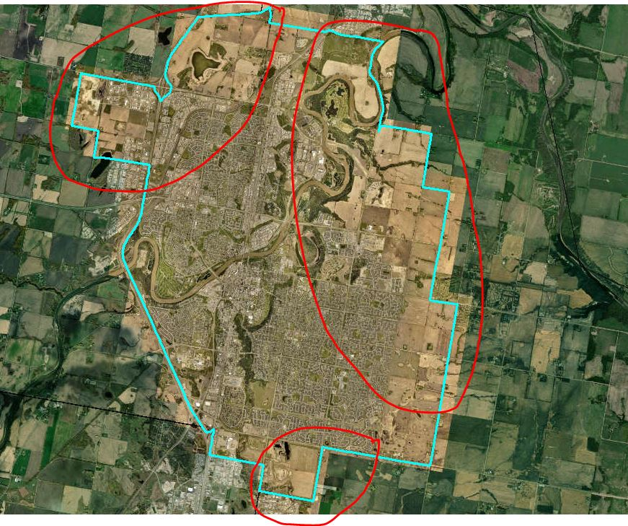
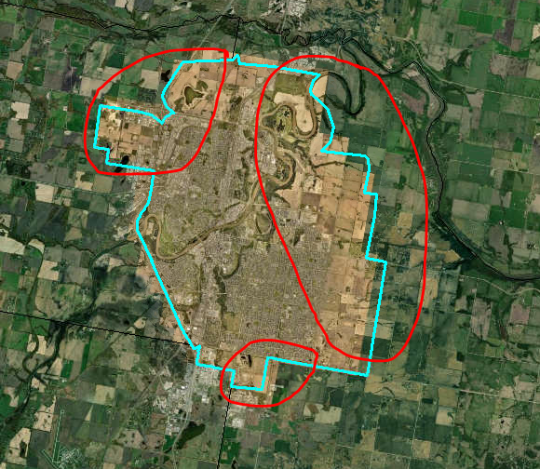

- Lethbridge (AB)

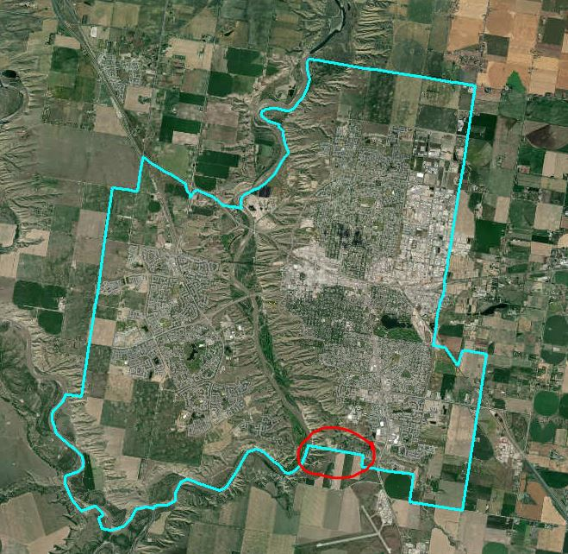
Original Image Corrected Image
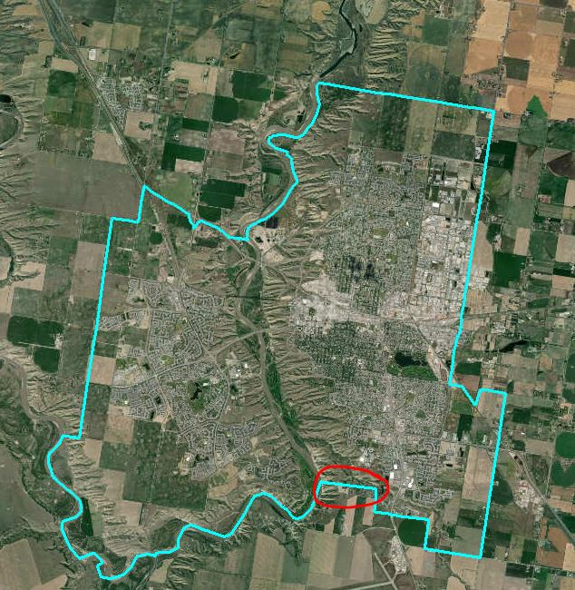

- Gold River (BC)

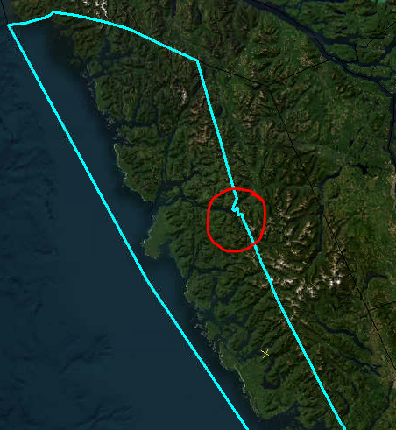
Original Image Corrected Image
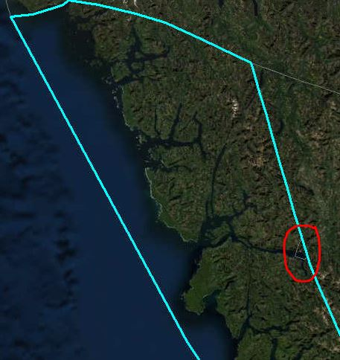
- Cornwall, Long Sault, Lakeview Heights (ON)

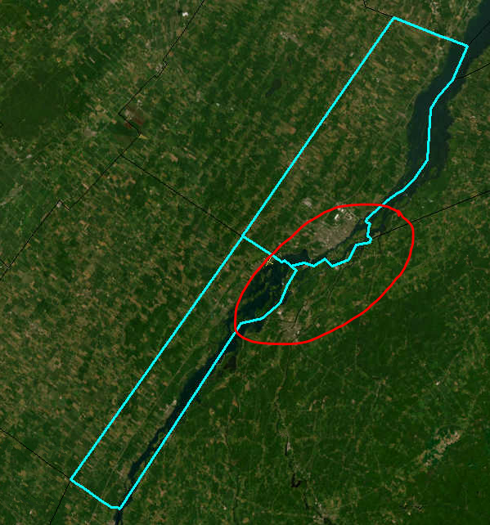
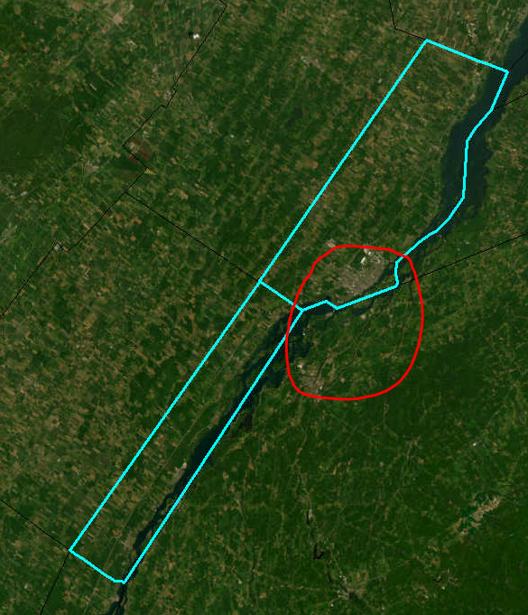
Original Image Corrected Image

- Welland (ON)

Original Image Corrected Image
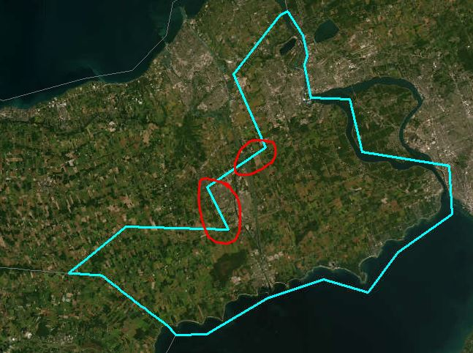
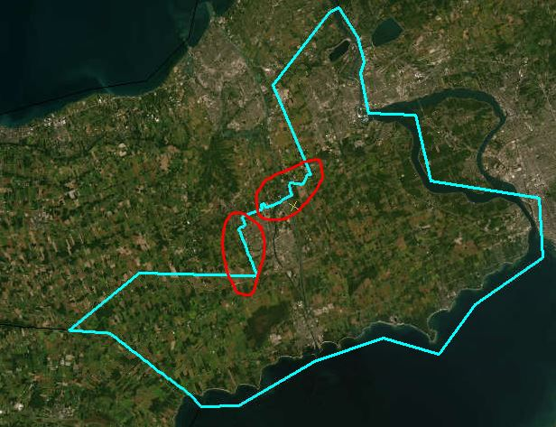

- Île-à-la-Crosse (SK)
Original Image Corrected Image
