**­­MSC Geography Package V6.9.0**

**Errata and Planned Changes**

1. **Resolved Issues**
2. The Public and Air Quality programs requested to change boundaries in the Metro Vancouver and Fraser Valley areas in British Columbia. These changes will affect the following derived sets:
   1. PubMesoZone
   2. PubStdZone
   3. AQStdZone
   4. Land CLCBaseZone

All details on the location metadata changes associated to these boundary changes can found in this spreadsheet:



These images represent the boundary changes for the detail depiction in that area:

Current Public meso alert location boundaries:

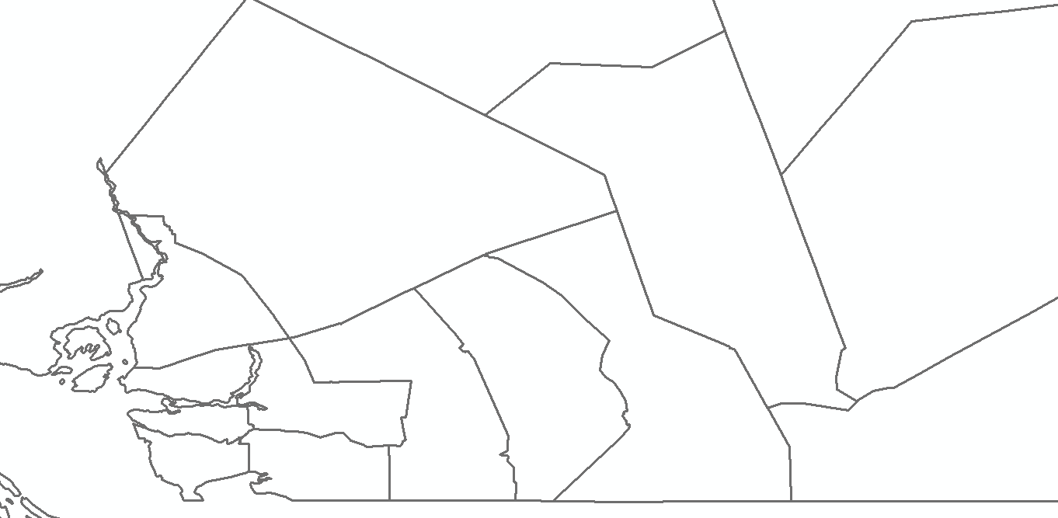

New Public meso alert location boundaries:

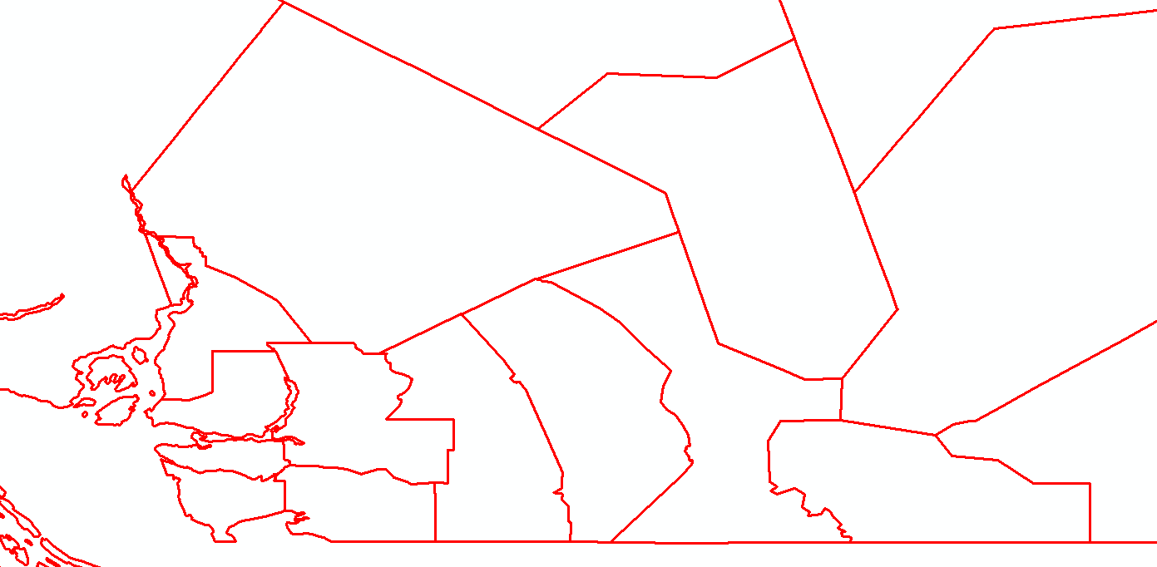

Current Public standard alert location boundaries:

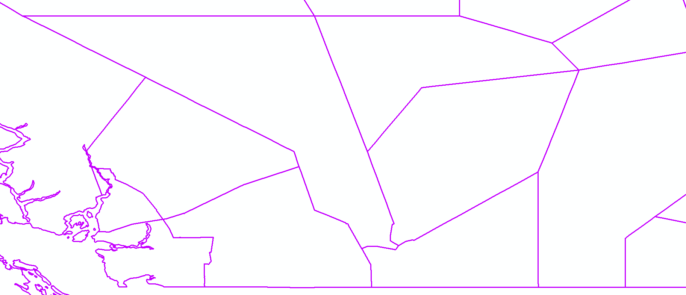

New Public standard alert location boundaries:

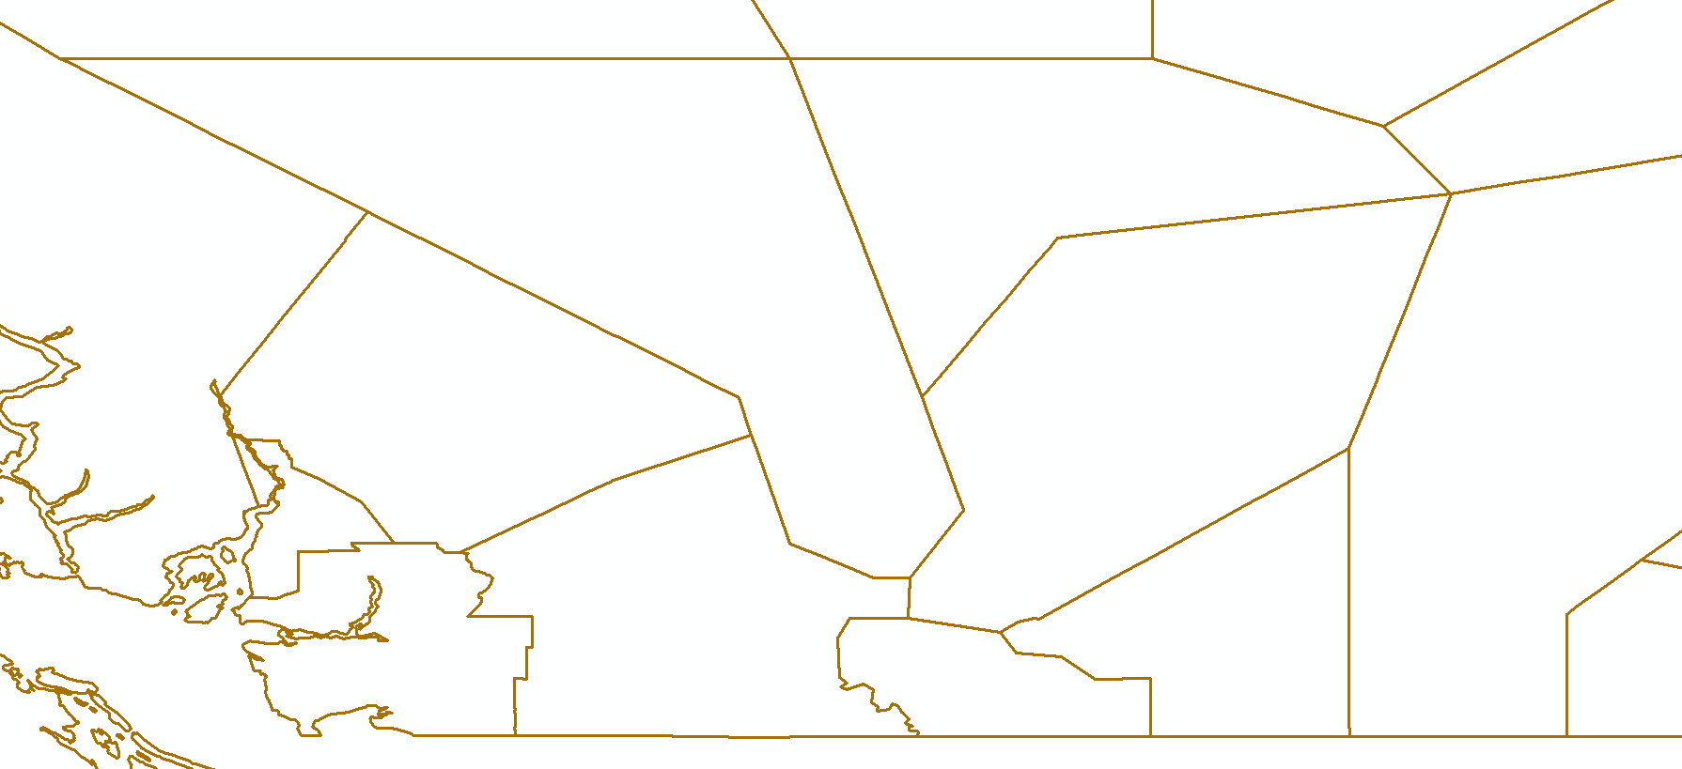

Current AQ alert location boundaries:

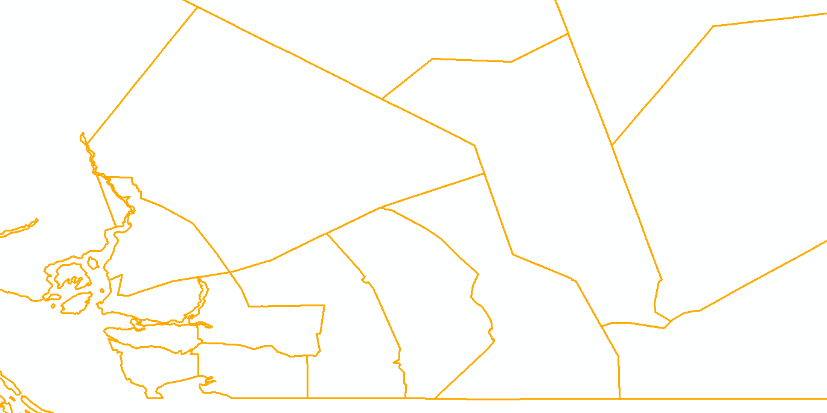

New AQ alert location boundaries:

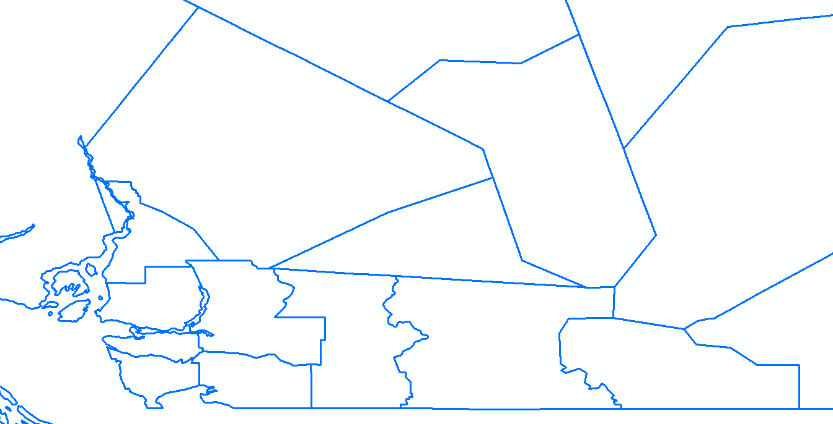

1. The Public program requested for the following name change for their alert location (fea1-1965):

Current:

English: Foothills Co. near Turner Valley and Black Diamond

French: cté de Foothills près de Turner Valley et de Black Diamond

Proposed:

English: Foothills Co. near Diamond Valley

French: cté de Foothills près de Diamond Valley

This would affect the following shapefile sets:

* Land PubMeso
* Land AQStdZone
* Land CLCBaseZone

1. The Ice program requested to remove the following location splits for their alerts. They will be removed from the IceSub derived shapefiles.

|  |  |  |  |
| --- | --- | --- | --- |
| **English Name** | **French Name** |  | **Feature Obj ID** |
| Baillie - eastern half | Baillie - moitié est |  | fea1-720 |
| Baillie - western half | Baillie - moitié ouest |  | fea1-721 |
| Amundsen - eastern half | Amundsen - moitié est |  | fea1-620 |
| Amundsen - western half | Amundsen - moitié ouest |  | fea1-622 |
| Peel - northern half | Peel - moitié nord |  | fea1-604 |
| Peel - southern half | Peel - moitié sud |  | fea1-605 |
| Regent - northern half | Regent - moitié nord |  | fea1-598 |
| Regent - southern half | Regent - moitié sud |  | fea1-599 |
| Igloolik - northern half | Igloolik - moitié nord |  | fea1-481 |
| Igloolik - southern half | Igloolik - moitié sud |  | fea1-482 |
| Barrow - eastern half | Barrow - moitié est |  | fea1-601 |
| Barrow - western half | Barrow - moitié ouest |  | fea1-602 |
| South Labrador Coast - northern half | côte du Labrador-Sud - moitié nord |  | fea1-312 |
| South Labrador Coast - southern half | côte du Labrador-Sud - moitié sud |  | fea1-313 |

These splits will be replaced by these standard locations:

|  |  |  |  |
| --- | --- | --- | --- |
| **English Name** | **French Name** |  | **Feature Obj ID** |
| Baillie | Baillie | fea1-719 | |
| Amundsen | Amundsen | fea1-617 | |
| Peel | Peel | fea1-603 | |
| Regent | Regent | fea1-597 | |
| Igloolik | Igloolik | fea1-480 | |
| Barrow | Barrow | fea1-600 | |
| South Labrador Coast | côte du Labrador-Sud | fea1-310 | |

1. Clients reported an issue with the exaggerated vertices values provided for a location in the CAP file as the first and last lat/long coordinates were different.

After investigation, we found out that it was a 2 parts polygon as there's a hole in the middle for another polygon representing a city.

These partners can't proceed these 2 part polygons which means that we will fill in the hole for these exaggerated polygons.

After investigation, we found out 3 polygons that had the issue which are the following:

* R.M. of Moose Jaw including Pasqua and Bushell Park (fea1-1582)
* R.M. of Sherwood including Grand Coulee (fea1-1595)
* R.M. of Corman Park including Martensville Warman and Langham (fea1-1741)

These boundary changes would affect the following shapefile sets:

* Land PubMeso
* Land AQStdZone
* Land CLCBaseZone

R.M. of Moose Jaw including Pasqua and Bushell Park (fea1-1582)

**Current boundaries: New boundaries:**

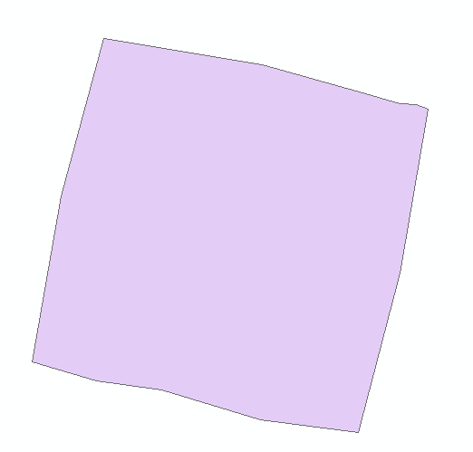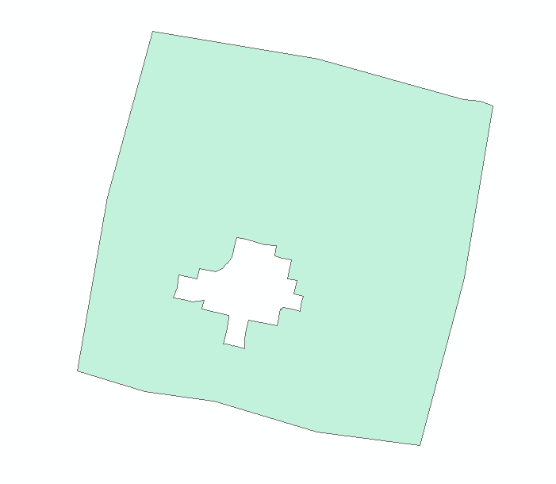

R.M. of Sherwood including Grand Coulee (fea1-1595)

**Current boundaries: New boundaries:**

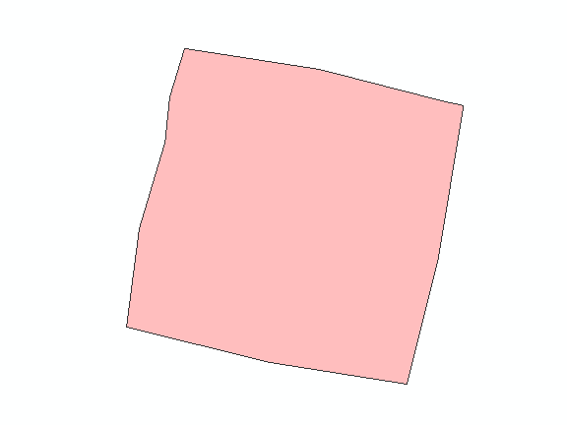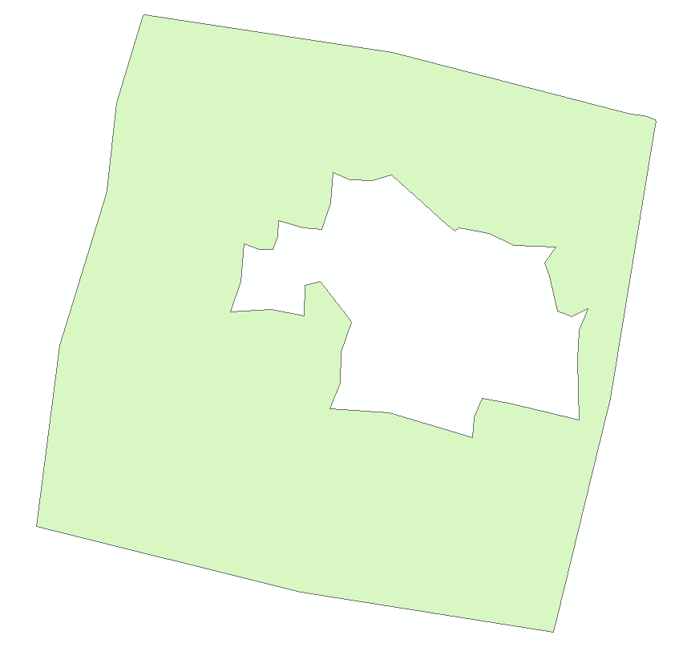

R.M. of Corman Park including Martensville Warman and Langham (fea1-1741)

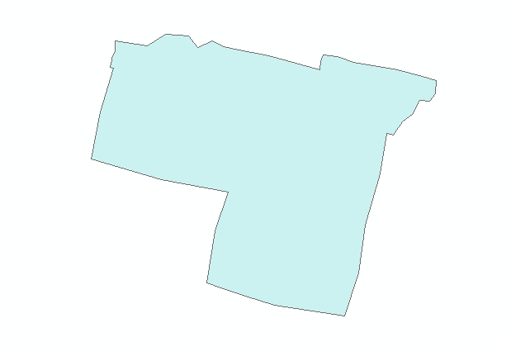**Current boundaries: New boundaries:**

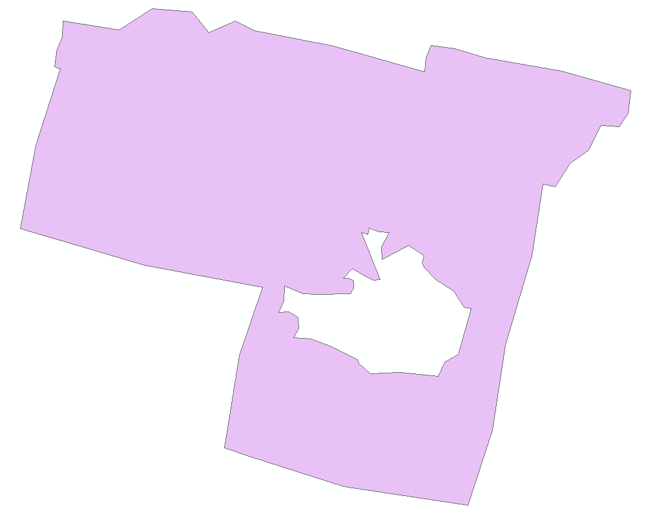

Related to these issues, the following 2 exaggerated polygons in the PubStd shapefile will have these new boundaries:

Martensville - Warman - Rosthern - Delisle – Wakaw (fea1-1734)

**Current boundaries: New boundaries:**

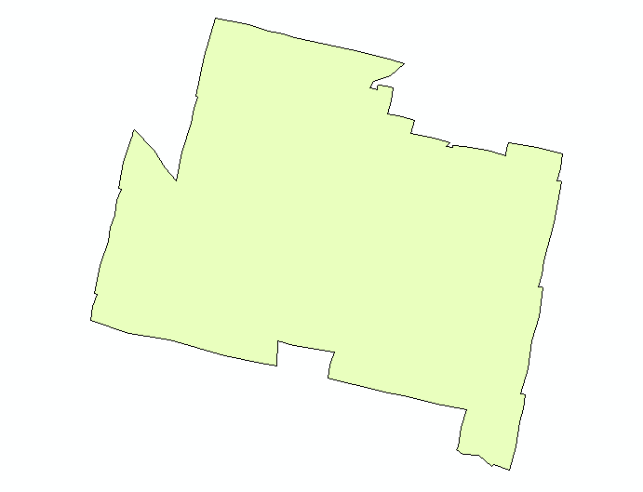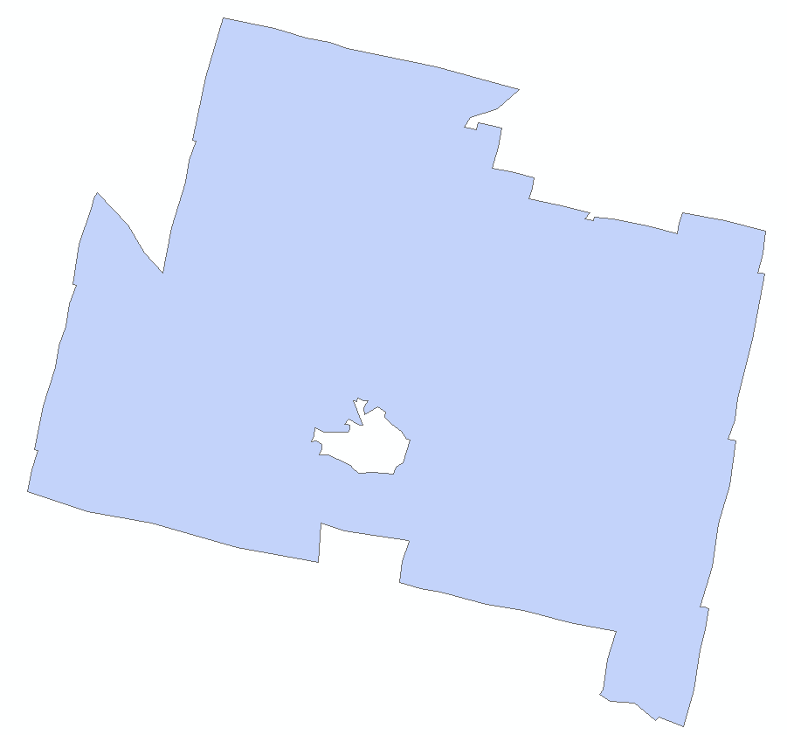

Fort Qu'Appelle - Indian Head - Lumsden - Pilot Butte (fea1-1588)

**Current boundaries: New boundaries:**

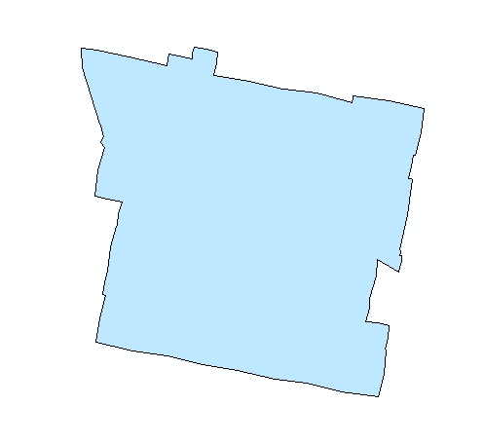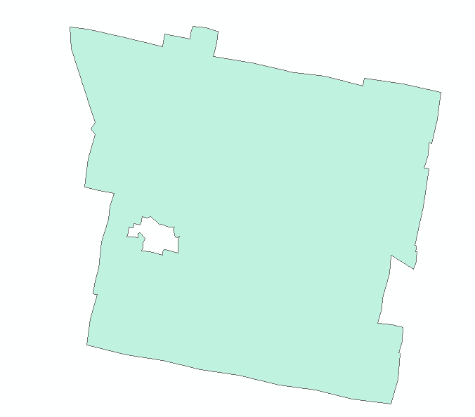

1. Related to the previous item, we found a hole that should not be there in a water exaggerated polygon representing this location:

| **Feature Obj ID** | **Name English** | **Name French** |
| --- | --- | --- |
| fea1-136 | Anticosti - northeastern half | Anticosti - moitié nord-est |

It would affect the following exaggerated shapefiles:

* Water IceSub
* Water MarSub

**Current boundaries:**

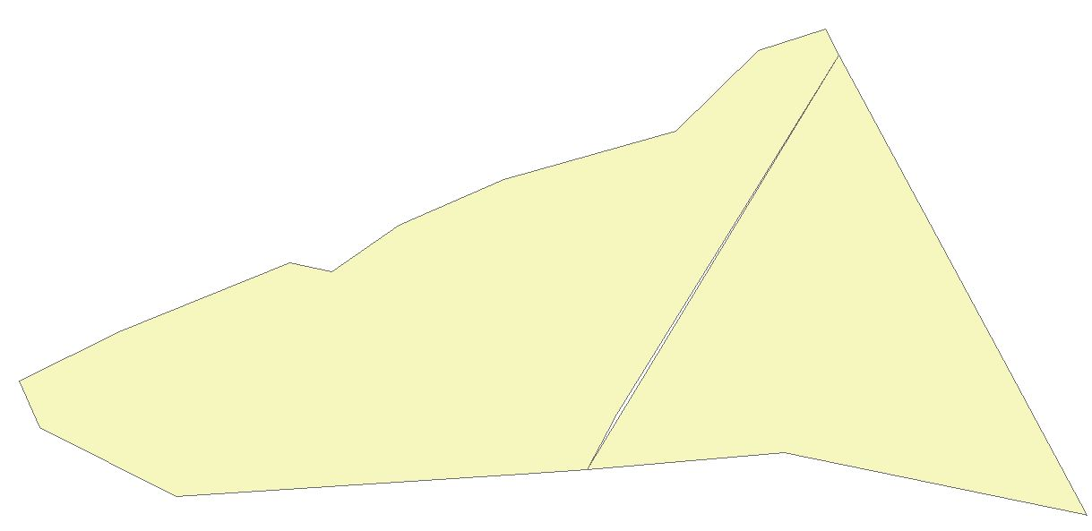

**New boundaries:**

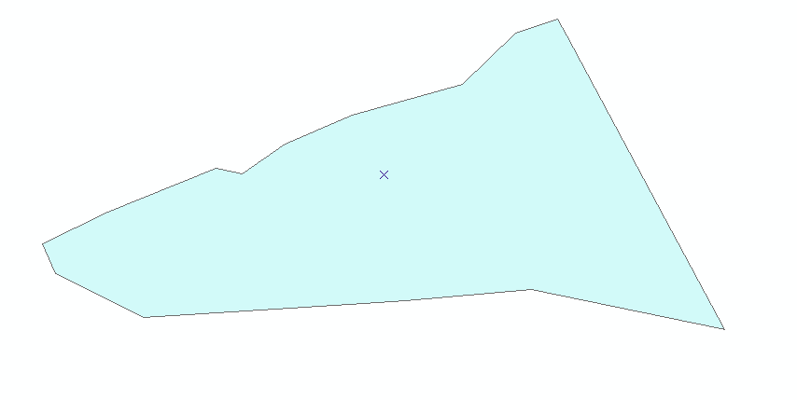

1. In the land CLC base shapefiles, the following locations should have these names:

|  |  |  |
| --- | --- | --- |
| **Feature Obj ID** | **English Name** | **French Name** |
| fea1-2327 | Howe Sound | baie Howe |
| fea1-1974 | Foothills Co. near Blackie | cté de Foothills près de Blackie |
| fea1-1969 | Foothills Co. near Cayley | cté de Foothills près de Cayley |
| fea1-1968 | Foothills Co. near High River and Aldersyde | cté de Foothills près de High River et d'Aldersyde |
| fea1-1966 | Foothills Co. near Longview and Eden Valley Res. | cté de Foothills près de Longview et de la rés. ind. Eden Valley |
| fea1-1967 | Foothills Co. near Okotoks and De Winton | cté de Foothills près d'Okotoks et De Winton |
| fea1-1964 | Foothills Co. near Priddis and Brown-Lowery Prov. Park | cté de Foothills près de Priddis et du Brown-Lowery Prov. Park |
| fea1-2798 | Bulkley Valley | vallée de Bulkley |
| fea1-2799 | Lakes District | district des lacs |
| fea1-2441 | Teslin | Teslin |
| fea1-2442 | Cassiar Mountains | chaîne des Cassiars |
| fea1-2443 | Watson Lake | Watson Lake |
| fea1-2335 | Metro Vancouver - central including the City of Vancouver Burnaby and New Westminster | Metro Vancouver - centre incluant la ville de Vancouver Burnaby et New Westminster |
| fea1-2803 | Duncan | Duncan |
| fea1-2804 | Nanaimo | Nanaimo |
| fea1-2805 | Comox Valley | vallée de Comox |
| fea1-2806 | Campbell River | Campbell River |
| fea1-1332 | Temiskaming Shores - Temagami | Temiskaming Shores - Temagami |
| fea1-1420 | R.M. of Victoria Beach | m.r. de Victoria Beach |

1. In the water CLC base shapefiles, the following locations should have these names:

|  |  |  |
| --- | --- | --- |
| **Feature Obj ID** | **English Name** | **French Name** |
| fea1-738 | Point Separation mile 913 to Kittigazuit Bay mile 1081 | pointe Separation mille 913 à la baie Kittigazuit mille 1081 |
| fea1-622 | Amundsen - western half | Amundsen - moitié ouest |
| fea1-2559 | Meelpaeg Lake | lac Meelpaeg |
| fea1-2544 | Smallwood Reservoir | réservoir Smallwood |
| fea1-283 | Gulf - Port au Port - southeastern half | Golfe - Port au Port - moitié sud-est |
| fea1-101 | North Channel | chenal du Nord |
| fea1-282 | Gulf - Port au Port - northwestern half | Golfe - Port au Port - moitié nord-ouest |

1. In the MarSub exaggerated and hybrid depictions, the boundary between ‘Explorer - southeastern half’ and ‘Explorer - northwestern half’ should change to follow the current coarse and detail boundary:

Current exaggerated boundary Current hybrid boundary

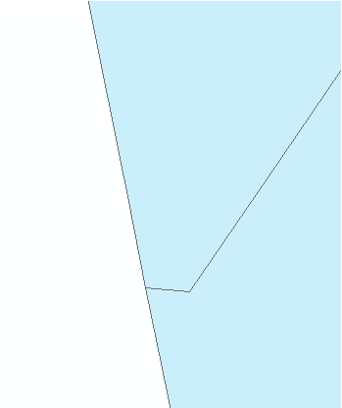

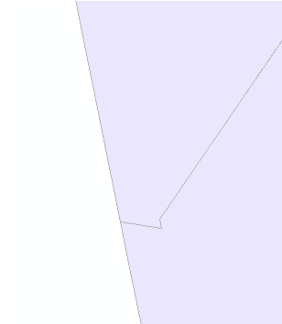

New hybrid and exaggerated boundary

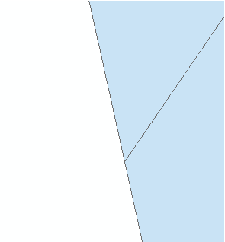

1. The Air Quality program requested to create a new site for their forecast products which will be added in the AQStdFcstSiteP shapefiles. It would have the following attribute values:

|  |  |
| --- | --- |
| **Name English** | Genesee |
| **Name French** | Genesee |
| **Location** | 53.3458334, -114.37 |
| **Province** | AB |
| **CLC code** | 070018 |
| **Feature Object ID** | fea1-2704 |

This site would replace the current ‘Parkland County’ site which will be removed from the AQStdFcstSiteP shapefiles.

1. For marine exaggerated polygons, in the Pacific waters, we found out that external ocean boundaries don’t use the detail boundaries as it should. This will also affect the hybrid shapefiles as it’s also using these exaggerated boundaries. The following shapefiles will be affected by these changes:

* MarStd hybrid and exaggerated shapefiles
* MarSub hybrid and exaggerated shapefiles

1. In the MarStd detail shapefile, we had extra land polygons representing islands that should not be there for the ‘Dixon Entrance East’ location. In the image below, I highlighted the extra polygons that will be removed:

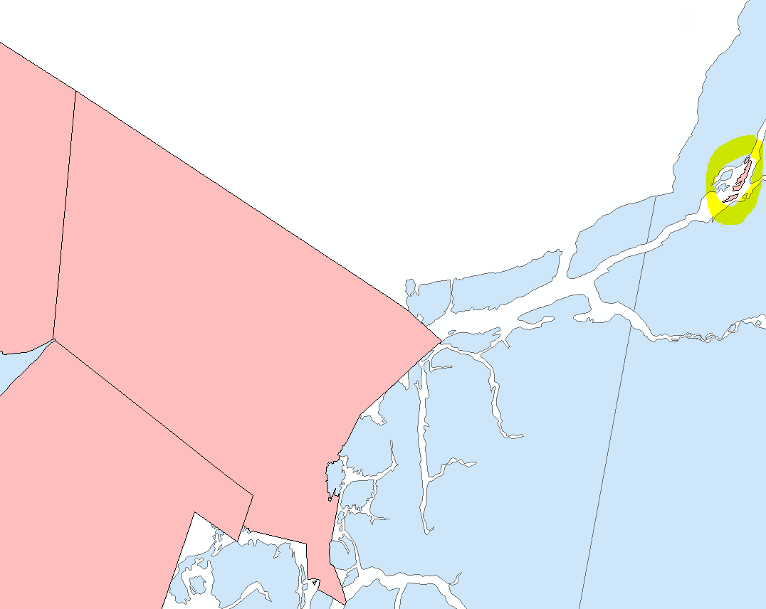

1. For the water CAP-CP shapefile, a client reported an issue with a CAP-CP geocode assigned to 2 locations. After review, the code 00242 was incorrectly assigned to the ‘Southern Georgian Bay’ location. This issue was fixed and value was changed to 00246 which is the expected geocode for this location.