SPECIFICATION
CANADIAN METEOROLOGICAL
MARKUP LANGUAGE
Version 2.1

History of the document
Version no | Date | Comments | Reviewers
2.1 | 2006-12-06 | Added the meteocode-forecast node under forecast, added pavement-forecast node to hold the elements under original forecast node. Removed the deplicated inclusion of the xsd files. | Jianling Hua
2.1 | 2006-08-23 | Removed sensors from metadata and moved the information to an instrument level. | Todd Billings
2.02 | 2005-12-13 | Changed height element name of the subsurface sensor node to sensor-depth. | Todd Billings
2.01 | 2005-11-30 | Updated elevation-units types table, air-quality types table. Added timezone types table. Updated timezoneType complex type structure definition. Added timezonetypeType simple type structure definition. Added stationStateType and instrumentStateType stationStateQualifierType structure definitions. Updated CMML data elements section with new element definitions ( station-state and instrument-state) | Todd Billings
2.0 | 2005-08-24 | Restructured for inclusion of metadata, observation-series, and forecasting nodes. | Todd Billings
1.0 | 2005-06-29 | Modified and restructured to finalize version 1.0 | Yungjae Cho
1.0 | 2005-05-12 | Inserted “network-station-id” and multiple sources | Yungjae Cho  Evan Leclair
0.9 | 2005-04-27 | Restructuration and finalisation of document for version 1.0. | François Gauvin  Gilles Larose  Evan Leclair
0.1 | 2004-06-15 | Creation of document. | François Gauvin
For more information, refer to the CMML_control_document
Table of contents
1. Overview 1
1.1. CMML Control Document 1
1.2. CMML Requirements 1
1.3. Meteocode-Forecast Requirements: 1
1.4. CMML Structure and Type Definitions 1
1.5. CMML Schema Organization 1
1.6. CMML Samples 1
2. CMML Data Element Nomenclature 2
3. CMML Framework Elements 3
3.1. <cmml> 3
4. CMML Header Elements 4
4.1. <product> 4
4.2. <source> 5
5. CMML Data Elements 6
5.1. <forecast> 6
5.1.1. <meteocode-forecast> 6
5.1.1.1. <location> 6
5.1.1.2. <parameters> 6
5.1.1.2.1. <accum-list> 6
5.1.1.2.2. <cloud-list> 7
5.1.1.2.3. <freezing-spray-list> 8
5.1.1.2.4. <precipitation-list> 9
5.1.1.2.5. <ice-cover-list> 10
5.1.1.2.6. <probability-of-precipitation-list> 10
5.1.1.2.7. <snow-level-list> 10
5.1.1.2.8. <temperature-list> 11
5.1.1.2.9. <UV-index-list> 12
5.1.1.2.10. <visibility-list> 12
5.1.1.2.11. <warning-list> 13
5.1.1.2.12. <wave-height-list> 13
5.1.1.2.13. <wind-list> 14
5.1.2. <pavement-forecast> 15
5.1.2.1. <location> 15
5.1.2.2. <time-layout> 17
5.1.2.3. <parameters> 17
5.1.2.3.2. <pressure> 17
5.1.2.3.3. <wind> 18
5.1.2.3.4. <temperature> 19
5.1.2.3.5. <precipitation> 20
5.1.2.3.6. <radiation> 21
5.1.2.3.7. <visibility> 21
5.1.2.3.8. <pavement> 22
5.1.2.3.9. <subsurface> 23
5.1.2.3.10. <air-quality> 24
5.1.2.3.11. <physical-status> 25
5.1.2.3.12. <humidity> 26
5.1.2.3.13. <snow> 27
5.1.2.3.14. <weather> 27
5.1.2.3.15. <extension> 28
5.2. <observation-series> 29
5.2.1. <origin> 29
5.2.2. <location> 29
5.2.3. <observation> 30
5.2.3.2. <pressure> 30
5.2.3.3. <wind> 30
5.2.3.4. <temperature> 31
5.2.3.5. <precipitation> 31
5.2.3.6. <radiation> 31
5.2.3.7. <visibility> 32
5.2.3.8. <pavement> 32
5.2.3.9. <subsurface> 32
5.2.3.10. <air-quality> 33
5.2.3.11. <physical-status> 33
5.2.3.12. <humidity> 33
5.2.3.13. <weather> 33
5.2.3.14. <snow> 34
5.2.3.15. <snapshot-camera> 34
5.2.3.16. <extension> 34
5.3. <metadata> 35
5.3.1. <location> 35
5.3.1.3. <region-metadata> 35
5.3.1.4. <station-metadata> 36
5.3.1.4.24. <pressure-instrument> 38
5.3.1.4.25. <wind-instrument> 42
5.3.1.4.26. <temperature-instrument> 45
5.3.1.4.27. <precipitation-instrument> 49
5.3.1.4.28. <radiation-instrument> 52
5.3.1.4.29. <visibility-instrument> 56
5.3.1.4.30. <pavement-instrument> 59
5.3.1.4.31. <subsurface-instrument> 62
5.3.1.4.32. <air-quality-instrument> 66
5.3.1.4.33. <humidity-instrument> 69
5.3.1.4.34. <snow-instrument> 73
5.3.1.4.35. <weather-instrument> 76
5.3.1.4.36. <snapshot-camera-instrument> 79
5.3.1.4.37. <extension-instrument> 83
5.3.2. <supplementary-metadata> 86
5.3.2.2. <categorical-definitions> 86
5.3.2.3. <conversion-definitions> 87
5.3.2.4. <sampling-definitions> 87
6. Common Element and Attribute Definitions 89
6.1. <point> 89
6.4. <qualifier> 89
6.5. <value> 89
6.6. <qc> 89
6.7. <contact> 90
6.8. <equipment-information> 90
6.9. <exception> 91
6.10. <excep-category> 91
7. XML Considerations 92
7.1. Namespace: 92
7.2. Schema: 92
7.3. Character Set: 92
Appendix A Requirements A-1
Appendix B Meteocode-Forecast Requirements B-1
Appendix C Structure and Type Definitions C-1
Appendix D Valid Head Types D-1
Appendix E Valid Forecast Types E-1
Appendix F Valid Observation Types F-1
Appendix G Valid Metadata Types G-1
Appendix H Schema Organization H-1
Appendix I References I-1
Glossary I-2
Quick Reference I-3

- Overview : This document defines the Canadian Meteorological Markup Language (CMML). CMML is a new XML language which is being developed to initially support the exchange of road weather data between all Provinces and Territories of Canada (PTC) and Environment Canada (EC). However, the specification is being written with enough flexibility to accommodate exchange of other environmental science and weather applications. In order to support the interoperability, the future versions of CMML, all non core data elements, e.g. site specific data elements will be handled by using extension tags.
  - CMML Control Document : The control document “CMML Control Document” defines the copyright and document distribution information relating to these specifications in addition to making the follow-up of its evolutions.
  - CMML Requirements: See Appendix A
  - Meteocode-Forecast Requirements: See Appendix B
  - CMML Structure and Type Definitions: See Appendix C
  - CMML Schema Organization: Appendix D
  - CMML Samples: In addition to providing a definition of the elements and their attributes, CMML sample files can be found separate of this document. Please refer to the control document to know more.
- CMML Data Element Nomenclature: This specification uses the following approach to describing elements:
  - Element and attribute names are all lower case.
  - Element and attribute names use a hyphen (“-“) to separate multiple word names so as to improve readability (ex. <creation-date>). Attribute and element names avoid the use of abbreviations to enhance readability.
  - Within this document, child elements are nested in a sub-paragraph under their parents.
  - Attributes are also nested but do not have the angle brackets (“<>”) and are italicized.
  - The element’s and attribute’s type is provided in braces (“{}”). For more information on each type refer to Appendix C .
  - If the element can occur zero or more times, an asterisk (“*”) is placed after its name. See section 5.2.3.2 for an example.
  - If the element occurs zero or one times, a question mark (“?”) follows its name. See section 5.3.2 for an example.
  - If the element must appear at least once, a plus sign (“+”) trails its name. See section 5.2.3 for an example.
  - Element names without a special trailing character must occur exactly once. Section 5.2.1 provides an example of an element that is required exactly once.
  - The order of element descriptions in the paragraphs below is not significant. Any required ordering of elements is specified in Appendix C .
- CMML Framework Elements:
  - <cmml> {cm:cmmlType}: The root element for CMML.
    - version {cm:non-emptyString}: Indicates which version of CMML the instance contains.
    - <head> {cm:headType}: Contains the header for the CMML instance. See section 4 for elements found in the <head> element.
    - <data> {cm:dataType}: Contains the environmental data. See section 5 for child elements of the <data> element.
- CMML Header Elements: CMML header provides information about the CMML product and the data it contains. These elements are children of the <head> element.
  - <product> {cm:productType}: Holds header information about the product.
    - operational-mode {cm:operational-modeType}: Defines the status of the product. Applications can review the content of this element to determine if they should perform further processing. Sample values include “test”, “developmental”, “experimental”, and “official” product.
      - Test Product: Indicates that this is an instance of an existing CMML product that contains some change being evaluated by a CMML development team. Users will typically not process this product.
      - Developmental Product: A new product that is not yet ready for public evaluation or use.
      - Experimental Product: Product is available for testing and evaluation for a specified, limited time period for the explicit purpose of obtaining customer feedback.
      - Official Product: Identifies an instance of an established CMML product.
    - <title> {xsd:string} [?]: Provides a concise summarization of what this CMML product contains.
    - <field> {cm:fieldType}: Specifies the general area within the environmental sciences that the data contained in the CMML instance is from. Example values include “meteorological” “hydrological” “oceanographical” “land surface” and “space”
    - <category> {cm:categoryType}: Defines the specific category that the product belongs to. Example values include “observation”, “forecast”, “analysis”, “statistics” and “metadata”. If a category is defined as “metadata”, only metadata blocks should be included in the cmml file, otherwise metadata must not be included.
    - <creation-date> {cm:creation-dateType}: The date and time that the product was prepared.
      - refresh-frequency {xsd:duration}: Used by the production center to help users know how often to return for updated data. The suggested refresh frequency will help well mannered users know what the provider believes is a reasonable time between repeated accesses of the system.
    - <current-issue> {xsd:dateTime}[?]: The issue date and time of this product.
    - <next-issue> {xsd:dateTime} [?]: The date and time of the next issue of this product.
    - <timezone>¹ {xsd:string}[?]: Provides the timezone of the forecast.
    - <status> {cm:scribe-statusType}[?]: Status of the bulletin, used for marine forecasts. See Table D-4: Valid types for product status.
    - <type>¹ {cm:scribe-typeType}[?]: See Table D-5: Valid types for product type.
    - <initials>¹ {xsd:string}[?]: Identification of product authors.
    - <valid-begin-time>¹ {xsd:dateTime}[?]: Date and time at which the validity of the forecast begins.
    - <valid-end-time>¹ {xsd:dateTime}[?]: Date and time at which the validity of the forecast ends.
    - <amended-regions> {cm:scribe-amended-regionsType}[?]: List of amended or corrected regions in the forecast.
      - <location> {cm:scribe-locationType} [+]: See section 5.1.1.1.
  - <source> {cm:sourceType}[+] : Holds information about the product’s source and links to credit and disclaimer information.
    - <more-information> {xsd:anyURI}[?] : A link to the web page of the forecast’s source or a more complete forecast.
    - <production-center> {cm:production-centerType}: Production Center identifies which organization creates the product.
      - <sub-center> {xsd:string} [?]: The part of the production center that prepared the product.
    - <disclaimer> {xsd:anyURI} [?]: The URL containing a disclaimer regarding the data.
    - <credit> {xsd:anyURI} [?]: The URL used to credit the source of the data.
    - <credit-logo> {xsd:anyURI} [?]: The image link used with the credit URL to acknowledge the data source.
    - <feedback> {xsd:anyURI} [?]: A URL to a web page used to provide the production center comments on the product.
- CMML Data Elements: These elements hold the environmental data. They are children of the <data> element. At least one child element (<forecast>, <observation-series>, or <metadata>) must be present in a <data> element.
  - <forecast> {cm:forecastType}[*]: Defines forecast information. At least one child element (<meteocode-forecast> or <pavement-forecast>) must be present in a <forecast> element.
    - <meteocode-forecast> {cm:scribe-forecastType}[*]: Weather elements forecasted by Environment Canada through the Scribe application forecast product.
      - <location> {cm:scribe-locationType}[+]: Defines the location for the data contained in the element <meteocode-forecast>. The element must contain one of the following elements: <point> or <msc-zone-code>.
        - <point> {cm:scribe-pointType}: Element used to define the geographical point for which the data is valid.
          - <latitude> {xsd:decimal}: The latitude of the point where the data is valid.
          - <longitude> {xsd:decimal}: The longitude of the point where the data is valid
        - <msc-zone-code> {cm:scribe-msc-zone-codeType}: Contains the Meteorological Service of Canada forecast zone code for which the data is valid.
          - status {cm:scribe-msc-zone-code-statusType}[?]: Indicates the status for the region, used for marine forecasts. See Table E-33: Valid values for meteocode-forecast msc zone code status.
        - <msc-zone-name> {cm:scribe-msc-zone-nameType}[+]: Name of the region.
          - lang {cm:scribe-langType}: Language. Values are “en” for English or “fr” for French.
      - <parameters> {cm:scribe-parametersType}[+]: Holds the environmental data. At least one child element must be present in a <parameters> element.
        - <accum-list> {cm:scribe-accum-listType}[*]: Container for descriptions of accumulation of precipitation.
          - units : Defines the units of the accumulation. The default value is “mm”. See Table E-49: Valid unit types for meteocode-forecast accumulation.
          - <accum-amount> {cm:scribe-accum-amountType} [*]
            - start {xsd:dateTime}: Specifies the start time of the period of time for which the data is valid.
            - end {xsd:dateTime}: Specifies the end time of the period of time for which the data is valid.
            - type { cm:scribe-accum-typeType }: Identifies the type of accumulation of precipitation. See Table E-26: Valid values for meteocode-forecast accumulation types.
            - <lower-limit> {cm:scribe-accum-lower-limitType}: Lower limit value of precipitation amount.
              - cumul-inf {xsd:decimal}: Value of lower cumulative precipitation amount of current precipitation amount type.
            - <upper-limit> {cm:scribe-accum-upper-limitType}: Upper limit value of precipitation amount.
              - cumul-sup {xsd:decimal}: Value of upper cumulative precipitation amount of current precipitation amount type.
        - <cloud-list> {cm:scribe-cloud-listType}[*]: Container for cloud cover descriptions
          - units {cm:scribe-cloud-unitsType}: Defines the units of the cloud cover. The default value is in tenth of the sky “deci”. See Table E-50: Valid unit types for meteocode-forecast cloud.
          - <cloud-cover> {cm:scribe-basic-cloud-coverType} [*]: Value of the cloud cover.
            - start {xsd:dateTime}: Specifies the start time of the period of time for which the data is valid.
            - end {xsd:dateTime}: Specifies the end time of the period of time for which the data is valid
          - <exception> {cm:scribe-cloud-cover-exceptionType} [*]: See section 6.9 for a description of an exception.
            - start {xsd:dateTime}: Specifies the start time of the period of time for which the data is valid.
            - end {xsd:dateTime}: Specifies the end time of the period of time for which the data is valid.
            - <excep-category> {cm:scribe-excep-categoryType}: See section 6.9 for definition.
            - <cloud-cover>” {cm:scribe-cloud-coverType}: A different value of cloud cover for the exception.
              - start {xsd:dateTime}: Specifies the start time of the period of time for which the data of the exception is valid.
              - end {xsd:dateTime}: Specifies the end time of the period of time for which the data of the exception is valid.
              - cover-start {xsd:nonNegativeInteger}: Value of cloud cover at exception start time.
              - cover-end {xsd:nonNegativeInteger}: Value of cloud cover at exception end time.
        - <freezing-spray-list> {cm:scribe-freezing-spray-listType}[*]: Container for the freezing spray, marine forecasts only.
          - <freezing-spray> {cm:scribe-freezing-sprayType}[*]
            - start {xsd:dateTime}: Specifies the start time of the period of time for which the data is valid.
            - end {xsd:dateTime}: Specifies the end time of the period of time for which the data is valid.
            - frequency {cm:scribe-freezing-spray-frequencyType}: See Table E-29: Valid types for meteocode-forecast freezing spray frequency.
            - intensity {cm:scribe-freezing-spray-intensityType}: See Table E-30: Valid types for meteocode-forecast freezing spray intensity.
            - occurrence{cm:scribe-freezing-spray-occurType}: See Table E-31: Valid types for meteocode-forecast freezing spray occurrence.
            - ice-cover-modifier {cm:scribe-freezing-spray-ice-coverType} [?]: Ice cover modifiers applied to the freezing spray . See Table E-32: Valid types for meteocode-forecast freezing spray ice cover modifier.
            - <exception> {cm:scribe-freezing-spray-exceptionType} [?]: See section 6.9 for a description of an exception.
              - start {xsd:dateTime}: Specifies the start time of the period of time for which the data is valid.
              - end {xsd:dateTime}: Specifies the end time of the period of time for which the data is valid.
              - <excep-category> {cm:scribe-excep-categoryType}: See section 6.9 for definition.
              - <freezing-spray> {cm:scribe-basic-freezing-sprayType} [*]: contains the same attributes/elements defined in section 5.1.1.2.3.1, but without an <exception>.
        - <precipitation-list> {cm:scribe-precipitation-listType}[*]: Container for the precipitation values.
          - <precipitation-event> {cm:scribe-precipitation-eventType} [*]
            - start {xsd:dateTime}: Specifies the start time of the period of time for which the data is valid.
            - end {xsd:dateTime}: Specifies the end time of the period of time for which the data is valid.
            - type {cm:scribe-precipitation-typeType}: See Table E-37: Valid types for meteocode-forecast precipitation types.
            - frequency{cm:scribe-precipitation-frequencyType}: See Table E-34: Valid types for meteocode-forecast precipitation frequency.
            - intensity{cm:scribe-precipitation-intensityType}: See Table E-35: Valid types for meteocode-forecast precipitation intensity.
            - occurrence{cm:scribe-precipitation-occurType}: See Table E-36: Valid types for meteocode-forecast precipitation occurrence.
            - <exception> {cm:scribe-precipitation-exceptionType} [?]: See section 6.9 for a description of an exception.
              - start {xsd:dateTime}: Specifies the start time of the period of time for which the data is valid.
              - end {xsd:dateTime}: Specifies the end time of the period of time for which the data is valid.
              - <excep-category> {cm:scribe-excep-categoryType}: See section 6.9 for definition.
              - <precipitation-event> {cm:scribe-basic-precipitation-eventType}: Contains the same attributes/elements defined in section 5.1.1.2.4.1, but without an <exception>.
            - <precipitation-event> {cm:scribe-precipitation-eventType} [*]: See section 5.1.1.2.4.1
              - <precipitation-event> {cm:scribe-precipitation-eventType} [*]: See section 5.1.1.2.4.1
Note: Since precipitation events can occur simultaneously, three levels of precipitation types are possible. Description of each of these levels is available in this XML format. Level 2 will be imbedded in level 1 and level 3 will be imbedded in level 2.
        - <ice-cover-list> {cm:scribe-ice-cover-listType}[*]: Container for the ice cover, marine forecast only.
          - units {xsd:string}: Defines the unit for the ice cover. The value is fixed at “%”.
          - <ice-cover> {cm:scribe-ice-cover-listType} [*]
            - start {xsd:dateTime}: Specifies the start time of the period of time for which the data is valid.
            - end {xsd:dateTime}: Specifies the end time of the period of time for which the data is valid.
        - <probability-of-precipitation-list> {cm:scribe-probability-of-precipitation-listType}[*]: Container for the probabilities of precipitation.
          - units:{xsd:string}: Defines the unit for the probability of precipitation. The value is fixed at “%”.
          - <probability-of-precipitation> {cm:scribe-probability-of-precipitation-Type}[*]
            - start {xsd:dateTime}: Specifies the start time of the period of time for which the data is valid.
            - end {xsd:dateTime}: Specifies the end time of the period of time for which the data is valid.
        - <snow-level-list> {cm:scribe-snow-level-listType}[*]: Container for snow level descriptions.
          - units {cm:scribe-snow-level-unitsType}: Defines the units of the snow level. The default value is “m”. See Table E-51: Valid unit types for meteocode-forecast snow level.
          - <snow-level> {cm:scribe-snow-levelType} [*]
            - start {xsd:dateTime}: Specifies the start time of the period of time for which the data is valid.
            - end {xsd:dateTime}: Specifies the end time of the period of time for which the data is valid.
        - <temperature-list> {cm:scribe-temperature-listType}[*]: Container for temperature descriptions.
          - type {cm:scribe-temperature-typeType}: Type of temperatures. See Table E-38: Valid values for meteocode-forecast temperature type.
          - units {cm:scribe-temperature-unitsType}: Defines the units of the temperature. The default value is “celsius”. See Table E-52: Valid unit types for meteocode-forecast temperature.
          - <temperature-value> {cm:scribe-temperature-valueType}[*]
            - trend {cm:scribe-temperature-trendType}[?]: Indicates a tendency. See Table E-40: Valid types for meteocode-forecast temperature trend.
            - ground-frost {xsd:string}[?]: Indicate a ground frost status. See Table E-39: Valid values for meteocode-forecast temperature ground-frost
            - start{xsd:dateTime}: Specifies the start time of the period of time for which the data is valid.
            - end {xsd:dateTime} : Specifies the end time of the period of time for which the data is valid.
            - <limit> {xsd:decimal}[?]: Climatological or sea-surface value of temperature. Real number. Value of -9999.00 indicates a missing value.
            - <lower-limit> {xsd:decimal}[?]: Lower value of a range of temperature (air-temperature or dew-point). Real number. Value of -9999.00 indicates a missing value.
            - <upper-limit> {xsd:decimal}[?]: Upper value of a range of temperature (air-temperature or dew-point). Real number. Value of -9999.00 indicates a missing value.
          - <exception> {cm:scribe-temperature-exceptionType}[*]: See section 6.9 for a description of an exception.
            - start {xsd:dateTime}: Specifies the start time of the period of time for which the data is valid.
            - end {xsd:dateTime}: Specifies the end time of the period of time for which the data is valid.
            - <excep-category> {cm:scribe-excep-categoryType}: See section 6.9 for definition.
            - <temperature-value> {cm:scribe-temperature-valueType}: See section 5.1.1.2.8.3 for definition.
        - <UV-index-list> {cm:scribe-UV-index-listType}[*]: Container for UV index forecast.
          - <UV-index> {cm:scribe-UV-indexType}[*]: Value of the UV index. Real number that varies from 0 to 15.
            - start {xsd:dateTime}: Specifies the start time of the period of time for which the data is valid.
            - end {xsd:dateTime} : Specifies the end time of the period of time for which the data is valid.
        - <visibility-list> {cm:scribe-visibility-listType}[*]: Container for the visibility values.
          - <visibility> {cm:scribe-visibilityType} [*]
            - start {xsd:dateTime}: Specifies the start time of the period of time for which the data is valid.
            - end {xsd:dateTime: Specifies the end time of the period of time for which the data is valid.
            - type {cm:scribe-visibility-typeType}: See Table E-42: Valid types for meteocode-forecast visibility.
            - frequency {cm:scribe-visibility-frequencyType}: See Table E-43: Valid types for meteocode-forecast visibility frequency.
            - <value> {cm:scribe-valueType}[?]: Distance of horizontal visibility
              - unit {cm:scribe-value-unitsType}: Defines the units of visibility value. The default value is “NM”. See Table E-53: Valid unit types for meteocode-forecast visibility value.
            - <exception> {cm:scribe-visibility-exceptionType} [?]: See 6.9 for a description of an exception.
              - start{xsd:dateTime}: Specifies the start time of the period of time for which the data is valid.
              - end {xsd:dateTime}: Specifies the end time of the period of time for which the data is valid.
              - <excep-category>{cm:scribe-excep-categoryType}: See section 6.9 for definition.
              - <visibility>{cm:scribe-basic-visibilityType}: Contains the same attributes/elements defined in section 5.1.1.2.10.1 but without an <exception>.
        - <warning-list>{cm:scribe-warning-listType}[*]: Container for warning descriptors. Three levels of warning can co-exist at the same time.
          - <warning-event> {cm:scribe-warning-eventType}[*]: Description of a warning event.
            - start {xsd:dateTime}: Specifies the start time of the period of time for which the data is valid.
            - end {xsd:dateTime}: Specifies the end time of the period of time for which the data is valid.
            - type {cm:scribe-warning-typeType}: Warning category. SeeTable E-44: Valid types for meteocode-forecast warning type
            - code {cm:scribe-warning-codeType}: See Table E-45: Valid values for meteocode-forecast warning codes.
            - status {cm:scribe-warning-statusType}: See Table E-46: Valid values for meteocode-forecast warning status.
            - <warning-event>{cm:scribe-warning-eventType}[*]: Second level of warning.
              - <warning-event>{cm:scribe-warning-eventType}[*]: Third level of warning.
        - <wave-height-list> {cm:scribe-wave-height-listType}[*]: Container for the wave height values.
          - units {cm:scribe-wave-height-unitsType}: Defines the units of the wave height. The default value is “m”. See Table E-54: Valid unit types for meteocode-forecast wave height.
          - <wave-height>{cm:scribe-wave-heightType}[*]: Container for the wave height.
            - start {xsd:dateTime}: Specifies the start time of the period of time for which the data is valid.
            - end {xsd:dateTime}: Specifies the end time of the period of time for which the data is valid.
            - ice-cover-modifier {cm:scribe-wave-height-ice-coverType}[?]: Ice cover modifiers applied to wave height. See Table E-41: Valid types for meteocode-forecast wave-height ice cover modifier.
            - <lower-limit>{xsd:decimal}: Lower value of a range of height. Real number.
            - <upper-limit>{xsd:decimal}: Upper value of a range of height. Real number.
        - <wind-list> {cm:scribe-wind-listType}[*]: Container for wind event descriptions.
          - units {cm: scribe-wind-unitsType}: Defines the units of the wind/gust speed. The default value is “kmh”. See Table E-55: Valid unit types for meteocode-forecast wind.
          - <wind> {cm:scribe-windType}[*]: Container for a wind event.
            - start {xsd:dateTime}: Specifies the start time of the period of time for which the data is valid.
            - end {xsd:dateTime}: Specifies the end time of the period of time for which the data is valid.
            - direction {cm:scribe-wind-directionType}: Wind direction. See Table E-47: Valid values for meteocode-forecast wind direction.
            - modificator {cm:scribe-wind-modificatorType} [?]: Modifiers applied to wind See Table E-48: Valid values for meteocode-forecast wind modificators.
            - <wind-speed> {cm:scribe-wind-speedType}: Wind speed. The default unit value is in “kmh”
              - <lower-limit> {xsd:positiveInteger}: Lower value of the speed. Positive integer.
              - <upper-limit> {xsd:positiveInteger}: Upper value of the speed. Positive integer.
            - <gust-speed> {cm:scribe-gust-speedType}[?]: Gust speed.
              - <lower-limit> {xsd:positiveInteger}: Lower value of the speed. Positive integer.
              - <upper-limit> {xsd:positiveInteger }: Upper value of the speed. Positive integer.
            - <exception> {cm:scribe-wind-exceptionType}[?]: See section 6.9 for a description of an exception.
              - start : {xsd:dateTime}Specifies the start time of the period of time for which the data is valid.
              - end {xsd:dateTime}: Specifies the end time of the period of time for which the data is valid.
              - <excep-category> {cm:scribe-excep-categoryType}: See section 6.9 for definition.
              - <wind> {cm:scribe-basic-wind-type}: Contains the same attributes/elements defined in section 5.1.1.2.13.2 but without an <exception>.
    - <pavement-forecast> {cm:pavement-forecastType}[*]: Defines pavement forecast information.
      - <location> {cm:locationType} [+]: Defines the location that provides the data contained in the element <forecast>. The element must contain exactly one of the following elements; <point>, <city>, <nws-zone>, <area>, <route>, or <station>.
        - <location-key> {xsd:string} : The location-key element is used to relate the location to its corresponding parameters. Must be unique.
        - <point> see section 6.1.
        - <city> {cm:cityType} [?]: Contains the city name for which the data is.
          - province {cm:provinceType}: The two digit abbreviation for the province that the city resides.
          - summarization: see section 6.2.
        - <nws-zone> {xsd: string} [?]: Contains the National Weather Service forecast zone code for which the data is valid.
          - province {cm:provinceType}: Defines the two letter province ID.
          - summarization: see section 6.2
        - <area> {cm:areaType} [?]: A geometrical shape may be used to define which grid points the data represents. The element must contain exactly one of its child elements.
          - <circle> {cm:circleType} [?]: A circular area about a grid point. The area can contain any number of grid points which are summarized.
            - <point> see section 6.1.
            - <radius> {cm:radiusType}: The distance from the center point of the circle to edge of the circular area.
              - radius-units {cm:radius-unitsType): The units of the radius measurement. Example values include “statute-miles” and “kilometers”.
          - <rectangle> {cm:rectangleType} [?]: A rectangular area is defined by two latitude and longitude pairs. These pairs form a diagonal from which a rectangle can be consistently constructed. The area can contain any number of grid points which are summarized.
            - <point> see section 6.1.
            - <point> see section 6.1.
          - <polygon> {cm:polygonType} [?]: A polygon area which is defined by three or more latitude and longitude pairs. The area can contain any number of grid points which are summarized.
            - <point> see section 6.1.
            - <point> see section 6.1.
            - <point> see section 6.1.
        - <route> {cm:linestringType} [?] : A linear road network which is defined by two or more latitude and longitude pairs.
          - <point> see section 6.1.
          - <point> see section 6.1.
        - <station> {cm: originType} [?]: Defines the station that provides the data.
          - type {cm:origintypeType} : Defines the type of station. Example values are “station” and “region”. See Table E-11: Valid pavement-forecast origintype types
          - <id> {cm: identifierType} [+]: Contains an id of station.
            - type {cm:identifiertypeType} : Defines the type of ID. Example values are “client” and “network”. See Table E-10: Valid pavement-forecast identifiertype types.
      - <time-layout> {cm:time-layoutElementType} [+]: Contains the start and stop valid times and any associated period names for the data. Since different environmental parameters have different time schemes (valid at different interval and available for different lengths of time into the future), there will be one <time-layout> element for each of these unique temporal configurations. Each data parameter will reference exactly one of these time layouts.
        - time-coordinate {cm:time-coordinateType}: The time coordinate can be either “local” or “UTC”. See Table E-21: Valid pavement-forecast time-coordinate types.
        - summarization see section 6.2.
        - <layout-key> {cm:layout-keyType}: The key used to associate this time layout with a particular parameter element.
        - <start-valid-time> {cm:start-valid-timeType} [+]: The start time of the period of time for which the data is valid.
          - period-name {xsd:string} [?]: Contains the name associated with this time interval (ex. TODAY).
        - <end-valid-time> {xsd:dateTime} [*]: The end time of the period of time for which the data is valid. The absence of this element indicates that the element is valid at a specific time.
      - <parameters> {cm:parametersType} [+]: Holds the environmental data.
        - applicable-location {xsd:string} : The applicable-location attribute is used to relate the location to a particular list of parameters.
        - <pressure> {cm:pressureType} [*]: Container for the pressure values.
          - index { xsd:nonNegativeInteger } [?]: Specifies the index for a same type of pressure. The default value is 1.
          - type {xsd:string}: Specifies the type of variable measured for pressure. Example values include “atmospheric” and “average-atmospheric”. See Table E-15: Valid types for pavement-forecast pressure
          - height {xsd:nonNegativeInteger}[?]: Defines the height where values was measured. The height unit is centimeters.
          - units {cm:unitType}[?]: Defines the units of the pressure value. The default value is “mb”. See Table E-22: Valid pavement-forecast unit types.
          - categorical-code {xsd:string}[?]: Defines the name of the code that represent the values. This code can be used to do the mapping with a conversion table that defines the meaning of each possible value that is already known by the requester.
          - time-layout see section 6.3.
          - categorical-table {cm:categorical-tableType} [?]: Foreign key to a list of categories that define the meaning of the value.
          - conversion-table {cm:conversion-tableType} [?]: Foreign key to a list of conversions tables that provide a equivalent value for the data.
          - sampling-table {cm:sampling-tableType} [?]: Foreign key to a list of sampling tables that provide precision for the data and how it was acquired.
          - <value> {xsd:anyType} [+]: The pressure value. Missing values are represented by an empty element and xsi:nil=”true”.
          - <name> {xsd:string} [?]: The name of this parameter. The name value can be used for display purposes.
        - <wind> {cm:windType} [*]: Container for the wind values.
          - index { xsd:nonNegativeInteger } [?]: Specifies the index for a same type of wind. The default value is 1.
          - type {xsd:string}: Specifies the type of variable measured for wind. Example values include “average-direction” and “speed”. See Table E-24: Valid types for pavement-forecast wind.
          - height {xsd:nonNegativeInteger}[?]: Defines the height where values was measured. The height unit is centimeters.
          - units {cm:unitType}[?]: Defines the units of the wind values. Example values include “deg” and “km/h”. The default value is “deg”. See Table E-22: Valid pavement-forecast unit types.
          - categorical-code {xsd:string}[?]: Defines the name of the code that represent the values. This code can be used to do the mapping with a conversion table that defines the meaning of each possible value that is already known by the requester.
          - time-layout see section 6.3.
          - categorical-table {cm:categorical-tableType} [?]: Foreign key to a list of categories that define the meaning of the value.
          - conversion-table {cm:conversion-tableType} [?]: Foreign key to a list of conversions tables that provide a equivalent value for the data.
          - sampling-table {cm:sampling-tableType} [?]: Foreign key to a list of sampling tables that provide precision for the data and how it was acquired.
          - <value> {xsd:anyType} [+]: The wind value. Missing values are represented by an empty element and xsi:nil=”true”.
          - <name> {xsd:string} [?]: The name of this parameter. The name value can be used for display purposes.
        - <temperature> {cm:temperatureType} [*]: Container for temperature data.
          - index { xsd:nonNegativeInteger } [?]: Specifies the index for a same type of temperature. The default value is 1.
          - type {xsd:string}: Specifies the type of variable measured for temperature. Example values include “maximum-air-temperature”, “minimum-air-temperature”, “air-temperature”, “dew point”, “wet bulb”. See Table E-20: Valid types for pavement-forecast temperature.
          - height {xsd:nonNegativeInteger}[?]: Defines the height where values was measured. The height unit is centimeters.
          - units {cm:unitType}[?]: Defines the units of the temperature value. Example values include “degF”, “degC”, and “K”. The default value is “degC”. See Table E-22: Valid pavement-forecast unit types.
          - categorical-code {xsd:string}[?]: Defines the name of the code that represent the values. This code can be used to do the mapping with a conversion table that defines the meaning of each possible value that is already known by the requester.
          - time-layout see section 6.3.
          - categorical-table {cm:categorical-tableType} [?]: Foreign key to a list of categories that define the meaning of the value.
          - conversion-table {cm:conversion-tableType} [?]: Foreign key to a list of conversions tables that provide a equivalent value for the data.
          - sampling-table {cm:sampling-tableType} [?]: Foreign key to a list of sampling tables that provide precision for the data and how it was acquired.
          - <value> {xsd:anyType} [+]: The temperature value. Missing values are represented by an empty element and xsi:nil=”true”.
          - <name> {xsd:string} [?]: The name of this parameter. The name value can be used for display purposes.
        - <precipitation> {cm:precipitationType} [*]: Container for the precipitation values
          - index { xsd:nonNegativeInteger } [?]: Specifies the index for a same type of precipitation. The default value is 1.
          - type {xsd:string}: Specifies the type of variable measured for precipitation. Example values include “rate”, “situation”. See Table E-14: Valid types for pavement-forecast precipitation.
          - height {xsd:nonNegativeInteger}[?]: Defines the height where values was measured. The height unit is centimeters.
          - units {cm:unitType}[?]: Defines the units of the precipitation value. Example values include “inches” and “millimeters”. The default value is “mm”. See Table E-22: Valid pavement-forecast unit types
          - categorical-code {xsd:string}[?]: Defines the name of the code that represent the values. This code can be used to do the mapping with a conversion table that defines the meaning of each possible value that is already known by the requester.
          - time-layout see section 6.3.
          - categorical-table {cm:categorical-tableType} [?]: Foreign key to a list of categories that define the meaning of the value.
          - conversion-table {cm:conversion-tableType} [?]: Foreign key to a list of conversions tables that provide a equivalent value for the data .
          - sampling-table {cm:sampling-tableType} [?]: Foreign key to a list of sampling tables that provide precision for the data and how it was acquired.
          - <value> {xsd:anyType} [+]: The precipitation type parameter’s value. Missing values are represented by an empty element and xsi:nil=”true”.
          - <name> {xsd:string} [?]: The name of this parameter. The name value can be used for display purposes.
        - <radiation> {cm:radiationType} [?]: Container for the radiation values .
          - index { xsd:nonNegativeInteger } [?]: Specifies the index for a same type of radiation. The default value is 1.
          - type {xsd:string}: Specifies the type of variable measured for radiation. Example values include “total-sun”, “total-radiation”, “average-short-wave-up” and “average-short-wave-down. See Table E-16: Valid types for pavement-forecast radiation
          - units {cm:unitType}[?]: Defines the units of the radiation values. Example values include “W/m²”. The default value is “W/m²”. See Table E-22: Valid pavement-forecast unit types.
          - categorical-code {xsd:string}[?]: Defines the name of the code that represent the values. This code can be used to do the mapping with a conversion table that defines the meaning of each possible value that is already known by the requester.
          - height {xsd:nonNegativeInteger}[?]: Defines the height where values was measured. The height unit is centimeters.
          - time-layout {cm:time-layoutType}: see section 6.3.
          - categorical-table {cm:categorical-tableType} [?]: Foreign key to a list of categories that define the meaning of the value .
          - conversion-table {cm:conversion-tableType} [?]: Foreign key to a list of conversions tables that provide a equivalent value for the data .
          - sampling-table {cm:sampling-tableType} [?]: Foreign key to a list of sampling tables that provide precision for the data and how it was acquired.
          - <value> {xsd:anyType} [+]: The radiation value. Missing values are represented by an empty element and xsi:nil=”true”.
          - <name> {xsd:string} [?]: The name of this parameter. The name value can be used for display purposes.
        - <visibility> {cm:visibilityType} [*]: Container for the visibility values .
          - index { xsd:nonNegativeInteger } [?]: Specifies the index for a same type of visibility. The default value is 1.
          - type {xsd:string}: Specifies the type of variable measured for visibility. Example values include “distance” and “situation”. See Table E-23: Valid types for pavement-forecast visibility.
          - height {xsd:nonNegativeInteger}[?]: Defines the height where values was measured. The height unit is centimeters.
          - units {cm:unitType}[?]: Defines the units of the visibility value. Example values include “km” and “m”. The default value is “m”. See Table E-22: Valid pavement-forecast unit types.
          - categorical-code {xsd:string}[?]: Defines the name of the code that represent the values. This code can be used to do the mapping with a conversion table that defines the meaning of each possible value that is already known by the requester.
          - time-layout {cm:time-layoutType}: see section 6.3.
          - categorical-table {cm:categorical-tableType} [?]: Foreign key to a list of categories that define the meaning of the value .
          - conversion-table {cm:conversion-tableType} [?]: Foreign key to a list of conversions tables that provide a equivalent value for the data .
          - sampling-table {cm:sampling-tableType} [?]: Foreign key to a list of sampling tables that provide precision for the data and how it was acquired.
          - <value> {xsd:anyType} [+]: The visibility value Missing values are represented by an empty element and xsi:nil=”true”.
          - <name> {xsd:string} [?]: The name of this parameter. The name value can be used for display purposes.
        - <pavement> {cm:pavementType} [*]: Container for the pavement values .
          - lane-number { xsd:nonNegativeInteger } [?]: Specifies the lane number where the values are measured. The default value is 1.
          - index² { xsd:nonNegativeInteger } [?]: Specifies the index for a same type of pavement. The default value is 1.
          - type {xsd:string}: Specifies the type of variable measured for pavement. Example values include “surface-status”, “temperature” and “salinity”. See Table E-12: Valid types for pavement-forecast pavement.
          - height {xsd: integer}[?]: Defines the height where values was measured. The height unit is centimeters.
          - units {cm:unitType}[?]: Defines the units of the pavement value. Example values include “degC”, “degF” and “K”. The default value is “degC”. See Table E-22: Valid pavement-forecast unit types.
          - categorical-code {xsd:string}[?]: Defines the name of the code that represent the values. This code can be used to do the mapping with a conversion table that defines the meaning of each possible value that is already known by the requester.
          - time-layout {cm:time-layoutType}: see section 6.3.
          - categorical-table {cm:categorical-tableType} [?]: Foreign key to a list of categories that define the meaning of the value .
          - conversion-table {cm:conversion-tableType} [?]: Foreign key to a list of conversions tables that provide a equivalent value for the data .
          - sampling-table {cm:sampling-tableType} [?]: Foreign key to a list of sampling tables that provide precision for the data and how it was acquired.
          - <value> {xsd:anyType} [+]: The pavement value. Missing values are represented by an empty element and xsi:nil=”true”.
          - <name> {xsd:string} [?]: The name of this parameter. The name value can be used for display purposes.
        - <subsurface> {cm:subsurfaceType} [*]: Container for the subsurface values.
          - lane-number { xsd:nonNegativeInteger } [?]: Specifies the lane number where the values are measured. The default value is 1.
          - index³ { xsd:nonNegativeInteger } [?]: Specifies the index for a same type of subsurface. The default value is 1.
          - type {xsd:string} : Specifies the type of variable measured for subsurface. Example values include “temperature”, “moisture” and “average-temperature”. See Table E-18: Valid types for pavement-forecast subsurface.
          - sensor-depth {xsd:nonNegativeInteger}: Defines the depth where the measure was taken. The depth will be measured in centimeters.
          - units {cm:unitType}[?]: Defines the units of the subsurface value. Example values include “degC”, “degF” and “K”. The default value is “degC”. See Table E-22: Valid pavement-forecast unit types.
          - categorical-code {xsd:string}[?]: Defines the name of the code that represent the values. This code can be used to do the mapping with a conversion table that defines the meaning of each possible value that is already known by the requester.
          - time-layout {cm:time-layoutType}: see section 6.3.
          - categorical-table {cm:categorical-tableType} [?]: Foreign key to a list of categories that define the meaning of the value .
          - conversion-table {cm:conversion-tableType} [?]: Foreign key to a list of conversions tables that provide a equivalent value for the data .
          - sampling-table {cm:sampling-tableType} [?]: Foreign key to a list of sampling tables that provide precision for the data and how it was acquired.
          - <value> {xsd:anyType} [+]: The subsurface value. Missing values are represented by an empty element and xsi:nil=”true”.
          - <name> {xsd:string} [?]: The name of this parameter. The name value can be used for display purposes.
        - <air-quality> {cm:airQualityType} [*]: Container for the air quality values .
          - index { xsd:nonNegativeInteger } [?]: Specifies the index for a same type of air-quality. The default value is 1.
          - type {xsd:string}: Specifies the type of variable measured for air quality. Example values include “carbon-monoxide”, “carbon-dioxide” and “ozone”. See Table E-6: Valid types for pavement-forecast air-quality.
          - height {xsd:nonNegativeInteger}[?]: Defines the height where values was measured. The height unit is centimeters.
          - units {cm:unitType}[?]: Defines the units of the air quality value. Example values include “ppm” and “ppb”. The default value is “ppb”. See Table E-22: Valid pavement-forecast unit types.
          - categorical-code {xsd:string}[?]: Defines the name of the code that represent the values. This code can be used to do the mapping with a conversion table that defines the meaning of each possible value that is already known by the requester.
          - time-layout {cm:time-layoutType}: see section 6.3.
          - categorical-table {cm:categorical-tableType} [?]: Foreign key to a list of categories that define the meaning of the value .
          - conversion-table {cm:conversion-tableType} [?]: Foreign key to a list of conversions tables that provide a equivalent value for the data .
          - sampling-table {cm:sampling-tableType} [?]: Foreign key to a list of sampling tables that provide precision for the data and how it was acquired.
          - <value> {xsd:anyType} [+]: The air quality value. Missing values are represented by an empty element and xsi:nil=”true”.
          - <name> {xsd:string} [?]: The name of this parameter. The name value can be used for display purposes.
        - <physical-status> {cm:physicalStatusType} [*]: Container for the physical status values .
          - type {xsd:string}: Specifies the type of variable measured for physical status. Example values include “door-open” and “battery-minimum-voltage”. See Table E-13: Valid types for pavement-forecast physical-status.
          - units {cm:unitType}[?]: Defines the units of the physical status value. Example values include “V” and “bitmap”. The default value is “V”. See Table E-22: Valid pavement-forecast unit types.
          - categorical-code {xsd:string}[?]: Defines the name of the code that represent the values. This code can be used to do the mapping with a conversion table that defines the meaning of each possible value that is already known by the requester.
          - time-layout {cm:time-layoutType}: see section 6.3.
          - <value> {xsd:anyType} [+]: The physical status value. Missing values are represented by an empty element and xsi:nil=”true” .
          - <name> {xsd:string} [?]: The name of this parameter. The name value can be used for display purposes.
          - categorical-table {cm:categorical-tableType} [?]: Foreign key to a list of categories that define the meaning of the value .
          - conversion-table {cm:conversion-tableType} [?]: Foreign key to a list of conversions tables that provide a equivalent value for the data .
          - sampling-table {cm:sampling-tableType} [?]: Foreign key to a list of sampling tables that provide precision for the data and how it was acquired.
        - <humidity> {cm:humidityType} [?]: Container for humidity values .
          - index { xsd:nonNegativeInteger } [?]: Specifies the index for a same type of humidity. The default value is 1.
          - type {xsd:string}: Specifies the type of variable measured for humidity. Examples values include “relative-humidity” and “average-relative-humidity”. See Table E-9: Valid types for pavement-forecast humidity.
          - height {xsd:nonNegativeInteger} [?]: Defines the height where values was measured. The height unit is centimeters.
          - units {cm:unitType}[?]: Defines the units of the humidity values. See Table E-22: Valid pavement-forecast unit types.
          - categorical-code {xsd:string}[?]: Defines the name of the code that represent the values. This code can be used to do the mapping with a conversion table that defines the meaning of each possible value that is already known by the requester.
          - time-layout {cm:time-layoutType}: see section 6.3.
          - categorical-table {cm:categorical-tableType} [?]: Foreign key to a list of categories that define the meaning of the value .
          - conversion-table {cm:conversion-tableType} [?]: Foreign key to a list of conversions tables that provide a equivalent value for the data .
          - sampling-table {cm:sampling-tableType} [?]: Foreign key to a list of sampling tables that provide precision for the data and how it was acquired.
          - <value> {xsd:anyType} [+]: The humidity value. Missing values are represented by an empty element and xsi:nil=”true”.
          - <name> {xsd:string} [?]: The name of this parameter. The name value can be used for display purposes.
        - <snow> {cm:snowType} [?]: Container for snow values .
          - index { xsd:nonNegativeInteger } [?]: Specifies the index for a same type of snow. The default value is 1.
          - type {xsd:string}: Specifies the type of variable measured for snow. See Table E-17: Valid types for pavement-forecast snow
          - height {xsd:nonNegativeInteger} [?]: Defines the height where values was measured. The height unit is centimeters.
          - units {cm:unitType}[?]: Defines the units of the snow values. Example values include “cm” and “mm”. The default value is “cm”.
          - categorical-code {xsd:string}[?]: Defines the name of the code that represent the values. This code can be used to do the mapping with a conversion table that defines the meaning of each possible value that is already known by the requester.
          - time-layout {cm:time-layoutType}: see section 6.3.
          - categorical-table {cm:categorical-tableType} [?]: Foreign key to a list of categories that define the meaning of the value .
          - conversion-table {cm:conversion-tableType} [?]: Foreign key to a list of conversions tables that provide a equivalent value for the data .
          - sampling-table {cm:sampling-tableType} [?]: Foreign key to a list of sampling tables that provide precision for the data and how it was acquired.
          - <value> {xsd:anyType} [+]: The snow value. Missing values are represented by an empty element and xsi:nil=”true”.
          - <name> {xsd:string} [?]: The name of this parameter. The name value can be used for display purposes.
        - <weather> {cm:weatherType} [?]: Container for weather values .
          - index { xsd:nonNegativeInteger } [?]: Specifies the index for a same type of weather. The default value is 1.
          - type {xsd:string}: Specifies the type of variable measured for weather. See Table E-25: Valid types for pavement-forecast weather.
          - height {xsd:nonNegativeInteger} [?]: Defines the height where values was measured. The height unit is centimeters.
          - units {cm:unitType}[?]: Defines the units of the weather values. The default value is “%”. See Table E-22: Valid pavement-forecast unit types.
          - categorical-code {xsd:string}[?]: Defines the name of the code that represent the values. This code can be used to do the mapping with a conversion table that defines the meaning of each possible value that is already known by the requester.
          - time-layout {cm:time-layoutType}: see section 6.3.
          - categorical-table {cm:categorical-tableType} [?]: Foreign key to a list of categories that define the meaning of the value .
          - conversion-table {cm:conversion-tableType} [?]: Foreign key to a list of conversions tables that provide a equivalent value for the data .
          - sampling-table {cm:sampling-tableType} [?]: Foreign key to a list of sampling tables that provide precision for the data and how it was acquired.
          - <value> {xsd:anyType} [+]: The weather value. Missing values are represented by an empty element and xsi:nil=”true”.
          - <name> {xsd:string} [?]: The name of this parameter. The name value can be used for display purposes.
        - <extension> {cm:extensionType} [*]: Container for any type of values.
          - index { xsd:nonNegativeInteger } [?]: Specifies the index for a same type of extension. The default value is 1.
          - type {xsd:string}: Specifies the type of variable measured for extension.
          - height {xsd:nonNegativeInteger} [?]: Defines the height where values was measured. The height unit is centimeters.
          - units {cm:unitType}[?]: Defines the units of the extension values. See Table E-22: Valid pavement-forecast unit types.
          - categorical-code {xsd:string}[?]: Defines the name of the code that represent the values. This code can be used to do the mapping with a conversion table that defines the meaning of each possible value that is already known by the requester.
          - time-layout {cm:time-layoutType}: see section 6.3.
          - categorical-table {cm:categorical-tableType} [?]: Foreign key to a list of categories that define the meaning of the value .
          - conversion-table {cm:conversion-tableType} [?]: Foreign key to a list of conversions tables that provide a equivalent value for the data .
          - sampling-table {cm:sampling-tableType} [?]: Foreign key to a list of sampling tables that provide precision for the data and how it was acquired.
          - <value> {xsd:anyType} [+]: The extension value. Missing values are represented by an empty element and xsi:nil=”true”.
          - <name> {xsd:string} [?]: The name of this parameter. The name value can be used for display purposes.
  - <observation-series> {cm:observation-seriesType}[*]: Defines a series of observations for a location.
    - <origin> {cm:originType} : The originator of the observation.
      - type{cm:origintypeType}: What type of originator. Example values include “station” and “region”.
      - <id> {cm:identifierType}[+] : A key that uniquely identifies the originator
        - type {cm:identifiertypeType}: What type of identifier. Example values include “client” and “network”.
    - <location> {cm:locationType}[?] : The location where the observation is being taken. This is an optional element that is included when the location of an observation changes from one observation to the next. Examples include mobile stations, or ad-hoc regions.
      - <point> : see section 6.1..
      - <area> {cm:areaType} [?]: A geometrical shape may be used to define which grid points the data represents. The element must contain exactly one of its child elements.
        - <circle> {cm:circleType} [?]: A circular area about a grid point. The area can contain any number of grid points which are summarized.
          - <point>: see section 6.1..
          - <radius> {cm:radiusType}: The distance from the center point of the circle to edge of the circular area.
          - radius-units {cm:radius-unitsType}: The units of the radius measurement. Example values include “statute-miles” and “kilometers”.
        - <rectangle> {cm:rectangleType} [?]: A rectangular area is defined by two latitude and longitude pairs. These pairs form a diagonal from which a rectangle can be consistently constructed. The area can contain any number of grid points which are summarized.
          - <point> see section 6.1.
          - <point> see section 6.1.
        - <polygon>{cm:polygonType} [?]: A polygon area which is defined by three or more latitude and longitude pairs. The area can contain any number of grid points which are summarized.
          - <point> see section 6.1.
          - <point> see section 6.1.
          - <point> see section 6.1.
      - <route> {cm:linestringType} [?] : A linear road network which is defined by two or more latitude and longitude pairs.
        - <point> see section 6.1.
        - <point> see section 6.1.
    - <observation> {cm:observationType}[+] : Holds the environmental data. At least one child element must exist.
      - valid-time {xsd:dateTime}: The date, time, and timezone of the observation.
      - <pressure> {cm:pressureObsType}[*]: Container for pressure measurements
        - index {xsd:nonNegativeInteger}: Specifies the index for a same type of pressure
        - type {cm:pressureTypeType}: The type of pressure measurement the pressure node is describing.
        - <qualifier> see section 6.4
        - <value> see section 6.5
        - <qc> see section 6.6
      - <wind> {cm:windObsType}[*]: Container for wind measurements
          - index {xsd:nonNegativeInteger}: Specifies the index for a same type of wind
          - type{cm:windTypeType}: The type of wind measurement the wind node is describing.
        - <qualifier> see section 6.4
        - <value> see section 6.5
        - <qc> see section 6.6
      - <temperature>{cm:temperatureObsType}[*]: Container for temperature measurements
        - index {xsd:nonNegativeInteger}: Specifies the index for a same type of temperature
        - type {cm:temperatureTypeType}: The type of temperature measurement the temperature node is describing.
        - <qualifier> see section 6.4
        - <value> see section 6.5
        - <qc> see section 6.6
      - <precipitation>{cm:precipitationObsType}[*]: Container for precipitation measurements
        - index {xsd:nonNegativeInteger}: Specifies the index for a same type of precipitation
        - type {cm:precipitationTypeType}: The type of precipitation measurement the precipitation node is describing.
        - <qualifier> see section 6.4
        - <value> see section 6.5
        - <qc> see section 6.6
      - <radiation>{cm:radiationObsType}[*]: Container for radiation measurements
        - index {xsd:nonNegativeInteger}: Specifies the index for a same type of radiation
        - type {cm:radiationTypeType}: The type of radiation measurement the radiation node is describing.
        - <qualifier> see section 6.4
        - <value> see section 6.5
        - <qc> see section 6.6
      - <visibility>{cm:visibilityObsType}[*]: Container for visibility measurements
        - index {xsd:nonNegativeInteger}: Specifies the index for a same type of visibility
        - type {cm:visibilityTypeType}: The type of visibility measurement the visibility node is describing.
        - <qualifier> see section 6.4
        - <value> see section 6.5
        - <qc> see section 6.6
      - <pavement>{cm:pavementObsType}[*]: Container for pavement measurements
        - index {xsd:nonNegativeInteger}: Specifies the index for a same type of pavement
        - type {cm:pavementTypeType}: The type of pavement measurement the pavement node is describing.
        - <qualifier> see section 6.4
        - <value> see section 6.5
        - <qc> see section 6.6
      - <subsurface>{cm:subsurfaceObsType}[*]: Container for subsurface measurements
        - index {xsd:nonNegativeInteger}: Specifies the index for a same type of subsurface
        - type {cm:subsurfaceTypeType}: The type of subsurface measurement the subsurface node is describing.
        - <qualifier> see section 6.4
        - <value> see section 6.5
        - <qc> see section 6.6
      - <air-quality> {cm:air-qualityObsType}[*]: Container for air-quality measurements
        - index {xsd:nonNegativeInteger}: Specifies the index for a same type of air-quality
        - type {cm:air-qualityTypeType}: The type of air-quality measurement the air-quality node is describing.
        - <qualifier> see section 6.4
        - <value> see section 6.5
        - <qc> see section 6.6
      - <physical-status>{cm:physical-statusObsType}[*]: Container for physical-status measurements
        - index {xsd:nonNegativeInteger}: Specifies the index for a same type of physical-status
        - type {cm:physical-statusTypeType}: The type of physical-status measurement the physical-status node is describing.
        - <qualifier> see section 6.4
        - <value> see section 6.5
        - <qc> see section 6.6
      - <humidity>{cm:humidityObsType}[*]: Container for humidity measurements
        - index {xsd:nonNegativeInteger}: Specifies the index for a same type of humidity
        - type {cm:humidityTypeType}: The type of humidity measurement the humidity node is describing.
        - <qualifier> see section 6.4
        - <value> see section 6.5
        - <qc> see section 6.6
      - <weather> {cm:weatherObsType}[*]: Container for weather measurements
        - index {xsd:nonNegativeInteger}: Specifies the index for a same type of weather
        - type {cm:weatherTypeType}: The type of weather measurement the weather node is describing.
        - <qualifier> see section 6.4
        - <value> see section 6.5
        - <qc> see section 6.6
      - <snow> {cm:snowObsType}[*]: Container for snow measurements
        - index {xsd:nonNegativeInteger}: Specifies the index for a same type of snow
        - type {cm:snowTypeType}: The type of snow measurement the snow node is describing.
        - <qualifier> see section 6.4
        - <value> see section 6.5
        - <qc> see section 6.6
      - <snapshot-camera> {cm:snapshot-cameraObsType}[*]: Container for snapshot-camera measurements
        - index {xsd:nonNegativeInteger}: Specifies the index for a same type of snapshot-camera
        - type {cm:snapshot-cameraTypeType}: The type of snapshot-camera measurement the snapshot-camera node is describing.
        - <qualifier> see section 6.4
        - <value> see section 6.5
        - <qc> see section 6.6
      - <extension> {cm:extensionObsType}[*]: Container for extension measurements
        - index {xsd:nonNegativeInteger}: Specifies the index for a same type of extension
        - <qualifier> see section 6.4
        - <value> see section 6.5
        - <qc> see section 6.6
  - <metadata> {cm:metadataType}[*]: Contains metadata.
    - <location> {cm:location-metadataType} [?] Metadata information about a specific location.
      - type {cm:origintypeType} What type of location. Example values include “station” and “region”
      - <id> {cm:identifierType}[+] : A key that uniquely identifies the location
        - type {cm:identifiertypeType}: What type of identifier. Example values include “client” and “network”.
      - <region-metadata> {cm:region-metadataType} [?] Metadata information about a region.
        - <name> {xsd:string} [?] A unique identifier for this location assigned by the client.
        - <description> {xsd:string} [?] A text description of this location that includes any relevant details that cannot be further specified in the CMML metadata.
        - <city> {xsd:string} [?] The city that contains or administers this location. Omit if not applicable.
        - <country> {cm:ISO-country-codeType} [?] Species the two-letter ISO country code for the country that contains this location.
        - <province> {cm:CA-province-codeType} [?] If the location is within Canada, this specifies the two-letter identifier code for the associated province or territory.
        - <state> {cm:US-state-codeType} [?] If the location is within the USA, this specifies the two-letter identifier code for the associated state or possession.
        - <climatic-zone> {xsd:string} [?] Specifies the climatic zone of this location, if available.
        - <district> {xsd:string} [?] Specifies the district that contains this location for those clients that group locations in that manner.
        - <timezone> {cm:timezoneType} [?] Specifies the time zone and time zone offset at this location.
        - <data-owner> {cm:contactType} [?] A reference to the contact that is responsible for distribution and dissemination of this locations data. See section 6.7
        - <area> {cm:areaType} [?] A region may represent a geographical area. This is represented in CMML by a closed polygon. Locations inside this polygon belong to the specified area.
        - <route> {cm:linestringType} [?] A region may represent a route along some path. This is represented in CMML by an open polygon. Locations on the line formed by the polygon belong to the specified route.
      - <station-metadata> {cm:station-metadataType} [?] Metadata information about a station. At least one child instrument must be present in a <station-metadata> element.
        - <name> {xsd:string} A unique identifier for this location assigned by the client.
        - <description> {xsd:string} A text description of this location that includes any relevant details that are cannot be further specified in the CMML metadata.
        - <city> {xsd:string} [?] The city that contains or administers this location. Omit if not applicable.
        - <country> {cm:ISO-country-codeType} Species the two-letter ISO country code for the country that contains this location.
        - <province> {cm:CA-province-codeType} If the location is within Canada, this specifies the two-letter identifier code for the associated province or territory. It should be noted that <state> or <province> must be present in a <station-metadata> element but not both. They are mutually exclusive.
        - <state> {cm:US-state-codeType} If the location is within the USA, this specifies the two-letter identifier code for the associated state or possession. It should be noted that <state> or <province> must be present in a <station-metadata> element but not both. They are mutually exclusive.
        - <climatic-zone> {xsd:string} [?] Specifies the climatic zone of this location, if available.
        - <district> {xsd:string} [?] Specifies the district that contains this location for those clients that group locations in that manner.
        - <timezone> {cm:timezoneType} Specifies the time zone and time zone offset at this location.
        - <data-owner> {cm:contactType} A reference to the organization that owns the rights to the data. SEE SECTION 6.7
        - <point> {cm:pointType} [?] A station is located at a specific geographic point. This includes the latitude, longitude and elevation of the station.
        - <station-state> {cm:stationStateType} Describes the state of the station. Examples include “active-operational”, “active-testing”, “inactive-uninstalled, “inactive-scheduled-maintenance”, and “inactive-unscheduled-maintenance”.
        - <category> {cm:station-categoryType} [?] Stations are categorized as “permanent”, “mobile”, or “transportable”.
        - <type> {cm:station-typeType} [?] Stations are either “automatic”, “staffed” of of “unknown” type.
        - <installation-date> {xsd:date} [?] The date when this station was installed at this location.
        - <commission-date> {xsd:date} [?] The date when this station was commissioned.
        - <last-maintenance-date> {xsd:date} [?] The date when this station was last maintained.
        - <last-inspection-date> {xsd:date} [?] The date when this station was last inspected.
        - <station-owner> {cm:contactType} [?] A reference to the contact that owns the station and associated equipment. See section 6.7
        - <station-maintainer> {cm:contactType} [?] A reference to the contact that is responsible for maintaining this station. See section 6.7
        - <rpu> {cm:rpuType} [?] Describes the station’s Remote Processing Unit (RPU).
          - cmml-index {xsd:nonNegativeInteger} Because the RPU can return physical status information, it is treated as a sensor-bearing instrument. This requires a CMML index. Since a station can have no more than one RPU, this index should always have a value of “1”. This is a required attribute to offer future flexibility
          - <equipment-information> {cm:equipment-informationType} [?] SEE SECTION 6.8
          - <ip-address> {cm:ip-addressType} [?] The IP address of the RPU, if it is connected to the internet.
          - <phone-number> {cm:phone-numberType} [?] The phone number of the RPU’s internal modem, if available.
          - <physical-status> {cm:physical-statusSensType} [*] Describes which CMML physical status data the RPU can return.
            - type {cm:windTypeType} The type of measurement the physical status sensor measures.
            - <description> {xsd:string} [*] A text description of the sensor.
            - <instrument-state> {xsd:string} Current state of the sensor.
            - <units>{cm:unitType} [*] The unit of measurement the sensor is measured in.
            - <accuracy>{xsd:string} [*] The accuracy of the sensor
            - <resolution>{xsd:string} [*] The resolution of the sensor.
            - <sampling-interval>{xsd:string} [*] The time between each sample.
            - <lower-range> {xsd:decimal} [*] The smallest value of the sensor.
            - <upper-range>{xsd:decimal} [*] The largest value of the sensor.
        - <reporting-frequency> {xsd:string} [?] Describes in words how frequently this station reports data.
        - <vegetation> {cm:vegetationType} [*] Describes the type of vegetation present at the site.
          - <type> {xsd:string} [?] Describes the type of vegetation.
          - <age> {xsd:string} [?] Indicates the age of the vegetation
          - <height> {xsd:string} [?] Indicates the height of the vegetation
          - <proximity> {xsd:string} [?] Indicates the proximity of the vegetation to the station
          - <direction> {cm:direction-codeType} [?] Indicates the direction of the vegetation.
        - <pressure-instrument> {cm:pressure-instrumentType} [*] Describes the various pressure instruments associated with this station.
          - cmml-index- {xsd:nonNegativeInteger} The CMML index is used to distinguish measurements returned by different instruments. This is a required attribute.
          - type- {cm:pressureTypeType} The CMML index is used to distinguish measurements returned by different instruments. This is a required attribute.
          - <description> {xsd:string} [?] Describes the instrument in detail, including any details deemed relevant by the client that are not captured elsewhere in the CMML metadata.
          - <instrument-state> {cm:instrumentStateType} Describes the state of the instrument. Examples include “active-operational”, “active-not-reporting”, “inactive-suppressed”, and “inactive-unscheduled-maintenance”.
          - <units>{cm:unitType} [?] The unit of measurement the sensor is measured in.
          - <accuracy>{xsd:string} [?] The accuracy of the sensor
          - <resolution>{xsd:string} [?] The resolution of the sensor.
          - <sampling-interval>{xsd:string} [?] The time between each sample.
          - <lower-range> {xsd:decimal} [?] The smallest value of the sensor.
          - <upper-range>{xsd:decimal} [?] The largest value of the sensor.
          - <instrument-id> {xsd:string} [?] A client assigned identifier for this instrument. This should be sufficient to identify the instrument if the associated station is also known.
          - <point> {cm:pointType} [?] Specifies the location of an instrument when different than the location of station it is associated with. Omit if not required. see section 6.1.
          - <equipment-information> {cm:equipment-informationType} [?] see section 6.8
          - <installation-date> {xsd:date} [?] The date this instrument was installed in its current location.
          - <commission-date> {xsd:date} [?] The date this instrument was commissioned.
          - <last-maintenance-date> {xsd:date} [?] The date this instrument was last maintained.
          - <last-inspection-date> {xsd:date} [?] The date this instrument was last inspected.
          - <calibration-history> {cm:calibration-historyType} [?] Describes when and how this instrument has been calibrated.
            - <calibration> {cm:calibrationType} [*] Each calibration event is recorded individually.
              - date {xsd:time} The date when this calibration was performed. This is a required attribute.
              - <calibrated-by> {cm:contactType} A client assigned identifier for the person or organization responsible for this calibration.
              - <comment> {cm:calibrationCommentType} [*] Any relevant details pertaining to this calibration.
          - <lane-number> {xsd:string} [?] A text description of the lane this instrument is located in. This should follow the standard used by the client.
          - <road-construction> {cm:road-constructionType} [?] Details the construction of the roadway in which a pavement or subsurface sensor is embedded. Omit for other sensors. Must contain exactly one of the following elements: <road>, <bridge>, or <overpass>.
            - <road> {cm:roadType} The default roadway type. Any roadway that is not a bridge or an overpass.
              - <surface> {cm:surfaceType} The type of material making up the road surface. The list presently defined is not comprehensive.
              - <slope> {cm:slopeType} [?] The angle, in degrees, that the road makes from the horizontal.
              - <aspect> {cm:aspectType} [?] The direction in which the slope faces at this location.
              - <pavement-surface-elevation> {cm:elevationType} [?] The elevation of the pavement surface.
              - <earthwork> {cm:earthworkType} [?] How the road is situated relative to surrounding land. The valid results are: “cut” – lower than surrounding land, “fill” – built up relative to surrounding land, or “neutral”.
            - <bridge> {cm:bridgeType} A bridge must be over water. For CMML metadata purposes, any other raised roadway will be considered an overpass.
              - <surface> {cm:surfaceType} The type of material making up the road surface. The list presently defined is not comprehensive.
              - <slope> {cm:slopeType} [?] The angle, in degrees, that the road makes from the horizontal.
              - <aspect> {cm:aspectType} [?] The direction in which the slope faces at this location.
              - <pavement-surface-elevation> {cm:elevationType} [?] The elevation of the pavement surface.
              - <material> {cm:bridge-or-overpass-materialType} [?] The primary material used in the bridge’s construction. The list presently defined is not comprehensive.
              - <water-surface-elevation> {cm:elevationType} [?] The typical elevation of the water surface beneath the bridge.
            - <overpass> {cm:overpassType} Any elevated roadway that does not cross over water.
            - <surface> {cm:surfaceType} The type of material making up the road surface. The list presently defined is not comprehensive.
              - <slope> {cm:slopeType} [?] The angle, in degrees, that the road makes from the horizontal.
              - <aspect> {cm:aspectType} [?] The direction in which the slope faces at this location.
              - <pavement-surface-elevation> {cm:elevationType} [?] The elevation of the pavement surface.
              - <material> {cm:bridge-or-overpass-materialType} [?] The primary material used in the overpass’s construction. The list presently defined is not comprehensive.
              - <lower-roadway-elevation> {cm:elevationType} [?] The elevation of the roadway or other surface immediately beneath the overpass.
          - <shadowing> {cm:shadowingType} [*] The times of day when this instrument will be in shadow at different times of the year.
            - start-date {xsd:gMonthDay} Specifies the first date at which this shadowing value is valid. This is a required attribute.
            - end-date {xsd:gMonthDay} Specifies the last date at which this shadowing value is valid. This is a required attribute.
            - <shadowing-starts> {xsd:time} Specifies the time of day when the instrument is first overcome by shadows.
            - <shadowing-ends> {xsd:time} Specifies the time of day when the instrument ceases to be in continual shadow.
        - <wind-instrument> {cm:wind-instrumentType} [*] Describes the various wind instruments associated with this station.
          - cmml-index- {xsd:nonNegativeInteger} The CMML index is used to distinguish measurements returned by different instruments. This is a required attribute.
          - type- {cm:windTypeType} The CMML index is used to distinguish measurements returned by different instruments. This is a required attribute.
          - <description> {xsd:string} [?] Describes the instrument in detail, including any details deemed relevant by the client that are not captured elsewhere in the CMML metadata.
          - <instrument-state> {cm:instrumentStateType} Describes the state of the instrument. Examples include “active-operational”, “active-not-reporting”, “inactive-suppressed”, and “inactive-unscheduled-maintenance”.
          - <units>{cm:unitType} [?] The unit of measurement the sensor is measured in.
          - <accuracy>{xsd:string} [?] The accuracy of the sensor
          - <resolution>{xsd:string} [?] The resolution of the sensor.
          - <sampling-interval>{xsd:string} [?] The time between each sample.
          - <lower-range> {xsd:decimal} [?] The smallest value of the sensor.
          - <upper-range>{xsd:decimal} [?] The largest value of the sensor.
          - <instrument-id> {xsd:string} [?] A client assigned identifier for this instrument. This should be sufficient to identify the instrument if the associated station is also known.
          - <point> {cm:pointType} [?] Specifies the location of an instrument when different than the location of station it is associated with. Omit if not required. see section 6.1.
          - <equipment-information> {cm:equipment-informationType} [?] see section 6.8
          - <installation-date> {xsd:date} [?] The date this instrument was installed in its current location.
          - <commission-date> {xsd:date} [?] The date this instrument was commissioned.
          - <last-maintenance-date> {xsd:date} [?] The date this instrument was last maintained.
          - <last-inspection-date> {xsd:date} [?] The date this instrument was last inspected.
          - <calibration-history> {cm:calibration-historyType} [?] Describes when and how this instrument has been calibrated.
            - <calibration> {cm:calibrationType} [*] Each calibration event is recorded individually.
              - date {xsd:time} The date when this calibration was performed. This is a required attribute.
              - <calibrated-by> {cm:contactType} A client assigned identifier for the person or organization responsible for this calibration.
              - <comment> {cm:calibrationCommentType} [*] Any relevant details pertaining to this calibration.
          - <lane-number> {xsd:string} [?] A text description of the lane this instrument is located in. This should follow the standard used by the client.
          - <road-construction> {cm:road-constructionType} [?] Details the construction of the roadway in which a pavement or subsurface sensor is embedded. Omit for other sensors. Must contain exactly one of the following elements: <road>, <bridge>, or <overpass>.
            - <road> {cm:roadType} The default roadway type. Any roadway that is not a bridge or an overpass.
              - <surface> {cm:surfaceType} The type of material making up the road surface. The list presently defined is not comprehensive.
              - <slope> {cm:slopeType} [?] The angle, in degrees, that the road makes from the horizontal.
              - <aspect> {cm:aspectType} [?] The direction in which the slope faces at this location.
              - <pavement-surface-elevation> {cm:elevationType} [?] The elevation of the pavement surface.
              - <earthwork> {cm:earthworkType} [?] How the road is situated relative to surrounding land. The valid results are: “cut” – lower than surrounding land, “fill” – built up relative to surrounding land, or “neutral”.
            - <bridge> {cm:bridgeType} A bridge must be over water. For CMML metadata purposes, any other raised roadway will be considered an overpass.
              - <surface> {cm:surfaceType} The type of material making up the road surface. The list presently defined is not comprehensive.
              - <slope> {cm:slopeType} [?] The angle, in degrees, that the road makes from the horizontal.
              - <aspect> {cm:aspectType} [?] The direction in which the slope faces at this location.
              - <pavement-surface-elevation> {cm:elevationType} [?] The elevation of the pavement surface.
              - <material> {cm:bridge-or-overpass-materialType} [?] The primary material used in the bridge’s construction. The list presently defined is not comprehensive.
              - <water-surface-elevation> {cm:elevationType} [?] The typical elevation of the water surface beneath the bridge.
            - <overpass> {cm:overpassType} Any elevated roadway that does not cross over water.
            - <surface> {cm:surfaceType} The type of material making up the road surface. The list presently defined is not comprehensive.
              - <slope> {cm:slopeType} [?] The angle, in degrees, that the road makes from the horizontal.
              - <aspect> {cm:aspectType} [?] The direction in which the slope faces at this location.
              - <pavement-surface-elevation> {cm:elevationType} [?] The elevation of the pavement surface.
              - <material> {cm:bridge-or-overpass-materialType} [?] The primary material used in the overpass’s construction. The list presently defined is not comprehensive.
              - <lower-roadway-elevation> {cm:elevationType} [?] The elevation of the roadway or other surface immediately beneath the overpass.
          - <shadowing> {cm:shadowingType} [*] The times of day when this instrument will be in shadow at different times of the year.
            - start-date {xsd:gMonthDay} Specifies the first date at which this shadowing value is valid. This is a required attribute.
            - end-date {xsd:gMonthDay} Specifies the last date at which this shadowing value is valid. This is a required attribute.
            - <shadowing-starts> {xsd:time} Specifies the time of day when the instrument is first overcome by shadows.
            - <shadowing-ends> {xsd:time} Specifies the time of day when the instrument ceases to be in continual shadow.
        - <temperature-instrument> {cm:temperature-instrumentType} [*] Describes the various temperature instruments associated with this station.
          - cmml-index- {xsd:nonNegativeInteger} The CMML index is used to distinguish measurements returned by different instruments. This is a required attribute.
          - type- {cm:temperatureTypeType} The CMML index is used to distinguish measurements returned by different instruments. This is a required attribute.
          - <description> {xsd:string} [?] Describes the instrument in detail, including any details deemed relevant by the client that are not captured elsewhere in the CMML metadata.
          - <instrument-state> {cm:instrumentStateType} Describes the state of the instrument. Examples include “active-operational”, “active-not-reporting”, “inactive-suppressed”, and “inactive-unscheduled-maintenance”.
          - <units>{cm:unitType} [?] The unit of measurement the sensor is measured in.
          - <accuracy>{xsd:string} [?] The accuracy of the sensor
          - <resolution>{xsd:string} [?] The resolution of the sensor.
          - <sampling-interval>{xsd:string} [?] The time between each sample.
          - <lower-range> {xsd:decimal} [?] The smallest value of the sensor.
          - <upper-range>{xsd:decimal} [?] The largest value of the sensor.
          - <instrument-id> {xsd:string} [?] A client assigned identifier for this instrument. This should be sufficient to identify the instrument if the associated station is also known.
          - <point> {cm:pointType} [?] Specifies the location of an instrument when different than the location of station it is associated with. Omit if not required. see section 6.1.
          - <equipment-information> {cm:equipment-informationType} [?] see section 6.8
          - <installation-date> {xsd:date} [?] The date this instrument was installed in its current location.
          - <commission-date> {xsd:date} [?] The date this instrument was commissioned.
          - <last-maintenance-date> {xsd:date} [?] The date this instrument was last maintained.
          - <last-inspection-date> {xsd:date} [?] The date this instrument was last inspected.
          - <calibration-history> {cm:calibration-historyType} [?] Describes when and how this instrument has been calibrated.
            - <calibration> {cm:calibrationType} [*] Each calibration event is recorded individually.
              - date {xsd:time} The date when this calibration was performed. This is a required attribute.
              - <calibrated-by> {cm:contactType} A client assigned identifier for the person or organization responsible for this calibration.
              - <comment> {cm:calibrationCommentType} [*] Any relevant details pertaining to this calibration.
          - <lane-number> {xsd:string} [?] A text description of the lane this instrument is located in. This should follow the standard used by the client.
          - <road-construction> {cm:road-constructionType} [?] Details the construction of the roadway in which a pavement or subsurface sensor is embedded. Omit for other sensors. Must contain exactly one of the following elements: <road>, <bridge>, or <overpass>.
            - <road> {cm:roadType} The default roadway type. Any roadway that is not a bridge or an overpass.
              - <surface> {cm:surfaceType} The type of material making up the road surface. The list presently defined is not comprehensive.
              - <slope> {cm:slopeType} [?] The angle, in degrees, that the road makes from the horizontal.
              - <aspect> {cm:aspectType} [?] The direction in which the slope faces at this location.
              - <pavement-surface-elevation> {cm:elevationType} [?] The elevation of the pavement surface.
              - <earthwork> {cm:earthworkType} [?] How the road is situated relative to surrounding land. The valid results are: “cut” – lower than surrounding land, “fill” – built up relative to surrounding land, or “neutral”.
            - <bridge> {cm:bridgeType} A bridge must be over water. For CMML metadata purposes, any other raised roadway will be considered an overpass.
              - <surface> {cm:surfaceType} The type of material making up the road surface. The list presently defined is not comprehensive.
              - <slope> {cm:slopeType} [?] The angle, in degrees, that the road makes from the horizontal.
              - <aspect> {cm:aspectType} [?] The direction in which the slope faces at this location.
              - <pavement-surface-elevation> {cm:elevationType} [?] The elevation of the pavement surface.
              - <material> {cm:bridge-or-overpass-materialType} [?] The primary material used in the bridge’s construction. The list presently defined is not comprehensive.
              - <water-surface-elevation> {cm:elevationType} [?] The typical elevation of the water surface beneath the bridge.
            - <overpass> {cm:overpassType} Any elevated roadway that does not cross over water.
            - <surface> {cm:surfaceType} The type of material making up the road surface. The list presently defined is not comprehensive.
              - <slope> {cm:slopeType} [?] The angle, in degrees, that the road makes from the horizontal.
              - <aspect> {cm:aspectType} [?] The direction in which the slope faces at this location.
              - <pavement-surface-elevation> {cm:elevationType} [?] The elevation of the pavement surface.
              - <material> {cm:bridge-or-overpass-materialType} [?] The primary material used in the overpass’s construction. The list presently defined is not comprehensive.
              - <lower-roadway-elevation> {cm:elevationType} [?] The elevation of the roadway or other surface immediately beneath the overpass.
          - <shadowing> {cm:shadowingType} [*] The times of day when this instrument will be in shadow at different times of the year.
            - start-date {xsd:gMonthDay} Specifies the first date at which this shadowing value is valid. This is a required attribute.
            - end-date {xsd:gMonthDay} Specifies the last date at which this shadowing value is valid. This is a required attribute.
            - <shadowing-starts> {xsd:time} Specifies the time of day when the instrument is first overcome by shadows.
            - <shadowing-ends> {xsd:time} Specifies the time of day when the instrument ceases to be in continual shadow.
        - <precipitation-instrument> {cm:precipitation-instrumentType} [*] Describes the various precipitation instruments associated with this station.
          - cmml-index- {xsd:nonNegativeInteger} The CMML index is used to distinguish measurements returned by different instruments. This is a required attribute.
          - type- {cm:precipitationTypeType} The CMML index is used to distinguish measurements returned by different instruments. This is a required attribute.
          - <description> {xsd:string} [?] Describes the instrument in detail, including any details deemed relevant by the client that are not captured elsewhere in the CMML metadata.
          - <instrument-state> {cm:instrumentStateType} Describes the state of the instrument. Examples include “active-operational”, “active-not-reporting”, “inactive-suppressed”, and “inactive-unscheduled-maintenance”.
          - <units>{cm:unitType} [?] The unit of measurement the sensor is measured in.
          - <accuracy>{xsd:string} [?] The accuracy of the sensor
          - <resolution>{xsd:string} [?] The resolution of the sensor.
          - <sampling-interval>{xsd:string} [?] The time between each sample.
          - <lower-range> {xsd:decimal} [?] The smallest value of the sensor.
          - <upper-range>{xsd:decimal} [?] The largest value of the sensor.
          - <instrument-id> {xsd:string} [?] A client assigned identifier for this instrument. This should be sufficient to identify the instrument if the associated station is also known.
          - <point> {cm:pointType} [?] Specifies the location of an instrument when different than the location of station it is associated with. Omit if not required. see section 6.1.
          - <equipment-information> {cm:equipment-informationType} [?] see section 6.8
          - <installation-date> {xsd:date} [?] The date this instrument was installed in its current location.
          - <commission-date> {xsd:date} [?] The date this instrument was commissioned.
          - <last-maintenance-date> {xsd:date} [?] The date this instrument was last maintained.
          - <last-inspection-date> {xsd:date} [?] The date this instrument was last inspected.
          - <calibration-history> {cm:calibration-historyType} [?] Describes when and how this instrument has been calibrated.
            - <calibration> {cm:calibrationType} [*] Each calibration event is recorded individually.
              - date {xsd:time} The date when this calibration was performed. This is a required attribute.
              - <calibrated-by> {cm:contactType} A client assigned identifier for the person or organization responsible for this calibration.
              - <comment> {cm:calibrationCommentType} [*] Any relevant details pertaining to this calibration.
          - <lane-number> {xsd:string} [?] A text description of the lane this instrument is located in. This should follow the standard used by the client.
          - <road-construction> {cm:road-constructionType} [?] Details the construction of the roadway in which a pavement or subsurface sensor is embedded. Omit for other sensors. Must contain exactly one of the following elements: <road>, <bridge>, or <overpass>.
            - <road> {cm:roadType} The default roadway type. Any roadway that is not a bridge or an overpass.
              - <surface> {cm:surfaceType} The type of material making up the road surface. The list presently defined is not comprehensive.
              - <slope> {cm:slopeType} [?] The angle, in degrees, that the road makes from the horizontal.
              - <aspect> {cm:aspectType} [?] The direction in which the slope faces at this location.
              - <pavement-surface-elevation> {cm:elevationType} [?] The elevation of the pavement surface.
              - <earthwork> {cm:earthworkType} [?] How the road is situated relative to surrounding land. The valid results are: “cut” – lower than surrounding land, “fill” – built up relative to surrounding land, or “neutral”.
            - <bridge> {cm:bridgeType} A bridge must be over water. For CMML metadata purposes, any other raised roadway will be considered an overpass.
              - <surface> {cm:surfaceType} The type of material making up the road surface. The list presently defined is not comprehensive.
              - <slope> {cm:slopeType} [?] The angle, in degrees, that the road makes from the horizontal.
              - <aspect> {cm:aspectType} [?] The direction in which the slope faces at this location.
              - <pavement-surface-elevation> {cm:elevationType} [?] The elevation of the pavement surface.
              - <material> {cm:bridge-or-overpass-materialType} [?] The primary material used in the bridge’s construction. The list presently defined is not comprehensive.
              - <water-surface-elevation> {cm:elevationType} [?] The typical elevation of the water surface beneath the bridge.
            - <overpass> {cm:overpassType} Any elevated roadway that does not cross over water.
            - <surface> {cm:surfaceType} The type of material making up the road surface. The list presently defined is not comprehensive.
              - <slope> {cm:slopeType} [?] The angle, in degrees, that the road makes from the horizontal.
              - <aspect> {cm:aspectType} [?] The direction in which the slope faces at this location.
              - <pavement-surface-elevation> {cm:elevationType} [?] The elevation of the pavement surface.
              - <material> {cm:bridge-or-overpass-materialType} [?] The primary material used in the overpass’s construction. The list presently defined is not comprehensive.
              - <lower-roadway-elevation> {cm:elevationType} [?] The elevation of the roadway or other surface immediately beneath the overpass.
          - <shadowing> {cm:shadowingType} [*] The times of day when this instrument will be in shadow at different times of the year.
            - start-date {xsd:gMonthDay} Specifies the first date at which this shadowing value is valid. This is a required attribute.
            - end-date {xsd:gMonthDay} Specifies the last date at which this shadowing value is valid. This is a required attribute.
            - <shadowing-starts> {xsd:time} Specifies the time of day when the instrument is first overcome by shadows.
            - <shadowing-ends> {xsd:time} Specifies the time of day when the instrument ceases to be in continual shadow.
        - <radiation-instrument> {cm:radiation-instrumentType} [*] Describes the various radiation instruments associated with this station.
          - cmml-index- {xsd:nonNegativeInteger} The CMML index is used to distinguish measurements returned by different instruments. This is a required attribute.
          - type- {cm:radiationTypeType} The CMML index is used to distinguish measurements returned by different instruments. This is a required attribute.
          - <description> {xsd:string} [?] Describes the instrument in detail, including any details deemed relevant by the client that are not captured elsewhere in the CMML metadata.
          - <instrument-state> {cm:instrumentStateType} Describes the state of the instrument. Examples include “active-operational”, “active-not-reporting”, “inactive-suppressed”, and “inactive-unscheduled-maintenance”.
          - <units>{cm:unitType} [?] The unit of measurement the sensor is measured in.
          - <accuracy>{xsd:string} [?] The accuracy of the sensor
          - <resolution>{xsd:string} [?] The resolution of the sensor.
          - <sampling-interval>{xsd:string} [?] The time between each sample.
          - <lower-range> {xsd:decimal} [?] The smallest value of the sensor.
          - <upper-range>{xsd:decimal} [?] The largest value of the sensor.
          - <instrument-id> {xsd:string} [?] A client assigned identifier for this instrument. This should be sufficient to identify the instrument if the associated station is also known.
          - <point> {cm:pointType} [?] Specifies the location of an instrument when different than the location of station it is associated with. Omit if not required. see section 6.1.
          - <equipment-information> {cm:equipment-informationType} [?] see section 6.8
          - <installation-date> {xsd:date} [?] The date this instrument was installed in its current location.
          - <commission-date> {xsd:date} [?] The date this instrument was commissioned.
          - <last-maintenance-date> {xsd:date} [?] The date this instrument was last maintained.
          - <last-inspection-date> {xsd:date} [?] The date this instrument was last inspected.
          - <calibration-history> {cm:calibration-historyType} [?] Describes when and how this instrument has been calibrated.
            - <calibration> {cm:calibrationType} [*] Each calibration event is recorded individually.
              - date {xsd:time} The date when this calibration was performed. This is a required attribute.
              - <calibrated-by> {cm:contactType} A client assigned identifier for the person or organization responsible for this calibration.
              - <comment> {cm:calibrationCommentType} [*] Any relevant details pertaining to this calibration.
          - <lane-number> {xsd:string} [?] A text description of the lane this instrument is located in. This should follow the standard used by the client.
          - <road-construction> {cm:road-constructionType} [?] Details the construction of the roadway in which a pavement or subsurface sensor is embedded. Omit for other sensors. Must contain exactly one of the following elements: <road>, <bridge>, or <overpass>.
            - <road> {cm:roadType} The default roadway type. Any roadway that is not a bridge or an overpass.
              - <surface> {cm:surfaceType} The type of material making up the road surface. The list presently defined is not comprehensive.
              - <slope> {cm:slopeType} [?] The angle, in degrees, that the road makes from the horizontal.
              - <aspect> {cm:aspectType} [?] The direction in which the slope faces at this location.
              - <pavement-surface-elevation> {cm:elevationType} [?] The elevation of the pavement surface.
              - <earthwork> {cm:earthworkType} [?] How the road is situated relative to surrounding land. The valid results are: “cut” – lower than surrounding land, “fill” – built up relative to surrounding land, or “neutral”.
            - <bridge> {cm:bridgeType} A bridge must be over water. For CMML metadata purposes, any other raised roadway will be considered an overpass.
              - <surface> {cm:surfaceType} The type of material making up the road surface. The list presently defined is not comprehensive.
              - <slope> {cm:slopeType} [?] The angle, in degrees, that the road makes from the horizontal.
              - <aspect> {cm:aspectType} [?] The direction in which the slope faces at this location.
              - <pavement-surface-elevation> {cm:elevationType} [?] The elevation of the pavement surface.
              - <material> {cm:bridge-or-overpass-materialType} [?] The primary material used in the bridge’s construction. The list presently defined is not comprehensive.
              - <water-surface-elevation> {cm:elevationType} [?] The typical elevation of the water surface beneath the bridge.
            - <overpass> {cm:overpassType} Any elevated roadway that does not cross over water.
            - <surface> {cm:surfaceType} The type of material making up the road surface. The list presently defined is not comprehensive.
              - <slope> {cm:slopeType} [?] The angle, in degrees, that the road makes from the horizontal.
              - <aspect> {cm:aspectType} [?] The direction in which the slope faces at this location.
              - <pavement-surface-elevation> {cm:elevationType} [?] The elevation of the pavement surface.
              - <material> {cm:bridge-or-overpass-materialType} [?] The primary material used in the overpass’s construction. The list presently defined is not comprehensive.
              - <lower-roadway-elevation> {cm:elevationType} [?] The elevation of the roadway or other surface immediately beneath the overpass.
          - <shadowing> {cm:shadowingType} [*] The times of day when this instrument will be in shadow at different times of the year.
            - start-date {xsd:gMonthDay} Specifies the first date at which this shadowing value is valid. This is a required attribute.
            - end-date {xsd:gMonthDay} Specifies the last date at which this shadowing value is valid. This is a required attribute.
            - <shadowing-starts> {xsd:time} Specifies the time of day when the instrument is first overcome by shadows.
            - <shadowing-ends> {xsd:time} Specifies the time of day when the instrument ceases to be in continual shadow.
        - <visibility-instrument> {cm:visibility-instrumentType} [*] Describes the various visibility instruments associated with this station.
          - cmml-index- {xsd:nonNegativeInteger} The CMML index is used to distinguish measurements returned by different instruments. This is a required attribute.
          - type- {cm:visibilityTypeType} The CMML index is used to distinguish measurements returned by different instruments. This is a required attribute.
          - <description> {xsd:string} [?] Describes the instrument in detail, including any details deemed relevant by the client that are not captured elsewhere in the CMML metadata.
          - <instrument-state> {cm:instrumentStateType} Describes the state of the instrument. Examples include “active-operational”, “active-not-reporting”, “inactive-suppressed”, and “inactive-unscheduled-maintenance”.
          - <units>{cm:unitType} [?] The unit of measurement the sensor is measured in.
          - <accuracy>{xsd:string} [?] The accuracy of the sensor
          - <resolution>{xsd:string} [?] The resolution of the sensor.
          - <sampling-interval>{xsd:string} [?] The time between each sample.
          - <lower-range> {xsd:decimal} [?] The smallest value of the sensor.
          - <upper-range>{xsd:decimal} [?] The largest value of the sensor.
          - <instrument-id> {xsd:string} [?] A client assigned identifier for this instrument. This should be sufficient to identify the instrument if the associated station is also known.
          - <point> {cm:pointType} [?] Specifies the location of an instrument when different than the location of station it is associated with. Omit if not required. see section 6.1.
          - <equipment-information> {cm:equipment-informationType} [?] see section 6.8
          - <installation-date> {xsd:date} [?] The date this instrument was installed in its current location.
          - <commission-date> {xsd:date} [?] The date this instrument was commissioned.
          - <last-maintenance-date> {xsd:date} [?] The date this instrument was last maintained.
          - <last-inspection-date> {xsd:date} [?] The date this instrument was last inspected.
          - <calibration-history> {cm:calibration-historyType} [?] Describes when and how this instrument has been calibrated.
            - <calibration> {cm:calibrationType} [*] Each calibration event is recorded individually.
              - date {xsd:time} The date when this calibration was performed. This is a required attribute.
              - <calibrated-by> {cm:contactType} A client assigned identifier for the person or organization responsible for this calibration.
              - <comment> {cm:calibrationCommentType} [*] Any relevant details pertaining to this calibration.
          - <lane-number> {xsd:string} [?] A text description of the lane this instrument is located in. This should follow the standard used by the client.
          - <road-construction> {cm:road-constructionType} [?] Details the construction of the roadway in which a pavement or subsurface sensor is embedded. Omit for other sensors. Must contain exactly one of the following elements: <road>, <bridge>, or <overpass>.
            - <road> {cm:roadType} The default roadway type. Any roadway that is not a bridge or an overpass.
              - <surface> {cm:surfaceType} The type of material making up the road surface. The list presently defined is not comprehensive.
              - <slope> {cm:slopeType} [?] The angle, in degrees, that the road makes from the horizontal.
              - <aspect> {cm:aspectType} [?] The direction in which the slope faces at this location.
              - <pavement-surface-elevation> {cm:elevationType} [?] The elevation of the pavement surface.
              - <earthwork> {cm:earthworkType} [?] How the road is situated relative to surrounding land. The valid results are: “cut” – lower than surrounding land, “fill” – built up relative to surrounding land, or “neutral”.
            - <bridge> {cm:bridgeType} A bridge must be over water. For CMML metadata purposes, any other raised roadway will be considered an overpass.
              - <surface> {cm:surfaceType} The type of material making up the road surface. The list presently defined is not comprehensive.
              - <slope> {cm:slopeType} [?] The angle, in degrees, that the road makes from the horizontal.
              - <aspect> {cm:aspectType} [?] The direction in which the slope faces at this location.
              - <pavement-surface-elevation> {cm:elevationType} [?] The elevation of the pavement surface.
              - <material> {cm:bridge-or-overpass-materialType} [?] The primary material used in the bridge’s construction. The list presently defined is not comprehensive.
              - <water-surface-elevation> {cm:elevationType} [?] The typical elevation of the water surface beneath the bridge.
            - <overpass> {cm:overpassType} Any elevated roadway that does not cross over water.
            - <surface> {cm:surfaceType} The type of material making up the road surface. The list presently defined is not comprehensive.
              - <slope> {cm:slopeType} [?] The angle, in degrees, that the road makes from the horizontal.
              - <aspect> {cm:aspectType} [?] The direction in which the slope faces at this location.
              - <pavement-surface-elevation> {cm:elevationType} [?] The elevation of the pavement surface.
              - <material> {cm:bridge-or-overpass-materialType} [?] The primary material used in the overpass’s construction. The list presently defined is not comprehensive.
              - <lower-roadway-elevation> {cm:elevationType} [?] The elevation of the roadway or other surface immediately beneath the overpass.
          - <shadowing> {cm:shadowingType} [*] The times of day when this instrument will be in shadow at different times of the year.
            - start-date {xsd:gMonthDay} Specifies the first date at which this shadowing value is valid. This is a required attribute.
            - end-date {xsd:gMonthDay} Specifies the last date at which this shadowing value is valid. This is a required attribute.
            - <shadowing-starts> {xsd:time} Specifies the time of day when the instrument is first overcome by shadows.
            - <shadowing-ends> {xsd:time} Specifies the time of day when the instrument ceases to be in continual shadow.
        - <pavement-instrument> {cm:pavement-instrumentType} [*] Describes the various pavement instruments associated with this station.
          - cmml-index- {xsd:nonNegativeInteger} The CMML index is used to distinguish measurements returned by different instruments. This is a required attribute.
          - type- {cm:pavementTypeType} The CMML index is used to distinguish measurements returned by different instruments. This is a required attribute.
          - <description> {xsd:string} [?] Describes the instrument in detail, including any details deemed relevant by the client that are not captured elsewhere in the CMML metadata.
          - <instrument-state> {cm:instrumentStateType} Describes the state of the instrument. Examples include “active-operational”, “active-not-reporting”, “inactive-suppressed”, and “inactive-unscheduled-maintenance”.
          - <units>{cm:unitType} [?] The unit of measurement the sensor is measured in.
          - <accuracy>{xsd:string} [?] The accuracy of the sensor
          - <resolution>{xsd:string} [?] The resolution of the sensor.
          - <sampling-interval>{xsd:string} [?] The time between each sample.
          - <lower-range> {xsd:decimal} [?] The smallest value of the sensor.
          - <upper-range>{xsd:decimal} [?] The largest value of the sensor.
          - <instrument-id> {xsd:string} [?] A client assigned identifier for this instrument. This should be sufficient to identify the instrument if the associated station is also known.
          - <point> {cm:pointType} [?] Specifies the location of an instrument when different than the location of station it is associated with. Omit if not required. see section 6.1.
          - <equipment-information> {cm:equipment-informationType} [?] see section 6.8
          - <installation-date> {xsd:date} [?] The date this instrument was installed in its current location.
          - <commission-date> {xsd:date} [?] The date this instrument was commissioned.
          - <last-maintenance-date> {xsd:date} [?] The date this instrument was last maintained.
          - <last-inspection-date> {xsd:date} [?] The date this instrument was last inspected.
          - <calibration-history> {cm:calibration-historyType} [?] Describes when and how this instrument has been calibrated.
            - <calibration> {cm:calibrationType} [*] Each calibration event is recorded individually.
              - date {xsd:time} The date when this calibration was performed. This is a required attribute.
              - <calibrated-by> {cm:contactType} A client assigned identifier for the person or organization responsible for this calibration.
              - <comment> {cm:calibrationCommentType} [*] Any relevant details pertaining to this calibration.
          - <lane-number> {xsd:string} [?] A text description of the lane this instrument is located in. This should follow the standard used by the client.
          - <road-construction> {cm:road-constructionType} [?] Details the construction of the roadway in which a pavement or subsurface sensor is embedded. Omit for other sensors. Must contain exactly one of the following elements: <road>, <bridge>, or <overpass>.
            - <road> {cm:roadType} The default roadway type. Any roadway that is not a bridge or an overpass.
              - <surface> {cm:surfaceType} The type of material making up the road surface. The list presently defined is not comprehensive.
              - <slope> {cm:slopeType} [?] The angle, in degrees, that the road makes from the horizontal.
              - <aspect> {cm:aspectType} [?] The direction in which the slope faces at this location.
              - <pavement-surface-elevation> {cm:elevationType} [?] The elevation of the pavement surface.
              - <earthwork> {cm:earthworkType} [?] How the road is situated relative to surrounding land. The valid results are: “cut” – lower than surrounding land, “fill” – built up relative to surrounding land, or “neutral”.
            - <bridge> {cm:bridgeType} A bridge must be over water. For CMML metadata purposes, any other raised roadway will be considered an overpass.
              - <surface> {cm:surfaceType} The type of material making up the road surface. The list presently defined is not comprehensive.
              - <slope> {cm:slopeType} [?] The angle, in degrees, that the road makes from the horizontal.
              - <aspect> {cm:aspectType} [?] The direction in which the slope faces at this location.
              - <pavement-surface-elevation> {cm:elevationType} [?] The elevation of the pavement surface.
              - <material> {cm:bridge-or-overpass-materialType} [?] The primary material used in the bridge’s construction. The list presently defined is not comprehensive.
              - <water-surface-elevation> {cm:elevationType} [?] The typical elevation of the water surface beneath the bridge.
            - <overpass> {cm:overpassType} Any elevated roadway that does not cross over water.
            - <surface> {cm:surfaceType} The type of material making up the road surface. The list presently defined is not comprehensive.
              - <slope> {cm:slopeType} [?] The angle, in degrees, that the road makes from the horizontal.
              - <aspect> {cm:aspectType} [?] The direction in which the slope faces at this location.
              - <pavement-surface-elevation> {cm:elevationType} [?] The elevation of the pavement surface.
              - <material> {cm:bridge-or-overpass-materialType} [?] The primary material used in the overpass’s construction. The list presently defined is not comprehensive.
              - <lower-roadway-elevation> {cm:elevationType} [?] The elevation of the roadway or other surface immediately beneath the overpass.
          - <shadowing> {cm:shadowingType} [*] The times of day when this instrument will be in shadow at different times of the year.
            - start-date {xsd:gMonthDay} Specifies the first date at which this shadowing value is valid. This is a required attribute.
            - end-date {xsd: gMonthDay } Specifies the last date at which this shadowing value is valid. This is a required attribute.
            - <shadowing-starts> {xsd:time} Specifies the time of day when the instrument is first overcome by shadows.
            - <shadowing-ends> {xsd:time} Specifies the time of day when the instrument ceases to be in continual shadow.
        - <subsurface-instrument> {cm:subsurface-instrumentType} [*] Describes the various subsurface instruments associated with this station.
          - cmml-index- {xsd:nonNegativeInteger} The CMML index is used to distinguish measurements returned by different instruments. This is a required attribute.
          - type- {cm:subsurfaceTypeType} The CMML index is used to distinguish measurements returned by different instruments. This is a required attribute.
          - <description> {xsd:string} [?] Describes the instrument in detail, including any details deemed relevant by the client that are not captured elsewhere in the CMML metadata.
          - <instrument-state> {cm:instrumentStateType} Describes the state of the instrument. Examples include “active-operational”, “active-not-reporting”, “inactive-suppressed”, and “inactive-unscheduled-maintenance”.
          - <units>{cm:unitType} [?] The unit of measurement the sensor is measured in.
          - <accuracy>{xsd:string} [?] The accuracy of the sensor
          - <resolution>{xsd:string} [?] The resolution of the sensor.
          - <sampling-interval>{xsd:string} [?] The time between each sample.
          - <lower-range> {xsd:decimal} [?] The smallest value of the sensor.
          - <upper-range>{xsd:decimal} [?] The largest value of the sensor.
          - <instrument-id> {xsd:string} [?] A client assigned identifier for this instrument. This should be sufficient to identify the instrument if the associated station is also known.
          - <point> {cm:pointType} [?] Specifies the location of an instrument when different than the location of station it is associated with. Omit if not required. see section 6.1.
          - <equipment-information> {cm:equipment-informationType} [?] see section 6.8
          - <installation-date> {xsd:date} [?] The date this instrument was installed in its current location.
          - <commission-date> {xsd:date} [?] The date this instrument was commissioned.
          - <last-maintenance-date> {xsd:date} [?] The date this instrument was last maintained.
          - <last-inspection-date> {xsd:date} [?] The date this instrument was last inspected.
          - <calibration-history> {cm:calibration-historyType} [?] Describes when and how this instrument has been calibrated.
            - <calibration> {cm:calibrationType} [*] Each calibration event is recorded individually.
              - date {xsd:time} The date when this calibration was performed. This is a required attribute.
              - <calibrated-by> {cm:contactType} A client assigned identifier for the person or organization responsible for this calibration.
              - <comment> {cm:calibrationCommentType} [*] Any relevant details pertaining to this calibration.
          - <lane-number> {xsd:string} [?] A text description of the lane this instrument is located in. This should follow the standard used by the client.
          - <road-construction> {cm:road-constructionType} [?] Details the construction of the roadway in which a pavement or subsurface sensor is embedded. Omit for other sensors. Must contain exactly one of the following elements: <road>, <bridge>, or <overpass>.
            - <road> {cm:roadType} The default roadway type. Any roadway that is not a bridge or an overpass.
              - <surface> {cm:surfaceType} The type of material making up the road surface. The list presently defined is not comprehensive.
              - <slope> {cm:slopeType} [?] The angle, in degrees, that the road makes from the horizontal.
              - <aspect> {cm:aspectType} [?] The direction in which the slope faces at this location.
              - <pavement-surface-elevation> {cm:elevationType} [?] The elevation of the pavement surface.
              - <earthwork> {cm:earthworkType} [?] How the road is situated relative to surrounding land. The valid results are: “cut” – lower than surrounding land, “fill” – built up relative to surrounding land, or “neutral”.
            - <bridge> {cm:bridgeType} A bridge must be over water. For CMML metadata purposes, any other raised roadway will be considered an overpass.
              - <surface> {cm:surfaceType} The type of material making up the road surface. The list presently defined is not comprehensive.
              - <slope> {cm:slopeType} [?] The angle, in degrees, that the road makes from the horizontal.
              - <aspect> {cm:aspectType} [?] The direction in which the slope faces at this location.
              - <pavement-surface-elevation> {cm:elevationType} [?] The elevation of the pavement surface.
              - <material> {cm:bridge-or-overpass-materialType} [?] The primary material used in the bridge’s construction. The list presently defined is not comprehensive.
              - <water-surface-elevation> {cm:elevationType} [?] The typical elevation of the water surface beneath the bridge.
            - <overpass> {cm:overpassType} Any elevated roadway that does not cross over water.
            - <surface> {cm:surfaceType} The type of material making up the road surface. The list presently defined is not comprehensive.
              - <slope> {cm:slopeType} [?] The angle, in degrees, that the road makes from the horizontal.
              - <aspect> {cm:aspectType} [?] The direction in which the slope faces at this location.
              - <pavement-surface-elevation> {cm:elevationType} [?] The elevation of the pavement surface.
              - <material> {cm:bridge-or-overpass-materialType} [?] The primary material used in the overpass’s construction. The list presently defined is not comprehensive.
              - <lower-roadway-elevation> {cm:elevationType} [?] The elevation of the roadway or other surface immediately beneath the overpass.
          - <shadowing> {cm:shadowingType} [*] The times of day when this instrument will be in shadow at different times of the year.
            - start-date {xsd: gMonthDay } Specifies the first date at which this shadowing value is valid. This is a required attribute.
            - end-date {xsd: gMonthDay } Specifies the last date at which this shadowing value is valid. This is a required attribute.
            - <shadowing-starts> {xsd:time} Specifies the time of day when the instrument is first overcome by shadows.
            - <shadowing-ends> {xsd:time} Specifies the time of day when the instrument ceases to be in continual shadow.
        - <air-quality-instrument> {cm:air-quality-instrumentType} [*] Describes the various air-quality instruments associated with this station.
          - cmml-index- {xsd:nonNegativeInteger} The CMML index is used to distinguish measurements returned by different instruments. This is a required attribute.
          - type- {cm:air-qualityTypeType} The CMML index is used to distinguish measurements returned by different instruments. This is a required attribute.
          - <description> {xsd:string} [?] Describes the instrument in detail, including any details deemed relevant by the client that are not captured elsewhere in the CMML metadata.
          - <instrument-state> {cm:instrumentStateType} Describes the state of the instrument. Examples include “active-operational”, “active-not-reporting”, “inactive-suppressed”, and “inactive-unscheduled-maintenance”.
          - <units>{cm:unitType} [?] The unit of measurement the sensor is measured in.
          - <accuracy>{xsd:string} [?] The accuracy of the sensor
          - <resolution>{xsd:string} [?] The resolution of the sensor.
          - <sampling-interval>{xsd:string} [?] The time between each sample.
          - <lower-range> {xsd:decimal} [?] The smallest value of the sensor.
          - <upper-range>{xsd:decimal} [?] The largest value of the sensor.
          - <instrument-id> {xsd:string} [?] A client assigned identifier for this instrument. This should be sufficient to identify the instrument if the associated station is also known.
          - <point> {cm:pointType} [?] Specifies the location of an instrument when different than the location of station it is associated with. Omit if not required. see section 6.1.
          - <equipment-information> {cm:equipment-informationType} [?] see section 6.8
          - <installation-date> {xsd:date} [?] The date this instrument was installed in its current location.
          - <commission-date> {xsd:date} [?] The date this instrument was commissioned.
          - <last-maintenance-date> {xsd:date} [?] The date this instrument was last maintained.
          - <last-inspection-date> {xsd:date} [?] The date this instrument was last inspected.
          - <calibration-history> {cm:calibration-historyType} [?] Describes when and how this instrument has been calibrated.
            - <calibration> {cm:calibrationType} [*] Each calibration event is recorded individually.
              - date {xsd:time} The date when this calibration was performed. This is a required attribute.
              - <calibrated-by> {cm:contactType} A client assigned identifier for the person or organization responsible for this calibration.
              - <comment> {cm:calibrationCommentType} [*] Any relevant details pertaining to this calibration.
          - <lane-number> {xsd:string} [?] A text description of the lane this instrument is located in. This should follow the standard used by the client.
          - <road-construction> {cm:road-constructionType} [?] Details the construction of the roadway in which a pavement or subsurface sensor is embedded. Omit for other sensors. Must contain exactly one of the following elements: <road>, <bridge>, or <overpass>.
            - <road> {cm:roadType} The default roadway type. Any roadway that is not a bridge or an overpass.
              - <surface> {cm:surfaceType} The type of material making up the road surface. The list presently defined is not comprehensive.
              - <slope> {cm:slopeType} [?] The angle, in degrees, that the road makes from the horizontal.
              - <aspect> {cm:aspectType} [?] The direction in which the slope faces at this location.
              - <pavement-surface-elevation> {cm:elevationType} [?] The elevation of the pavement surface.
              - <earthwork> {cm:earthworkType} [?] How the road is situated relative to surrounding land. The valid results are: “cut” – lower than surrounding land, “fill” – built up relative to surrounding land, or “neutral”.
            - <bridge> {cm:bridgeType} A bridge must be over water. For CMML metadata purposes, any other raised roadway will be considered an overpass.
              - <surface> {cm:surfaceType} The type of material making up the road surface. The list presently defined is not comprehensive.
              - <slope> {cm:slopeType} [?] The angle, in degrees, that the road makes from the horizontal.
              - <aspect> {cm:aspectType} [?] The direction in which the slope faces at this location.
              - <pavement-surface-elevation> {cm:elevationType} [?] The elevation of the pavement surface.
              - <material> {cm:bridge-or-overpass-materialType} [?] The primary material used in the bridge’s construction. The list presently defined is not comprehensive.
              - <water-surface-elevation> {cm:elevationType} [?] The typical elevation of the water surface beneath the bridge.
            - <overpass> {cm:overpassType} Any elevated roadway that does not cross over water.
            - <surface> {cm:surfaceType} The type of material making up the road surface. The list presently defined is not comprehensive.
              - <slope> {cm:slopeType} [?] The angle, in degrees, that the road makes from the horizontal.
              - <aspect> {cm:aspectType} [?] The direction in which the slope faces at this location.
              - <pavement-surface-elevation> {cm:elevationType} [?] The elevation of the pavement surface.
              - <material> {cm:bridge-or-overpass-materialType} [?] The primary material used in the overpass’s construction. The list presently defined is not comprehensive.
              - <lower-roadway-elevation> {cm:elevationType} [?] The elevation of the roadway or other surface immediately beneath the overpass.
          - <shadowing> {cm:shadowingType} [*] The times of day when this instrument will be in shadow at different times of the year.
            - start-date {xsd: gMonthDay } Specifies the first date at which this shadowing value is valid. This is a required attribute.
            - end-date {xsd: gMonthDay } Specifies the last date at which this shadowing value is valid. This is a required attribute.
            - <shadowing-starts> {xsd:time} Specifies the time of day when the instrument is first overcome by shadows.
            - <shadowing-ends> {xsd:time} Specifies the time of day when the instrument ceases to be in continual shadow.
        - <humidity-instrument> {cm:humidity-instrumentType} [*] Describes the various humidity instruments associated with this station.
          - cmml-index- {xsd:nonNegativeInteger} The CMML index is used to distinguish measurements returned by different instruments. This is a required attribute.
          - type- {cm:humidityTypeType} The CMML index is used to distinguish measurements returned by different instruments. This is a required attribute.
          - <description> {xsd:string} [?] Describes the instrument in detail, including any details deemed relevant by the client that are not captured elsewhere in the CMML metadata.
          - <instrument-state> {cm:instrumentStateType} Describes the state of the instrument. Examples include “active-operational”, “active-not-reporting”, “inactive-suppressed”, and “inactive-unscheduled-maintenance”.
          - <units>{cm:unitType} [?] The unit of measurement the sensor is measured in.
          - <accuracy>{xsd:string} [?] The accuracy of the sensor
          - <resolution>{xsd:string} [?] The resolution of the sensor.
          - <sampling-interval>{xsd:string} [?] The time between each sample.
          - <lower-range> {xsd:decimal} [?] The smallest value of the sensor.
          - <upper-range>{xsd:decimal} [?] The largest value of the sensor.
          - <instrument-id> {xsd:string} [?] A client assigned identifier for this instrument. This should be sufficient to identify the instrument if the associated station is also known.
          - <point> {cm:pointType} [?] Specifies the location of an instrument when different than the location of station it is associated with. Omit if not required. see section 6.1.
          - <equipment-information> {cm:equipment-informationType} [?] see section 6.8
          - <installation-date> {xsd:date} [?] The date this instrument was installed in its current location.
          - <commission-date> {xsd:date} [?] The date this instrument was commissioned.
          - <last-maintenance-date> {xsd:date} [?] The date this instrument was last maintained.
          - <last-inspection-date> {xsd:date} [?] The date this instrument was last inspected.
          - <calibration-history> {cm:calibration-historyType} [?] Describes when and how this instrument has been calibrated.
            - <calibration> {cm:calibrationType} [*] Each calibration event is recorded individually.
              - date {xsd:time} The date when this calibration was performed. This is a required attribute.
              - <calibrated-by> {cm:contactType} A client assigned identifier for the person or organization responsible for this calibration.
              - <comment> {cm:calibrationCommentType} [*] Any relevant details pertaining to this calibration.
          - <lane-number> {xsd:string} [?] A text description of the lane this instrument is located in. This should follow the standard used by the client.
          - <road-construction> {cm:road-constructionType} [?] Details the construction of the roadway in which a pavement or subsurface sensor is embedded. Omit for other sensors. Must contain exactly one of the following elements: <road>, <bridge>, or <overpass>.
            - <road> {cm:roadType} The default roadway type. Any roadway that is not a bridge or an overpass.
              - <surface> {cm:surfaceType} The type of material making up the road surface. The list presently defined is not comprehensive.
              - <slope> {cm:slopeType} [?] The angle, in degrees, that the road makes from the horizontal.
              - <aspect> {cm:aspectType} [?] The direction in which the slope faces at this location.
              - <pavement-surface-elevation> {cm:elevationType} [?] The elevation of the pavement surface.
              - <earthwork> {cm:earthworkType} [?] How the road is situated relative to surrounding land. The valid results are: “cut” – lower than surrounding land, “fill” – built up relative to surrounding land, or “neutral”.
            - <bridge> {cm:bridgeType} A bridge must be over water. For CMML metadata purposes, any other raised roadway will be considered an overpass.
              - <surface> {cm:surfaceType} The type of material making up the road surface. The list presently defined is not comprehensive.
              - <slope> {cm:slopeType} [?] The angle, in degrees, that the road makes from the horizontal.
              - <aspect> {cm:aspectType} [?] The direction in which the slope faces at this location.
              - <pavement-surface-elevation> {cm:elevationType} [?] The elevation of the pavement surface.
              - <material> {cm:bridge-or-overpass-materialType} [?] The primary material used in the bridge’s construction. The list presently defined is not comprehensive.
              - <water-surface-elevation> {cm:elevationType} [?] The typical elevation of the water surface beneath the bridge.
            - <overpass> {cm:overpassType} Any elevated roadway that does not cross over water.
            - <surface> {cm:surfaceType} The type of material making up the road surface. The list presently defined is not comprehensive.
              - <slope> {cm:slopeType} [?] The angle, in degrees, that the road makes from the horizontal.
              - <aspect> {cm:aspectType} [?] The direction in which the slope faces at this location.
              - <pavement-surface-elevation> {cm:elevationType} [?] The elevation of the pavement surface.
              - <material> {cm:bridge-or-overpass-materialType} [?] The primary material used in the overpass’s construction. The list presently defined is not comprehensive.
              - <lower-roadway-elevation> {cm:elevationType} [?] The elevation of the roadway or other surface immediately beneath the overpass.
          - <shadowing> {cm:shadowingType} [*] The times of day when this instrument will be in shadow at different times of the year.
            - start-date {xsd: gMonthDay } Specifies the first date at which this shadowing value is valid. This is a required attribute.
            - end-date {xsd: gMonthDay } Specifies the last date at which this shadowing value is valid. This is a required attribute.
            - <shadowing-starts> {xsd:time} Specifies the time of day when the instrument is first overcome by shadows.
            - <shadowing-ends> {xsd:time} Specifies the time of day when the instrument ceases to be in continual shadow.
        - <snow-instrument> {cm:snow-instrumentType} [*] Describes the various snow instruments associated with this station.
          - cmml-index- {xsd:nonNegativeInteger} The CMML index is used to distinguish measurements returned by different instruments. This is a required attribute.
          - type- {cm:snowTypeType} The CMML index is used to distinguish measurements returned by different instruments. This is a required attribute.
          - <description> {xsd:string} [?] Describes the instrument in detail, including any details deemed relevant by the client that are not captured elsewhere in the CMML metadata.
          - <instrument-state> {cm:instrumentStateType} Describes the state of the instrument. Examples include “active-operational”, “active-not-reporting”, “inactive-suppressed”, and “inactive-unscheduled-maintenance”.
          - <units>{cm:unitType} [?] The unit of measurement the sensor is measured in.
          - <accuracy>{xsd:string} [?] The accuracy of the sensor
          - <resolution>{xsd:string} [?] The resolution of the sensor.
          - <sampling-interval>{xsd:string} [?] The time between each sample.
          - <lower-range> {xsd:decimal} [?] The smallest value of the sensor.
          - <upper-range>{xsd:decimal} [?] The largest value of the sensor.
          - <instrument-id> {xsd:string} [?] A client assigned identifier for this instrument. This should be sufficient to identify the instrument if the associated station is also known.
          - <point> {cm:pointType} [?] Specifies the location of an instrument when different than the location of station it is associated with. Omit if not required. see section 6.1.
          - <equipment-information> {cm:equipment-informationType} [?] see section 6.8
          - <installation-date> {xsd:date} [?] The date this instrument was installed in its current location.
          - <commission-date> {xsd:date} [?] The date this instrument was commissioned.
          - <last-maintenance-date> {xsd:date} [?] The date this instrument was last maintained.
          - <last-inspection-date> {xsd:date} [?] The date this instrument was last inspected.
          - <calibration-history> {cm:calibration-historyType} [?] Describes when and how this instrument has been calibrated.
            - <calibration> {cm:calibrationType} [*] Each calibration event is recorded individually.
              - date {xsd:time} The date when this calibration was performed. This is a required attribute.
              - <calibrated-by> {cm:contactType} A client assigned identifier for the person or organization responsible for this calibration.
              - <comment> {cm:calibrationCommentType} [*] Any relevant details pertaining to this calibration.
          - <lane-number> {xsd:string} [?] A text description of the lane this instrument is located in. This should follow the standard used by the client.
          - <road-construction> {cm:road-constructionType} [?] Details the construction of the roadway in which a pavement or subsurface sensor is embedded. Omit for other sensors. Must contain exactly one of the following elements: <road>, <bridge>, or <overpass>.
            - <road> {cm:roadType} The default roadway type. Any roadway that is not a bridge or an overpass.
              - <surface> {cm:surfaceType} The type of material making up the road surface. The list presently defined is not comprehensive.
              - <slope> {cm:slopeType} [?] The angle, in degrees, that the road makes from the horizontal.
              - <aspect> {cm:aspectType} [?] The direction in which the slope faces at this location.
              - <pavement-surface-elevation> {cm:elevationType} [?] The elevation of the pavement surface.
              - <earthwork> {cm:earthworkType} [?] How the road is situated relative to surrounding land. The valid results are: “cut” – lower than surrounding land, “fill” – built up relative to surrounding land, or “neutral”.
            - <bridge> {cm:bridgeType} A bridge must be over water. For CMML metadata purposes, any other raised roadway will be considered an overpass.
              - <surface> {cm:surfaceType} The type of material making up the road surface. The list presently defined is not comprehensive.
              - <slope> {cm:slopeType} [?] The angle, in degrees, that the road makes from the horizontal.
              - <aspect> {cm:aspectType} [?] The direction in which the slope faces at this location.
              - <pavement-surface-elevation> {cm:elevationType} [?] The elevation of the pavement surface.
              - <material> {cm:bridge-or-overpass-materialType} [?] The primary material used in the bridge’s construction. The list presently defined is not comprehensive.
              - <water-surface-elevation> {cm:elevationType} [?] The typical elevation of the water surface beneath the bridge.
            - <overpass> {cm:overpassType} Any elevated roadway that does not cross over water.
            - <surface> {cm:surfaceType} The type of material making up the road surface. The list presently defined is not comprehensive.
              - <slope> {cm:slopeType} [?] The angle, in degrees, that the road makes from the horizontal.
              - <aspect> {cm:aspectType} [?] The direction in which the slope faces at this location.
              - <pavement-surface-elevation> {cm:elevationType} [?] The elevation of the pavement surface.
              - <material> {cm:bridge-or-overpass-materialType} [?] The primary material used in the overpass’s construction. The list presently defined is not comprehensive.
              - <lower-roadway-elevation> {cm:elevationType} [?] The elevation of the roadway or other surface immediately beneath the overpass.
          - <shadowing> {cm:shadowingType} [*] The times of day when this instrument will be in shadow at different times of the year.
            - start-date {xsd: gMonthDay } Specifies the first date at which this shadowing value is valid. This is a required attribute.
            - end-date {xsd: gMonthDay } Specifies the last date at which this shadowing value is valid. This is a required attribute.
            - <shadowing-starts> {xsd:time} Specifies the time of day when the instrument is first overcome by shadows.
            - <shadowing-ends> {xsd:time} Specifies the time of day when the instrument ceases to be in continual shadow.
        - <weather-instrument> {cm:weather-instrumentType} [*] Describes the various weather instruments associated with this station.
          - cmml-index- {xsd:nonNegativeInteger} The CMML index is used to distinguish measurements returned by different instruments. This is a required attribute.
          - type- {cm:weatherTypeType} The CMML index is used to distinguish measurements returned by different instruments. This is a required attribute.
          - <description> {xsd:string} [?] Describes the instrument in detail, including any details deemed relevant by the client that are not captured elsewhere in the CMML metadata.
          - <instrument-state> {cm:instrumentStateType} Describes the state of the instrument. Examples include “active-operational”, “active-not-reporting”, “inactive-suppressed”, and “inactive-unscheduled-maintenance”.
          - <units>{cm:unitType} [?] The unit of measurement the sensor is measured in.
          - <accuracy>{xsd:string} [?] The accuracy of the sensor
          - <resolution>{xsd:string} [?] The resolution of the sensor.
          - <sampling-interval>{xsd:string} [?] The time between each sample.
          - <lower-range> {xsd:decimal} [?] The smallest value of the sensor.
          - <upper-range>{xsd:decimal} [?] The largest value of the sensor.
          - <instrument-id> {xsd:string} [?] A client assigned identifier for this instrument. This should be sufficient to identify the instrument if the associated station is also known.
          - <point> {cm:pointType} [?] Specifies the location of an instrument when different than the location of station it is associated with. Omit if not required. see section 6.1.
          - <equipment-information> {cm:equipment-informationType} [?] see section 6.8
          - <installation-date> {xsd:date} [?] The date this instrument was installed in its current location.
          - <commission-date> {xsd:date} [?] The date this instrument was commissioned.
          - <last-maintenance-date> {xsd:date} [?] The date this instrument was last maintained.
          - <last-inspection-date> {xsd:date} [?] The date this instrument was last inspected.
          - <calibration-history> {cm:calibration-historyType} [?] Describes when and how this instrument has been calibrated.
            - <calibration> {cm:calibrationType} [*] Each calibration event is recorded individually.
              - date {xsd:time} The date when this calibration was performed. This is a required attribute.
              - <calibrated-by> {cm:contactType} A client assigned identifier for the person or organization responsible for this calibration.
              - <comment> {cm:calibrationCommentType} [*] Any relevant details pertaining to this calibration.
          - <lane-number> {xsd:string} [?] A text description of the lane this instrument is located in. This should follow the standard used by the client.
          - <road-construction> {cm:road-constructionType} [?] Details the construction of the roadway in which a pavement or subsurface sensor is embedded. Omit for other sensors. Must contain exactly one of the following elements: <road>, <bridge>, or <overpass>.
            - <road> {cm:roadType} The default roadway type. Any roadway that is not a bridge or an overpass.
              - <surface> {cm:surfaceType} The type of material making up the road surface. The list presently defined is not comprehensive.
              - <slope> {cm:slopeType} [?] The angle, in degrees, that the road makes from the horizontal.
              - <aspect> {cm:aspectType} [?] The direction in which the slope faces at this location.
              - <pavement-surface-elevation> {cm:elevationType} [?] The elevation of the pavement surface.
              - <earthwork> {cm:earthworkType} [?] How the road is situated relative to surrounding land. The valid results are: “cut” – lower than surrounding land, “fill” – built up relative to surrounding land, or “neutral”.
            - <bridge> {cm:bridgeType} A bridge must be over water. For CMML metadata purposes, any other raised roadway will be considered an overpass.
              - <surface> {cm:surfaceType} The type of material making up the road surface. The list presently defined is not comprehensive.
              - <slope> {cm:slopeType} [?] The angle, in degrees, that the road makes from the horizontal.
              - <aspect> {cm:aspectType} [?] The direction in which the slope faces at this location.
              - <pavement-surface-elevation> {cm:elevationType} [?] The elevation of the pavement surface.
              - <material> {cm:bridge-or-overpass-materialType} [?] The primary material used in the bridge’s construction. The list presently defined is not comprehensive.
              - <water-surface-elevation> {cm:elevationType} [?] The typical elevation of the water surface beneath the bridge.
            - <overpass> {cm:overpassType} Any elevated roadway that does not cross over water.
            - <surface> {cm:surfaceType} The type of material making up the road surface. The list presently defined is not comprehensive.
              - <slope> {cm:slopeType} [?] The angle, in degrees, that the road makes from the horizontal.
              - <aspect> {cm:aspectType} [?] The direction in which the slope faces at this location.
              - <pavement-surface-elevation> {cm:elevationType} [?] The elevation of the pavement surface.
              - <material> {cm:bridge-or-overpass-materialType} [?] The primary material used in the overpass’s construction. The list presently defined is not comprehensive.
              - <lower-roadway-elevation> {cm:elevationType} [?] The elevation of the roadway or other surface immediately beneath the overpass.
          - <shadowing> {cm:shadowingType} [*] The times of day when this instrument will be in shadow at different times of the year.
            - start-date {xsd: gMonthDay } Specifies the first date at which this shadowing value is valid. This is a required attribute.
            - end-date {xsd: gMonthDay } Specifies the last date at which this shadowing value is valid. This is a required attribute.
            - <shadowing-starts> {xsd:time} Specifies the time of day when the instrument is first overcome by shadows.
            - <shadowing-ends> {xsd:time} Specifies the time of day when the instrument ceases to be in continual shadow.
        - <snapshot-camera-instrument> {cm:snapshot-camera-instrumentType} [*] Describes the various snapshot-camera instruments associated with this station.
          - cmml-index- {xsd:nonNegativeInteger} The CMML index is used to distinguish measurements returned by different instruments. This is a required attribute.
          - type- {cm:snapshot-cameraTypeType} The CMML index is used to distinguish measurements returned by different instruments. This is a required attribute.
          - <description> {xsd:string} [?] Describes the instrument in detail, including any details deemed relevant by the client that are not captured elsewhere in the CMML metadata.
          - <instrument-state> {cm:instrumentStateType} Describes the state of the instrument. Examples include “active-operational”, “active-not-reporting”, “inactive-suppressed”, and “inactive-unscheduled-maintenance”.
          - <units>{cm:unitType} [?] The unit of measurement the sensor is measured in.
          - <accuracy>{xsd:string} [?] The accuracy of the sensor
          - <resolution>{xsd:string} [?] The resolution of the sensor.
          - <sampling-interval>{xsd:string} [?] The time between each sample.
          - <lower-range> {xsd:decimal} [?] The smallest value of the sensor.
          - <upper-range>{xsd:decimal} [?] The largest value of the sensor.
          - <instrument-id> {xsd:string} [?] A client assigned identifier for this instrument. This should be sufficient to identify the instrument if the associated station is also known.
          - <point> {cm:pointType} [?] Specifies the location of an instrument when different than the location of station it is associated with. Omit if not required. see section 6.1.
          - <equipment-information> {cm:equipment-informationType} [?] see section 6.8
          - <installation-date> {xsd:date} [?] The date this instrument was installed in its current location.
          - <commission-date> {xsd:date} [?] The date this instrument was commissioned.
          - <last-maintenance-date> {xsd:date} [?] The date this instrument was last maintained.
          - <last-inspection-date> {xsd:date} [?] The date this instrument was last inspected.
          - <calibration-history> {cm:calibration-historyType} [?] Describes when and how this instrument has been calibrated.
            - <calibration> {cm:calibrationType} [*] Each calibration event is recorded individually.
              - date {xsd:time} The date when this calibration was performed. This is a required attribute.
              - <calibrated-by> {cm:contactType} A client assigned identifier for the person or organization responsible for this calibration.
              - <comment> {cm:calibrationCommentType} [*] Any relevant details pertaining to this calibration.
          - <lane-number> {xsd:string} [?] A text description of the lane this instrument is located in. This should follow the standard used by the client.
          - <road-construction> {cm:road-constructionType} [?] Details the construction of the roadway in which a pavement or subsurface sensor is embedded. Omit for other sensors. Must contain exactly one of the following elements: <road>, <bridge>, or <overpass>.
            - <road> {cm:roadType} The default roadway type. Any roadway that is not a bridge or an overpass.
              - <surface> {cm:surfaceType} The type of material making up the road surface. The list presently defined is not comprehensive.
              - <slope> {cm:slopeType} [?] The angle, in degrees, that the road makes from the horizontal.
              - <aspect> {cm:aspectType} [?] The direction in which the slope faces at this location.
              - <pavement-surface-elevation> {cm:elevationType} [?] The elevation of the pavement surface.
              - <earthwork> {cm:earthworkType} [?] How the road is situated relative to surrounding land. The valid results are: “cut” – lower than surrounding land, “fill” – built up relative to surrounding land, or “neutral”.
            - <bridge> {cm:bridgeType} A bridge must be over water. For CMML metadata purposes, any other raised roadway will be considered an overpass.
              - <surface> {cm:surfaceType} The type of material making up the road surface. The list presently defined is not comprehensive.
              - <slope> {cm:slopeType} [?] The angle, in degrees, that the road makes from the horizontal.
              - <aspect> {cm:aspectType} [?] The direction in which the slope faces at this location.
              - <pavement-surface-elevation> {cm:elevationType} [?] The elevation of the pavement surface.
              - <material> {cm:bridge-or-overpass-materialType} [?] The primary material used in the bridge’s construction. The list presently defined is not comprehensive.
              - <water-surface-elevation> {cm:elevationType} [?] The typical elevation of the water surface beneath the bridge.
            - <overpass> {cm:overpassType} Any elevated roadway that does not cross over water.
            - <surface> {cm:surfaceType} The type of material making up the road surface. The list presently defined is not comprehensive.
              - <slope> {cm:slopeType} [?] The angle, in degrees, that the road makes from the horizontal.
              - <aspect> {cm:aspectType} [?] The direction in which the slope faces at this location.
              - <pavement-surface-elevation> {cm:elevationType} [?] The elevation of the pavement surface.
              - <material> {cm:bridge-or-overpass-materialType} [?] The primary material used in the overpass’s construction. The list presently defined is not comprehensive.
              - <lower-roadway-elevation> {cm:elevationType} [?] The elevation of the roadway or other surface immediately beneath the overpass.
          - <shadowing> {cm:shadowingType} [*] The times of day when this instrument will be in shadow at different times of the year.
            - start-date {xsd: gMonthDay } Specifies the first date at which this shadowing value is valid. This is a required attribute.
            - end-date {xsd: gMonthDay } Specifies the last date at which this shadowing value is valid. This is a required attribute.
            - <shadowing-starts> {xsd:time} Specifies the time of day when the instrument is first overcome by shadows.
            - <shadowing-ends> {xsd:time} Specifies the time of day when the instrument ceases to be in continual shadow.
        - <extension-instrument> {cm:extension-instrumentType} [*] Describes the various extension instruments associated with this station.
          - cmml-index- {xsd:nonNegativeInteger} The CMML index is used to distinguish measurements returned by different instruments. This is a required attribute.
          - sensor-name- {cm:extensionTypeType} The CMML index is used to distinguish measurements returned by different instruments. This is a required attribute.
          - <description> {xsd:string} [?] Describes the instrument in detail, including any details deemed relevant by the client that are not captured elsewhere in the CMML metadata.
          - <instrument-state> {cm:instrumentStateType} Describes the state of the instrument. Examples include “active-operational”, “active-not-reporting”, “inactive-suppressed”, and “inactive-unscheduled-maintenance”.
          - <units>{cm:unitType} [?] The unit of measurement the sensor is measured in.
          - <accuracy>{xsd:string} [?] The accuracy of the sensor
          - <resolution>{xsd:string} [?] The resolution of the sensor.
          - <sampling-interval>{xsd:string} [?] The time between each sample.
          - <lower-range> {xsd:decimal} [?] The smallest value of the sensor.
          - <upper-range>{xsd:decimal} [?] The largest value of the sensor.
          - <instrument-id> {xsd:string} [?] A client assigned identifier for this instrument. This should be sufficient to identify the instrument if the associated station is also known.
          - <point> {cm:pointType} [?] Specifies the location of an instrument when different than the location of station it is associated with. Omit if not required. see section 6.1.
          - <equipment-information> {cm:equipment-informationType} [?] see section 6.8
          - <installation-date> {xsd:date} [?] The date this instrument was installed in its current location.
          - <commission-date> {xsd:date} [?] The date this instrument was commissioned.
          - <last-maintenance-date> {xsd:date} [?] The date this instrument was last maintained.
          - <last-inspection-date> {xsd:date} [?] The date this instrument was last inspected.
          - <calibration-history> {cm:calibration-historyType} [?] Describes when and how this instrument has been calibrated.
            - <calibration> {cm:calibrationType} [*] Each calibration event is recorded individually.
              - date {xsd:time} The date when this calibration was performed. This is a required attribute.
              - <calibrated-by> {cm:contactType} A client assigned identifier for the person or organization responsible for this calibration.
              - <comment> {cm:calibrationCommentType} [*] Any relevant details pertaining to this calibration.
          - <lane-number> {xsd:string} [?] A text description of the lane this instrument is located in. This should follow the standard used by the client.
          - <road-construction> {cm:road-constructionType} [?] Details the construction of the roadway in which a pavement or subsurface sensor is embedded. Omit for other sensors. Must contain exactly one of the following elements: <road>, <bridge>, or <overpass>.
            - <road> {cm:roadType} The default roadway type. Any roadway that is not a bridge or an overpass.
              - <surface> {cm:surfaceType} The type of material making up the road surface. The list presently defined is not comprehensive.
              - <slope> {cm:slopeType} [?] The angle, in degrees, that the road makes from the horizontal.
              - <aspect> {cm:aspectType} [?] The direction in which the slope faces at this location.
              - <pavement-surface-elevation> {cm:elevationType} [?] The elevation of the pavement surface.
              - <earthwork> {cm:earthworkType} [?] How the road is situated relative to surrounding land. The valid results are: “cut” – lower than surrounding land, “fill” – built up relative to surrounding land, or “neutral”.
            - <bridge> {cm:bridgeType} A bridge must be over water. For CMML metadata purposes, any other raised roadway will be considered an overpass.
              - <surface> {cm:surfaceType} The type of material making up the road surface. The list presently defined is not comprehensive.
              - <slope> {cm:slopeType} [?] The angle, in degrees, that the road makes from the horizontal.
              - <aspect> {cm:aspectType} [?] The direction in which the slope faces at this location.
              - <pavement-surface-elevation> {cm:elevationType} [?] The elevation of the pavement surface.
              - <material> {cm:bridge-or-overpass-materialType} [?] The primary material used in the bridge’s construction. The list presently defined is not comprehensive.
              - <water-surface-elevation> {cm:elevationType} [?] The typical elevation of the water surface beneath the bridge.
            - <overpass> {cm:overpassType} Any elevated roadway that does not cross over water.
            - <surface> {cm:surfaceType} The type of material making up the road surface. The list presently defined is not comprehensive.
              - <slope> {cm:slopeType} [?] The angle, in degrees, that the road makes from the horizontal.
              - <aspect> {cm:aspectType} [?] The direction in which the slope faces at this location.
              - <pavement-surface-elevation> {cm:elevationType} [?] The elevation of the pavement surface.
              - <material> {cm:bridge-or-overpass-materialType} [?] The primary material used in the overpass’s construction. The list presently defined is not comprehensive.
              - <lower-roadway-elevation> {cm:elevationType} [?] The elevation of the roadway or other surface immediately beneath the overpass.
          - <shadowing> {cm:shadowingType} [*] The times of day when this instrument will be in shadow at different times of the year.
            - start-date {xsd: gMonthDay } Specifies the first date at which this shadowing value is valid. This is a required attribute.
            - end-date {xsd: gMonthDay } Specifies the last date at which this shadowing value is valid. This is a required attribute.
            - <shadowing-starts> {xsd:time} Specifies the time of day when the instrument is first overcome by shadows.
            - <shadowing-ends> {xsd:time} Specifies the time of day when the instrument ceases to be in continual shadow.
    - <supplementary-metadata> {cm:supplementary-metadataType} [?] Metadata to help further define the interpretation of observed data. At least one child element of either <conversion-definitions>, <categorical-definitions>, or <sampling-definitions> and one <data-owner> element must be present in a <supplementary-metadata> element.
      - <data-owner> {cm:contactType} A reference to the organization that owns the rights to the data. SEE SECTION 6.7
      - <categorical-definitions> {cm:categorical-DefinitionsType} [?] Contains the definitions of categories found in parameter value elements
        - <categorical-table> {cm:categorical-tableType} [+] Contains the categorical data.
          - category {xsd:string} The category corresponding to the value. This is a required attribute.
          - units {xsd:string} The units of the data in the categories. This is a required attribute.
          - <categorical-key> {xsd:string} The primary key relating the data in the parameter element to a particular categorical table.
          - <value> {cm:valueCategoryType} [+] The value found in the data.
      - <conversion-definitions> {cm:conversion-definitionsType} [?] Contains look-up tables used to relate numerical data to an equivalent value.
        - <conversion-table> {cm:conversion-tableType} [+] Holds the range of data associated with each equivalent value.
          - units {xsd:string} Specifies the units. This is a required attribute.
          - <conversion-key> The primary key relating the data in the parameter element to a particular conversion table.
          - <start-value> {xsd:anyType} The starting value of the range of data for which the value is equivalent.
          - <end-value> {xsd:anyType} The ending value of the range of data for which the value is equivalent.
          - <equivalent-value> {xsd:string} The equivalent value of the data.
      - <sampling-definitions> {cm:sampling-definitionsType} [?] Contains look-up tables used to qualify the values. N.B. : To obtain sampling period you must calculate the following equation: sampling-period = sampling-start + (number-of-samples * sample-interval)
        - <sampling-table> {cm:sampling-tableType} [+] Holds the range of data associated with each equivalent value
          - <sampling-key> The primary key relating the data in the parameter element to a particular sampling table.
          - <sampling-interval> {cm:sampling-intervalType} The interval between each sample. Must be a non-negative integer number.
            - units {xsd:string} Specifies the time units used to define the sampling interval.
          - <number-of-samples> {xsd:nonNegativeInteger} Specifies the number of samples in the sampling period.
          - <sampling-start> {xsd:nonNegativeInteger} Start of measure into the sampling period in the same units. Example: For a sampling period of 600seconds (10 minutes), if we only take sample from the last 2 minutes the value will be 480.
- Common Element and Attribute Definitions :
  - <point> {cm:pointType} [?]: Element used to define the grid point for which the data is valid.
    - <latitude> {xsd:decimal}: The latitude of the point where the data is valid.
    - <longitude> {xsd:decimal}: The longitude of the point where the data is valid.
    - <elevation> {cm:elevationType}: The elevation of the point where the data is valid.
      - datum {cm:datumType} : A reference point for the elevation. See Table E-7: Valid pavement-forecast datum types.
      - units {cm:elevation-unitsType } : The units of measurement the elevation is in. See Table E-8: Valid pavement-forecast elevation-units types.
  - summarization {cm:summarizationType} [?]: See Table E-19: Valid pavement-forecast summarization types.
    - Type of Spatial Summarization: Collections of grid point values may be summarized into a single value. If this is done, the type of summarization will be provided (mean, median, mode, centroid value etc.).
    - Type of Temporal Summarization: A number of grid point values may be summarized for a given period of time. When this is done, the type of temporal summarization will be provided (period, hourly, 3 hourly, daily, etc.).
    - A value of “none” indicates that the values are valid at a single grid point or time.
  - time-layout {cm: time-layoutAttributeType}: Defines the key to the appropriate valid times and any relevant period name information.
  - <qualifier> {cm:qualifierType}[*]: Element used to hold optional values that describe the parent Element it belongs to.
    - type {cm:qualifiertypeType} : The type of qualifier. Example values include “height”, “name”, “lane-number”, “conversion-table”,”categorical-table”, “sensor-depth”, and “sampling-table”.
    - units {cm:unitType} : Indicates what unit of measurement the qualifier is in.
  - <value> {cm:valueType}: Element used to hold a single observed value
    - units {cm:unitType} : Indicates what unit of measurement the value is in.
  - <qc> {cm:qcType}[*]: Contains quality control elements
    - performer {xsd:string} : Who performed the quality control.
    - <summary> {cm:summaryType }: A summary of the most severe problem with the value observed.
    - <qc-flag> {cm:qc-flagType} [+]: Element used to define the quality control that was carried out on the value and the result of this one.
      - type {cm:qc-flagtypeType}: Specifies the type of quality control that this flag defines. Examples values include “range”, “temporal” and “inter-variable”.
      - value {cm:qc-flagvalueType}: The value resulting from the quality control. Examples values include “doubtful” and “inconsistency”.
      - associated-measurement-category {cm:measurement-categoryType} [?]: The parameter that is associated with the current measurement when quality control type is "inter-variable".
      - associated-measurement-type { cm:measurement-typeType } [?]: The parameter type that is associated with the current measurement types when quality control type is "inter-variable".
      - <message> {xsd:messageType} [+]: Element that contains the quality control message.
        - language {xsd:string} [?]: The language of the message. Examples values include “en”and “fr”. The default value is “en”.
  - <contact>{cm:contactType} A person or organization that can be contacted for additional information about certain designated areas of responsibility.
    - <name> {xsd:string} The name of the contact or contact organization.
    - <address> {xsd:string} [?] A mailing address for this contact.
    - <phone-number>{cm:phone-numberType} [?] A phone number where this contact can be reached.
    - <email> {cm:emailType} [?] An email address where this contact can be reached.
  - <equipment-information>{cm:equipmentType} Each significant piece of equipment associated with a station needs to have certain common values recorded, if they are available. Significant pieces of equipment include the RPU and all measuring instruments.
    - <manufacturer> {xsd:string} [?] Specifies the name of the manufacturer of this piece of equipment.
    - <model-number> {xsd:string} [?]Specifies the model number of this piece of equipment, if available.
    - <serial-number> {xsd:string} [?] Specifies the serial number of this piece of equipment, if available.
  - <exception>: An exception or local effect is defined as the occurrence of a weather element specific to a location/time inside a forecast region. The exception generally refers to a particular geographical location in the forecast region (Along the coast, Over higher terrain, Inland …). The exception statement is attached to the main weather element or it can stand alone if no main condition exist but some weather element is forecasted as an exception. The exception value will be kept constant for the duration of weather element to which it is related. Thus, exceptions will not be interpolated, they will have a constant value for a define duration. Main weather elements (not exceptions) can be interpolated. Only the following elements for meteocode-forecast can have exceptions: cloud, precipitation, temperature, wind, visibility and freezing spray. They are defined as {cm:scribe-cloud-cover-exceptionType}, {cm:scribe-precipitation-event-exceptionType}, {cm:scribe-temperature-value-exceptionType}, {cm:scribe-wind-exceptionType}, {cm:scribe-visibilty-exceptionType} and {cm:scribe-freezing-spray-exceptionType} respectively.
  - <excep-category> {cm:scribe-excep-categoryType}:
    - excep-type {cm:scribe-excep-typeType}: See Table E-28: Valid values for meteocode-forecast exception types.
    - excep-code {cm:scribe-excep-codeType}: See Table E-27: Valid values for meteocode-forecast exception codes.
    - <excep-description> {cm:scribe-excep-discriptionType}: Description of the exception.
      - lang {cm:scribe-langType}: Language. Values are “en” for English or “fr” for French.
- XML Considerations .
  - Namespace: CMML will use the namespace http://www_todefine_com
  - Schema: CMML will use XML Schema to perform validity checking.
  - Character Set: CMML will use ISO-8859-1 encoding.

Requirements
The Road Weather Information System for Canada (RWISC) is being implemented to provide a more efficient, sustainable and safer highway system. This is achieved by integrating a Canada-wide network of Environmental System Sensors (ESS) and instrumented vehicles which provide a continuous stream of observation data describing road conditions. Provincial Computer Centers acquire data from fixed and mobile ESS stations in real-time.
In order to facilitate this integration, a requirement was identified to develop a standard way of exchanging data between Canadian provincial servers and federal government servers. By leveraging standards, RWISC will be able to tie together disparate information from multiple heterogeneous systems nationally and facilitate information transfer between various agencies to support their needs.
After reviewing the strengths of NOAA’s Digital Weather Markup Language (DWML) and the Road Web Markup Language (RWML) from Japan, it was decided to adopt DWML as the basis for a new XML schema standard to facilitate data exchange between diversified systems. DWML is not ideally suited for moving road weather information and it required major modifications. As a result, the Canadian Meteorological Markup Language (CMML) evolved.
CMML is an XML language for the encoding and transfer of weather and road weather data to standardize data transfer between RWIN and Provincial Computer Centers. The CMML specification is being written with enough flexibility to accommodate other environmental science and sensor applications. The CMML element definitions are based on the National Transportation Communications for ITS Protocol (NTCIP) Centre to Field standard (NTCIP 1204), and World Meteorological Organization (WMO) standards. By providing general flexibility and ease of maintenance, emphasis on industry standards minimizes development efforts and encourages interaction with other decision support systems.

Meteocode-Forecast Requirements
The Storm Prediction Centers of Canada currently produce Canadian weather forecasts using the Scribe forecast product application. These forecasts are available in two formats. The first one is a text format to which all Canadian are used to. The second one is a digital format called meteocode in which all weather elements are described explicitly. In fact, the text format is generated from the digital format and constitute a generalization of the detailed weather elements suite contained in the digital format. The digital format has now been translated in XML format for the benefit of any user that would like to extract and format, partially or totally, any of the official Weather Elements forecasted by Environment Canada.

Structure and Type Definitions
Complex Types C-6
air-qualityInsType C-6
air-qualityObsType C-8
air-qualityType C-9
areaType C-9
base-metadataType C-10
basic-instrumentType C-11
bridgeType C-12
calibration-historyType C-12
calibrationType C-12
categorical-tableType C-13
circleType C-13
cityType C-13
cmmlType C-13
contactType C-14
conversion-tableType C-14
creation-dateType C-14
dataType C-15
elevationType C-15
equipment-informationType C-15
extensionInsType C-16
extensionType C-18
forecast-locationType C-19
forecastType C-19
headType C-19
humidityInsType C-20
humidityObsType C-22
humidityType C-23
identifierType C-23
instrumentType C-24
linestringType C-26
location-metadataType C-26
locationType C-26
measurementType C-27
messageType C-27
metadataType C-27
nws-zoneType C-27
observation-seriesType C-28
observationType C-29
originType C-29
overpassType C-29
parametersType C-31
pavement-forecastType C-32
pavementInsType C-33
pavementObsType C-35
pavementType C-36
physical-statusInsType C-37
physical-statusObsType C-38
physical-statusType C-39
pointType C-39
polygonType C-39
precipitationInsType C-40
precipitationObsType C-42
precipitationType C-43
pressureInsType C-44
pressureObsType C-46
pressureType C-47
production-centerType C-47
productType C-48
qc-flagType C-49
qcType C-49
qualifierType C-49
radiationInsType C-50
radiationObsType C-52
radiationType C-53
radiusType C-53
rectangleType C-53
region-metadataType C-54
road-constructionType C-55
roadType C-55
roadwayType C-55
rpuType C-56
sampling-tableType C-56
scribe-accum-amountType C-57
scribe-accum-listType C-57
scribe-accum-lower-limitType C-57
scribe-accum-upper-limitType C-57
scribe-amended-regionsType C-58
scribe-basic-cloud-coverType C-58
scribe-basic-exceptionType C-58
scribe-basic-freezing-sprayType C-59
scribe-basic-precipitation-eventType C-59
scribe-basic-visibilityType C-60
scribe-basic-windType C-60
scribe-cloud-cover-exceptionType C-61
scribe-cloud-coverType C-61
scribe-cloud-listType C-62
scribe-excep-categoryType C-62
scribe-forecastType C-63
scribe-freezing-spray-exceptionType C-63
scribe-freezing-spray-listType C-63
scribe-freezing-sprayType C-64
scribe-gust-speedType C-64
scribe-ice-cover-listType C-64
scribe-ice-coverType C-65
scribe-locationType C-65
scribe-msc-zone-codeType C-65
scribe-msc-zone-nameType C-65
scribe-parametersType C-66
scribe-pointType C-66
scribe-precipitation-event-exceptionType C-67
scribe-precipitation-eventType C-67
scribe-precipitation-listType C-67
scribe-probability-of-precipitation-listType C-67
scribe-probability-of-precipitationType C-67
scribe-snow-level-listType C-67
scribe-snow-levelType C-69
scribe-temperature-listType C-69
scribe-temperature-value-exceptionType C-69
scribe-temperature-valueType C-69
scribe-UV-index-listType C-69
scribe-valueType C-69
scribe-visibility-exceptionType C-71
scribe-visibility-listType C-71
scribe-visibilityType C-72
scribe-warning-eventType C-72
scribe-warning-listType C-73
scribe-wave-height-listType C-73
scribe-wave-heightType C-73
scribe-wind-exceptionType C-74
scribe-wind-listType C-74
scribe-wind-speedType C-74
scribe-windType C-75
shadowingType C-75
snapshot-cameraInsType C-76
snapshot-cameraObsType C-78
snowInsType C-79
snowObsType C-81
snowType C-82
sourceType C-83
start-valid-timeType C-83
station-metadataType C-84
subsurfaceInsType C-87
subsurfaceObsType C-89
subsurfaceType C-90
supplementary-metadataType C-91
temperatureInsType C-92
temperatureObsType C-94
temperatureType C-95
time-layoutElementType C-96
timezoneType C-96
valueCategoryType C-96
valueType C-96
vegetationType C-97
visibilityInsType C-98
visibilityObsType C-100
visibilityType C-101
weatherInsType C-102
weatherObsType C-104
weatherType C-105
windInsType C-106
windObsType C-108
windType C-109
Simple Types C-109
air-qualityTypeType C-109
bridge-or-overpass-materialType C-109
calibrationCommentType C-109
CA-province-codeType C-110
categoryType C-110
datumType C-110
direction-codeType C-110
earthworkType C-110
elevation-unitsType C-110
emailType C-110
fieldType C-110
humidityTypeType C-110
identifiertypeType C-110
instrumentStateType C-110
ip-addressType C-110
ISO-country-codeType C-110
layout-keyType C-110
measurement-categoryType C-110
measurement-typeType C-111
non-emptyString C-111
offsetType C-111
operational-modeType C-111
origintypeType C-111
pavementTypeType C-111
phone-numberType C-111
physical-statusTypeType C-111
precipitationTypeType C-111
pressureTypeType C-111
provinceType C-111
qc-flagtypeType C-111
qc-flagvalueType C-111
radiationTypeType C-111
radius-unitsType C-112
scribe-accum-typeType C-112
scribe-accum-unitsType C-112
scribe-cloud-unitsType C-112
scribe-excep-codeType C-112
scribe-excep-typeType C-112
scribe-freezing-spray-frequencyType C-112
scribe-freezing-spray-ice-cover-modifierType C-112
scribe-freezing-spray-intensityType C-112
scribe-freezing-spray-occurType C-112
scribe-langType C-112
scribe-msc-zone-code-statusType C-112
scribe-precipitation-frequencyType C-112
scribe-precipitation-intensityType C-112
scribe-precipitation-occurType C-112
scribe-precipitation-typeType C-113
scribe-snow-level-unitsType C-113
scribe-statusType C-113
scribe-temperature-ground-frostType C-113
scribe-temperature-trendType C-113
scribe-temperature-typeType C-113
scribe-temperature-unitsType C-113
scribe-typeType C-113
scribe-value-unitsType C-113
scribe-visibility-frequencyType C-113
scribe-visibility-typeType C-113
scribe-warning-codeType C-113
scribe-warning-statusType C-113
scribe-warning-typeType C-113
scribe-wave-height-ice-cover-modifierType C-114
scribe-wave-height-unitsType C-114
scribe-wind-directionType C-114
scribe-wind-modificatorsType C-114
scribe-wind-unitsType C-114
slopeType C-114
snapshot-cameraTypeType C-114
snowTypeType C-114
stateType C-114
station-categoryType C-114
stationStateType C-114
station-typeType C-114
subsurfaceTypeType C-114
summarizationType C-114
summaryType C-114
surfaceType C-115
temperatureTypeType C-115
time-coordinateType C-115
time-layoutAttributeType C-115
timeUnitsType C-115
timezonetypeType C-115
unitType C-115
US-state-codeType C-115
visibilityTypeType C-115
weatherTypeType C-115
windTypeType C-115

Complex Types
air-qualityInsType
diagram | 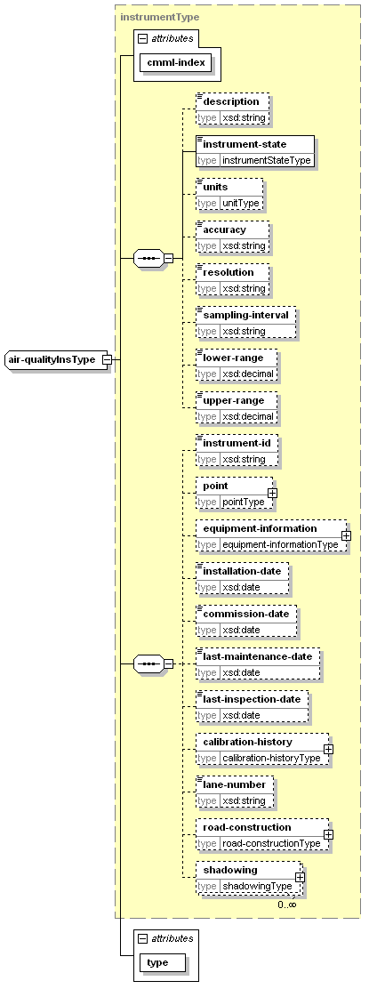
type | extension of instrumentType
properties
  base | instrumentType
children | description instrument-state units accuracy resolution sampling-interval lower-range upper-range instrument-id point equipment-information installation-date commission-date last-maintenance-date last-inspection-date calibration-history lane-number road-construction shadowing
used by
  element | station-metadataType/air-quality-instrument
attributes
  Name | Type | Use | Default | Fixed
  cmml-index | xsd:nonNegativeInteger | required
  type | air-qualityTypeType | required
air-qualityObsType
diagram | 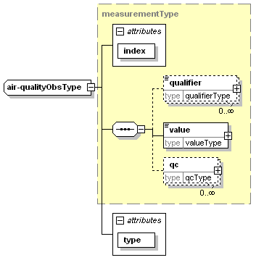
type | extension of measurementType
properties
  base | measurementType
children | qualifier value qc
used by
  element | observationType/air-quality
attributes
  Name | Type | Use | Default | Fixed
  index | xsd:nonNegativeInteger | required
  type | air-qualityTypeType | required
air-qualityType
diagram | 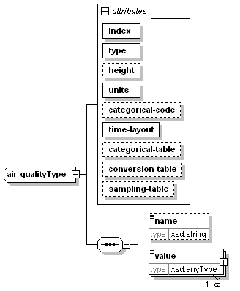
children | name value
used by
  element | parametersType/air-quality
attributes
  Name | Type | Use | Default | Fixed
  index | xsd:nonNegativeInteger | required
  type | air-qualityTypeType | required
  height | xsd:nonNegativeInteger | optional
  units | unitType | required
  categorical-code | xsd:string | optional
  time-layout | time-layoutAttributeType | required
  categorical-table | xsd:string | optional
  conversion-table | xsd:string | optional
  sampling-table | xsd:string | optional
areaType
diagram | 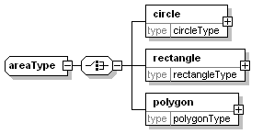
children | circle rectangle polygon
used by
  elements | locationType/area forecast-locationType/area region-metadataType/area
base-metadataType
diagram | 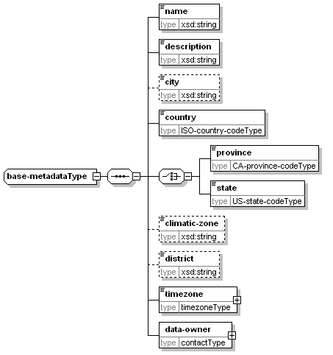
children | name description city country province state climatic-zone district timezone data-owner
used by
  complexTypes | region-metadataType station-metadataType
basic-instrumentType
diagram | 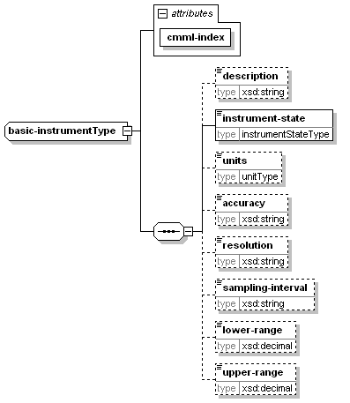
children | description instrument-state units accuracy resolution sampling-interval lower-range upper-range
used by
  complexTypes | instrumentType physical-statusInsType
attributes
  Name | Type | Use | Default | Fixed
  cmml-index | xsd:nonNegativeInteger | required
bridgeType
diagram | 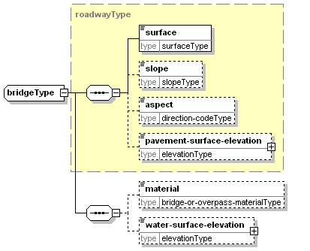
type | extension of roadwayType
properties
  base | roadwayType
children | surface slope aspect pavement-surface-elevation material water-surface-elevation
used by
  element | road-constructionType/bridge
calibration-historyType
diagram | 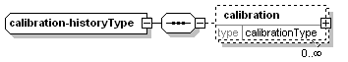
children | calibration
used by
  element | instrumentType/calibration-history
calibrationType
diagram | 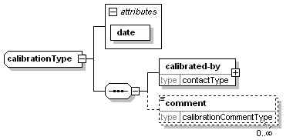
children | calibrated-by comment
used by
  element | calibration-historyType/calibration
attributes
  Name | Type | Use | Default | Fixed
  date | xsd:date | required
categorical-tableType
diagram | 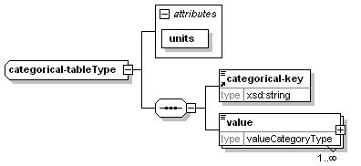
children | categorical-key value
used by
  element | supplementary-metadataType/categorical-definitions/categorical-table
attributes
  Name | Type | Use | Default | Fixed
  units | unitType | required
circleType
diagram | 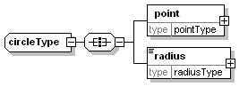
children | point radius
used by
  element | areaType/circle
cityType
diagram | 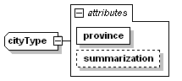
type | extension of xsd:string
properties
  base | xsd:string
used by
  element | forecast-locationType/city
attributes
  Name | Type | Use | Default | Fixed
  province | provinceType | required
  summarization | summarizationType | optional
cmmlType
diagram | 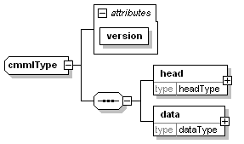
children | head data
used by
  element | cmml
attributes
  Name | Type | Use | Default | Fixed
  version | non-emptyString | required
contactType
diagram | 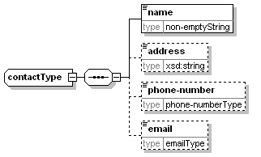
children | name address phone-number email
used by
  elements | calibrationType/calibrated-by supplementary-metadataType/data-owner base-metadataType/data-owner station-metadataType/station-maintainer station-metadataType/station-owner
conversion-tableType
diagram | 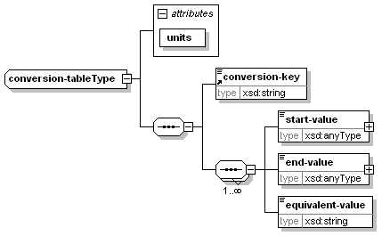
children | conversion-key start-value end-value equivalent-value
used by
  element | supplementary-metadataType/conversion-definitions/conversion-table
attributes
  Name | Type | Use | Default | Fixed
  units | unitType | required
creation-dateType
diagram | 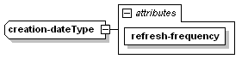
type | extension of xsd:dateTime
properties
  base | xsd:dateTime
used by
  element | productType/creation-date
attributes
  Name | Type | Use | Default | Fixed
  refresh-frequency | xsd:duration | required
dataType
diagram | 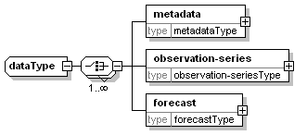
children | metadata observation-series forecast
used by
  element | cmmlType/data
elevationType
diagram | 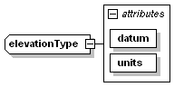
type | extension of xsd:decimal
properties
  base | xsd:decimal
used by
  elements | pointType/elevation overpassType/lower-roadway-elevation roadwayType/pavement-surface-elevation subsurfaceInsType/sensor-depth bridgeType/water-surface-elevation
attributes
  Name | Type | Use | Default | Fixed
  datum | datumType | required
  units | elevation-unitsType | required
equipment-informationType
diagram | 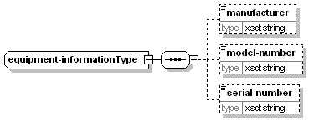
children | manufacturer model-number serial-number
used by
  elements | rpuType/equipment-information instrumentType/equipment-information
type | extension of instrumentType
properties
  base | instrumentType
children | description instrument-state units accuracy resolution sampling-interval lower-range upper-range instrument-id point equipment-information installation-date commission-date last-maintenance-date last-inspection-date calibration-history lane-number road-construction shadowing
used by
  element | station-metadataType/extension-instrument
attributes
  Name | Type | Use | Default | Fixed
  cmml-index | xsd:nonNegativeInteger | required
  sensor-name | xsd:string | required
extensionInsType
diagram | 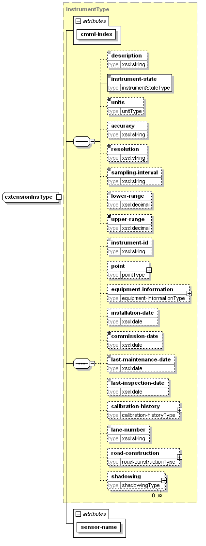
type | extension of instrumentType
properties
  base | instrumentType
children | description instrument-state units accuracy resolution sampling-interval lower-range upper-range instrument-id point equipment-information installation-date commission-date last-maintenance-date last-inspection-date calibration-history lane-number road-construction shadowing
used by
  element | station-metadataType/extension-instrument
attributes
  Name | Type | Use | Default | Fixed
  cmml-index | xsd:nonNegativeInteger | required
  sensor-name | xsd:string | required
extensionType
diagram | 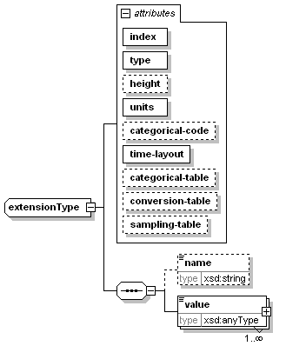
children | name value
used by
  element | parametersType/extension
attributes
  Name | Type | Use | Default | Fixed
  index | xsd:nonNegativeInteger | required
  type | xsd:string | required
  height | xsd:nonNegativeInteger | optional
  units | unitType | required
  categorical-code | xsd:string | optional
  time-layout | time-layoutAttributeType | required
  categorical-table | xsd:string | optional
  conversion-table | xsd:string | optional
  sampling-table | xsd:string | optional
forecast-locationType
diagram | 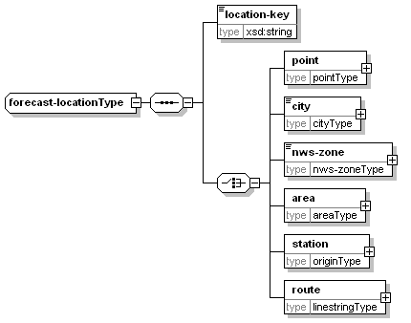
children | location-key point city nws-zone area station route
forecastType
diagram | 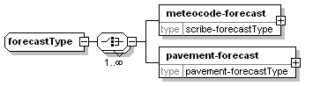
children | meteocode-forecast pavement-forecast
used by
  element | dataType/forecast
headType
diagram | 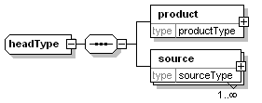
children | product source
used by
  element | cmmlType/head
humidityInsType
diagram | 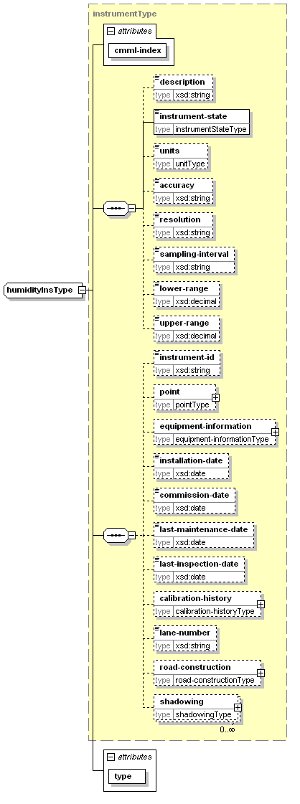
type | extension of instrumentType
properties
  base | instrumentType
children | description instrument-state units accuracy resolution sampling-interval lower-range upper-range instrument-id point equipment-information installation-date commission-date last-maintenance-date last-inspection-date calibration-history lane-number road-construction shadowing
used by
  element | station-metadataType/humidity-instrument
attributes
  Name | Type | Use | Default | Fixed
  cmml-index | xsd:nonNegativeInteger | required
  type | humidityTypeType | required
humidityObsType
diagram | 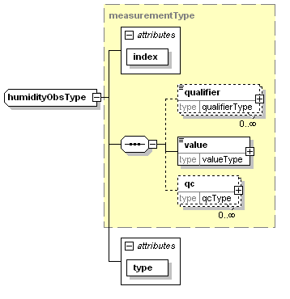
type | extension of measurementType
properties
  base | measurementType
children | qualifier value qc
used by
  element | observationType/humidity
attributes
  Name | Type | Use | Default | Fixed
  index | xsd:nonNegativeInteger | required
  type | humidityTypeType | required
humidityType
diagram | 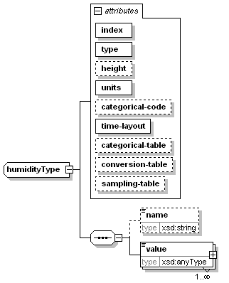
children | name value
used by
  element | parametersType/humidity
attributes
  Name | Type | Use | Default | Fixed
  index | xsd:nonNegativeInteger | required
  type | humidityTypeType | required
  height | xsd:nonNegativeInteger | optional
  units | unitType | required
  categorical-code | xsd:string | optional
  time-layout | time-layoutAttributeType | required
  categorical-table | xsd:string | optional
  conversion-table | xsd:string | optional
  sampling-table | xsd:string | optional
identifierType
diagram | 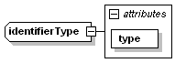
properties
  mixed | true
used by
  element | originType/id
attributes
  Name | Type | Use | Default | Fixed
  type | identifiertypeType | required
instrumentType
diagram | 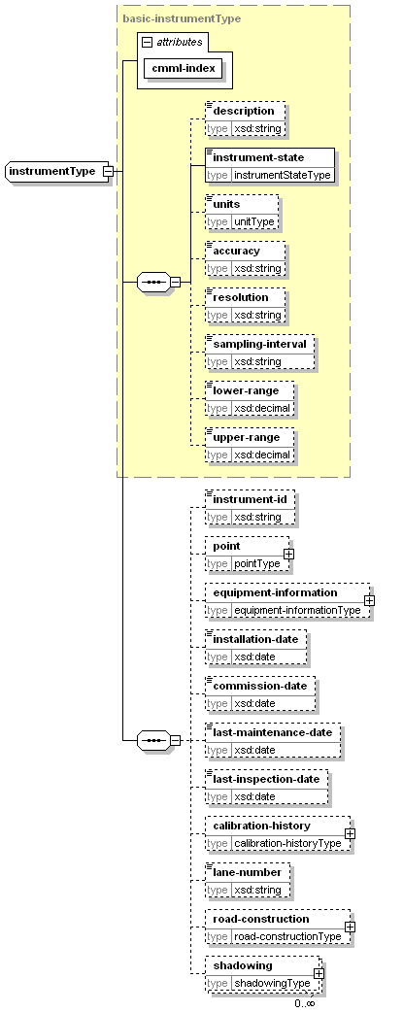
type | extension of basic-instrumentType
properties
  base | basic-instrumentType
children | description instrument-state units accuracy resolution sampling-interval lower-range upper-range instrument-id point equipment-information installation-date commission-date last-maintenance-date last-inspection-date calibration-history lane-number road-construction shadowing
used by
  complexTypes | air-qualityInsType extensionInsType humidityInsType pavementInsType precipitationInsType pressureInsType radiationInsType snapshot-cameraInsType snowInsType subsurfaceInsType temperatureInsType visibilityInsType weatherInsType windInsType
attributes
  Name | Type | Use | Default | Fixed
  cmml-index | xsd:nonNegativeInteger | required
linestringType
diagram | 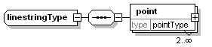
children | point
used by
  elements | locationType/route forecast-locationType/route region-metadataType/route
location-metadataType
diagram | 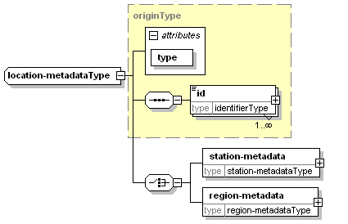
type | extension of originType
properties
  base | originType
children | id station-metadata region-metadata
used by
  element | metadataType/location
attributes
  Name | Type | Use | Default | Fixed
  type | origintypeType | required
locationType
diagram | 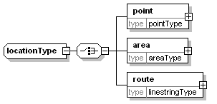
children | point area route
used by
  elements | pavement-forecastType/location observation-seriesType/location
measurementType
diagram | 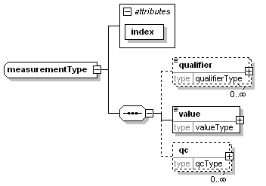
children | qualifier value qc
used by
  element | observationType/extension
  complexTypes | air-qualityObsType humidityObsType pavementObsType physical-statusObsType precipitationObsType pressureObsType radiationObsType snapshot-cameraObsType snowObsType subsurfaceObsType temperatureObsType visibilityObsType weatherObsType windObsType
attributes
  Name | Type | Use | Default | Fixed
  index | xsd:nonNegativeInteger | required
messageType
diagram | 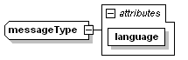
properties
  mixed | true
used by
  element | qc-flagType/message
attributes
  Name | Type | Use | Default | Fixed
  language |  | required
metadataType
diagram | 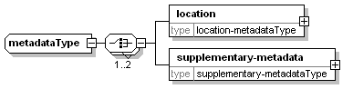
children | location supplementary-metadata
used by
  element | dataType/metadata
nws-zoneType
diagram | 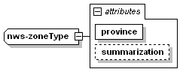
type | extension of xsd:string
properties
  base | xsd:string
used by
  element | forecast-locationType/nws-zone
attributes
  Name | Type | Use | Default | Fixed
  province | provinceType | required
  summarization | summarizationType | optional
observation-seriesType
diagram | 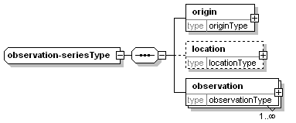
children | origin location observation
used by
  element | dataType/observation-series
observationType
diagram | 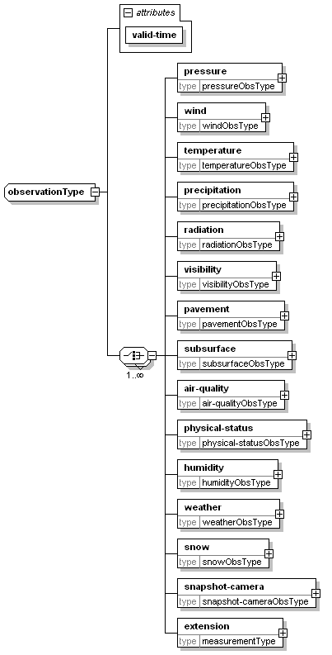
children | pressure wind temperature precipitation radiation visibility pavement subsurface air-quality physical-status humidity weather snow snapshot-camera extension
used by
  element | observation-seriesType/observation
attributes
  Name | Type | Use | Default | Fixed
  valid-time | xsd:dateTime | required
originType
diagram | 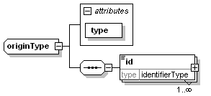
children | id
used by
  elements | observation-seriesType/origin forecast-locationType/station
  complexType | location-metadataType
attributes
  Name | Type | Use | Default | Fixed
  type | origintypeType | required
overpassType
diagram | 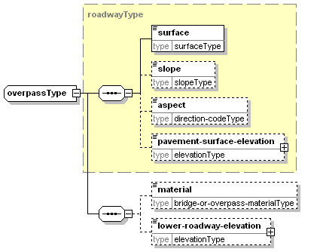
type | extension of roadwayType
properties
  base | roadwayType
children | surface slope aspect pavement-surface-elevation material lower-roadway-elevation
used by
  element | road-constructionType/overpass
parametersType
diagram | 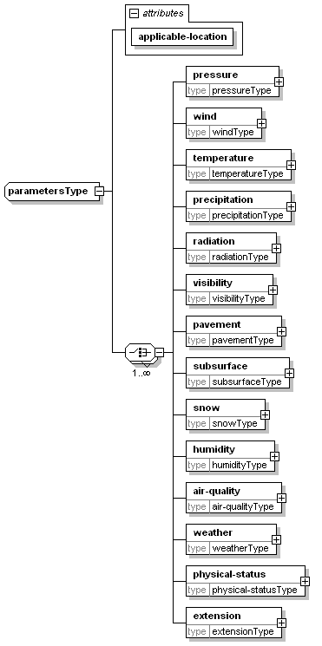
children | pressure wind temperature precipitation radiation visibility pavement subsurface snow humidity air-quality weather physical-status extension
used by
  element | pavement-forecastType/parameters
attributes
  Name | Type | Use | Default | Fixed
  applicable-location | non-emptyString | required
pavement-forecastType
diagram | 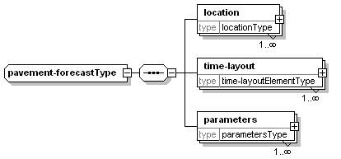
children | location time-layout parameters
used by
  element | forecastType/pavement-forecast
pavementInsType
diagram | 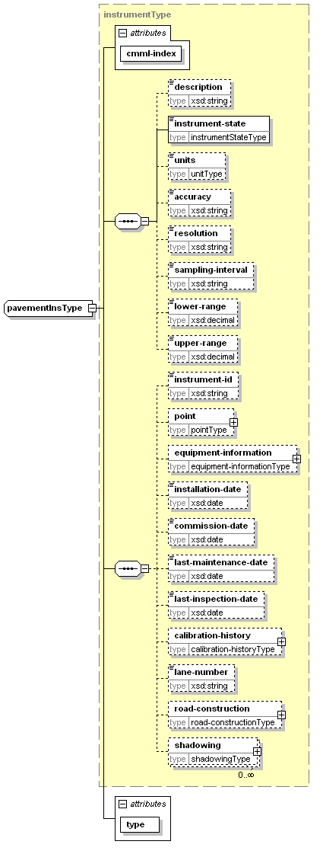
type | extension of instrumentType
properties
  base | instrumentType
children | description instrument-state units accuracy resolution sampling-interval lower-range upper-range instrument-id point equipment-information installation-date commission-date last-maintenance-date last-inspection-date calibration-history lane-number road-construction shadowing
used by
  element | station-metadataType/pavement-instrument
attributes
  Name | Type | Use | Default | Fixed
  cmml-index | xsd:nonNegativeInteger | required
  type | pavementTypeType | required
pavementObsType
diagram | 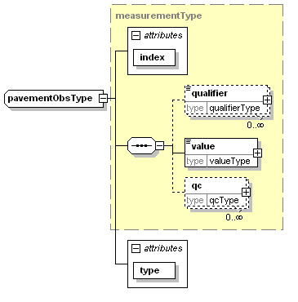
type | extension of measurementType
properties
  base | measurementType
children | qualifier value qc
used by
  element | observationType/pavement
attributes
  Name | Type | Use | Default | Fixed
  index | xsd:nonNegativeInteger | required
  type | pavementTypeType | required
pavementType
diagram | 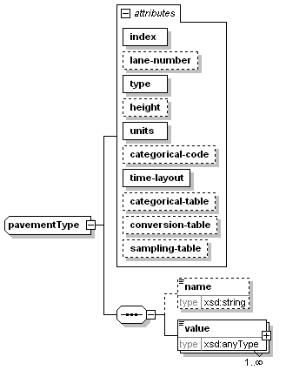
children | name value
used by
  element | parametersType/pavement
attributes
  Name | Type | Use | Default | Fixed
  index | xsd:nonNegativeInteger | required
  lane-number | xsd:nonNegativeInteger | optional
  type | pavementTypeType | required
  height | xsd:integer | optional
  units | unitType | required
  categorical-code | xsd:string | optional
  time-layout | time-layoutAttributeType | required
  categorical-table | xsd:string | optional
  conversion-table | xsd:string | optional
  sampling-table | xsd:string | optional
physical-statusInsType
diagram | 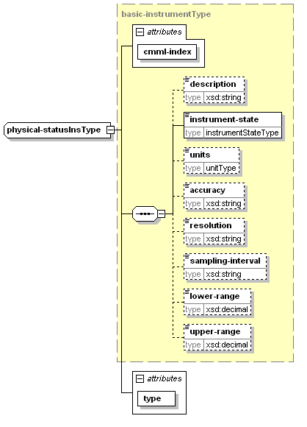
type | extension of basic-instrumentType
properties
  base | basic-instrumentType
children | description instrument-state units accuracy resolution sampling-interval lower-range upper-range
used by
  element | rpuType/physical-status
attributes
  Name | Type | Use | Default | Fixed
  cmml-index | xsd:nonNegativeInteger | required
  type | physical-statusTypeType | required
physical-statusObsType
diagram | 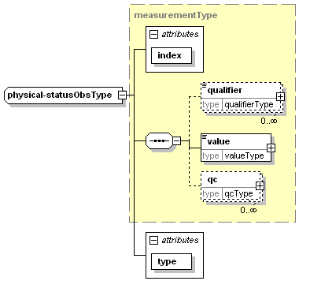
type | extension of measurementType
properties
  base | measurementType
children | qualifier value qc
used by
  element | observationType/physical-status
attributes
  Name | Type | Use | Default | Fixed
  index | xsd:nonNegativeInteger | required
  type | physical-statusTypeType | required
physical-statusType
diagram | 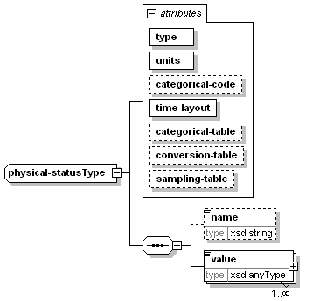
children | name value
used by
  element | parametersType/physical-status
attributes
  Name | Type | Use | Default | Fixed
  type | physical-statusTypeType | required
  units | unitType | required
  categorical-code | xsd:string | optional
  time-layout | time-layoutAttributeType | required
  categorical-table | xsd:string | optional
  conversion-table | xsd:string | optional
  sampling-table | xsd:string | optional
pointType
diagram | 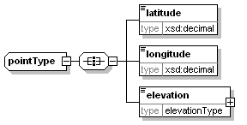
children | latitude longitude elevation
used by
  elements | locationType/point forecast-locationType/point linestringType/point circleType/point rectangleType/point polygonType/point station-metadataType/point instrumentType/point
polygonType
diagram | 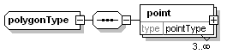
children | point
used by
  element | areaType/polygon
precipitationInsType
diagram | 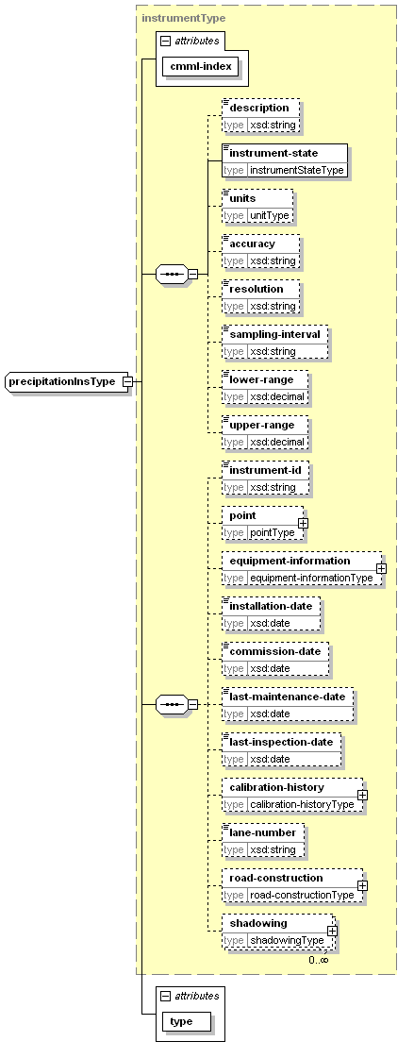
type | extension of instrumentType
properties
  base | instrumentType
children | description instrument-state units accuracy resolution sampling-interval lower-range upper-range instrument-id point equipment-information installation-date commission-date last-maintenance-date last-inspection-date calibration-history lane-number road-construction shadowing
used by
  element | station-metadataType/precipitation-instrument
attributes
  Name | Type | Use | Default | Fixed
  cmml-index | xsd:nonNegativeInteger | required
  type | precipitationTypeType | required
precipitationObsType
diagram | 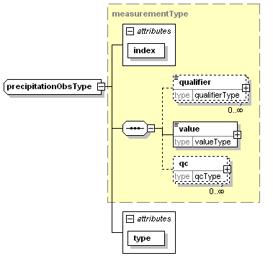
type | extension of measurementType
properties
  base | measurementType
children | qualifier value qc
used by
  element | observationType/precipitation
attributes
  Name | Type | Use | Default | Fixed
  index | xsd:nonNegativeInteger | required
  type | precipitationTypeType | required
precipitationType
diagram | 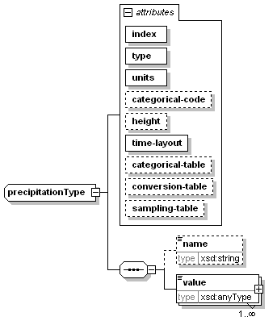
children | name value
used by
  element | parametersType/precipitation
attributes
  Name | Type | Use | Default | Fixed
  index | xsd:nonNegativeInteger | required
  type | precipitationTypeType | required
  units | unitType | required
  categorical-code | xsd:string | optional
  height | xsd:nonNegativeInteger | optional
  time-layout | time-layoutAttributeType | required
  categorical-table | xsd:string | optional
  conversion-table | xsd:string | optional
  sampling-table | xsd:string | optional
pressureInsType
diagram | 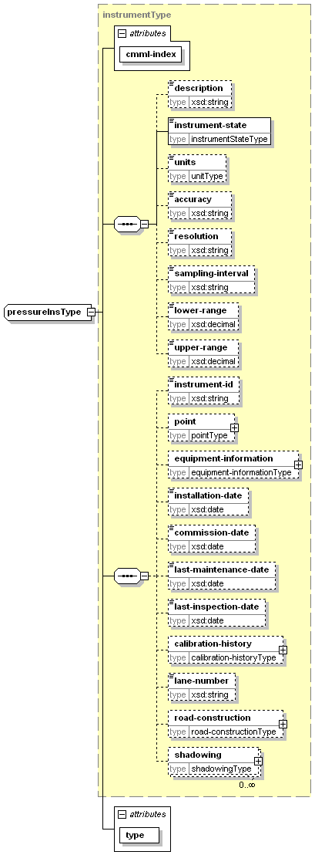
type | extension of instrumentType
properties
  base | instrumentType
children | description instrument-state units accuracy resolution sampling-interval lower-range upper-range instrument-id point equipment-information installation-date commission-date last-maintenance-date last-inspection-date calibration-history lane-number road-construction shadowing
used by
  element | station-metadataType/pressure-instrument
attributes
  Name | Type | Use | Default | Fixed
  cmml-index | xsd:nonNegativeInteger | required
  type | pressureTypeType | required
pressureObsType
diagram | 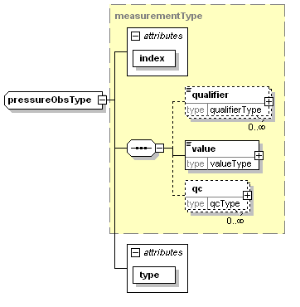
type | extension of measurementType
properties
  base | measurementType
children | qualifier value qc
used by
  element | observationType/pressure
attributes
  Name | Type | Use | Default | Fixed
  index | xsd:nonNegativeInteger | required
  type | pressureTypeType | required
pressureType
diagram | 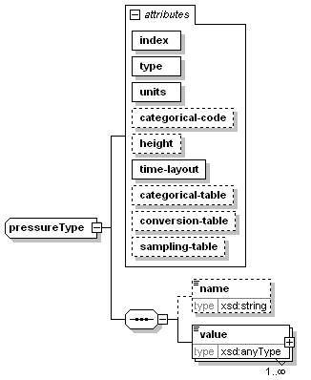
children | name value
used by
  element | parametersType/pressure
attributes
  Name | Type | Use | Default | Fixed
  index | xsd:nonNegativeInteger | required
  type | pressureTypeType | required
  units | unitType | required
  categorical-code | xsd:string | optional
  height | xsd:nonNegativeInteger | optional
  time-layout | time-layoutAttributeType | required
  categorical-table | xsd:string | optional
  conversion-table | xsd:string | optional
  sampling-table | xsd:string | optional
production-centerType
diagram | 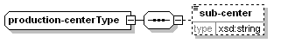
properties
  mixed | true
children | sub-center
used by
  element | sourceType/production-center
productType
diagram | 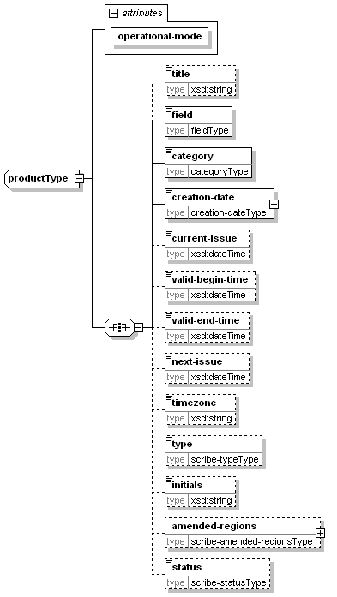
children | title field category creation-date current-issue valid-begin-time valid-end-time next-issue timezone type initials amended-regions status
used by
  element | headType/product
attributes
  Name | Type | Use | Default | Fixed
  operational-mode | operational-modeType | required
qc-flagType
diagram | 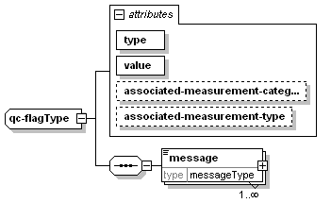
children | message
used by
  element | qcType/qc-flag
attributes
  Name | Type | Use | Default | Fixed
  type | qc-flagtypeType | required
  value | qc-flagvalueType | required
  associated-measurement-category | measurement-categoryType | optional
  associated-measurement-type | measurement-typeType | optional
qcType
diagram | 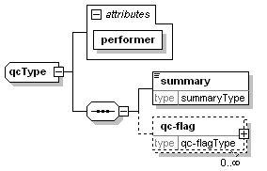
children | summary qc-flag
used by
  element | measurementType/qc
attributes
  Name | Type | Use | Default | Fixed
  performer | non-emptyString | required
qualifierType
diagram | 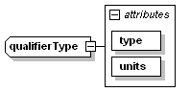
properties
  mixed | true
used by
  element | measurementType/qualifier
attributes
  Name | Type | Use | Default | Fixed
  type |  | required
  units | unitType | required
radiationInsType
diagram | 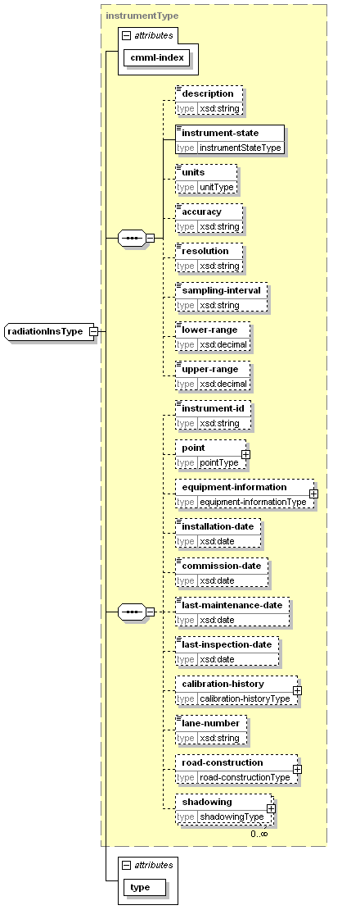
type | extension of instrumentType
properties
  base | instrumentType
children | description instrument-state units accuracy resolution sampling-interval lower-range upper-range instrument-id point equipment-information installation-date commission-date last-maintenance-date last-inspection-date calibration-history lane-number road-construction shadowing
used by
  element | station-metadataType/radiation-instrument
attributes
  Name | Type | Use | Default | Fixed
  cmml-index | xsd:nonNegativeInteger | required
  type | radiationTypeType | required
radiationObsType
diagram | 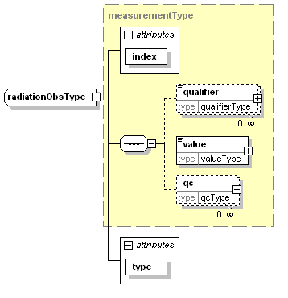
type | extension of measurementType
properties
  base | measurementType
children | qualifier value qc
used by
  element | observationType/radiation
attributes
  Name | Type | Use | Default | Fixed
  index | xsd:nonNegativeInteger | required
  type | radiationTypeType | required
radiationType
diagram | 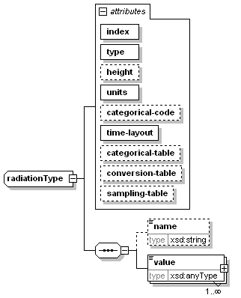
children | name value
used by
  element | parametersType/radiation
attributes
  Name | Type | Use | Default | Fixed
  index | xsd:nonNegativeInteger | required
  type | radiationTypeType | required
  height | xsd:nonNegativeInteger | optional
  units | unitType | required
  categorical-code | xsd:string | optional
  time-layout | time-layoutAttributeType | required
  categorical-table | xsd:string | optional
  conversion-table | xsd:string | optional
  sampling-table | xsd:string | optional
radiusType
diagram | 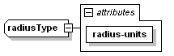
type | extension of xsd:decimal
properties
  base | xsd:decimal
used by
  element | circleType/radius
attributes
  Name | Type | Use | Default | Fixed
  radius-units | radius-unitsType | required
rectangleType
diagram | 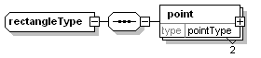
children | point
used by
  element | areaType/rectangle
region-metadataType
diagram | 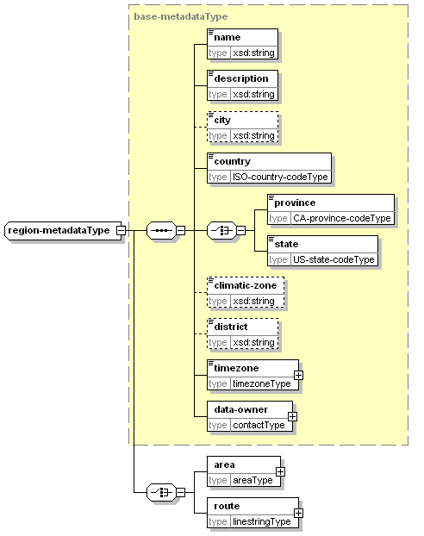
type | extension of base-metadataType
properties
  base | base-metadataType
children | name description city country province state climatic-zone district timezone data-owner area route
used by
  element | location-metadataType/region-metadata
road-constructionType
diagram | 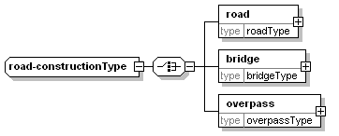
children | road bridge overpass
used by
  element | instrumentType/road-construction
roadType
diagram | 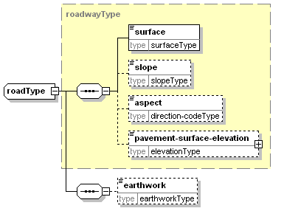
type | extension of roadwayType
properties
  base | roadwayType
children | surface slope aspect pavement-surface-elevation earthwork
used by
  element | road-constructionType/road
roadwayType
diagram | 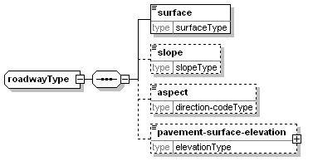
children | surface slope aspect pavement-surface-elevation
used by
  complexTypes | bridgeType overpassType roadType
rpuType
diagram | 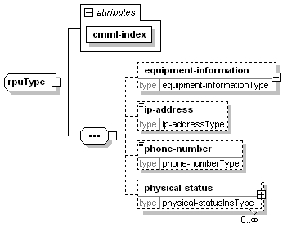
children | equipment-information ip-address phone-number physical-status
used by
  element | station-metadataType/rpu
attributes
  Name | Type | Use | Default | Fixed
  cmml-index | xsd:nonNegativeInteger | required
sampling-tableType
diagram | 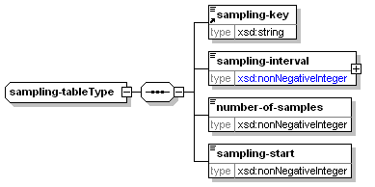
children | sampling-key sampling-interval number-of-samples sampling-start
used by
  element | supplementary-metadataType/sampling-definitions/sampling-table
scribe-accum-amountType
diagram | 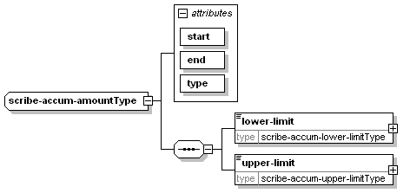
children | lower-limit upper-limit
used by
  element | scribe-accum-listType/accum-amount
attributes
  Name | Type | Use | Default | Fixed
  start | xsd:dateTime | required
  end | xsd:dateTime | required
  type | scribe-accum-typeType | required
scribe-accum-listType
diagram | 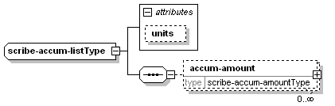
children | accum-amount
used by
  element | scribe-parametersType/accum-list
attributes
  Name | Type | Use | Default | Fixed
  units | scribe-accum-unitsType |  | mm
scribe-accum-lower-limitType
diagram | 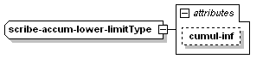
type | extension of xsd:decimal
properties
  base | xsd:decimal
used by
  element | scribe-accum-amountType/lower-limit
attributes
  Name | Type | Use | Default | Fixed
  cumul-inf | xsd:decimal | optional
scribe-accum-upper-limitType
diagram | 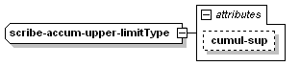
type | extension of xsd:decimal
properties
  base | xsd:decimal
used by
  element | scribe-accum-amountType/upper-limit
attributes
  Name | Type | Use | Default | Fixed
  cumul-sup | xsd:decimal | optional
scribe-amended-regionsType
diagram | 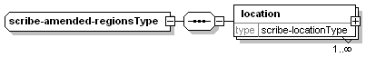
children | location
used by
  element | productType/amended-regions
scribe-basic-cloud-coverType
diagram | 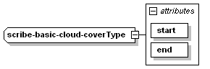
type | extension of xsd:nonNegativeInteger
properties
  base | xsd:nonNegativeInteger
used by
  element | scribe-cloud-listType/cloud-cover
  complexType | scribe-cloud-coverType
attributes
  Name | Type | Use | Default | Fixed
  start | xsd:dateTime | required
  end | xsd:dateTime | required
scribe-basic-exceptionType
diagram | 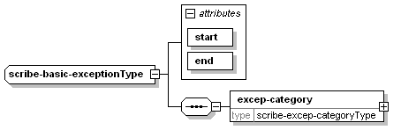
children | excep-category
used by
  complexTypes | scribe-cloud-cover-exceptionType scribe-freezing-spray-exceptionType scribe-precipitation-event-exceptionType scribe-temperature-value-exceptionType scribe-visibility-exceptionType scribe-wind-exceptionType
attributes
  Name | Type | Use | Default | Fixed
  start | xsd:dateTime | required
  end | xsd:dateTime | required
scribe-basic-freezing-sprayType
diagram | 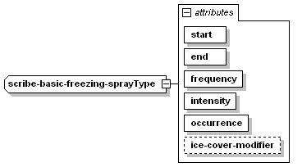
used by
  element | scribe-freezing-spray-exceptionType/freezing-spray
  complexType | scribe-freezing-sprayType
attributes
  Name | Type | Use | Default | Fixed
  start | xsd:dateTime | required
  end | xsd:dateTime | required
  frequency | scribe-freezing-spray-frequencyType | required
  intensity | scribe-freezing-spray-intensityType | required
  occurrence | scribe-freezing-spray-occurType | required
  ice-cover-modifier | scribe-freezing-spray-ice-cover-modifierType | optional
scribe-basic-precipitation-eventType
diagram | 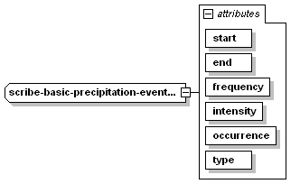
used by
  element | scribe-precipitation-event-exceptionType/precipitation-event
  complexType | scribe-precipitation-eventType
attributes
  Name | Type | Use | Default | Fixed
  start | xsd:dateTime | required
  end | xsd:dateTime | required
  frequency | scribe-precipitation-frequencyType | required
  intensity | scribe-precipitation-intensityType | required
  occurrence | scribe-precipitation-occurType | required
  type | scribe-precipitation-typeType | required
scribe-basic-visibilityType
diagram | 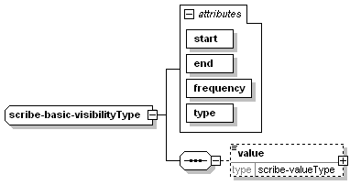
children | value
used by
  element | scribe-visibility-exceptionType/visibility
  complexType | scribe-visibilityType
attributes
  Name | Type | Use | Default | Fixed
  start | xsd:dateTime | required
  end | xsd:dateTime | required
  frequency | scribe-visibility-frequencyType | required
  type | scribe-visibility-typeType | required
scribe-basic-windType
diagram | 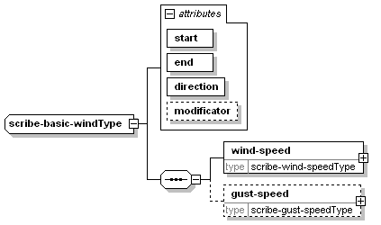
children | wind-speed gust-speed
used by
  element | scribe-wind-exceptionType/wind
  complexType | scribe-windType
attributes
  Name | Type | Use | Default | Fixed
  start | xsd:dateTime | required
  end | xsd:dateTime | required
  direction | scribe-wind-directionType | required
  modificator | scribe-wind-modificatorsType | optional
scribe-cloud-cover-exceptionType
diagram | 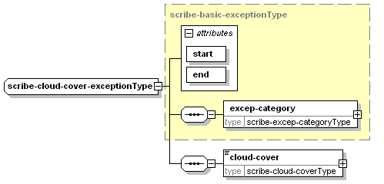
type | extension of scribe-basic-exceptionType
properties
  base | scribe-basic-exceptionType
children | excep-category cloud-cover
used by
  element | scribe-cloud-listType/exception
attributes
  Name | Type | Use | Default | Fixed
  start | xsd:dateTime | required
  end | xsd:dateTime | required
scribe-cloud-coverType
diagram | 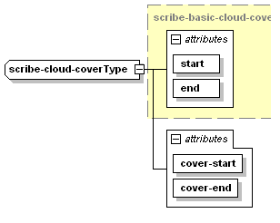
type | extension of scribe-basic-cloud-coverType
properties
  base | scribe-basic-cloud-coverType
used by
  element | scribe-cloud-cover-exceptionType/cloud-cover
attributes
  Name | Type | Use | Default | Fixed
  start | xsd:dateTime | required
  end | xsd:dateTime | required
  cover-start | xsd:nonNegativeInteger | required
  cover-end | xsd:nonNegativeInteger | required
scribe-cloud-listType
diagram | 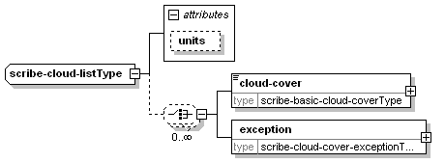
children | cloud-cover exception
used by
  element | scribe-parametersType/cloud-list
attributes
  Name | Type | Use | Default | Fixed
  units | scribe-cloud-unitsType |  | deci
scribe-excep-categoryType
diagram | 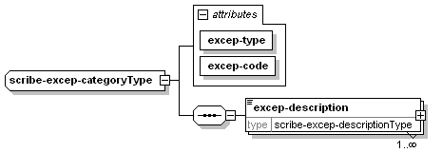
children | excep-description
used by
  element | scribe-basic-exceptionType/excep-category
attributes
  Name | Type | Use | Default | Fixed
  excep-type | scribe-excep-typeType | required
  excep-code | scribe-excep-codeType | required
scribe-excep-descriptionType
diagram | 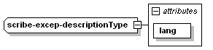
type | extension of xsd:string
properties
  base | xsd:string
used by
  element | scribe-excep-categoryType/excep-description
attributes
  Name | Type | Use | Default | Fixed
  lang | scribe-langType | required
scribe-forecastType
diagram | 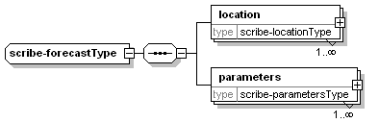
children | location parameters
used by
  element | forecastType/meteocode-forecast
scribe-freezing-spray-exceptionType
diagram | 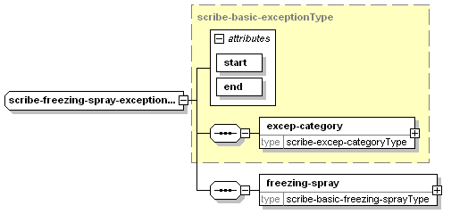
type | extension of scribe-basic-exceptionType
properties
  base | scribe-basic-exceptionType
children | excep-category freezing-spray
used by
  element | scribe-freezing-sprayType/exception
attributes
  Name | Type | Use | Default | Fixed
  start | xsd:dateTime | required
  end | xsd:dateTime | required
scribe-freezing-spray-listType
diagram | 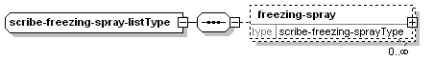
children | freezing-spray
used by
  element | scribe-parametersType/freezing-spray-list
scribe-freezing-sprayType
diagram | 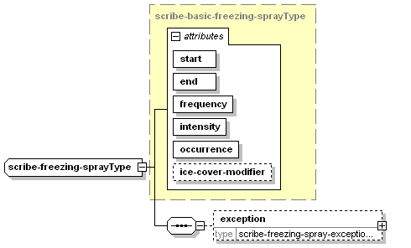
type | extension of scribe-basic-freezing-sprayType
properties
  base | scribe-basic-freezing-sprayType
children | exception
used by
  element | scribe-freezing-spray-listType/freezing-spray
attributes
  Name | Type | Use | Default | Fixed
  start | xsd:dateTime | required
  end | xsd:dateTime | required
  frequency | scribe-freezing-spray-frequencyType | required
  intensity | scribe-freezing-spray-intensityType | required
  occurrence | scribe-freezing-spray-occurType | required
  ice-cover-modifier | scribe-freezing-spray-ice-cover-modifierType | optional
scribe-gust-speedType
diagram | 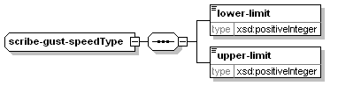
children | lower-limit upper-limit
used by
  element | scribe-basic-windType/gust-speed
scribe-ice-cover-listType
diagram | 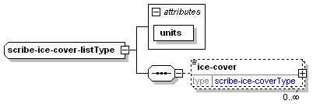
children | ice-cover
used by
  element | scribe-parametersType/ice-cover-list
attributes
  Name | Type | Use | Default | Fixed
  units | xsd:string | required |  | %
scribe-ice-coverType
diagram | 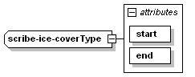
type | extension of xsd:nonNegativeInteger
properties
  base | xsd:nonNegativeInteger
used by
  element | scribe-ice-cover-listType/ice-cover
attributes
  Name | Type | Use | Default | Fixed
  start | xsd:dateTime | required
  end | xsd:dateTime | required
scribe-locationType
diagram | 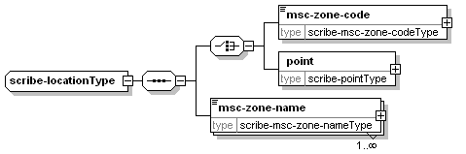
children | msc-zone-code point msc-zone-name
used by
  elements | scribe-amended-regionsType/location scribe-forecastType/location
scribe-msc-zone-codeType
diagram | 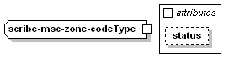
type | extension of xsd:string
properties
  base | xsd:string
used by
  element | scribe-locationType/msc-zone-code
attributes
  Name | Type | Use | Default | Fixed
  status | scribe-msc-zone-code-statusType
scribe-msc-zone-nameType
diagram | 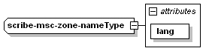
type | extension of xsd:string
properties
  base | xsd:string
used by
  element | scribe-locationType/msc-zone-name
attributes
  Name | Type | Use | Default | Fixed
  lang | scribe-langType | required
scribe-parametersType
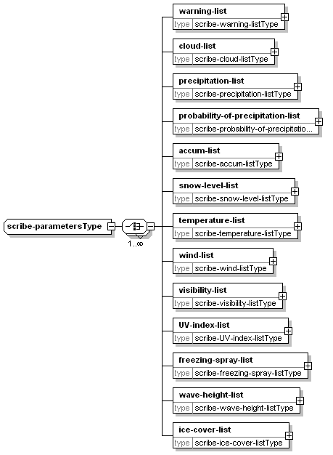
warning-list cloud-list precipitation-list probability-of-precipitation-list accum-list snow-level-list temperature-list wind-list visibility-list UV-index-list freezing-spray-list wave-height-list ice-cover-list
element | scribe-forecastType/parameters

scribe-pointType
diagram | 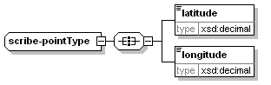
children | latitude longitude
used by
  element | scribe-locationType/point
scribe-precipitation-event-exceptionType
diagram | 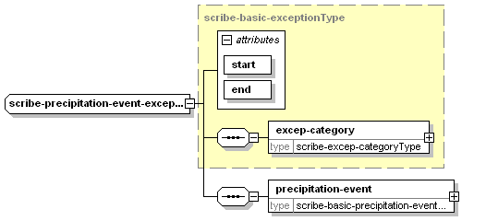
type | extension of scribe-basic-exceptionType
properties
  base | scribe-basic-exceptionType
children | excep-category precipitation-event
used by
  element | scribe-precipitation-eventType/exception
attributes
  Name | Type | Use | Default | Fixed
  start | xsd:dateTime | required
  end | xsd:dateTime | required
scribe-precipitation-eventType
diagram | 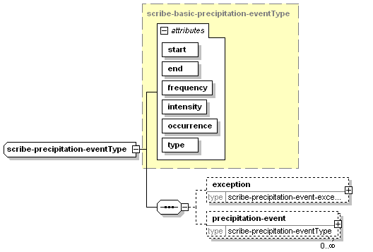
type | extension of scribe-basic-precipitation-eventType
properties
  base | scribe-basic-precipitation-eventType
children | exception precipitation-event
used by
  elements | scribe-precipitation-listType/precipitation-event scribe-precipitation-eventType/precipitation-event
attributes
  Name | Type | Use | Default | Fixed
  start | xsd:dateTime | required
  end | xsd:dateTime | required
  frequency | scribe-precipitation-frequencyType | required
  intensity | scribe-precipitation-intensityType | required
  occurrence | scribe-precipitation-occurType | required
  type | scribe-precipitation-typeType | required
scribe-precipitation-listType
diagram | 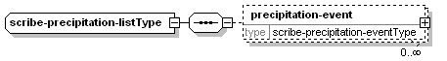
children | precipitation-event
used by
  element | scribe-parametersType/precipitation-list
scribe-probability-of-precipitation-listType
diagram | 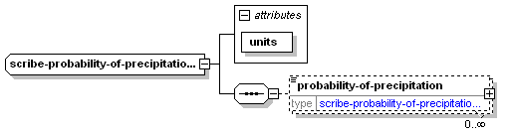
children | probability-of-precipitation
used by
  element | scribe-parametersType/probability-of-precipitation-list
attributes
  Name | Type | Use | Default | Fixed
  units | xsd:string | required |  | %
scribe-probability-of-precipitationType
diagram | 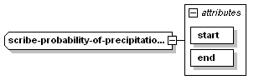
type | extension of xsd:nonNegativeInteger
properties
  base | xsd:nonNegativeInteger
used by
  element | scribe-probability-of-precipitation-listType/probability-of-precipitation
attributes
  Name | Type | Use | Default | Fixed
  start | xsd:dateTime | required
  end | xsd:dateTime | required
scribe-snow-level-listType
diagram | 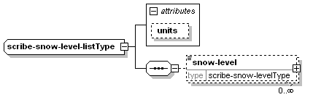
children | snow-level
used by
  element | scribe-parametersType/snow-level-list
attributes
  Name | Type | Use | Default | Fixed
  units | scribe-snow-level-unitsType |  | m
scribe-snow-levelType
diagram | 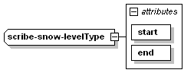
type | extension of xsd:nonNegativeInteger
properties
  base | xsd:nonNegativeInteger
used by
  element | scribe-snow-level-listType/snow-level
attributes
  Name | Type | Use | Default | Fixed
  start | xsd:dateTime | required
  end | xsd:dateTime | required
scribe-temperature-listType
diagram | 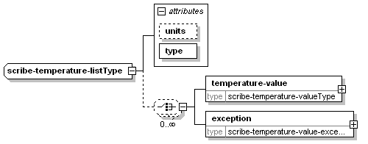
children | temperature-value exception
used by
  element | scribe-parametersType/temperature-list
attributes
  Name | Type | Use | Default | Fixed
  units | scribe-temperature-unitsType |  | celsius
  type | scribe-temperature-typeType | required
scribe-temperature-value-exceptionType
diagram | 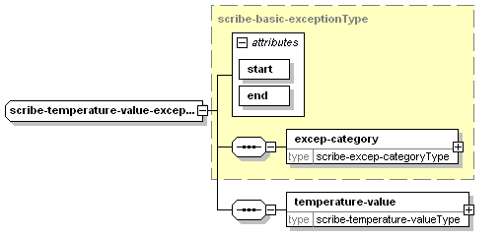
type | extension of scribe-basic-exceptionType
properties
  base | scribe-basic-exceptionType
children | excep-category temperature-value
used by
  element | scribe-temperature-listType/exception
attributes
  Name | Type | Use | Default | Fixed
  start | xsd:dateTime | required
  end | xsd:dateTime | required
scribe-temperature-valueType
diagram | 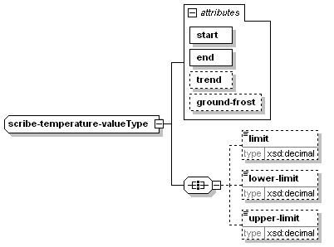
children | limit lower-limit upper-limit
used by
  elements | scribe-temperature-listType/temperature-value scribe-temperature-value-exceptionType/temperature-value
attributes
  Name | Type | Use | Default | Fixed
  start | xsd:dateTime | required
  end | xsd:dateTime | required
  trend | scribe-temperature-trendType
  ground-frost | scribe-temperature-ground-frostType
scribe-UV-index-listType
diagram | 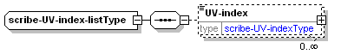
children | UV-index
used by
  element | scribe-parametersType/UV-index-list
scribe-valueType
diagram | 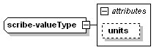
type | extension of xsd:decimal
properties
  base | xsd:decimal
used by
  element | scribe-basic-visibilityType/value
attributes
  Name | Type | Use | Default | Fixed
  units | scribe-value-unitsType |  | NM
scribe-UV-indexType
diagram | 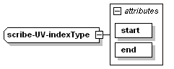
type | extension of xsd:decimal
properties
  base | xsd:decimal
used by
  element | scribe-UV-index-listType/UV-index
attributes
  Name | Type | Use | Default | Fixed
  start | xsd:dateTime | required
  end | xsd:dateTime | required
scribe-visibility-exceptionType
diagram | 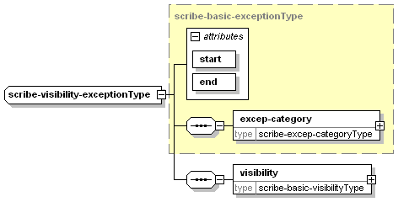
type | extension of scribe-basic-exceptionType
properties
  base | scribe-basic-exceptionType
children | excep-category visibility
used by
  element | scribe-visibilityType/exception
attributes
  Name | Type | Use | Default | Fixed
  start | xsd:dateTime | required
  end | xsd:dateTime | required
scribe-visibility-listType
diagram | 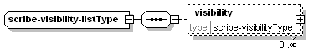
children | visibility
used by
  element | scribe-parametersType/visibility-list
scribe-visibilityType
diagram | 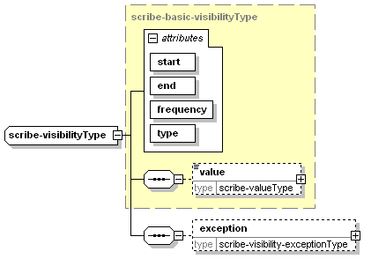
type | extension of scribe-basic-visibilityType
properties
  base | scribe-basic-visibilityType
children | value exception
used by
  element | scribe-visibility-listType/visibility
attributes
  Name | Type | Use | Default | Fixed
  start | xsd:dateTime | required
  end | xsd:dateTime | required
  frequency | scribe-visibility-frequencyType | required
  type | scribe-visibility-typeType | required
scribe-warning-eventType
diagram | 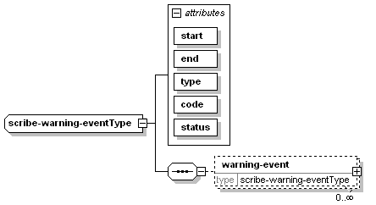
children | warning-event
used by
  elements | scribe-warning-listType/warning-event scribe-warning-eventType/warning-event
attributes
  Name | Type | Use | Default | Fixed
  start | xsd:dateTime | required
  end | xsd:dateTime | required
  type | scribe-warning-typeType | required
  code | scribe-warning-codeType | required
  status | scribe-warning-statusType | required
scribe-warning-listType
diagram | 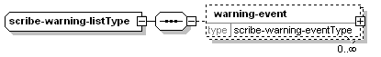
children | warning-event
used by
  element | scribe-parametersType/warning-list
scribe-wave-height-listType
diagram | 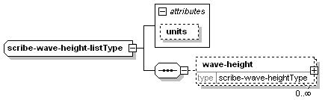
children | wave-height
used by
  element | scribe-parametersType/wave-height-list
attributes
  Name | Type | Use | Default | Fixed
  units | scribe-wave-height-unitsType |  | m
scribe-wave-heightType
diagram | 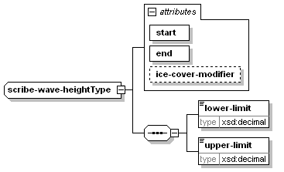
children | lower-limit upper-limit
used by
  element | scribe-wave-height-listType/wave-height
attributes
  Name | Type | Use | Default | Fixed
  start | xsd:dateTime | required
  end | xsd:dateTime | required
  ice-cover-modifier | scribe-wave-height-ice-cover-modifierType | optional
scribe-wind-exceptionType
diagram | 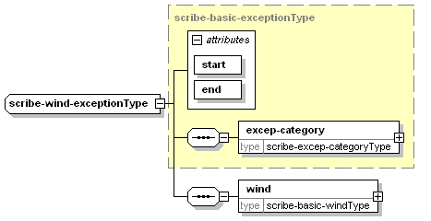
type | extension of scribe-basic-exceptionType
properties
  base | scribe-basic-exceptionType
children | excep-category wind
used by
  element | scribe-windType/exception
attributes
  Name | Type | Use | Default | Fixed
  start | xsd:dateTime | required
  end | xsd:dateTime | required
scribe-wind-listType
diagram | 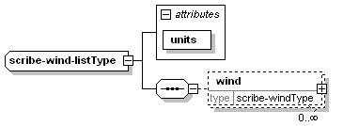
children | wind
used by
  element | scribe-parametersType/wind-list
attributes
  Name | Type | Use | Default | Fixed
  units | scribe-wind-unitsType | required
scribe-wind-speedType
diagram | 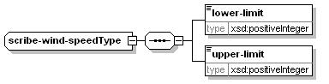
children | lower-limit upper-limit
used by
  element | scribe-basic-windType/wind-speed
scribe-windType
diagram | 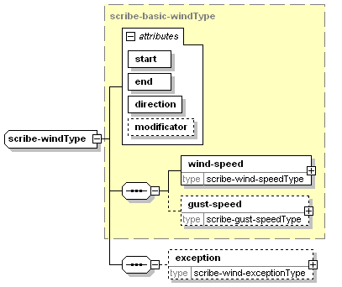
type | extension of scribe-basic-windType
properties
  base | scribe-basic-windType
children | wind-speed gust-speed exception
used by
  element | scribe-wind-listType/wind
attributes
  Name | Type | Use | Default | Fixed
  start | xsd:dateTime | required
  end | xsd:dateTime | required
  direction | scribe-wind-directionType | required
  modificator | scribe-wind-modificatorsType | optional
shadowingType
diagram | 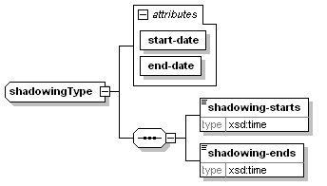
children | shadowing-starts shadowing-ends
used by
  element | instrumentType/shadowing
attributes
  Name | Type | Use | Default | Fixed
  start-date | xsd:gMonthDay | required
  end-date | xsd:gMonthDay | required
snapshot-cameraInsType
diagram | 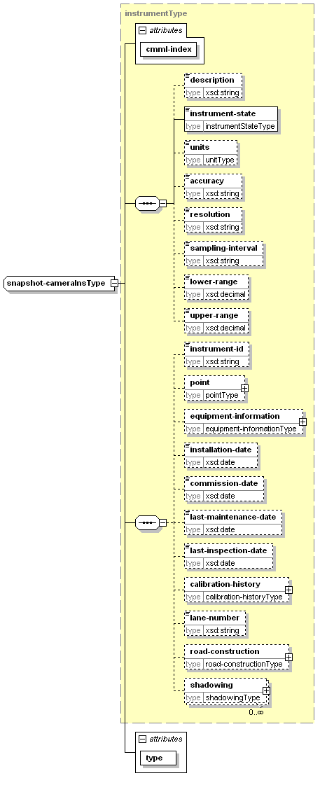
type | extension of instrumentType
properties
  base | instrumentType
children | description instrument-state units accuracy resolution sampling-interval lower-range upper-range instrument-id point equipment-information installation-date commission-date last-maintenance-date last-inspection-date calibration-history lane-number road-construction shadowing
used by
  element | station-metadataType/snapshot-camera-instrument
attributes
  Name | Type | Use | Default | Fixed
  cmml-index | xsd:nonNegativeInteger | required
  type | snapshot-cameraTypeType | required
snapshot-cameraObsType
diagram | 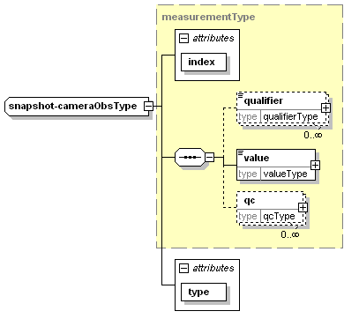
type | extension of measurementType
properties
  base | measurementType
children | qualifier value qc
used by
  element | observationType/snapshot-camera
attributes
  Name | Type | Use | Default | Fixed
  index | xsd:nonNegativeInteger | required
  type | snapshot-cameraTypeType | required
snowInsType
diagram | 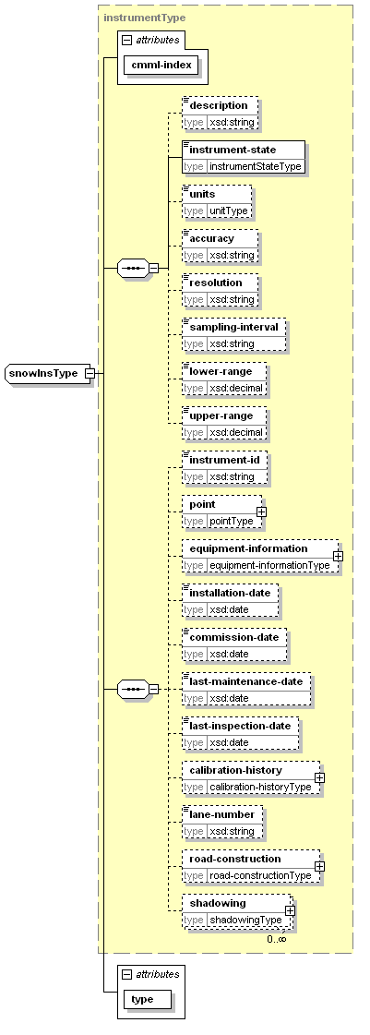
type | extension of instrumentType
properties
  base | instrumentType
children | description instrument-state units accuracy resolution sampling-interval lower-range upper-range instrument-id point equipment-information installation-date commission-date last-maintenance-date last-inspection-date calibration-history lane-number road-construction shadowing
used by
  element | station-metadataType/snow-instrument
attributes
  Name | Type | Use | Default | Fixed
  cmml-index | xsd:nonNegativeInteger | required
  type | snowTypeType | required
snowObsType
diagram | 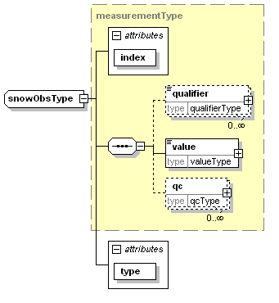
type | extension of measurementType
properties
  base | measurementType
children | qualifier value qc
used by
  element | observationType/snow
attributes
  Name | Type | Use | Default | Fixed
  index | xsd:nonNegativeInteger | required
  type | snowTypeType | required
snowType
diagram | 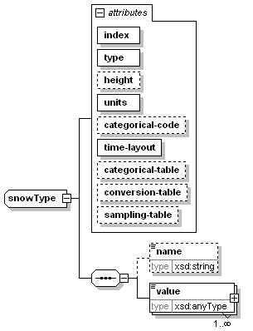
children | name value
used by
  element | parametersType/snow
attributes
  Name | Type | Use | Default | Fixed
  index | xsd:nonNegativeInteger | required
  type | snowTypeType | required
  height | xsd:nonNegativeInteger | optional
  units | unitType | required
  categorical-code | xsd:string | optional
  time-layout | time-layoutAttributeType | required
  categorical-table | xsd:string | optional
  conversion-table | xsd:string | optional
  sampling-table | xsd:string | optional
sourceType
diagram | 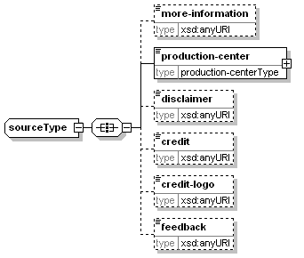
children | more-information production-center disclaimer credit credit-logo feedback
used by
  element | headType/source
start-valid-timeType
diagram | 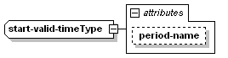
type | extension of xsd:dateTime
properties
  base | xsd:dateTime
used by
  element | time-layoutElementType/start-valid-time
attributes
  Name | Type | Use | Default | Fixed
  period-name | xsd:string | optional
station-metadataType
diagram | 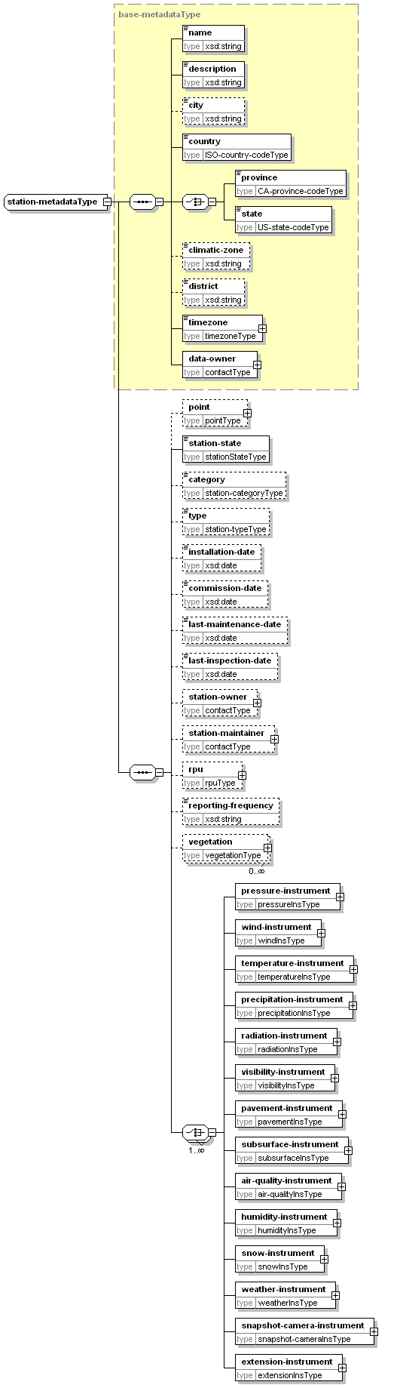
type | extension of base-metadataType
properties
  base | base-metadataType
children | name description city country province state climatic-zone district timezone data-owner point station-state category type installation-date commission-date last-maintenance-date last-inspection-date station-owner station-maintainer rpu reporting-frequency vegetation pressure-instrument wind-instrument temperature-instrument precipitation-instrument radiation-instrument visibility-instrument pavement-instrument subsurface-instrument air-quality-instrument humidity-instrument snow-instrument weather-instrument snapshot-camera-instrument extension-instrument
used by
  element | location-metadataType/station-metadata
subsurfaceInsType
diagram | 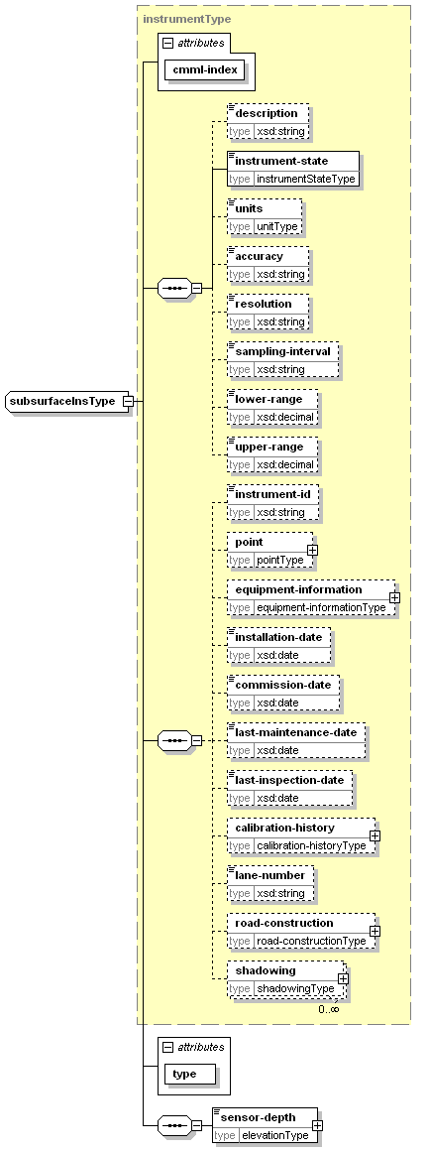
type | extension of instrumentType
properties
  base | instrumentType
children | description instrument-state units accuracy resolution sampling-interval lower-range upper-range instrument-id point equipment-information installation-date commission-date last-maintenance-date last-inspection-date calibration-history lane-number road-construction shadowing sensor-depth
used by
  element | station-metadataType/subsurface-instrument
attributes
  Name | Type | Use | Default | Fixed
  cmml-index | xsd:nonNegativeInteger | required
  type | subsurfaceTypeType | required
subsurfaceObsType
diagram | 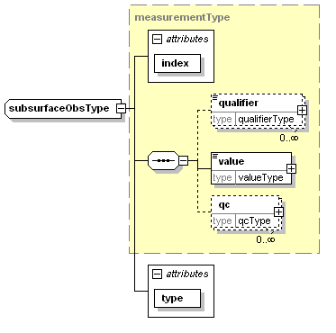
type | extension of measurementType
properties
  base | measurementType
children | qualifier value qc
used by
  element | observationType/subsurface
attributes
  Name | Type | Use | Default | Fixed
  index | xsd:nonNegativeInteger | required
  type | subsurfaceTypeType | required
subsurfaceType
diagram | 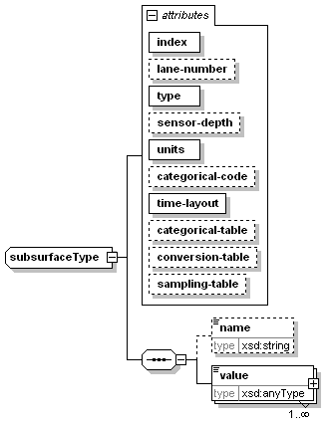
children | name value
used by
  element | parametersType/subsurface
attributes
  Name | Type | Use | Default | Fixed
  index | xsd:nonNegativeInteger | required
  lane-number | xsd:nonNegativeInteger | optional | 1
  type | subsurfaceTypeType | required
  sensor-depth | xsd:nonNegativeInteger | optional | 5
  units | unitType | required
  categorical-code | xsd:string | optional
  time-layout | time-layoutAttributeType | required
  categorical-table | xsd:string | optional
  conversion-table | xsd:string | optional
  sampling-table | xsd:string | optional
supplementary-metadataType
diagram | 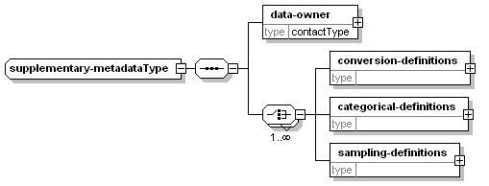
children | data-owner conversion-definitions categorical-definitions sampling-definitions
used by
  element | metadataType/supplementary-metadata
temperatureInsType
diagram | 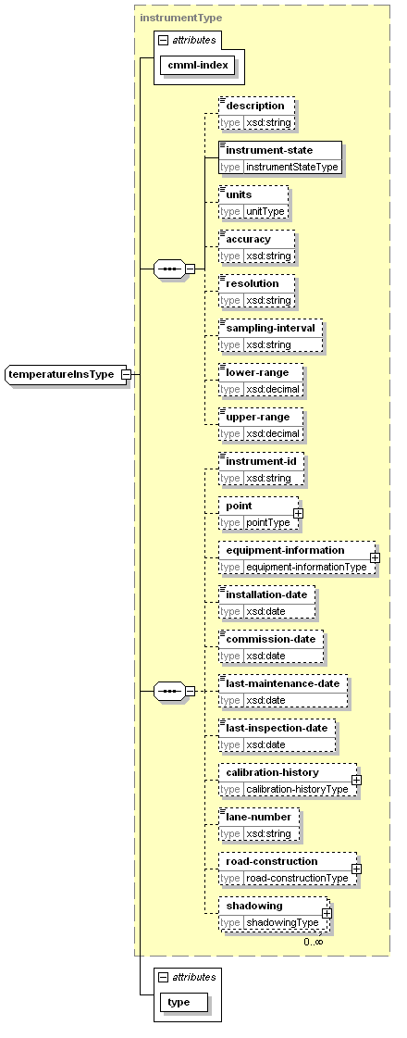
type | extension of instrumentType
properties
  base | instrumentType
children | description instrument-state units accuracy resolution sampling-interval lower-range upper-range instrument-id point equipment-information installation-date commission-date last-maintenance-date last-inspection-date calibration-history lane-number road-construction shadowing
used by
  element | station-metadataType/temperature-instrument
attributes
  Name | Type | Use | Default | Fixed
  cmml-index | xsd:nonNegativeInteger | required
  type | temperatureTypeType | required
temperatureObsType
diagram | 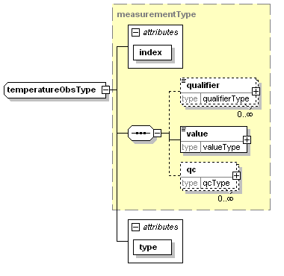
type | extension of measurementType
properties
  base | measurementType
children | qualifier value qc
used by
  element | observationType/temperature
attributes
  Name | Type | Use | Default | Fixed
  index | xsd:nonNegativeInteger | required
  type | temperatureTypeType | required
temperatureType
diagram | 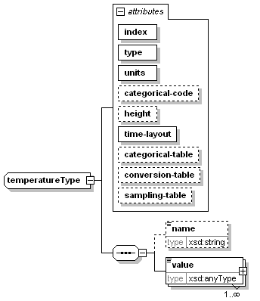
children | name value
used by
  element | parametersType/temperature
attributes
  Name | Type | Use | Default | Fixed
  index | xsd:nonNegativeInteger | required
  type | temperatureTypeType | required
  units | unitType | required
  categorical-code | xsd:string | optional
  height | xsd:nonNegativeInteger | optional
  time-layout | time-layoutAttributeType | required
  categorical-table | xsd:string | optional
  conversion-table | xsd:string | optional
  sampling-table | xsd:string | optional
time-layoutElementType
diagram | 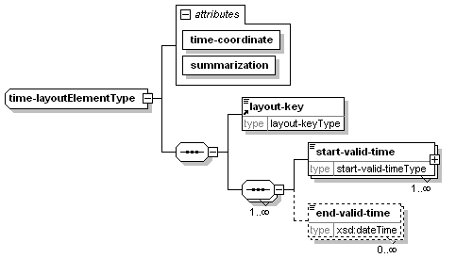
children | layout-key start-valid-time end-valid-time
used by
  element | pavement-forecastType/time-layout
attributes
  Name | Type | Use | Default | Fixed
  time-coordinate | time-coordinateType | required
  summarization | summarizationType | required
timezoneType
diagram | 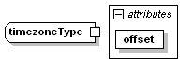
type | extension of timezonetypeType
properties
  base | timezonetypeType
used by
  element | base-metadataType/timezone
attributes
  Name | Type | Use | Default | Fixed
  offset | offsetType | required
valueCategoryType
diagram | 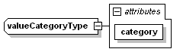
type | extension of xsd:string
properties
  base | xsd:string
used by
  element | categorical-tableType/value
attributes
  Name | Type | Use | Default | Fixed
  category | non-emptyString | required
valueType
diagram | 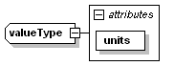
properties
  mixed | true
used by
  element | measurementType/value
attributes
  Name | Type | Use | Default | Fixed
  units | unitType | required
vegetationType
diagram | 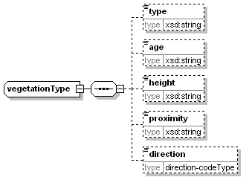
children | type age height proximity direction
used by
  element | station-metadataType/vegetation
visibilityInsType
diagram | 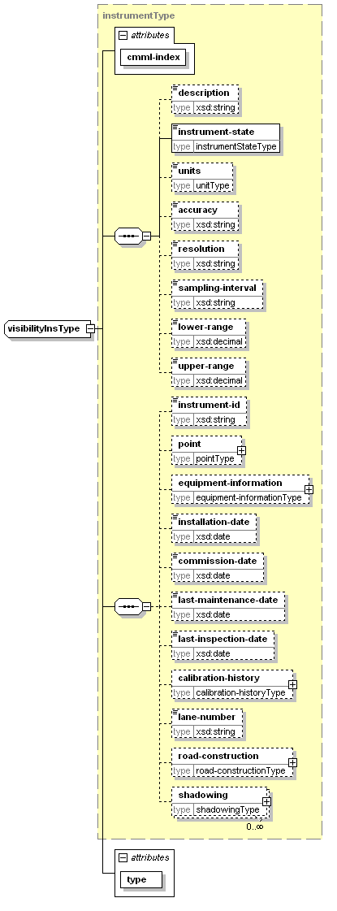
type | extension of instrumentType
properties
  base | instrumentType
children | description instrument-state units accuracy resolution sampling-interval lower-range upper-range instrument-id point equipment-information installation-date commission-date last-maintenance-date last-inspection-date calibration-history lane-number road-construction shadowing
used by
  element | station-metadataType/visibility-instrument
attributes
  Name | Type | Use | Default | Fixed
  cmml-index | xsd:nonNegativeInteger | required
  type | visibilityTypeType | required
visibilityObsType
diagram | 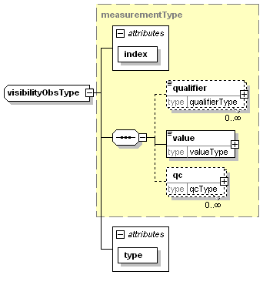
type | extension of measurementType
properties
  base | measurementType
children | qualifier value qc
used by
  element | observationType/visibility
attributes
  Name | Type | Use | Default | Fixed
  index | xsd:nonNegativeInteger | required
  type | visibilityTypeType | required
visibilityType
diagram | 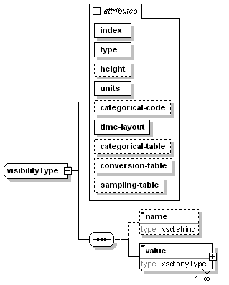
children | name value
used by
  element | parametersType/visibility
attributes
  Name | Type | Use | Default | Fixed
  index | xsd:nonNegativeInteger | required
  type | visibilityTypeType | required
  height | xsd:nonNegativeInteger | optional
  units | unitType | required
  categorical-code | xsd:string | optional
  time-layout | time-layoutAttributeType | required
  categorical-table | xsd:string | optional
  conversion-table | xsd:string | optional
  sampling-table | xsd:string | optional
weatherInsType
diagram | 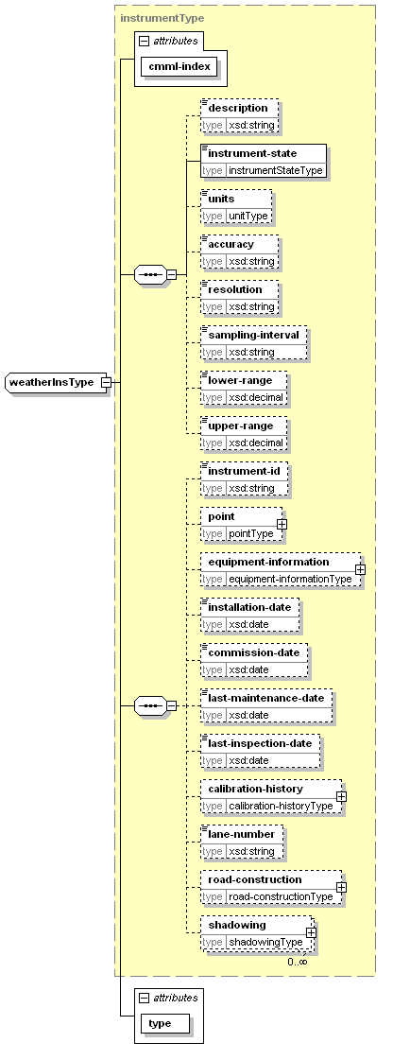
type | extension of instrumentType
properties
  base | instrumentType
children | description instrument-state units accuracy resolution sampling-interval lower-range upper-range instrument-id point equipment-information installation-date commission-date last-maintenance-date last-inspection-date calibration-history lane-number road-construction shadowing
used by
  element | station-metadataType/weather-instrument
attributes
  Name | Type | Use | Default | Fixed
  cmml-index | xsd:nonNegativeInteger | required
  type | weatherTypeType | required
weatherObsType
diagram | 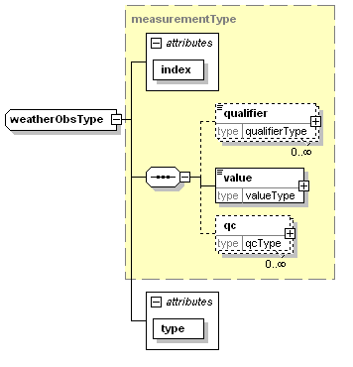
type | extension of measurementType
properties
  base | measurementType
children | qualifier value qc
used by
  element | observationType/weather
attributes
  Name | Type | Use | Default | Fixed
  index | xsd:nonNegativeInteger | required
  type | weatherTypeType | required
weatherType
diagram | 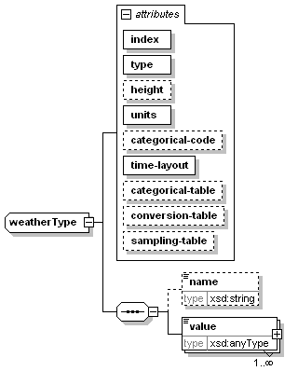
children | name value
used by
  element | parametersType/weather
attributes
  Name | Type | Use | Default | Fixed
  index | xsd:nonNegativeInteger | required
  type | weatherTypeType | required
  height | xsd:nonNegativeInteger | optional
  units | unitType | required
  categorical-code | xsd:string | optional
  time-layout | time-layoutAttributeType | required
  categorical-table | xsd:string | optional
  conversion-table | xsd:string | optional
  sampling-table | xsd:string | optional
windInsType
diagram | 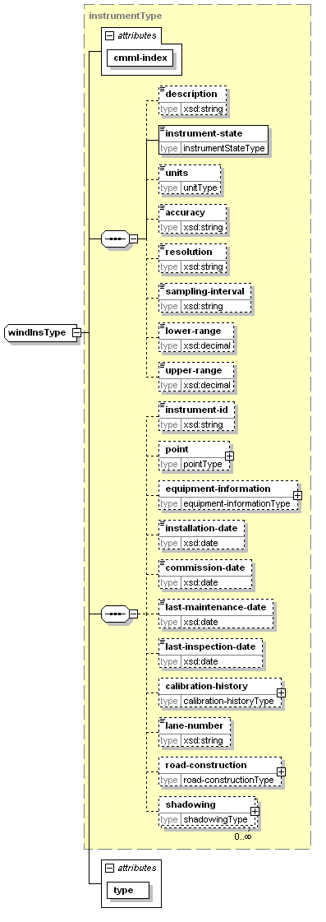
type | extension of instrumentType
properties
  base | instrumentType
children | description instrument-state units accuracy resolution sampling-interval lower-range upper-range instrument-id point equipment-information installation-date commission-date last-maintenance-date last-inspection-date calibration-history lane-number road-construction shadowing
used by
  element | station-metadataType/wind-instrument
attributes
  Name | Type | Use | Default | Fixed
  cmml-index | xsd:nonNegativeInteger | required
  type | windTypeType | required
windObsType
diagram | 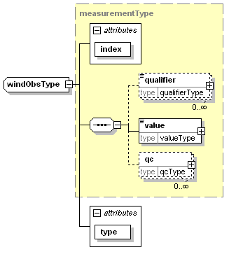
type | extension of measurementType
properties
  base | measurementType
children | qualifier value qc
used by
  element | observationType/wind
attributes
  Name | Type | Use | Default | Fixed
  index | xsd:nonNegativeInteger | required
  type | windTypeType | required
windType
diagram | 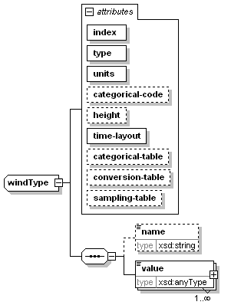
children | name value
used by
  element | parametersType/wind
attributes
  Name | Type | Use | Default | Fixed
  index | xsd:nonNegativeInteger | required
  type | windTypeType | required
  units | unitType | required
  categorical-code | xsd:string | optional
  height | xsd:nonNegativeInteger | optional
  time-layout | time-layoutAttributeType | required
  categorical-table | xsd:string | optional
  conversion-table | xsd:string | optional
  sampling-table | xsd:string | optional

Simple Types
air-qualityTypeType
type | restriction of xsd:string
used by
  attributes | air-qualityType/@type air-qualityObsType/@type air-qualityInsType/@type
bridge-or-overpass-materialType
type | restriction of xsd:string
used by
  elements | bridgeType/material overpassType/material
calibrationCommentType
type | xsd:string
used by
  element | calibrationType/comment
CA-province-codeType
type | restriction of xsd:string
used by
  element | base-metadataType/province
categoryType
type | restriction of xsd:string
used by
  element | productType/category
datumType
type | restriction of xsd:string
used by
  attribute | elevationType/@datum
direction-codeType
type | restriction of xsd:string
used by
  elements | roadwayType/aspect vegetationType/direction
earthworkType
type | restriction of xsd:string
used by
  element | roadType/earthwork
elevation-unitsType
type | restriction of xsd:string
used by
  attribute | elevationType/@units
emailType
type | restriction of xsd:string
used by
  element | contactType/email
fieldType
type | restriction of xsd:string
used by
  element | productType/field
humidityTypeType
type | restriction of xsd:string
used by
  attributes | humidityType/@type humidityObsType/@type humidityInsType/@type
identifiertypeType
type | restriction of xsd:string
used by
  attribute | identifierType/@type
instrumentStateType
type | restriction of xsd:string
used by
  element | basic-instrumentType/instrument-state
ip-addressType
type | restriction of xsd:string
used by
  element | rpuType/ip-address
ISO-country-codeType
type | restriction of xsd:string
used by
  element | base-metadataType/country
layout-keyType
type | restriction of xsd:string
used by
  element | layout-key
measurement-categoryType
type | restriction of xsd:string
used by
  attribute | qc-flagType/@associated-measurement-category
measurement-typeType
type | restriction of xsd:string
used by
  attribute | qc-flagType/@associated-measurement-type
non-emptyString
type | restriction of xsd:string
used by
  element | contactType/name
  attributes | parametersType/@applicable-location valueCategoryType/@category qcType/@performer cmmlType/@version
offsetType
type | restriction of xsd:decimal
used by
  attribute | timezoneType/@offset
operational-modeType
type | restriction of xsd:string
used by
  attribute | productType/@operational-mode
origintypeType
type | restriction of xsd:string
used by
  attribute | originType/@type
pavementTypeType
type | restriction of xsd:string
used by
  attributes | pavementType/@type pavementObsType/@type pavementInsType/@type
phone-numberType
type | restriction of xsd:string
used by
  elements | rpuType/phone-number contactType/phone-number
physical-statusTypeType
type | restriction of xsd:string
used by
  attributes | physical-statusType/@type physical-statusObsType/@type physical-statusInsType/@type
precipitationTypeType
type | restriction of xsd:string
used by
  attributes | precipitationType/@type precipitationObsType/@type precipitationInsType/@type
pressureTypeType
type | restriction of xsd:string
used by
  attributes | pressureType/@type pressureObsType/@type pressureInsType/@type
provinceType
type | restriction of xsd:string
used by
  attributes | cityType/@province nws-zoneType/@province
qc-flagtypeType
type | restriction of xsd:string
used by
  attribute | qc-flagType/@type
qc-flagvalueType
type | restriction of xsd:string
used by
  attribute | qc-flagType/@value
radiationTypeType
type | restriction of xsd:string
used by
  attributes | radiationType/@type radiationObsType/@type radiationInsType/@type
radius-unitsType
type | restriction of xsd:string
used by
  attribute | radiusType/@radius-units
scribe-accum-typeType
type | restriction of xsd:string
used by
  attribute | scribe-accum-amountType/@type
scribe-accum-unitsType
type | restriction of xsd:string
used by
  attribute | scribe-accum-listType/@units
scribe-cloud-unitsType
type | restriction of xsd:string
used by
  attribute | scribe-cloud-listType/@units
scribe-excep-codeType
type | restriction of xsd:string
used by
  attribute | scribe-excep-categoryType/@excep-code
scribe-excep-typeType
type | restriction of xsd:string
used by
  attribute | scribe-excep-categoryType/@excep-type
scribe-freezing-spray-frequencyType
type | restriction of xsd:string
used by
  attribute | scribe-basic-freezing-sprayType/@frequency
scribe-freezing-spray-ice-cover-modifierType
type | restriction of xsd:string
used by
  attribute | scribe-basic-freezing-sprayType/@ice-cover-modifier
scribe-freezing-spray-intensityType
type | restriction of xsd:string
used by
  attribute | scribe-basic-freezing-sprayType/@intensity
scribe-freezing-spray-occurType
type | restriction of xsd:string
used by
  attribute | scribe-basic-freezing-sprayType/@occurrence
scribe-langType
type | restriction of xsd:string
used by
  attributes | scribe-msc-zone-nameType/@lang scribe-excep-descriptionType/@lang
scribe-msc-zone-code-statusType
type | restriction of xsd:string
used by
  attribute | scribe-msc-zone-codeType/@status
scribe-precipitation-frequencyType
type | restriction of xsd:string
used by
  attribute | scribe-basic-precipitation-eventType/@frequency
scribe-precipitation-intensityType
type | restriction of xsd:string
used by
  attribute | scribe-basic-precipitation-eventType/@intensity
scribe-precipitation-occurType
type | restriction of xsd:string
used by
  attribute | scribe-basic-precipitation-eventType/@occurrence
scribe-precipitation-typeType
type | restriction of xsd:string
used by
  attribute | scribe-basic-precipitation-eventType/@type
scribe-snow-level-unitsType
type | restriction of xsd:string
used by
  attribute | scribe-snow-level-listType/@units
scribe-statusType
type | restriction of xsd:string
used by
  element | productType/status
scribe-temperature-ground-frostType
type | restriction of xsd:string
used by
  attribute | scribe-temperature-valueType/@ground-frost
scribe-temperature-trendType
type | restriction of xsd:string
used by
  attribute | scribe-temperature-valueType/@trend
scribe-temperature-typeType
type | restriction of xsd:string
used by
  attribute | scribe-temperature-listType/@type
scribe-temperature-unitsType
type | restriction of xsd:string
used by
  attribute | scribe-temperature-listType/@units
scribe-typeType
type | restriction of xsd:string
used by
  element | productType/type
scribe-value-unitsType
type | restriction of xsd:string
used by
  attribute | scribe-valueType/@units
scribe-visibility-frequencyType
type | restriction of xsd:string
used by
  attribute | scribe-basic-visibilityType/@frequency
scribe-visibility-typeType
type | restriction of xsd:string
used by
  attribute | scribe-basic-visibilityType/@type
scribe-warning-codeType
type | restriction of xsd:string
used by
  attribute | scribe-warning-eventType/@code
scribe-warning-statusType
type | restriction of xsd:string
used by
  attribute | scribe-warning-eventType/@status
scribe-warning-typeType
type | restriction of xsd:string
used by
  attribute | scribe-warning-eventType/@type
scribe-wave-height-ice-cover-modifierType
type | restriction of xsd:string
used by
  attribute | scribe-wave-heightType/@ice-cover-modifier
scribe-wave-height-unitsType
type | restriction of xsd:string
used by
  attribute | scribe-wave-height-listType/@units
scribe-wind-directionType
type | restriction of xsd:string
used by
  attribute | scribe-basic-windType/@direction
scribe-wind-modificatorsType
type | restriction of xsd:string
used by
  attribute | scribe-basic-windType/@modificator
scribe-wind-unitsType
type | restriction of xsd:string
used by
  attribute | scribe-wind-listType/@units
slopeType
type | xsd:decimal
used by
  element | roadwayType/slope
snapshot-cameraTypeType
type | restriction of xsd:string
used by
  attributes | snapshot-cameraObsType/@type snapshot-cameraInsType/@type
snowTypeType
type | restriction of xsd:string
used by
  attributes | snowType/@type snowObsType/@type snowInsType/@type
stateType
type | restriction of xsd:string
station-categoryType
type | restriction of xsd:string
used by
  element | station-metadataType/category
stationStateType
type | restriction of xsd:string
used by
  element | station-metadataType/station-state
station-typeType
type | restriction of xsd:string
used by
  element | station-metadataType/type
subsurfaceTypeType
type | restriction of xsd:string
used by
  attributes | subsurfaceType/@type subsurfaceObsType/@type subsurfaceInsType/@type
summarizationType
type | restriction of xsd:string
used by
  attributes | time-layoutElementType/@summarization cityType/@summarization nws-zoneType/@summarization
summaryType
type | restriction of xsd:string
used by
  element | qcType/summary
surfaceType
type | restriction of xsd:string
used by
  element | roadwayType/surface
temperatureTypeType
type | restriction of xsd:string
used by
  attributes | temperatureType/@type temperatureObsType/@type temperatureInsType/@type
time-coordinateType
type | restriction of xsd:string
used by
  attribute | time-layoutElementType/@time-coordinate
time-layoutAttributeType
type | restriction of xsd:string
used by
  attributes | pressureType/@time-layout windType/@time-layout temperatureType/@time-layout precipitationType/@time-layout radiationType/@time-layout visibilityType/@time-layout pavementType/@time-layout subsurfaceType/@time-layout snowType/@time-layout humidityType/@time-layout air-qualityType/@time-layout weatherType/@time-layout physical-statusType/@time-layout extensionType/@time-layout
timeUnitsType
type | restriction of xsd:string
timezonetypeType
type | restriction of xsd:string
used by
  complexType | timezoneType
unitType
type | restriction of xsd:string
used by
  element | basic-instrumentType/units
  attributes | valueType/@units qualifierType/@units sampling-tableType/sampling-interval/@units conversion-tableType/@units categorical-tableType/@units extensionType/@units physical-statusType/@units weatherType/@units air-qualityType/@units humidityType/@units snowType/@units subsurfaceType/@units pavementType/@units visibilityType/@units radiationType/@units precipitationType/@units temperatureType/@units windType/@units pressureType/@units
US-state-codeType
type | restriction of xsd:string
used by
  element | base-metadataType/state
visibilityTypeType
type | restriction of xsd:string
used by
  attributes | visibilityType/@type visibilityObsType/@type visibilityInsType/@type
weatherTypeType
type | restriction of xsd:string
used by
  attributes | weatherType/@type weatherObsType/@type weatherInsType/@type
windTypeType
type | restriction of xsd:string
used by
  attributes | windType/@type windObsType/@type windInsType/@type

- Valid Head Types

category types
forecast | analysis | observation | statistics
metadata
Table D-1: Valid types for category

field types
meteorological | hydrological
oceanographical | land surface
space
Table D-2: Valid types for field

operational-mode types
official | developmental | experimental | test
Table D-3: Valid types for operational-mode

product status values
English | French | Description
active | actif | Product is issued for the current season.
inactive season | saison inactive | Product is not issued for the current season.
temporarily inactive | inactif temporairement | Product is temporarily not issued.
Table D-4: Valid types for product status

product type values
English | French | Description
regular | régulier | Product is issued on normal issue time.
modification | modification | Product is issued out of the regular issue time to indicate a modification from the regular issue (revised forecast).
Table D-5: Valid types for product type

Valid Forecast Types
Note: Double exclamation (“!!”) marked types are supported by NTCIP 1204 v02.17

pavement-forecast air-quality types
carbon-monoxide!! | carbon-dioxide!! | nitrous-oxide!! | nitrogen-dioxide!!
sulfur-dioxide!! | ozone!! | small-particulate!!
Table E-6: Valid types for pavement-forecast air-quality

pavement-forecast datum types
station-reference-level | mean-sea-level | pavement-surface
Table E-7: Valid pavement-forecast datum types

pavement-forecast elevation-units types
cm | in | ft
m
Table E-8: Valid pavement-forecast elevation-units types

pavement-forecast humidity types
relative-humidity!! | average-relative-humidity | maximum-relative-humidity
relative-humidity-at-minimum-temperature | relative-humidity-at-maximum-temperature
Table E-9: Valid types for pavement-forecast humidity

pavement-forecast identifiertype types
client | network
Table E-10: Valid pavement-forecast identifiertype types

pavement-forecast origintype types
station | region
Table E-11: Valid pavement-forecast origintype types

pavement-forecast pavement types
sensor-location!! | type!! | elevation!! | solar-energy!!
sensor-type!! | temperature!! | temperature-at-2-to-10-cm-depth!! | salinity!!
freeze-point!! | black-ice!! | sensor-error!! | water-depth!!
conductivity!! | ice-thickness!! | average-temperature | average-conductivity
conductivity-code | average-conductivity-compensated | conductivity-code-compensated | surface-state
error-status | surface-status!! | water-or-ice-thickness
Table E-12: Valid types for pavement-forecast pavement

pavement-forecast physical-status types
door-open!! | battery-minimum-voltage | battery-maximum-voltage
Table E-13: Valid types for pavement-forecast physical-status

pavement-forecast precipitation types
water-depth!! | moisture-on-sensor!! | rate!! | situation!!
start-time!! | end-time!! | total-over-10minutes | total-over-hour!!
total-over-3hours!! | total-over-6hours!! | total-over-12hours!! | total-over-24hours!!
situation-WMO4680 | situation-WMO4680-over-15minutes | situation-WMO4680-over-hour | temporal-dispersion
coverage | probability | rainfall | qualifier
Table E-14: Valid types for pavement-forecast precipitation

pavement-forecast pressure types
atmospheric!! | average-atmospheric
Table E-15: Valid types for pavement-forecast pressure

pavement-forecast radiation types
total-sun!! | cloud-situation!! | instantaneous-terrestrial-radiation!! | instantaneous-solar-radiation!!
total-radiation!! | total-radiation-period!! | average-energy-long-wave-up | average-energy-short-wave-down
average-energy-long-wave-down | average-energy-short-wave-up | average-albedo | average-net-solar
average-net-infrared | average-sky-temperature | average-ground-temperature | average-net-total-radiation
Table E-16: Valid types for pavement-forecast radiation

pavement-forecast snow types
adjacent-snow-depth!! | roadway-unpacked-snow-depth!! | roadway-packed-snow-depth!! | snowfall-accumulation-rate!!
roadway-snow-depth | roadway-maximum-snow-depth | roadway-minimum-snow-depth | distance-between-sensor-and-snow
maximum-distance-between-sensor-and-snow | minimum-distance-between-sensor-and-snow | snowfall
Table E-17: Valid types for pavement-forecast snow

pavement-forecast subsurface types
sensor-location!! | type!! | temperature!! | moisture!!
sensor-error!! | average-temperature | sensor-depth!!
Table E-18: Valid types for pavement-forecast subsurface

pavement-forecast summarization types
none | mean | medium
mode | maximum | minimum
Table E-19: Valid pavement-forecast summarization types

pavement-forecast temperature types
air-temperature!! | wet-bulb!! | dew-point!! | maximum-air-temperature-over-24hours!!
minimum-air-temperature-over-24hours!! | average-air-temperature | average-dew-point | minimum-air-temperature
dew-point-at-minimum-temperature | maximum-air-temperature | dew-point-at-maximum-temperature | air-temperature-at-maximum-relative-humidity
dew-point-at-maximum-relative-humidity
Table E-20: Valid types for pavement-forecast temperature

pavement-forecast time-coordinate types
UTC | local
Table E-21: Valid pavement-forecast time-coordinate types

pavement-forecast unit types
km/h | unitless | W/m2 | kg/kg
mm/h | mS | % | V
bitmap | m/s | degF | degC
K | deg | mm | cm
m | km | in | ft
statute-miles | ppm | ppb | h
min | s | mb | string
code | micrograms/m3 | milli-mhos/10cm | image
Table E-22: Valid pavement-forecast unit types

pavement-forecast visibility types
distance!! | situation!!
Table E-23: Valid types for pavement-forecast visibility

pavement-forecast wind types
average-direction!! | direction!! | speed!! | situation!!
maximum-speed!! | direction-at-maximum-speed!! | average-scalar-speed-last-2minutes | average-vectorial-speed-last-2minutes
average-direction-last-2minutes | standard-deviation-of-direction-last-2minutes | average-scalar-speed-over-10minutes | average-vectorial-speed-over-10minutes
average-direction-over-10minutes | standard-deviation-of-direction-over-10minutes | standard-deviation-of-direction-over-60minutes | average-scalar-speed-over-60minutes
average-vectorial-speed-over-60minutes | average-speed!!
Table E-24: Valid types for pavement-forecast wind

pavement-forecast weather types
condition | alert | cloud-coverage
Table E-25: Valid types for pavement-forecast weather

meteocode-forecast accumulation types
English | French | Description
ice pellet | grésil | Ice pellet amount in cm
snow | neige | Snow amount in cm
rain | pluie | Rain amount in mm
freezing rain | pluie verglaçante | Freezing amount in mm
Table E-26: Valid values for meteocode-forecast accumulation types

meteocode-forecast exception codes
English | French | Description
area | zone
period | période
region | région
sector | secteur
topo | topo | Topographic feature
city | ville
Table E-27: Valid values for meteocode-forecast exception codes

meteocode-forecast exception types
English | French¹ | Description²
except | sauf | Weather element value for a specific location that differs from the main conditions.
only | seulement | Weather element that applies only to a specific location.
mainly | surtout | N/A
Table E-28: Valid values for meteocode-forecast exception types

meteocode-forecast freezing spray frequency
English | French | Description
continuous | continu | Freezing spray present continously
occasional | occasionnel | Freezing spray present at times
Table E-29: Valid types for meteocode-forecast freezing spray frequency

meteocode-forecast freezing spray intensity
English | French¹ | Description²
heavy | fort
moderate | modéré
light | faible
Table E-30: Valid types for meteocode-forecast freezing spray intensity

meteocode-forecast freezing spray occurrence
English | French¹ | Description²
certain | certain
possible | possible
risk | risque | Risk: less than 50% chance of occurence
Table E-31: Valid types for meteocode-forecast freezing spray occurrence

meteocode-forecast freezing spray ice cover modifier
English | French | Description
open water | en eaux libres
outside ice edge | à l’extérieur de la limite des glaces
ice covered | couvert de glace
Table E-32: Valid types for meteocode-forecast freezing spray ice cover modifier

meteocode-forecast msc zone code status
English | French¹ | Description²
active | actif | Region forecast issued for the current season
active last season | actif dernière saison | Last region forecast issued for the current season
active last temporarily | actif dernier temporairement | Last region forecast issued before a temporary closing period
inactive season | saison inactive | Region forecast not issued for the current season
temporarily inactive | inactif temporairement | Region forecast not issued for a temporary period
Table E-33: Valid values for meteocode-forecast msc zone code status

meteocode-forecast precipitation frequency
English | French¹ | Description²
brief | bref | Precipitations that are not continuous
few | peu | Precipitations that are not continuous
frequent | frequent | Precipitations that are not continuous
occasional | occasionnel | Precipitations that are not continuous
continuous | continu | Precipitations that fall continuously
Table E-34: Valid types for meteocode-forecast precipitation frequency

meteocode-forecast precipitation intensity
English | French | Description
heavy | fort
moderate | modéré
nil | nil
light | faible
very light | très faible | Future development.
Table E-35: Valid types for meteocode-forecast precipitation intensity

meteocode-forecast precipitation occurrence
English | French¹ | Description²
certain | certain
possible | possible
risk | risque | Risk: less than 50% chance of occurence
Table E-36: Valid types for meteocode-forecast precipitation occurrence

meteocode-forecast precipitation types
English | French¹ | Description²
hail | grêle
blizzard | blizzard
blowing snow | poudrerie
waterspout | trombe marine
ice cristal | cristaux de glace
ice pellet | grésil
drizzle | bruine
rain | pluie
shower | averses
snow | neige
wet snow | neige fondante
snow squall | bourrasque de neige
flurries | averses de neige
wet snow flurries | averses de neige fondante
thunderstorm | orages
freezing drizzle | bruine verglaçante
freezing rain | pluie verglaçante
Table E-37: Valid types for meteocode-forecast precipitation types

meteocode-forecast temperature types
English | French | Description
air | température de l’air | Surface air temperature
dew-point | point de rosée | Dew-point temperature
climatology | climatologie | Climatological air temperature
sea-surface | température à la surface de la mer | Sea surface temperature
Table E-38: Valid values for meteocode-forecast temperature type

meteocode-forecast temperature ground-frost
English | French | Description¹
frost | gel
widespread frost | gel généralisé
ground frost | gel au sol
risk of ground frost | risque de gel au sol
Table E-39: Valid values for meteocode-forecast temperature ground-frost

meteocode-forecast temperature trend
English | French | Description
fall | baisse
rise | hausse
interpolated | interpolé | Interpolated temperature values
max | max
min | min
intermediate point | point intermédiaire | Additional temperature values used to describe the evolution of changes.
stationary | stationnaire
Table E-40: Valid types for meteocode-forecast temperature trend

meteocode-forecast wave height ice cover modifier
English | French¹ | Description²
open water | en eaux libres
outside ice edge | au-delà de la limite des glaces
ice covered | couvert de glace
Table E-41: Valid types for meteocode-forecast wave-height ice cover modifier

meteocode-forecast visibility types
English | French | Description
fog banks | bancs de brouillard
ice fog banks | bancs de brouillard glacé
fog | brouillard
areas of fog | brouillard par endroits
ice fog | brouillard glace
mist | brume
areas of mist | brume par endroits
haze | brume sèche
foggy | brumeux
fog patches | brumeux par endroits
blowing dust | chasse-poussière
smoke | fumée
sea smoke | fumée de mer
fog patches | nappes de brouillard
ice fog patches | nappes de brouillard glacé
precipitation | précipitations | Due to precipitation
blowing snow | poudrerie
drifting snow | poudrerie basse
local drifting snow | poudrerie par endroits
local blowing snow | poudrerie haute par endroits
smog | smog
Table E-42: Valid types for meteocode-forecast visibility

meteocode-forecast visibility frequency
English | French | Description
continuous | continu | Spacial or temporal coverage near 100%
occasional | occasionnel | Spacial or temporal coverage 26% to 50%
Table E-43: Valid types for meteocode-forecast visibility frequency

meteocode-forecast warning types
English | French¹ | Description²
warning | avertissement
advisory | avis
Table E-44: Valid types for meteocode-forecast warning type

meteocode-forecast warning code
English | French¹ | Description²
arctic air | air arctique | Arctic outflow
blizzard | blizzard
snow squall | bourrasques de neige
freezing drizzle | bruine verglaçante
blowind dust | chasse-poussière
gale | coup de vent
others | divers | Weather warning
freezing spray | embrun verglaçant
widespread frost | gel generalisé
ground frost | gel au sol
hail | grêle | Hail storm
ice pellet | grésil
humidex | humidex
squall line | ligne de grain
snow | neige
heavy snow | neige abondante
heavy snow and blowing snow | neige abondante et poudrerie
snow and ice pellet | neige et grésil
snow and blowing snow | neige et poudrerie
nil | nil
storm surge | onde de tempête
marine thunderstorm | orage marin
severe thunderstorm | orage violent
hurricane | ouragan
heavy rain | pluie abondante
rain and freezing drizzle | pluie et bruine verglaçante
freezing rain | pluie verglaçante
blowing snow | poudrerie
air quality | qualité de l’air
flash freeze | refroidissement soudain
wind chill | refroidissement éolien
winter storm | tempête hivernale
tropical storm | tempête tropicale
tornado | tornade
waterspout | trombe marine
heat wave | vague de chaleur
cold wave | vague de froid
marine winds | vents marins
suêtes winds | vents suêtes
storm winds | vents de tempête
strong winds | vents violents
wreckhouse winds | vents wreckhouse
Table E-45: Valid values for meteocode-forecast warning codes

meteocode-forecast warning status
English | French | Description
cancelled | annulé
downgraded | abaissé
issued | émis
in effect | en vigueur
end | fin
upgraded | haussé
maintained | maintenu
updated | mis à jour
nil | nil
Table E-46: Valid values for meteocode-forecast warning status

meteocode-forecast wind direction
English | French¹ | Description²
east | est
nil | nil
north | nord
northeast | nord-est
northwest | nord-ouest
west | ouest
easterly | du secteur est
northerly | du secteur nord
northeasterly | du secteur nord-est
northwesterly | du secteur nord-ouest
westerly | du secteur ouest
southerly | du secteur sud
southeasterly | du secteur sud-est
southwesterly | du secteur sud-ouest
south | sud
southeast | sud-est
southwest | sud-ouest
variable | variable | From any direction
Table E-47: Valid values for meteocode-forecast wind direction

meteocode-forecast wind modificators
English | French | Description
onshore | vers la côte
offshore | de la côte
inflow | de la mer
outflow | de la terre
Table E-48: Valid values for meteocode-forecast wind modificators

meteocode-forecast accum-units types
English | French | Description¹
cm | cm | Centimeter
hndin | hndin | Hundred of inches
in | in | Inch
mm | mm | Millimeters
Table E-49: Valid unit types for meteocode-forecast accumulation

meteocode-forecast cloud-units types
English | French | Description¹
deci | deci | Tenth
octo | octo | Eighth
percent | pourcent | Percent
Table E-50: Valid unit types for meteocode-forecast cloud

meteocode-forecast snow-level-units types
English | French | Description¹
m | m | Meter
Table E-51: Valid unit types for meteocode-forecast snow level

meteocode-forecast temperature-unit types
English | French | Description¹
celsius | celsius | Celsius
fahrenheit | fahrenheit | Fahrenheit
Table E-52: Valid unit types for meteocode-forecast temperature

meteocode-forecast value-units types
English | French | Description¹
m | m | Meter
mi | mi | Mile
km | km | Kilometer
NM | MN | Nautical mile
Table E-53: Valid unit types for meteocode-forecast visibility value

meteocode-forecast wave-height-units types
English | French | Description¹
m | m | Meter
ft | ft | Feet
Table E-54: Valid unit types for meteocode-forecast wave height

meteocode-forecast wind-units types
English | French | Description¹
kmh | kmh | Kilometer per hour
kt | nd | Knot
msec | msec | Meter per second
mph | mph | Mile per hour
Table E-55: Valid unit types for meteocode-forecast wind

Valid Observation Types
air-quality types: refer to Table E-6 in Appendix E
datum types: refer to Table E-7 in Appendix E
elevation-units types: refer to Table E-8 in Appendix E
humidity types: refer to Table E-9 in Appendix E
identifiertype types: refer to Table E-10 in Appendix E
origintype types: refer to Table E-11 in Appendix E
pavement types: refer to Table E-12 in Appendix E
physical-status types: refer to Table E-13 in Appendix E
precipitation types: refer to Table E-14in Appendix E
pressure types: refer to Table E-15 in Appendix E
radiation types: refer to Table E-16 in Appendix E
snow types: refer to Table E-17 in Appendix E
subsurface types: refer to Table E-18 in Appendix E
temperature types: refer to Table E-20 in Appendix E
unit types: refer to Table E-22 in Appendix E
visibility types: refer to Table E-23 in Appendix E
weather types: refer to Table E-25 in Appendix E
wind types: refer to Table E-24in Appendix E

measurement-category types
pressure | wind | temperature | precipitation
radiation | visibility | pavement | subsurface
air-quality | physical-status | humidity | weather
snow | snapshot-camera
Table F-56: Valid types for measurement-category

qc-flagtype types
presence | integrity | range | temporal
inter-variable | spatial
Table F-57: Valid types for qc-flagtype

qc-flagvalue types
missing | error | doubtful | inconsistency
estimated | corrected
Table F-58: Valid types for qc-flagvalue

qualifier types
conversion-table | lane-number | sampling-table | categorical-table
height | name
Table F-59: Valid types for qualifier

snapshot-camera types
camera-location!! | camera-error!! | filename!!
image!!
Table F-60: Valid types for snapshot-camera

summary types
accepted/passed | error | missing | doubtful
inconsistency | corrected | estimated
Table F-61: Valid types for (QC) summary

timezone types
ADT | AST | CDT | CST
EDT | EST | MDT | MST
NDT | NST | PDT | PST
AKST | AKDT | HAST | HADT
SST
Table F-62: Valid types for timezone

Valid Metadata Types
Air-quality-sensor types: refer to Table E-6 in Appendix E .

Bridge or Overpass Material
steel | PCC(solid) | PCC(hollow) | other
Table G-63 Valid bridge-or-overpass-material values.

Earthwork
cut | fill | neutral
Table G-64 Valid earthwork values.
Humidity-sensor-types: refer to Table E-9 in Appendix E .
Instrument state types
active-operational | active-not-reporting | active-qc-failure
active-element-missing | inactive-uninstalled | inactive-retired
inactive-suppressed | inactive-scheduled-maintenance | inactive-unscheduled-maintenance
Table G-65 Valid instrument state qualifier values.
Pavement-sensor types: refer to Table E-12 in Appendix E .
Physical-status-sensor types: refer to Table E-13 in Appendix E .
Precipitation-sensor types: refer to Table E-14 in Appendix E .
Pressure-sensor types: refer to Table E-15 in Appendix E .
Radiation-sensor types: refer to Table E-16 in Appendix E .
Snapshot-camera-sensor types: refer to Table F-60 in .
Snow-sensor types: refer to Table E-17 in Appendix E .
States
on | off
Table G-66 Valid state values.

Station Categories
permanent | mobile | transportable
Table G-67 Valid station-category values.

Station state types
active-operational | active-testing | active-suppressed
active-not-reporting | inactive-uninstalled | inactive-retired
inactive-suppressed | inactive-scheduled-maintenance | inactive-unscheduled-maintenance
Table G-68 Valid station state qualifier values.

Station Types
automatic | staffed | unknown
Table G-69 Valid station-type values.
Subsurface-sensor types: refer to Table E-18 in Appendix E .
Surface types
PCC | asphalt | asphalt over PCC | other
Table G-70 Valid surface values.
Temperature-sensor types: refer to Table E-20 in Appendix E .
Time Units
h | Min | s
Table G-71 Valid timeUnits values.
Units: refer to Table E-22 in Appendix E .
Visibility-sensor types: refer to Table E-23 in Appendix E .
Weather-sensor types: refer to Table E-25 in Appendix E .
Wind-sensor types: refer to Table E-24 in Appendix E .

Schema Organization
XSD File Structure
The indentation shows the relationship between xsd files. Example: The parameters.xsd schema file has a reference which enables it to use any of the type definitions defined in the attribute_list.xsd schema file.
cmml.xsd (top level)
- head.xsd
- data.xsd
  - forecast.xsd
    - scribe-forecast.xsd
      - scribe-location.xsd
      - scribe-parameters.xsd
        - scribe-prediction.xsd
          - scribe-attribute_list.xsd
    - time_layout.xsd
    - parameters.xsd
  - observation-series.xsd
    - observation.xsd
      - measurement.xsd
        - qc.xsd
  - metadata.xsd
    - location-metadata.xsd
      - instrument.xsd
        - attribute_list.xsd
        - location.xsd
          - origin.xsd
    - supplementary-metadata.xsd

Type Definition Location
Complex Type | Definition Location
air-qualityInsType | instrument.xsd
air-qualityObsType | measurement.xsd
air-qualityType | parameters.xsd
areaType | location.xsd
base-metadataType | location-metadata.xsd
basic-instrumentType | instrument.xsd
bridgeType | instrument.xsd
calibration-historyType | instrument.xsd
calibrationType | instrument.xsd
categorical-tableType | supplementary-metadata.xsd
circleType | location.xsd
cityType | location.xsd
cmmlType | cmml.xsd
contactType | location-metadata.xsd
conversion-tableType | supplementary-metadata.xsd
creation-dateType | head.xsd
dataType | data.xsd
elevationType | location.xsd
equipment-informationType | instrument.xsd
extensionInsType | instrument.xsd
extensionType | parameters.xsd
forecast-locationType | location.xsd
forecastType | forecast.xsd
headType | head.xsd
humidityInsType | instrument.xsd
humidityObsType | measurement.xsd
humidityType | parameters.xsd
identifierType | origin.xsd
instrumentType | instrument.xsd
linestringType | location.xsd
location-metadataType | location-metadata.xsd
locationType | location.xsd
measurementType | measurement.xsd
messageType | qc.xsd
metadataType | metadata.xsd
nws-zoneType | location.xsd
observation-seriesType | observation-series.xsd
observationType | observation.xsd
originType | origin.xsd
overpassType | instrument.xsd
parametersType | parameters.xsd
pavement-forecastType | forecast.xsd
pavementInsType | instrument.xsd
pavementObsType | measurement.xsd
pavementType | parameters.xsd
physical-statusInsType | instrument.xsd
physical-statusObsType | measurement.xsd
physical-statusType | parameters.xsd
pointType | location.xsd
polygonType | location.xsd
precipitationInsType | instrument.xsd
precipitationObsType | measurement.xsd
precipitationType | parameters.xsd
pressureInsType | instrument.xsd
pressureObsType | measurement.xsd
pressureType | parameters.xsd
production-centerType | head.xsd
productType | head.xsd
qc-flagType | qc.xsd
qcType | qc.xsd
qualifierType | measurement.xsd
radiationInsType | instrument.xsd
radiationObsType | measurement.xsd
radiationType | parameters.xsd
radiusType | location.xsd
rectangleType | location.xsd
region-metadataType | location-metadata.xsd
road-constructionType | instrument.xsd
roadType | instrument.xsd
roadwayType | instrument.xsd
rpuType | location-metadata.xsd
sampling-tableType | supplementary-metadata.xsd
scribe-accum-amountType | scribe-prediction.xsd
scribe-accum-listType | scribe-parameters.xsd
scribe-accum-lower-limitType | scribe-prediction.xsd
scribe-accum-upper-limitType | scribe-prediction.xsd
scribe-amended-regionsType | head.xsd
scribe-basic-cloud-coverType | scribe-prediction.xsd
scribe-basic-exceptionType | scribe-prediction.xsd
scribe-basic-freezing-sprayType | scribe-prediction.xsd
scribe-basic-precipitation-eventType | scribe-prediction.xsd
scribe-basic-visibilityType | scribe-prediction.xsd
scribe-basic-windType | scribe-prediction.xsd
scribe-cloud-cover-exceptionType | scribe-prediction.xsd
scribe-cloud-coverType | scribe-prediction.xsd
scribe-cloud-listType | scribe-parameters.xsd
scribe-excep-categoryType | scribe-prediction.xsd
scribe-excep-descriptionType | scribe-prediction.xsd
scribe-forecastType | scribe-forecast.xsd
scribe-freezing-spray-exceptionType | scribe-prediction.xsd
scribe-freezing-spray-listType | scribe-parameters.xsd
scribe-freezing-sprayType | scribe-prediction.xsd
scribe-gust-speedType | scribe-prediction.xsd
scribe-ice-cover-listType | scribe-parameters.xsd
scribe-ice-coverType | scribe-prediction.xsd
scribe-locationType | scribe-location.xsd
scribe-msc-zone-codeType | scribe-location.xsd
scribe-msc-zone-nameType | scribe-location.xsd
scribe-parametersType | scribe-parameters.xsd
scribe-pointType | scribe-location.xsd
scribe-precipitation-event-exceptionType | scribe-prediction.xsd
scribe-precipitation-eventType | scribe-prediction.xsd
scribe-precipitation-listType | scribe-parameters.xsd
scribe-probability-of-precipitation-listType | scribe-parameters.xsd
scribe-probability-of-precipitationType | scribe-prediction.xsd
scribe-snow-level-listType | scribe-parameters.xsd
scribe-snow-levelType | scribe-prediction.xsd
scribe-temperature-listType | scribe-parameters.xsd
scribe-temperature-value-exceptionType | scribe-prediction.xsd
scribe-temperature-valueType | scribe-prediction.xsd
scribe-UV-index-listType | scribe-parameters.xsd
scribe-UV-indexType | scribe-prediction.xsd
scribe-valueType | scribe-prediction.xsd
scribe-visibility-exceptionType | scribe-prediction.xsd
scribe-visibility-listType | scribe-parameters.xsd
scribe-visibilityType | scribe-prediction.xsd
scribe-warning-eventType | scribe-prediction.xsd
scribe-warning-listType | scribe-parameters.xsd
scribe-wave-height-listType | scribe-parameters.xsd
scribe-wave-heightType | scribe-prediction.xsd
scribe-wind-exceptionType | scribe-prediction.xsd
scribe-wind-listType | scribe-parameters.xsd
scribe-wind-speedType | scribe-prediction.xsd
scribe-windType | scribe-prediction.xsd
shadowingType | instrument.xsd
snapshot-cameraInsType | instrument.xsd
snapshot-cameraObsType | measurement.xsd
snowInsType | instrument.xsd
snowObsType | measurement.xsd
snowType | parameters.xsd
sourceType | head.xsd
start-valid-timeType | time_layout.xsd
station-metadataType | location-metadata.xsd
subsurfaceInsType | instrument.xsd
subsurfaceObsType | measurement.xsd
subsurfaceType | parameters.xsd
supplementary-metadataType | supplementary-metadata.xsd
temperatureInsType | instrument.xsd
temperatureObsType | measurement.xsd
temperatureType | parameters.xsd
time-layoutElementType | time_layout.xsd
timezoneType | location-metadata.xsd
valueCategoryType | supplementary-metadata.xsd
valueType | measurement.xsd
vegetationType | location-metadata.xsd
visibilityInsType | instrument.xsd
visibilityObsType | measurement.xsd
visibilityType | parameters.xsd
weatherInsType | instrument.xsd
weatherObsType | measurement.xsd
weatherType | parameters.xsd
windInsType | instrument.xsd
windObsType | measurement.xsd
windType | parameters.xsd

Simple Type | Definition Location
air-qualityTypeType | attribute_list.xsd
bridge-or-overpass-materialType | instrument.xsd
calibrationCommentType | instrument.xsd
CA-province-codeType | attribute_list.xsd
categoryType | head.xsd
datumType | location.xsd
direction-codeType | attribute_list.xsd
earthworkType | instrument.xsd
elevation-unitsType | location.xsd
emailType | attribute_list.xsd
fieldType | head.xsd
humidityTypeType | attribute_list.xsd
identifiertypeType | origin.xsd
instrumentStateType | instrument.xsd
ip-addressType | attribute_list.xsd
ISO-country-codeType | attribute_list.xsd
layout-keyType | time_layout.xsd
measurement-categoryType | attribute_list.xsd
measurement-typeType | attribute_list.xsd
non-emptyString | attribute_list.xsd
offsetType | attribute_list.xsd
operational-modeType | head.xsd
origintypeType | origin.xsd
pavementTypeType | attribute_list.xsd
phone-numberType | attribute_list.xsd
physical-statusTypeType | attribute_list.xsd
precipitationTypeType | attribute_list.xsd
pressureTypeType | attribute_list.xsd
provinceType | location.xsd
qc-flagtypeType | qc.xsd
qc-flagvalueType | qc.xsd
radiationTypeType | attribute_list.xsd
radius-unitsType | location.xsd
scribe-accum-typeType | scribe-attribute_list.xsd
scribe-accum-unitsType | scribe-attribute_list.xsd
scribe-cloud-unitsType | scribe-attribute_list.xsd
scribe-excep-codeType | scribe-attribute_list.xsd
scribe-excep-typeType | scribe-attribute_list.xsd
scribe-freezing-spray-frequencyType | scribe-attribute_list.xsd
scribe-freezing-spray-ice-cover-modifierType | scribe-attribute_list.xsd
scribe-freezing-spray-intensityType | scribe-attribute_list.xsd
scribe-freezing-spray-occurType | scribe-attribute_list.xsd
scribe-langType | scribe-attribute_list.xsd
scribe-msc-zone-code-statusType | scribe-attribute_list.xsd
scribe-precipitation-frequencyType | scribe-attribute_list.xsd
scribe-precipitation-intensityType | scribe-attribute_list.xsd
scribe-precipitation-occurType | scribe-attribute_list.xsd
scribe-precipitation-typeType | scribe-attribute_list.xsd
scribe-snow-level-unitsType | scribe-attribute_list.xsd
scribe-statusType | head.xsd
scribe-temperature-ground-frostType | scribe-attribute_list.xsd
scribe-temperature-trendType | scribe-attribute_list.xsd
scribe-temperature-typeType | scribe-attribute_list.xsd
scribe-temperature-unitsType | scribe-attribute_list.xsd
scribe-typeType | head.xsd
scribe-value-unitsType | scribe-attribute_list.xsd
scribe-visibility-frequencyType | scribe-attribute_list.xsd
scribe-visibility-typeType | scribe-attribute_list.xsd
scribe-warning-codeType | scribe-attribute_list.xsd
scribe-warning-statusType | scribe-attribute_list.xsd
scribe-warning-typeType | scribe-attribute_list.xsd
scribe-wave-height-ice-cover-modifierType | scribe-attribute_list.xsd
scribe-wave-height-unitsType | scribe-attribute_list.xsd
scribe-wind-directionType | scribe-attribute_list.xsd
scribe-wind-modificatorsType | scribe-attribute_list.xsd
scribe-wind-unitsType | scribe-attribute_list.xsd
slopeType | instrument.xsd
snapshot-cameraTypeType | attribute_list.xsd
snowTypeType | attribute_list.xsd
stateType | attribute_list.xsd
station-categoryType | location-metadata.xsd
stationStateType | location-metadata.xsd
station-typeType | location-metadata.xsd
subsurfaceTypeType | attribute_list.xsd
summarizationType | location.xsd
summaryType | qc.xsd
surfaceType | instrument.xsd
temperatureTypeType | attribute_list.xsd
time-coordinateType | time_layout.xsd
time-layoutAttributeType | parameters.xsd
timeUnitsType | location-metadata.xsd
timezonetypeType | attribute_list.xsd
unitType | attribute_list.xsd
US-state-codeType | attribute_list.xsd
visibilityTypeType | attribute_list.xsd
weatherTypeType | attribute_list.xsd
windTypeType | attribute_list.xsd

References

- Meteorological Development Laboratory National Digital Forecast Data XML (EXPERIMENTAL - Production) http://www.nws.noaa.gov/mdl/XML/production_xml.htm
- National Transportation Communications for ITS Protocol Object Definitions for (NTCIP)Environmental Sensor Stations (NTCIP 1204 v2.17.doc) http://www.ntcip.org/
- World Meteorological Organization (WMO)
http://www.wmo.ch/index-en.html
- W3C Technical Reports and Publications for XML Schema definition language http://www.w3.org/TR/xmlschema-0/

Glossary
CMML Canadian Meteorological Markup Language
DMF Data Management Framework
DWML Digital Weather Markup Language
EC Environment Canada
ESS Environmental Sensor Station
IP Internet Protocol
MTQ Ministry of Transports Quebec
NOAA National Oceanic and Atmospheric Administration
NTCIP National Transportation Communications for ITS Protocol
NWS National Weather Service
PTC Provinces and Territories of Canada
QC Quality Control
RPU Remote Processing Unit
RWIN Road Weather Information Network
RWIS Road Weather Information System
RWISC Road Weather Information System for Canada
RWML Road Web Markup Language
UTC Universal Coordinated Time
WMO World Meteorological Organization
XML Extensible Markup Language

Quick Reference

A
accum-amount 8
end 8
lower-limit See lower-limit(accum)
start 8
type 8
upper-limit See upper-limit(accum)
accum-list 7
accum-amount 8
units 8
air-quality(Obs) 38
index 39
qc 39
qualifier 39
type 39
value 39
air-quality(PF) 29
categorical-code 29
categorical-table 29
conversion-table 29
height 29
index 29
name 30
sampling-table 29
time-layout 29
type 29
units 29
value 30
air-quality-instrument 78
accuracy 78
calibration-history 79
cmml-index 78
commission-date 79
description 78
equipment-information 79
installation-date 79
instrument-id 78
instrument-state 78
last-inspection-date 79
last-maintenance-date 79
lower-range 78
point 79
resolution 78
sampling-interval 78
type 78
units 78
upper-range 78
area 19, 35
circle 19, 35
polygon 19, 35
rectangle 19, 35
B
bridge 48, 52, 56, 60, 64, 68, 72, 76, 80, 84, 88, 92, 96, 100
aspect 48, 52, 56, 60, 64, 68, 72, 76, 80, 84, 88, 92, 97, 101
material 48, 52, 56, 60, 64, 68, 72, 76, 80, 85, 89, 93, 97, 101
pavement-surface-elevation 48, 52, 56, 60, 64, 68, 72, 76, 80, 84, 88, 92, 97, 101
slope 48, 52, 56, 60, 64, 68, 72, 76, 80, 84, 88, 92, 96, 100
surface 48, 52, 56, 60, 64, 68, 72, 76, 80, 84, 88, 92, 96, 100
water-surface-elevation 48, 52, 56, 60, 64, 68, 72, 77, 81, 85, 89, 93, 97, 101
C
calibrated-by 47, 51, 55, 59, 63, 67, 71, 75, 79, 83, 87, 91, 95, 99
calibration 47, 51, 55, 59, 63, 67, 71, 75, 79, 83, 87, 91, 95, 99
calibrated-by 47, 51, 55, 59, 63, 67, 71, 75, 79, 83, 87, 91, 95, 99
comment 47, 51, 55, 59, 63, 67, 71, 75, 79, 83, 87, 91, 96, 100
date 47, 51, 55, 59, 63, 67, 71, 75, 79, 83, 87, 91, 95, 99
calibration-history 46, 50, 55, 59, 63, 67, 71, 75, 79, 83, 87, 91, 95, 99
calibration 47, 51, 55, 59, 63, 67, 71, 75, 79, 83, 87, 91, 95, 99
categorical-definitions 102
categorical-table 102
categorical-table 102
categorical-key 102
category 102
units 102
value 102
circle 19, 35
point 19, 35
radius 19, 35
city 18
province 18
summarization 18
cloud-cover 8
end 8
start 8
cloud-cover(excep) 9
cover-end 9
cover-start 9
end 9
start 9
cloud-list 8
cloud-cover 8
exception See exception(cloud)
units 8
cmml 3
data 3
head 3
version 3
contact 106
address 106
email 106
name 106
phone-number 106
conversion-definitions 103
conversion-table 103
conversion-table 103
conversion-key 103
end-value 103
equivalent-value 103
start-value 103
units 103
creation-date 4
refresh-frequency 4
D
data 3
forecast 7
meatdata 41
observation-series 34
E
elevation 105
datum 105
units 105
equipment-information 107
manufacturer 107
model-number 107
serial-number 107
excep-category 107
excep-code 107
excep-description 107
excep-type 107
excep-description 107
lang 107
exception(cloud) 9
cloud-cover See cloud-cover(excep)
end 9
excep-category 9
start 9
exception(freezing) 10
end 10
excep-category 10
freezing-spray 10
start 10
exception(precip) 11
end 11
excep-category 11
precipitation-event 11
start 11
exception(temperature) 14
end 14
excep-category 14
start 14
temperature-value 14
exception(visibility) 15
end 15
excep-category 15
start 15
visibility See visibility(MF)
exception(wind) 18
end 18
excep-category 18
start 18
wind See wind(MF)
extension(Obs) 40
index 40
qc 41
qualifier 40
value 41
extension(PF) 33
categorical-code 34
categorical-table 34
conversion-table 34
height 34
index 33
name 34
sampling-table 34
time-layout 34
type 33
units 34
value 34
extension-instrument 98
accuracy 98
calibration-history 99
cmml-index 98
commission-date 99
description 98
equipment-information 99
installation-date 99
instrument-id 99
instrument-state 98
last-inspection-date 99
last-maintenance-date 99
lower-range 99
point 99
resolution 98
sampling-interval 99
sensor-name 98
units 98
upper-range 99
F
forecast 7
meteocode-forecast 7
pavement-forecast 18
freezing-spray 9
end 9
exception See exception(freezing)
frequency 10
ice-cover-modifier 10
intensity 10
occurrence 10
start 9
freezing-spray-list 9
freezing-spray 9
G
gust-speed 17
lower-limit 17
upper-limit 18
H
head 3
product 4
source 5
humidity(Obs) 39
index 39
qc 39
qualifier 39
type 39
value 39
humidity(PF) 31
categorical-code 31
categorical-table 31
conversion-table 31
height 31
index 31
name 31
sampling-table 31
time-layout 31
type 31
units 31
value 31
humidity-instrument 82
accuracy 82
calibration-history 83
cmml-index 82
commission-date 83
description 82
equipment-information 83
installation-date 83
instrument-id 83
instrument-state 82
last-inspection-date 83
last-maintenance-date 83
lower-range 82
point 83
resolution 82
sampling-interval 82
type 82
units 82
upper-range 82
I
ice-cover 12
end 12
start 12
ice-cover-list 12
ice-cover 12
units 12
id 20, 34, 41
type 20, 35, 41
instrument
lane-number 47, 51, 55, 59, 63, 67, 71, 75, 79, 83, 87, 91, 96, 100
road-construction 47, 51, 55, 59, 63, 67, 71, 75, 79, 84, 88, 92, 96, 100
shadowing 49, 53, 57, 61, 65, 69, 73, 77, 81, 85, 89, 93, 97, 101
L
location 18
area 19
city 18
location-key 18
nws-zone 18
point 18
route 19
station 20
location(MD) 41
id 41
region-metadata 41
station-metadata 42
type 41
location(MF) 7
msc-zone-code 7
point See point(MF)
location(MF)-zone-name 7
location(Obs) 35
area 35
point 35
route 36
lower-limit(accum) 8
cumul-inf 8
M
message 106
language 106
metadata 41
location See location(MD)
supplementary-metadata 102
meteocode-forecast 7
location See location(MF)
parameters See parameters(MF)
msc-zone-code 7
status 7
msc-zone-name 7
lang 7
N
nws-zone 18
province 19
summarization 19
O
observation 36
air-quality See air-quality(Obs)
extension See extension(Obs)
humidity See humidity(Obs)
pavement See pavement(Obs)
physical-status See physical-status(Obs)
precipitation See precipitation(Obs)
pressure See pressure(Obs)
radiation See radiation(Obs)
snapshot-camera See snapshot-camera(Obs)
snow See snow(Obs)
subsurface See subsurface(Obs)
temperature See temperature(Obs)
valid-time 36
visibility See visibility(Obs)
weather See weather(Obs)
wind See wind(Obs)
observation-series 34
location See location(Obs)
observation 36
origin 34
origin 34
id 34
type 34
overpass 48, 52, 56, 60, 64, 69, 73, 77, 81, 85, 89, 93, 97, 101
aspect 48, 52, 56, 61, 65, 69, 73, 77, 81, 85, 89, 93, 97, 101
lower-roadway-elevation 49, 53, 57, 61, 65, 69, 73, 77, 81, 85, 89, 93, 97, 101
material 48, 52, 57, 61, 65, 69, 73, 77, 81, 85, 89, 93, 97, 101
pavement-surface-elevation 48, 52, 57, 61, 65, 69, 73, 77, 81, 85, 89, 93, 97, 101
slope 48, 52, 56, 61, 65, 69, 73, 77, 81, 85, 89, 93, 97, 101
surface 48, 52, 56, 60, 65, 69, 73, 77, 81, 85, 89, 93, 97, 101
P
parameters(MF) 7
accum-list 7
cloud-list 8
freezing-spray-list 9
ice-cover-list 12
precipitation-list 10
probability-of-precipitation-list 12
snow-level-list 12
temperature-list 13
UV-index-list 14
visibility-list 14
warning-list 15
wave-height-list 16
wind-list 17
parameters(PF) 20
air-quality See air-quality(PF)
applicable-location 21
extension See extension(PF)
humidity See humidity(PF)
pavement See pavement(PF)
physical-status See physical-status(PF)
precipitation See precipitation(PF)
pressure See pressure(PF)
radiation See radiation(PF)
snow See snow(PF)
subsurface See subsurface(PF)
temperature See temperature(PF)
visibility See visibility(PF)
weather See weather(PF)
wind See wind(PF)
pavement(Obs) 38
index 38
qc 38
qualifier 38
type 38
value 38
pavement(PF) 26
categorical-code 27
categorical-table 27
conversion-table 27
height 27
index 26
lane-number 26
name 27
sampling-table 27
time-layout 27
type 27
units 27
value 27
pavement-forecast 18
location 18
parameters See parameters(PF)
time-layout 20
pavement-instrument 70
accuracy 70
calibration-history 71
cmml-index 70
commission-date 71
description 70
equipment-information 71
installation-date 71
instrument-id 70
instrument-state 70
last-inspection-date 71
last-maintenance-date 71
lower-range 70
point 70
resolution 70
sampling-interval 70
type 70
units 70
upper-range 70
physical-status(MD) 44
accuracy 44
description 44
instrument-state 44
lower-range 45
resolution 44
sampling-interval 44
type 44
units 44
upper-range 45
physical-status(Obs) 39
index 39
qc 39
qualifier 39
type 39
value 39
physical-status(PF) 30
categorical-code 30
categorical-table 30
conversion-table 30
name 30
sampling-table 30
time-layout 30
type 30
units 30
value 30
point 105
elevation 105
latitude 105
longitude 105
point(MF) 7
latitude 7
longitude 7
polygon 19
point 19, 35
polygon 35
precipitation(Obs) 37
index 37
qc 37
qualifier 37
type 37
value 37
precipitation(PF) 23
categorical-code 24
categorical-table 24
conversion-table 24
height 24
index 23
name 24
sampling-table 24
time-layout 24
type 24
units 24
value 24
precipitation-event(L1) 10
end 11
exception See exception(precip)
frequency 11
intensity 11
occurrence 11
precipitation-event See precipitation-event(L1)
start 11
type 11
precipitation-instrument 57
accuracy 58
calibration-history 59
cmml-index 57
commission-date 58
description 57
equipment-information 58
installation-date 58
instrument-id 58
instrument-state 58
last-inspection-date 59
last-maintenance-date 59
lower-range 58
point 58
resolution 58
sampling-interval 58
type 57
units 58
upper-range 58
precipitation-list 10
precipitation-event See precipitation-event(L1)
pressure(Obs) 36
index 36
qc 36
qualifier 36
type 36
value 36
pressure(PF) 21
categorical-code 21
categorical-table 21
conversion-table 21
height 21
index 21
name 21
sampling-table 21
time-layout 21
type 21
units 21
value 21
pressure-instrument 45
accuracy 46
calibration-history 46
cmml-index 45
commission-date 46
description 45
equipment-information 46
installation-date 46
instrument-id 46
instrument-state 45
last-inspection-date 46
last-maintenance-date 46
lower-range 46
point 46
resolution 46
sampling-interval 46
type 45
units 46
upper-range 46
probability-of-precipitation 12
end 12
start 12
probability-of-precipitation-list 12
probability-of-precipitation 12
unit 12
product 4
amended-regions 5
category 4
creation-date 4
current-issue 5
field 4
initials 5
next-issue 5
operational-mode 4
status 5
timezone 5
title 4
type 5
valid-begin-time 5
valide-end-time 5
production-center 5
sub-center 5
Q
qc 106
performer 106
qc-flag 106
summary 106
qc-flag 106
associated-measurement-type 106
associated-meaurement-category 106
message 106
type 106
value 106
qualifier 105
type 105
units 105
R
radiation(Obs) 37
index 37
qc 37
qualifier 37
type 37
value 37
radiation(PF) 24
categorical-code 25
categorical-table 25
conversion-table 25
height 25
index 24
name 25
sampling-table 25
time-layout 25
type 24
units 25
value 25
radiation-instrument 61
accuracy 62
calibration-history 63
cmml-index 61
commission-date 63
description 62
equipment-information 62
installation-date 62
instrument-id 62
instrument-state 62
last-inspection-date 63
last-maintenance-date 63
lower-range 62
point 62
resolution 62
sampling-interval 62
type 62
units 62
upper-range 62
radius 19, 35
radius-units 19, 35
rectangle 19, 35
point 19, 35
region-metadata 41
area 42
city 41
climatic-zone 41
country 41
data-owner 42
description 41
district 42
name 41
province 41
route 42
state 41
timezone 42
road 47, 51, 55, 59, 63, 67, 71, 76, 80, 84, 88, 92, 96, 100
aspect 47, 51, 55, 60, 64, 68, 72, 76, 80, 84, 88, 92, 96, 100
earthwork 47, 51, 56, 60, 64, 68, 72, 76, 80, 84, 88, 92, 96, 100
pavement-surface-elevation 47, 51, 55, 60, 64, 68, 72, 76, 80, 84, 88, 92, 96, 100
slope 47, 51, 55, 59, 64, 68, 72, 76, 80, 84, 88, 92, 96, 100
surface 47, 51, 55, 59, 63, 68, 72, 76, 80, 84, 88, 92, 96, 100
road-construction 47, 51, 55, 59, 63, 67, 71, 75, 79, 84, 88, 92, 96, 100
bridge 48, 52, 56, 60, 64, 68, 72, 76, 80, 84, 88, 92, 96, 100
overpass 48, 52, 56, 60, 64, 69, 73, 77, 81, 85, 89, 93, 97, 101
road 47, 51, 55, 59, 63, 67, 71, 76, 80, 84, 88, 92, 96, 100
route 19, 36
point 19, 20, 36
rpu 44
cmml-index 44
equipment-information 44
ip-address 44
phone-number 44
physical-status See physical-status(MD)
S
sampling-definitions 103
sampling-table 103
sampling-interval 103
units 103
sampling-table 103
number-of-samples 103
sampling-interval 103
sampling-key 103
sampling-start 104
shadowing 49, 53, 57, 61, 65, 69, 73, 77, 81, 85, 89, 93, 97, 101
end-date 49, 53, 57, 61, 65, 69, 73, 77, 81, 85, 89, 93, 98, 102
shadowing-ends 49, 53, 57, 61, 65, 69, 73, 78, 82, 86, 90, 94, 98, 102
shadowing-starts 49, 53, 57, 61, 65, 69, 73, 77, 82, 86, 90, 94, 98, 102
start-date 49, 53, 57, 61, 65, 69, 73, 77, 81, 85, 89, 93, 98, 102
snapshot-camera(Obs) 40
index 40
qc 40
qualifier 40
type 40
value 40
snapshot-camera-instrument 94
accuracy 94
calibration-history 95
cmml-index 94
commission-date 95
description 94
equipment-information 95
installation-date 95
instrument-id 95
instrument-state 94
last-inspection-date 95
last-maintenance-date 95
lower-range 94
point 95
resolution 94
sampling-interval 94
type 94
units 94
upper-range 94
snow(Obs) 40
index 40
qc 40
qualifier 40
type 40
value 40
snow(PF) 32
categorical-code 32
categorical-table 32
conversion-table 32
height 32
index 32
name 32
sampling-table 32
time-layout 32
type 32
units 32
value 32
snow-instrument 86
accuracy 86
calibration-history 87
cmml-index 86
commission-date 87
description 86
equipment-information 87
installation-date 87
instrument-id 87
instrument-state 86
last-inspection-date 87
last-maintenance-date 87
lower-range 86
point 87
resolution 86
sampling-interval 86
type 86
units 86
upper-range 86
snow-level 13
end 13
start 13
snow-level-list 12
snow-level 13
unit 13
source 5
credit 6
credit-logo 6
disclaimer 5
feedback 6
more-information 5
production-center 5
start-valid-time 20
period-name 20
station 20
id 20
type 20
station-metadata 42
air-quality-instrument 78
category 43
city 42
climatic-zone 43
commission-date 43
country 42
data-owner 43
description 42
district 43
extension-instrument 98
humidity-instrument 82
installation-date 43
last-inspection-date 43
last-maintenance-date 43
name 42
pavement-instrument 70
point 43
precipitation-instrument 57
pressure-instrument 45
province 42
radiation-instrument 61
reporting-frequency 45
rpu 44
snapshot-camera-instrument 94
snow-instrument 86
state 42
station-maintainer 44
station-owner 43
station-state 43
subsurface-instrument 74
temperature-instrument 53
timezone 43
type 43
vegetation 45
visibility-instrument 65
weather-instrument 90
wind-instrument 49
subsurface(Obs) 38
index 38
qc 38
qualifier 38
type 38
value 38
subsurface(PF) 27
categorical-code 28
categorical-table 28
conversion-table 28
index 28
lane-number 28
name 29
sampling-table 28
time-layout 28
type 28
units 28
value 29
subsurface-instrument 74
accuracy 74
calibration-history 75
cmml-index 74
commission-date 75
description 74
equipment-information 75
installation-date 75
instrument-id 74
instrument-state 74
last-inspection-date 75
last-maintenance-date 75
lower-range 74
point 74
resolution 74
sampling-interval 74
type 74
units 74
upper-range 74
summarization 105
supplementary-metadata 102
categorical-definitions 102
conversion-definitions 103
data-owner 102
sampling-definitions 103
T
temperature(Obs) 36
index 37
qc 37
qualifier 37
type 37
value 37
temperature(PF) 22
categorical-code 23
categorical-table 23
conversion-table 23
height 23
index 22
name 23
sampling-table 23
time-layout 23
type 23
units 23
value 23
temperature-instrument 53
accuracy 54
calibration-history 55
cmml-index 53
commission-date 54
description 53
equipment-information 54
installation-date 54
instrument-id 54
instrument-state 53
last-inspection-date 54
last-maintenance-date 54
lower-range 54
point 54
resolution 54
sampling-interval 54
type 53
units 54
upper-range 54
temperature-list 13
exception See exception(temperature)
temperature-value 13
type 13
units 13
temperature-value 13
end 13
ground-frost 13
limit 13
lower-limit 13
start 13
trend 13
upper-limit 14
time-layout 20, 105
end-valid-time 20
layout-key 20
start-valid-time 20
summarization 20
time-coordinate 20
U
upper-limit(accum) 8
cumul-sup 8
UV-index 14
end 14
start 14
UV-index-list 14
UV-index 14
V
value 105
units 106
value(MF) 15
units 15
vegetation 45
age 45
direction 45
height 45
proximity 45
type 45
visibility(MF) 14
end 15
exception See exception(visibility)
frequency 15
start 14
type 15
value See value(MF)
visibility(Obs) 37
index 38
qc 38
qualifier 38
type 38
value 38
visibility(PF) 25
categorical-code 26
categorical-table 26
conversion-table 26
height 26
index 25
name 26
sampling-table 26
time-layout 26
type 25
units 26
value 26
visibility-instrument 65
accuracy 66
calibration-history 67
cmml-index 66
commission-date 67
description 66
equipment-information 66
installation-date 67
instrument-id 66
instrument-state 66
last-inspection-date 67
last-maintenance-date 67
lower-range 66
point 66
resolution 66
sampling-interval 66
type 66
units 66
upper-range 66
visibility-list 14
visibility See visibility(MF)
W
waring-list 15
warning-event See warning-event(L1)
warning-event(L1) 15
code 16
end 16
start 16
status 16
type 16
warning-event See warning-event(L1)
wave-height 16
end 16
ice-cover-modifier 16
lower-limit 17
start 16
upper-limit 17
wave-height-list 16
units 16
wave-height 16
weather(Obs) 39
index 39
qc 40
qualifier 40
type 40
value 40
weather(PF) 32
categorical-code 33
categorical-table 33
conversion-table 33
height 33
index 32
name 33
sampling-table 33
time-layout 33
type 33
units 33
value 33
weather-instrument 90
accuracy 90
calibration-history 91
cmml-index 90
commission-date 91
description 90
equipment-information 91
installation-date 91
instrument-id 91
instrument-state 90
last-inspection-date 91
last-maintenance-date 91
lower-range 90
point 91
resolution 90
sampling-interval 90
type 90
units 90
upper-range 90
wind(MF) 17
direction 17
end 17
exception See exception(wind)
gust-speed 17
modificatior 17
start 17
wind-speed 17
wind(Obs) 36
index 36
qc 36
qualifier 36
type 36
value 36
wind(PF) 22
categorical-code 22
categorical-table 22
conversion-table 22
height 22
index 22
name 22
sampling-table 22
time-layout 22
type 22
units 22
value 22
wind-instrument 49
accuracy 50
calibration-history 50
cmml-index 49
commission-date 50
description 49
equipment-information 50
installation-date 50
instrument-id 50
instrument-state 49
last-inspection-date 50
last-maintenance-date 50
lower-range 50
point 50
resolution 50
sampling-interval 50
type 49
units 50
upper-range 50
wind-list 17
units 17
wind See wind(MF)
wind-speed 17
lower-limit 17
upper-limit 17

It is required when CMML document contains <meteocode-forecast> element.
It is required when CMML document contains <meteocode-forecast> element.
2 Pavement index is also associated to a puck. For instance, index 1 represents the pavement value from puck 1
3 Subsurface index is also associated to a puck. For instance, index 1 represents the subsurface value from puck 1.
The French values are not available in this CMML schema version
When the Description in the tables is not filled it is either not applicable or the term is auto descriptive
The French values are not available in this CMML schema version
When the Description in the tables is not filled it is either not applicable or the term is auto descriptive
The French values are not available in this CMML schema version
When the Description in the tables is not filled it is either not applicable or the term is auto descriptive
The French values are not available in this CMML schema version
When the Description in the tables is not filled it is either not applicable or the term is auto descriptive
The French values are not available in this CMML schema version
When the Description in the tables is not filled it is either not applicable or the term is auto descriptive
The French values are not available in this CMML schema version
When the Description in the tables is not filled it is either not applicable or the term is auto descriptive
The French values are not available in this CMML schema version
When the Description in the tables is not filled it is either not applicable or the term is auto descriptive
The French values are not available in this CMML schema version
When the Description in the tables is not filled it is either not applicable or the term is auto descriptive
The French values are not available in this CMML schema version
When the Description in the tables is not filled it is either not applicable or the term is auto descriptive
The French values are not available in this CMML schema version
When the Description in the tables is not filled it is either not applicable or the term is auto descriptive
The French values are not available in this CMML schema version
When the Description in the tables is not filled it is either not applicable or the term is auto descriptive
The French values are not available in this CMML schema version
When the Description in the tables is not filled it is either not applicable or the term is auto descriptive
The French values are not available in this CMML schema version
When the Description in the tables is not filled it is either not applicable or the term is auto descriptive

