MSC Geography Package V6.10.0
Errata and Planned Changes

- The new Coastal Flooding program will be operational in April 2024 (except in Quebec and Ontario) and will require a new set of shapefiles to cover the entire country’s coastline. The new shapefile set will be named FldStdZone. Each shapefile will have 353 polygon/line features (polygons for hybrid and exaggerated depictions; lines for detail and coarse depictions) which will be used to issue the Coastal Flooding alert. All details on these new locations are available in this spreadsheet:
Here are images representing these new storm surge locations in different depictions:

Hybrid depiction (green polygons):
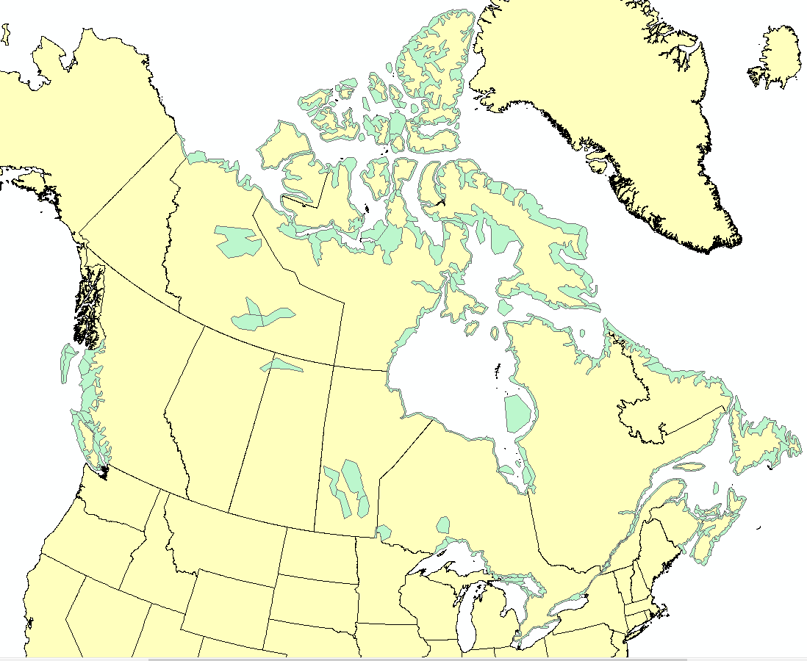
Detail depiction (green lines):
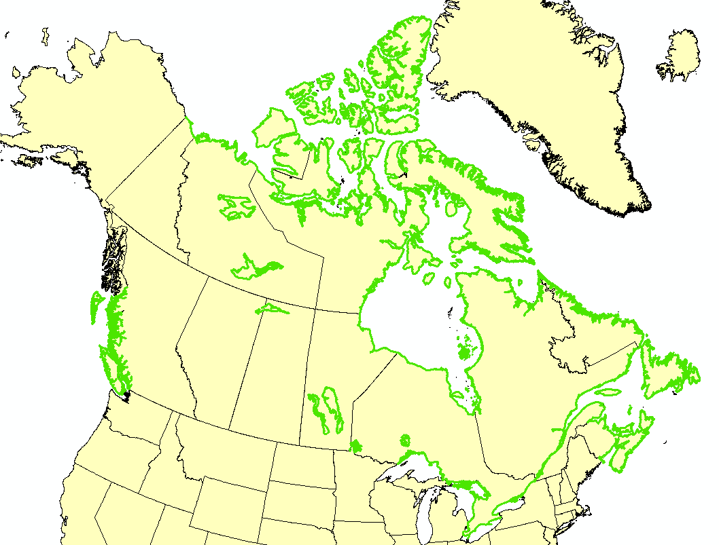

Coarse depiction (green lines):

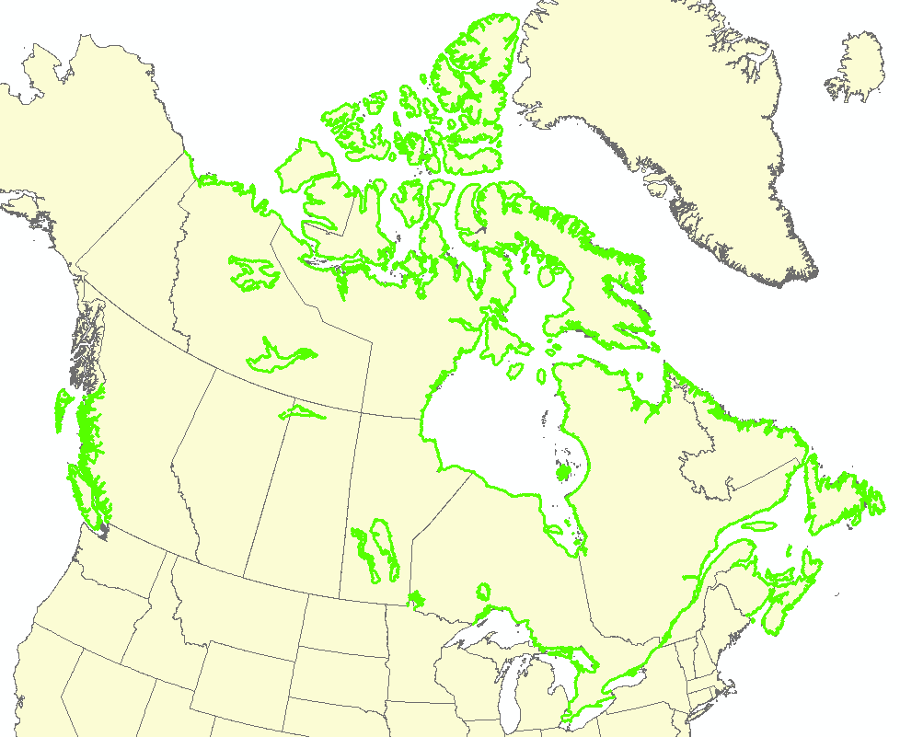
Exaggerated depiction (green polygons)
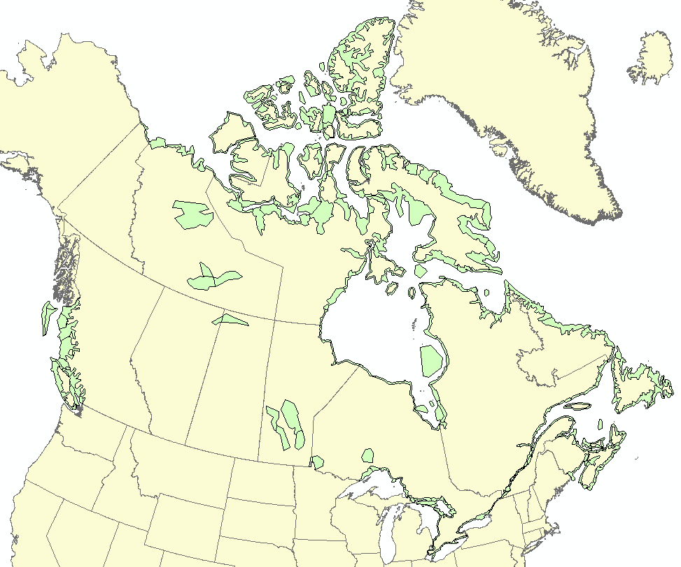

- For the Tsunami usage, we updated shapes so that they follow the coastline instead of having large inland polygons just like the coastal flooding shapes. Also, in order to meet our partners requirements regarding the number of vertices for the exaggerated and hybrid polygons, we created new tsunami locations in Quebec, Nova Scotia, Newfoundland and Labrador. Just like the Coastal Flooding shapefile set, the detail and coarse shapefiles will represent lines that follow coastlines and shorelines as hybrid and exaggerated shapefiles will have ribbon polygons that will cover land and water areas along the shorelines and coastlines. All details on these changes are available in this spreadsheet:
Here are images representing these tsunami locations in different depictions:
Hybrid depiction:
West Coast East Coast
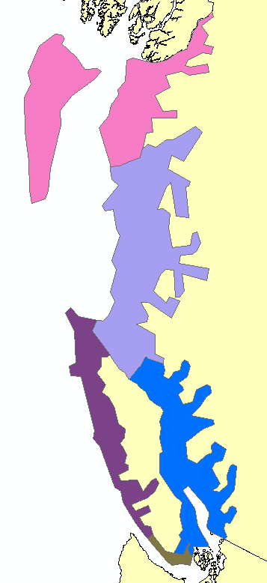
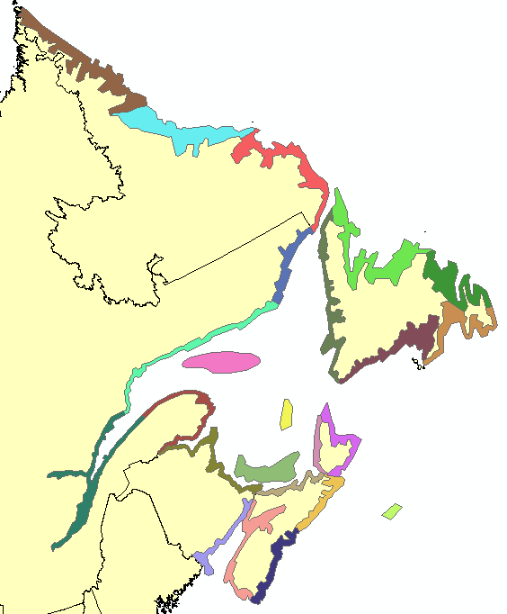

Exaggerated depiction:
West Coast East Coast
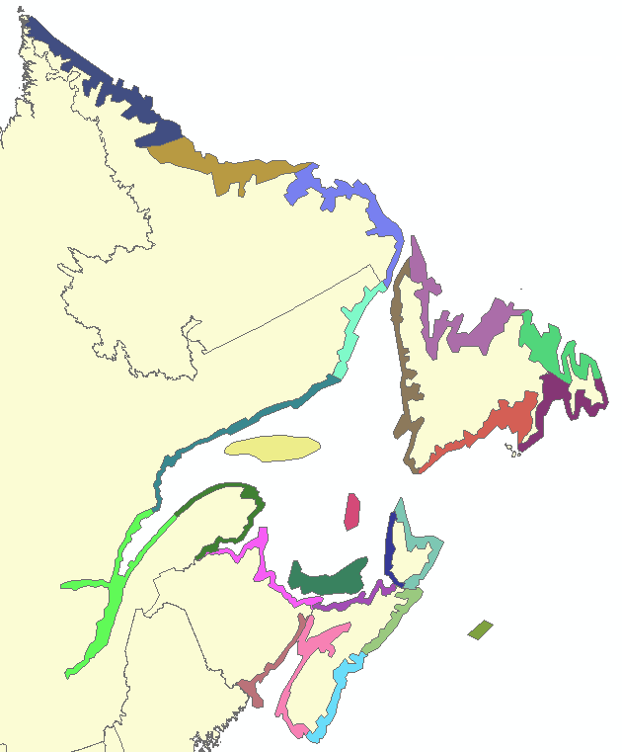
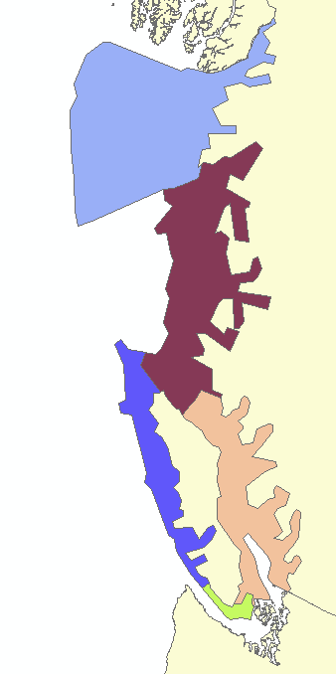

Detail depiction:
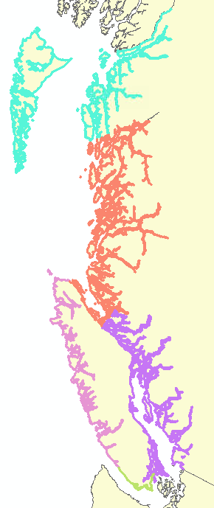
West Coast East Coast
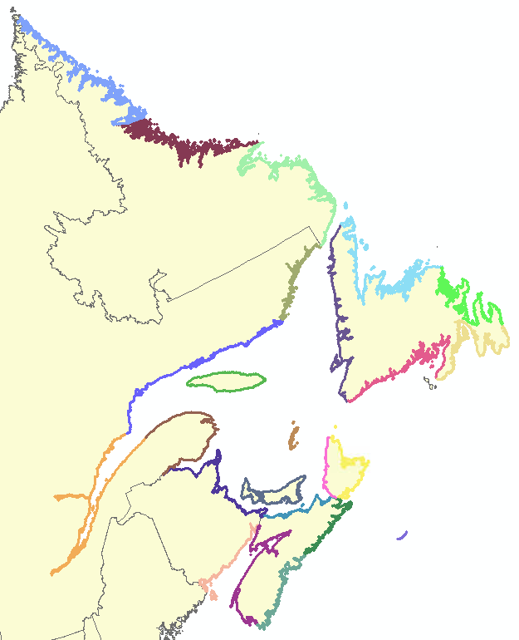

Coarse depiction:
West Coast East Coast
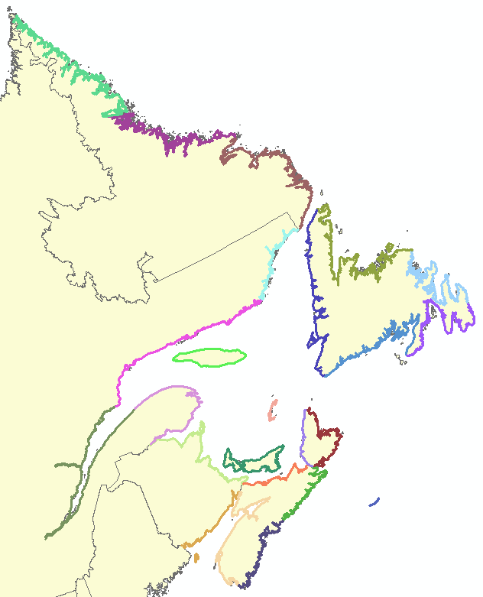
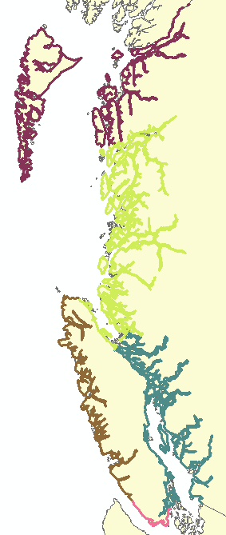

- The roads in the PubStdSiteL, AQStdSiteL and CLCBaseSiteL shapefiles will change to the following:

- A hybrid set will be created which will be the current exaggerated set with minor adjustments as 5 km buffer has been removed at the end of certain roads.
- The exaggerated set will be updated with overlaps between neighbouring roads. For this set, a 5 km buffer will be applied on the current exaggerated set.
Here’s a subset of the PubStdSiteL set in the hybrid and exaggerated depictions:
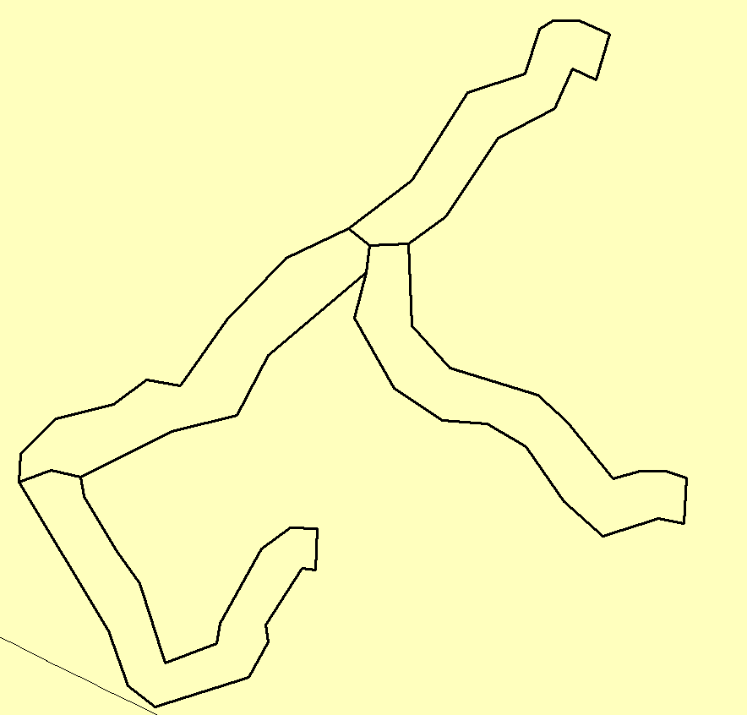
Exaggerated depiction Hybrid depiction
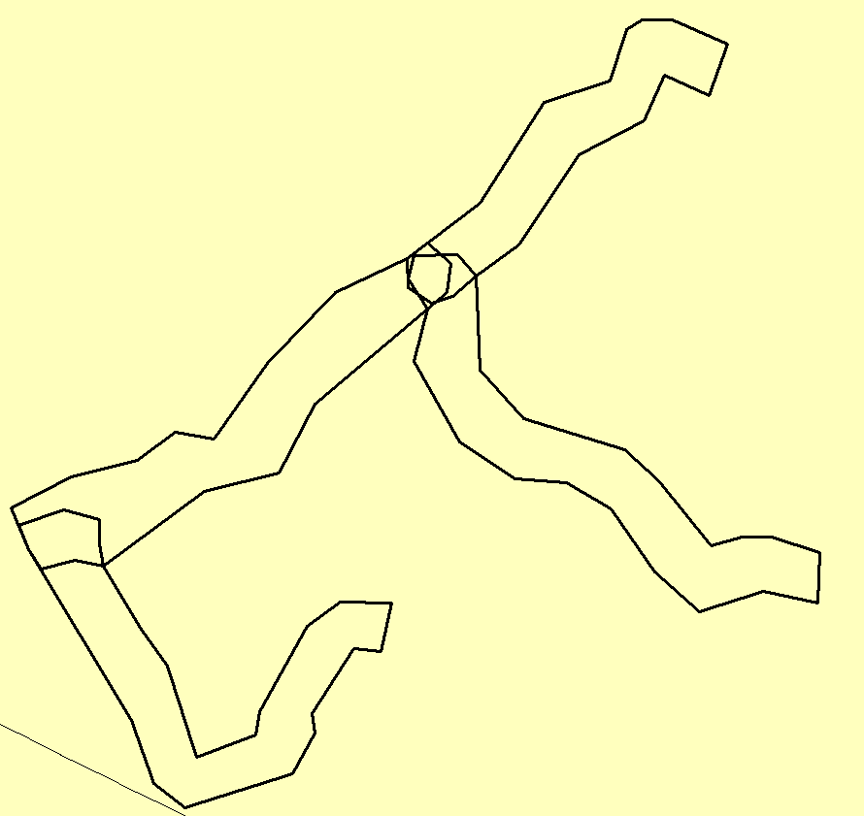

- Partners reported a typo in the following English location name: R.M.of Ellice-Archie incl. St-Lazare McAuley and Manson
A space is missing between ‘R.M.’ and ‘of’.
This English name would need to be fixed in the following shapefile sets:
- PubMeso
- AQStdZone
- Land CLCBaseZone

- In multiple water shapefiles and for different depictions, we fixed a few self-intersecting issues for polygons. To fix those issues, boundaries were moved of a few meters only. Here’s the list of locations, shapefiles and depictions that are affected by those fixes:
Feature Obj ID | English Name | French Name | Shapefile sets | Depictions
fea1-174 | Grand Manan | Grand Manan | MarStd, MarSub, IceStd, IceSub, water HurStd, water CLC base zone and water CAP-CP | Detail
fea1-184 | Southwestern Shore | littoral sud-ouest | MarStd, water CAP-CP (detail depiction only), IceStd and HurStd | Detail, Coarse and Hybrid
fea1-472 | Lake of the Woods | lac des Bois | MarStd, MarSub, and water HurStd | Detail
fea1-48 | Central Coast from McInnes Island to Pine Island | côte centrale de l'île McInnes à l'Île Pine | MarStd | Detail
fea1-594 | Admiralty | Admiralty | MarStd, MarSub, water CAP-CP, water CLC base, IceSub and IceStd | Detail
fea1-745 | Baker | Baker | MarStd, water CLC base, water CAP-CP and MarSub | Detail
fea1-28 | Juan de Fuca Strait - central strait | détroit de Juan de Fuca - partie centrale | MarSub | Coarse

- The Air Quality program is requesting for a new forecast site for Fort Simpson in the Northwest Territories which will be added to the AQStdFcstSiteP and CLCBaseSiteP shapefiles. Here’s information about that location:
Name English | Fort Simpson
Name French | Fort Simpson
English Public Forecast Associated | Ft. Simpson Region including Jean Marie River (094300)
French Public Forecast Associated | région de Ft. Simpson incluant Jean Marie River (094300)
Location | 61.8609, -121.3527
CLC code | 090154
Feature Object ID | fea1-3375
- In the CLCBaseSiteP shapefiles, the site representing ‘Tofino’ (fea1-2864) will be removed.

- The Air Quality program is requesting to retire the following forecast sites:
Name (English and French) | Greenwood
CLC code | 010008
Feature Object ID | fea1-768

Name (English and French) | Comox
CLC code | 080023
Feature Object ID | fea1-2275
These sites will be removed from the AQStdFcstSiteP shapefiles.

- The CLC geocode value for the ‘Central Fraser Valley’ Air Quality alert location will change from '082711-082712' to '082711-082712-082721'. This will affect the AQStdZone shapefiles.

- The Air Quality program requested to change the name for this forecast site:
Old Name (English and French) | Courtenay
New English Name | Comox Valley
New French Name | vallée de Comox
CLC code | 080015
Feature Object ID | fea1-2267

This name will change in the AQStdFcstSiteP and CLCBaseSiteP shapefiles.

- The Public program requested to fix a typo for this Saskatchewan location name:
Old English Name | R.M. of Scott including Yellowgrass Lang and Lewvan
Old French Name | m.r. de Scott incluant Yellowgrass Lang et Lewvan
New English Name | R.M. of Scott including Yellow Grass Lang and Lewvan
New French Name | m.r. de Scott incluant Yellow Grass Lang et Lewvan
CLC code | 062512
Feature Object ID | fea1-1627

This name will change in the PubMesoZone, AQStdZone and land CLCBaseZone shapefile sets.

